Bikaner_survey_report

Great Indian Bustard Recovery Program, Wildlife Institute of India

06/05/2021

## 4. Results

### 4.1. Population status of Mammals

Our extensive surveys covered 89 cells (12816 km2 area) through a transect effort of 1442 km in 2021. Data generated from these surveys provided estimates of species’ occupancy, density and abundance. At the same time, we collected data on habitat and disturbance at 802 points to estimate the effects of natural and anthropogenic changes on animal populations.

#### 4.1.1. Chinkara

Our extensive surveys resulted in detection of 1880 individual chinkara belonging to 684 herds. The encounter rate of chinkara herds and individuals was 60.39 ± 6.49 per 100km and 139.78 ± 18.72 oer 100 km respectively.

Distance data of these observations was best explained by a half-normal key function with cosine(2) adjustments (Figure ). The estimated herd effective strip width was 136.43 ± 7.28 m for a truncation distance of 330 m. The estimated Chinkara density across the landscape was 4.27 ± 0.65 animals/sq.km with an average group size of 2.75 ± 0.18. This amounts to 54745 ± 8392 in the studied landscape.

Model selection summary for Chinkara line transect

Model

Key function

Formula

-value

se()

AIC

3

Half-normal with cosine adjustment term of order 2

~1

0.823

0.413

0.022

0.000

4

Uniform with cosine adjustment terms of order 1,2

NA

0.491

0.433

0.016

0.428

1

Half-normal

~1

0.276

0.445

0.014

0.463

2

Half-normal

~1

0.276

0.445

0.014

0.463

5

Hazard-rate

~1

0.165

0.467

0.021

1.887

6

Hazard-rate

~1

0.165

0.467

0.021

1.887

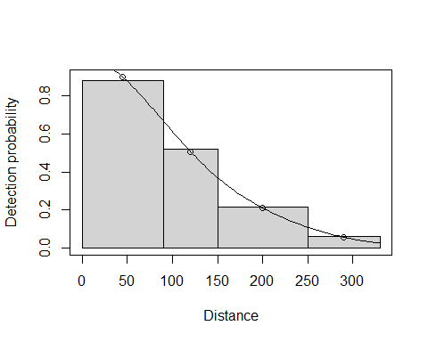

Best fit detection model for Chinkara

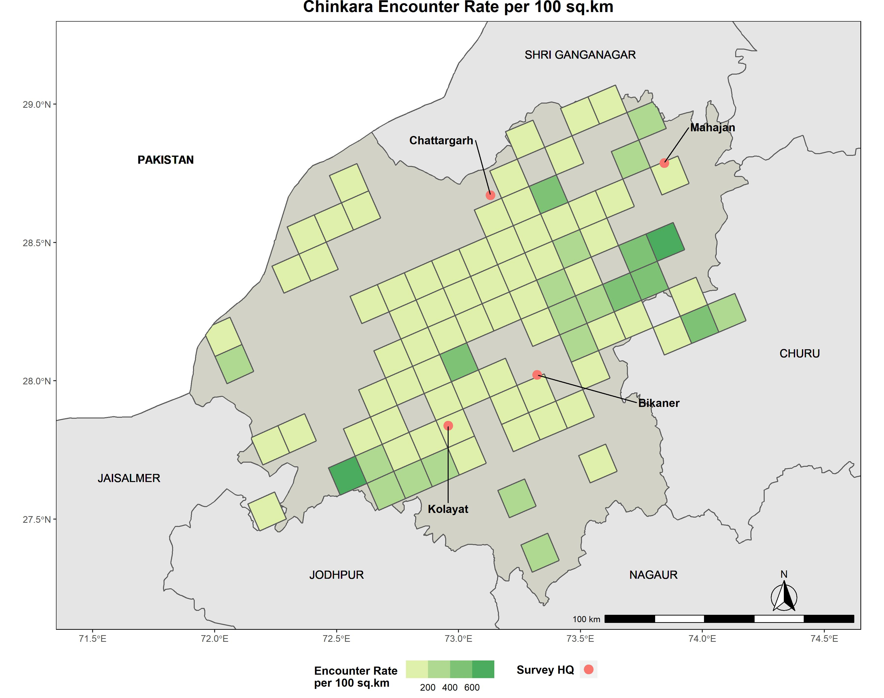

Spatial distribution of Chinkara population

#### 4.1.2 Desert Fox

We detected 122 fox individuals during our survey, with an encounter rate of 9.16 ± 1.34 per 100 sq.km. These observations were best explained by a half-normal key function detection model with cosine(2) adjustments (Figure ). The estimated effective strip width was 62.16 ± 6.4 m for a truncation distance of 200 m. The estimated Desert Fox density across the landscape was 0.58 ± 0.11 individuals per sq.km and the average group size was 1.12 ± 0.06. This adds up to 7456 ± 1356 in the study area.

Model selection summary for Chinkara line transect

Model

Key function

Formula

-value

se()

AIC

3

Half-normal with cosine adjustment term of order 2

~1

0.879

0.311

0.032

0.000

5

Hazard-rate

~1

0.640

0.353

0.047

0.198

6

Hazard-rate

~1

0.640

0.353

0.047

0.198

1

Half-normal

~1

0.189

0.366

0.025

1.052

2

Half-normal

~1

0.189

0.366

0.025

1.052

4

Uniform with cosine adjustment terms of order 1,2,3

NA

NA

0.315

0.034

1.982

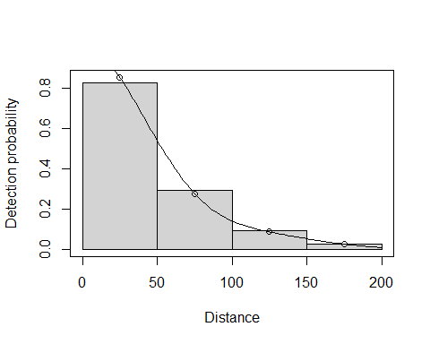

Best fit detection model for Desert Fox

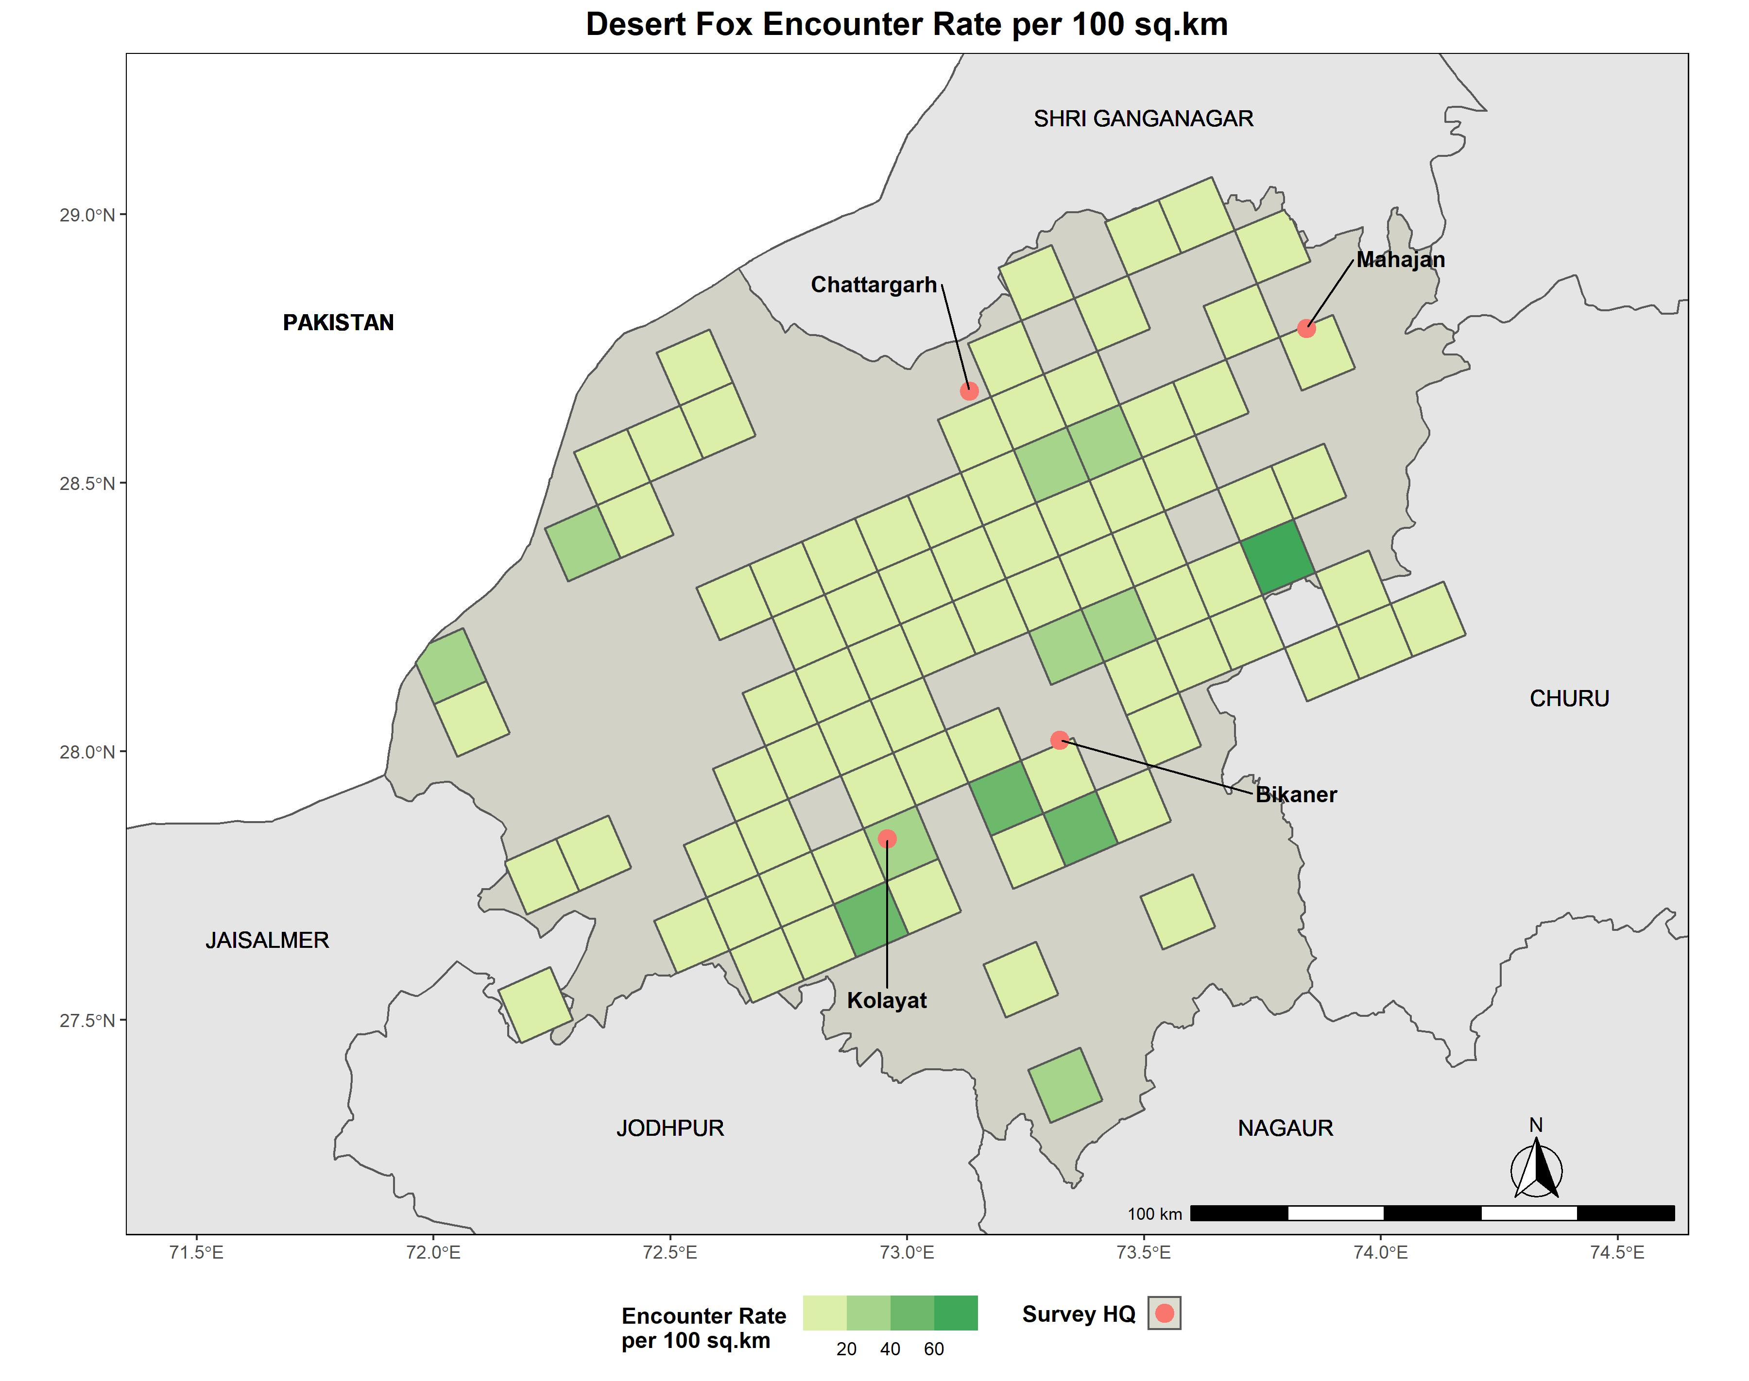

Spatial distribution of Desert Fox population

### 4.2 Habitat status

Habitat characterization along transects during 2017 survey showed that the landscape was dominated by: a) Flat followed by undulating terrain (Figure ); b) Soil followed by sand substrate; c) Scrubland followed by agriculture_inactive and agriculture_active land-cover (Figure ); and d) Kheemp/ Leptadenia pyrotechnica > Khejri/ Prosopis cineraria > Bhui/ Aerva pseudotomentosa > Phog/ Calligonum polygonoides > Burhia Rattlepod/ ChughCrotalaria burhia > crownflower/ giant milkweed/ AakCalotrpis procera > Sind Crowfoot Grass/ GhantiaDactylocrenium scindium > Prosopis juliflora vegetation. Among human artifacts (threats), fence was the most common followed by character(0) and water_source (Figure ).

Descriptive statistics of habitat covariates

Feature

Variable

Mean

SE

rank

Substrate

Soil

0.8

(0.02)

1

Active_Disturbance

Human

0.6

(0.03)

1

Infrastructure

Fence

0.6

(0.03)

1

Landcover

Scrubland

0.6

(0.03)

1

Terrain

Flat

0.55

(0.03)

1

Infrastructure

Powerline

0.52

(0.03)

2

Active_Disturbance

Livestock

0.51

(0.03)

2

Infrastructure

Water_source

0.48

(0.03)

3

Substrate

Sand

0.4

(0.03)

2

Terrain

Undulating

0.36

(0.03)

2

Landcover

Agriculture_inactive

0.35

(0.03)

2

Active_Disturbance

No_active_disturbance

0.28

(0.02)

3

Infrastructure

Road

0.23

(0.03)

4

Active_Disturbance

Dog

0.2

(0.02)

4

Infrastructure

Settlement

0.19

(0.02)

5

Landcover

Agriculture_active

0.17

(0.02)

3

Landcover

Grassland

0.15

(0.02)

4

Infrastructure

No_infrastructure

0.13

(0.02)

6

Active_Disturbance

Machinery

0.12

(0.02)

5

Infrastructure

Farm_hut

0.09

(0.02)

7

Terrain

Sloping

0.09

(0.01)

3

Infrastructure

Industrial_uses

0.01

* 8
* Substrate
* Gravel
* 0.01
* (0.01)
* 3
* Substrate
* Rocky
* 0
  + 4

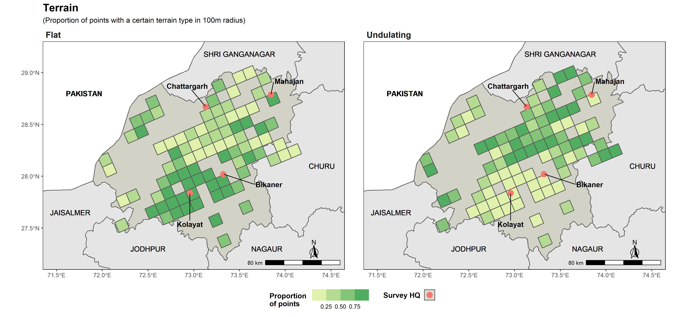

Spatial gradient of Terrain in the Bikaner Landscape measured as the proportion of point having a particular terrain type

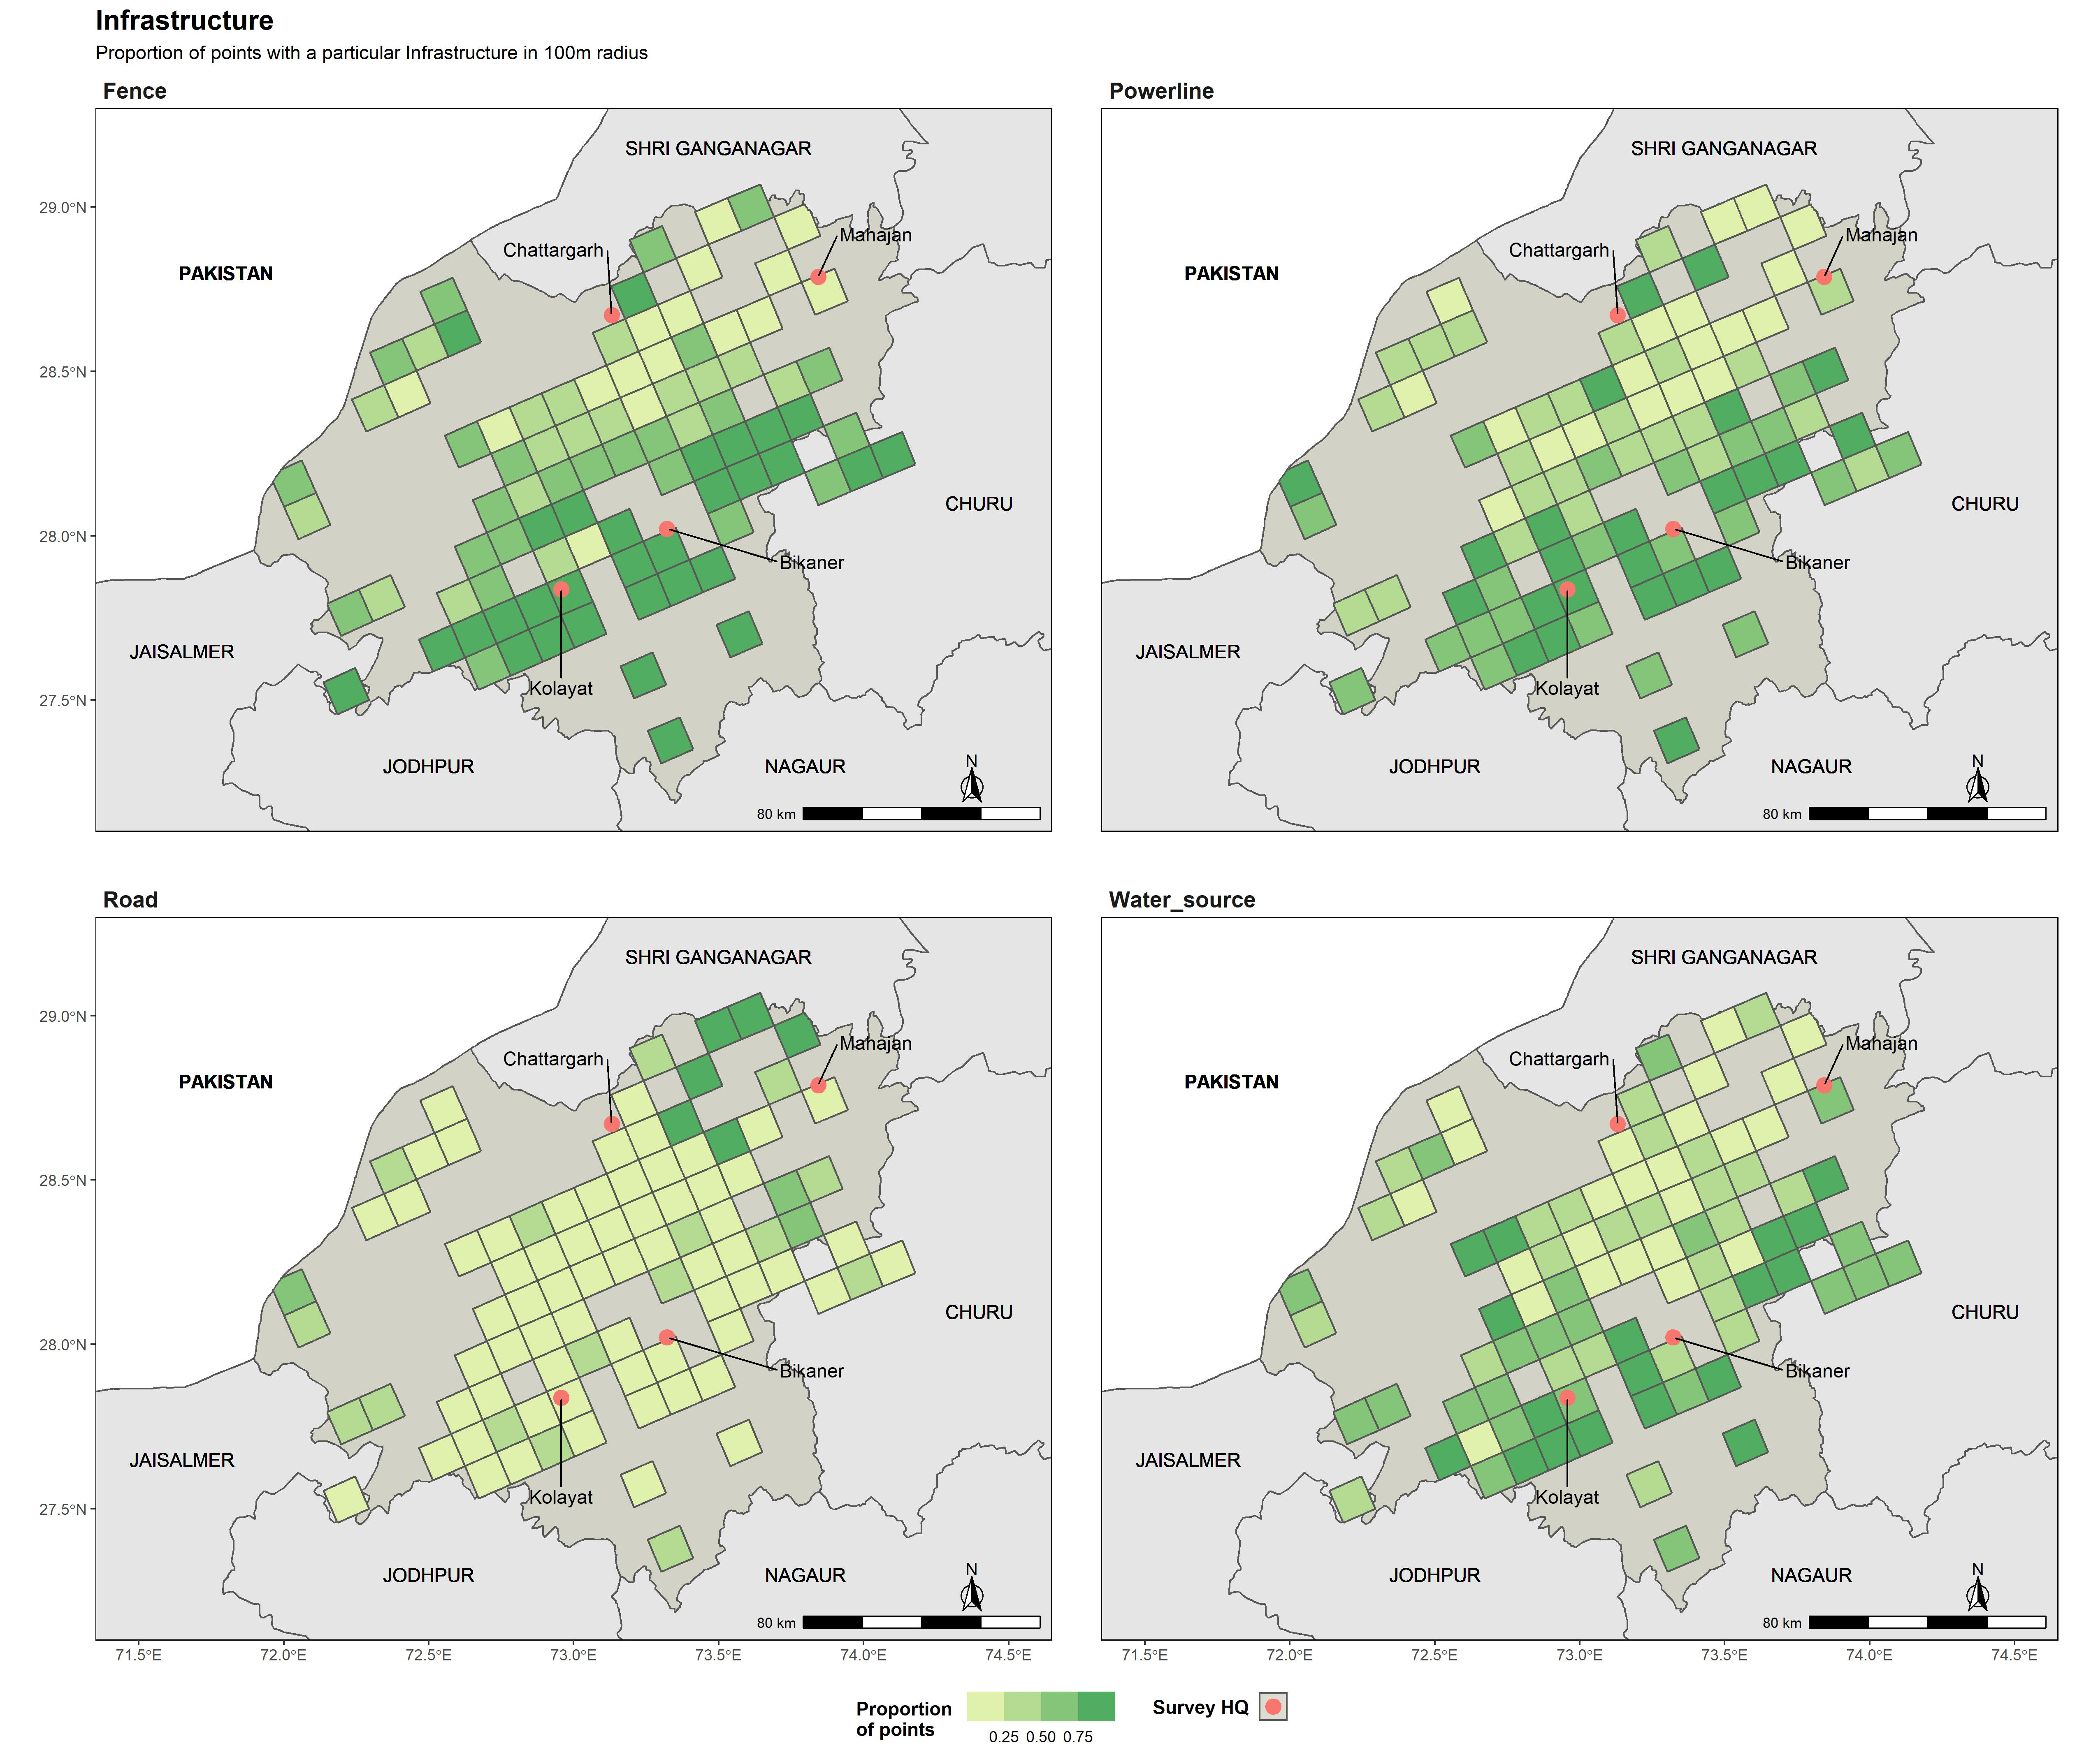

Spatial gradient of Infrastructure presence in the Bikaner Landscape measured as the proportion of point having a particular infrastructure within 100m radiius

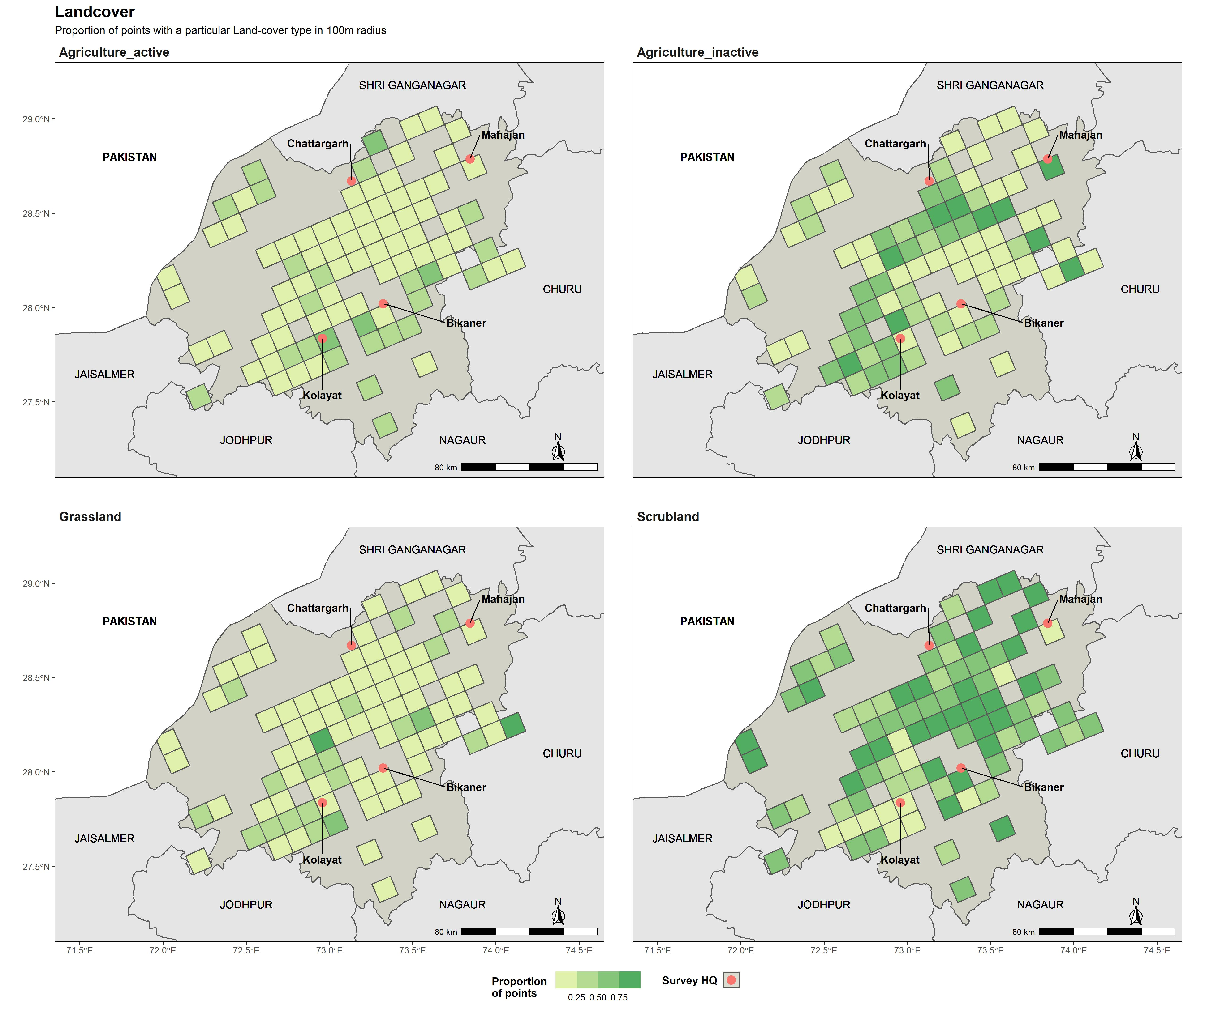

Spatial gradient of Land-use measured by the proportion of point having a particular landcover type within 100m radius

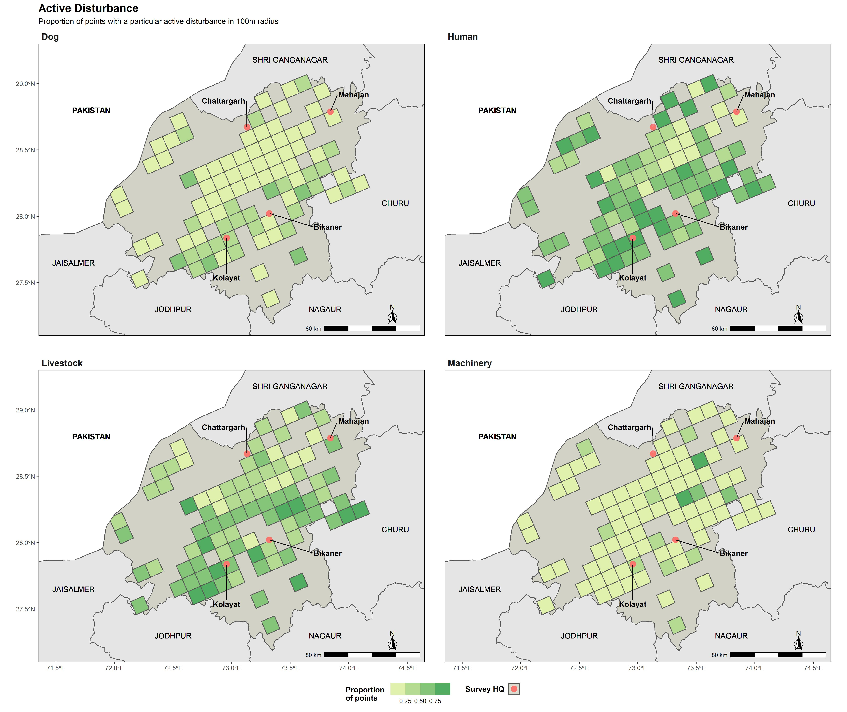

Gradient of anthropogenic disturbance measured as the proportion of points having a particular disturbance within 100m radius