BPMN Study Guide
Complete Question Bank
Q1. What is the loop marker used for?
✔ To indicate an activity that can be executed several times based on a condition
✗ To go back to a previous flow node when a condition is met
✗ To execute an activity multiple times either in parallel or in sequence
✗ It can be applied to a subprocess when its activities can be multiple or optional
✔ Correct Answer: To indicate an activity that can be executed several times based on a condition
Explanation: The Loop marker (circular arrow) on a task means the task repeats as long as a defined condition is true — like a 'while' loop. It is NOT a multi-instance marker (parallel/sequential repetitions) nor an ad-hoc marker (optional activities). It does not redirect flow to a previous node; it simply re-executes the same task.

Q2. What is the main advantage of Call Activities?
✔ Reusability
✗ Automation
✗ Cooperation
✗ Velocity
✔ Correct Answer: Reusability
Explanation: Call Activities reference a globally defined process or task, allowing it to be invoked from multiple different processes. This makes reusability the primary advantage — you define the logic once and call it from anywhere (e.g., Finance, Marketing, Operations) without duplicating the model.

Q3. What is true about this diagram? (Timer event subprocess with 'Notify delay to customer')
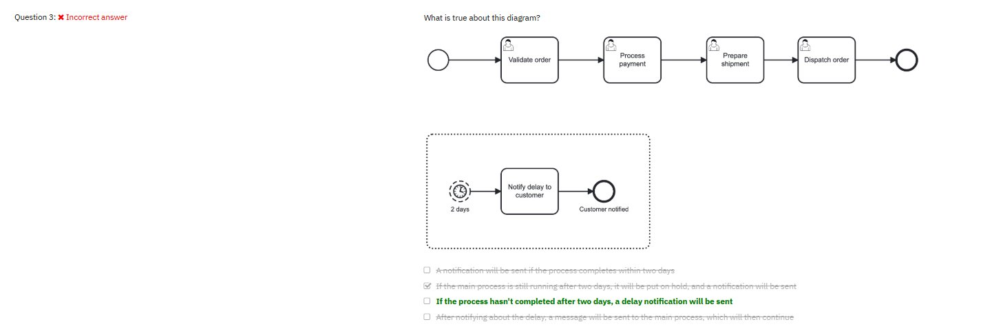
✗ A notification will be sent if the process completes within two days
✗ If the main process is still running after two days, it will be put on hold and a notification will be sent
✔ If the process hasn't completed after two days, a delay notification will be sent
✗ After notifying about the delay, a message will be sent to the main process, which will then continue
✔ Correct Answer: If the process hasn't completed after two days, a delay notification will be sent
Explanation: The dotted boundary indicates a Non-Interrupting Event Subprocess triggered by a Timer event set to '2 days'. Non-interrupting means the main process CONTINUES running — it is NOT put on hold. If the main process is still active after 2 days, the event subprocess fires and executes 'Notify delay to customer' in parallel. No message is sent back to the main process.

Q4. Which BPMN element can be best named with a question?
✗ The parallel gateway
✔ The data based exclusive gateway
✗ The conditional event
✗ The undefined task
✔ Correct Answer: The data based exclusive gateway
Explanation: An Exclusive (XOR) Gateway makes a decision — exactly one path is taken based on a condition. It's best described as a question (e.g., 'Is the order approved?') because its outgoing paths represent YES/NO or multiple mutually exclusive answers. Parallel gateways activate all paths unconditionally and don't represent a decision question.

Q5. Which statement accurately describes the nature of tasks in BPMN?
✗ The process actively monitors and waits for the outcome of a Manual task
✗ Script tasks in BPMN require human decision-making during their execution
✔ Service tasks in BPMN are designed to be executed automatically by a system
✗ All tasks in BPMN are designed to be automated by systems
✔ Correct Answer: Service tasks in BPMN are designed to be executed automatically by a system
Explanation: Service Tasks are fully automated — executed by a system, application, or web service without human involvement. Manual Tasks are performed by humans WITHOUT software support (the process doesn't monitor them). Script Tasks run a script automatically by the process engine, not by humans. Not all BPMN tasks are automated — User Tasks and Manual Tasks require human participation.

Q6. Which statement is true regarding event subprocesses?
✗ They don't need an end event since the main process already has one
✗ They start after the main process is completed
✔ They can be interrupting or non-interrupting
✗ They can't share data with the main process
✔ Correct Answer: They can be interrupting or non-interrupting
Explanation: Event Subprocesses are triggered by a start event within a parent process. If interrupting (solid border start event), the parent process is paused/cancelled when triggered. If non-interrupting (dashed border start event), both the subprocess and the parent process run in parallel. They do need their own end events, they fire DURING (not after) the main process, and they share the same data scope as the parent.

Q7. Which of the following is FALSE regarding BPMN?
✗ BPMN is a powerful modeling language for business processes
✗ BPMN specifies an agreed set of symbols for process modeling
✔ BPMN is primarily designed to model organizational structures
✗ BPMN is an open standard notation for process modeling and automation
✔ Correct Answer: BPMN is primarily designed to model organizational structures
Explanation: This is the FALSE statement. BPMN (Business Process Model and Notation) is designed to model PROCESSES — the flow of work, events, and decisions. Organizational structures (hierarchies, reporting lines, departments) are modeled by other notations such as organizational charts or ArchiMate. All other options are true: BPMN is a standard, uses agreed symbols, and supports automation.

Q8. What do messages do in BPMN?
✗ They can only be sent internally within the same process instance
✔ They enable point to point communication between processes and/or other systems
✗ Primarily represent communication via email
✗ Broadcast a notification received potentially by multiple different processes simultaneously
✔ Correct Answer: They enable point to point communication between processes and/or other systems
Explanation: Messages in BPMN represent directed, point-to-point communication between a sender and a specific receiver — between separate pools/participants or external systems. They are NOT broadcasts (that's what Signals do). Messages are not limited to email — they represent any form of inter-process communication. They cross pool boundaries, so they cannot be sent within the same process instance.

Q9. What are events in BPMN?
✗ Circumstances that lead to a different process path in the flow
✗ Things that need to be done during a process
✔ Things that can happen to the process
✗ Primarily used to represent meetings or corporate gatherings
✔ Correct Answer: Things that can happen to the process
Explanation: Events in BPMN are occurrences that happen TO the process — they affect the flow. Start events trigger the process, end events conclude it, and intermediate events occur during the flow. They are not tasks (things to be done), not gateway conditions (different path logic), and not organizational meetings. The core definition is something that 'happens' and influences the process.

Q10. What is a subprocess in BPMN?
✔ A group of elements or flow nodes used within a larger parent process
✗ A process that does not contain a start or end event
✗ A strategic process model that has yet to be finished
✗ A process that can only be called externally by another process
✔ Correct Answer: A group of elements or flow nodes used within a larger parent process
Explanation: A Subprocess is a compound activity that contains its own internal process flow (tasks, events, gateways) embedded within a parent process. It must have its own start and end events. It is NOT exclusively called externally (that's a Call Activity). It's a way to organize and hide complexity within a parent process, making diagrams cleaner.

Q11. In the diagram shown, which process model is syntactically correct?
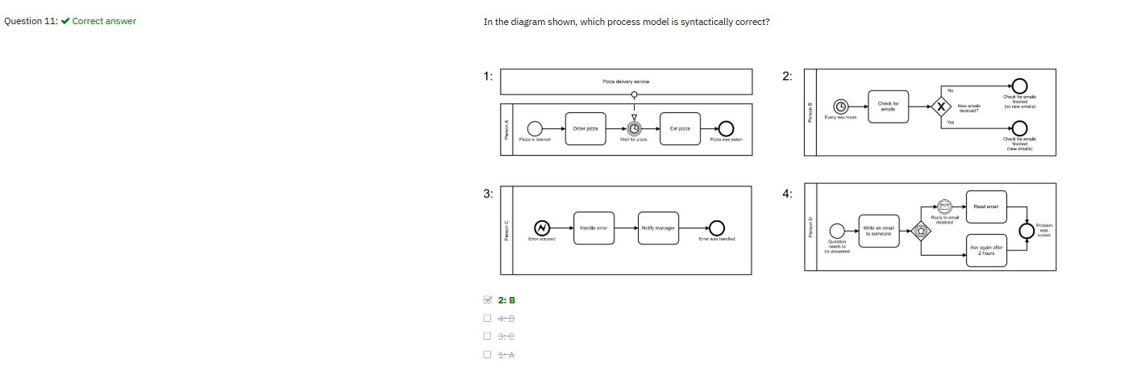
✔ 2: B
✗ 4: D
✗ 3: C
✗ 1: A
✔ Correct Answer: 2: B
Explanation: Process B is syntactically correct. Process A is invalid — it has a signal intermediate event placed incorrectly on the sequence flow. Process C is invalid — an escalation start event inside a regular (non-event) subprocess is not allowed. Process D is invalid — the event-based gateway is followed by a task directly, but event-based gateways must be followed only by catching events (message, timer, etc.), not tasks.

Q12. According to the diagram, which task gets executed if the customer paid with a credit card and the purchase order was not successful?
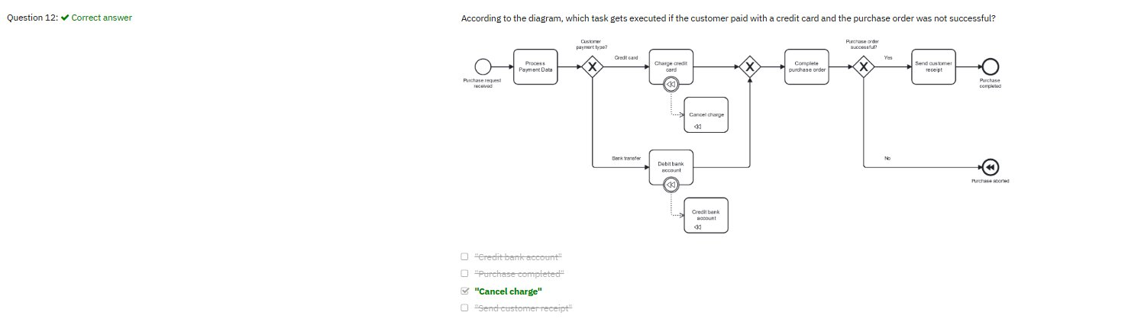
✗ Credit bank account
✗ Purchase completed
✔ Cancel charge
✗ Send customer receipt
✔ Correct Answer: Cancel charge
Explanation: The credit card path triggers 'Charge credit card' (which has a compensation marker ⏮). When the purchase order fails (No path → Purchase aborted end event with compensation trigger), compensation is activated. 'Cancel charge' is the designated compensation handler linked via dashed association — it executes to reverse/undo the charge. This is the BPMN compensation pattern.

Q13. What does this task do? (Task with a hand/pointing finger icon)
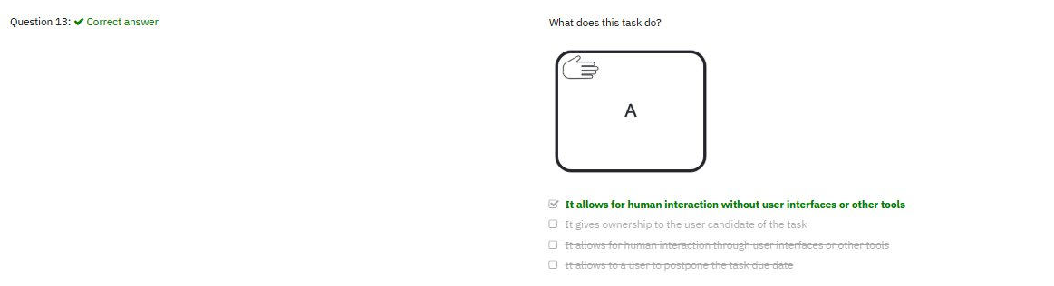
✔ It allows for human interaction without user interfaces or other tools
✗ It gives ownership to the user candidate of the task
✗ It allows for human interaction through user interfaces or other tools
✗ It allows to a user to postpone the task due date
✔ Correct Answer: It allows for human interaction without user interfaces or other tools
Explanation: The open hand icon (without lines/stripes) represents a Manual Task — work performed by a human WITHOUT the aid of any software application or system. Examples include physical tasks like filing papers or assembling a product. This differs from a User Task (pointing finger with lines) which requires interaction THROUGH a software UI or tool. The process engine does not manage or monitor manual task execution.

Q14. Consider the following diagram. What does the first gateway ensure?
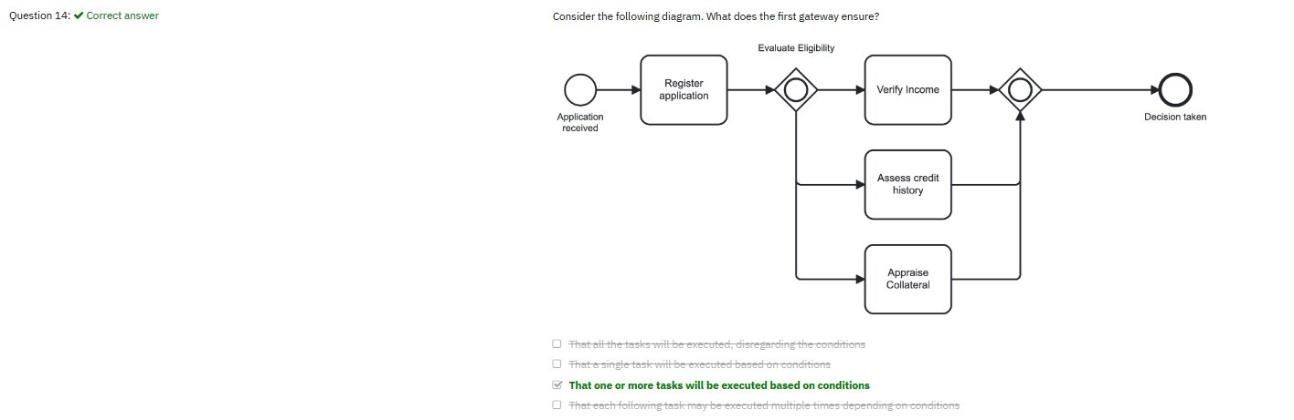
✗ That all the tasks will be executed, disregarding the conditions
✗ That a single task will be executed based on conditions
✔ That one or more tasks will be executed based on conditions
✗ That each following task may be executed multiple times depending on conditions
✔ Correct Answer: That one or more tasks will be executed based on conditions
Explanation: The circle inside a diamond symbol is the Inclusive (OR) Gateway. It evaluates all outgoing paths' conditions and activates ONE OR MORE simultaneously — whichever conditions evaluate to true. If all conditions are true, all paths fire. If only one is true, only one fires. It's not 'all paths always' (Parallel Gateway) and not 'exactly one path' (Exclusive XOR Gateway).

Q15. In which scenario should you use an error event?
✔ When the task is not able to be completed
✗ When there is an issue even if the task is still able to be completed
✗ When there is an issue within the process engine itself
✗ Following event-based gateways if a certain event is not received
✔ Correct Answer: When the task is not able to be completed
Explanation: Error Events model fatal business errors — situations where a task or subprocess CANNOT complete and normal flow must stop. When a task fails entirely, an error is thrown and caught by an error boundary event or error start event in an event subprocess. Non-fatal issues use Escalation Events. Process engine faults are technical issues, not BPMN error events. Event-based gateways use timer/message catching events, not error events.

Q16. Which of the processes in the diagram better shows an example of compensation?
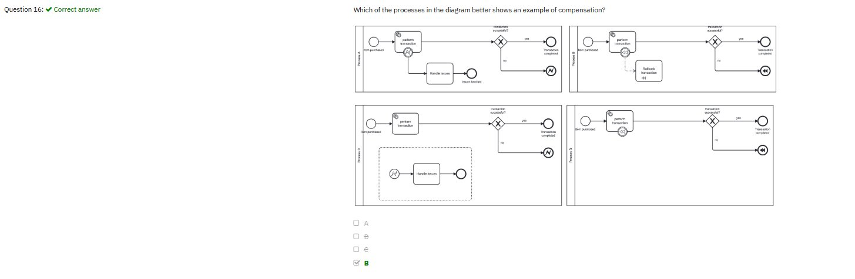
✗ A
✔ B
✗ C
✗ D
✔ Correct Answer: B
Explanation: Process B correctly demonstrates BPMN compensation: (1) 'Perform transaction' has a compensation marker, (2) 'Rollback transaction' is the compensation handler connected via dashed association with its own ⏮ marker, and (3) a compensation end event triggers rollback when the transaction fails. Process A uses an escalation event (non-fatal). Process C has an ad-hoc subprocess. Process D has the compensation marker but no linked compensation handler task.

Q17. Consider the following use case. What happens if the invoice fails?
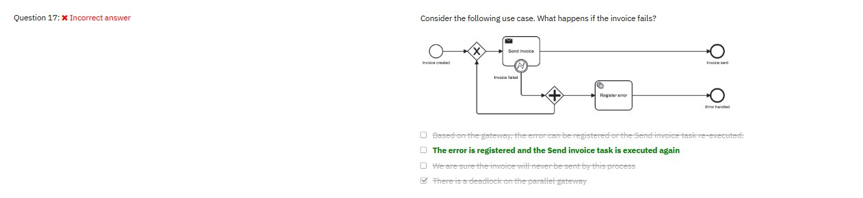
✗ Based on the gateway, the error can be registered or the Send invoice task re-executed
✔ The error is registered, and the Send invoice task is executed again
✗ We are sure the invoice will never be sent by this process
✗ There is a deadlock on the parallel gateway
✔ Correct Answer: The error is registered and the Send invoice task is executed again
Explanation: Looking at the diagram: when the invoice fails, the error boundary event catches it and flows to the parallel gateway (+). The parallel gateway merges with the main flow token AND triggers 'Register error'. After registration, the flow loops back to 'Send Invoice' to retry it. So both the error is registered AND the task is re-executed. Note: In our earlier session this was marked as a deadlock question — this updated diagram shows a different flow where retry is the correct interpretation.

Q18. You have created a Communication process to be called by several processes from Finance and Marketing departments. How can this be achieved?
✗ You can achieve this by using the Event subprocess
✗ You can achieve this by using the Expanded subprocess
✔ You can achieve this by using the Call activity
✗ You can achieve this by using the Collapsed subprocess
✔ Correct Answer: You can achieve this by using the Call activity
Explanation: A Call Activity references a globally defined reusable process, allowing it to be invoked from multiple different processes across departments. Event, Expanded, and Collapsed Subprocesses are all embedded WITHIN a single parent process and cannot be shared or reused globally. The key indicator is 'called by SEVERAL processes from different departments' — that's exactly what Call Activities are designed for.

Q19. What is the primary purpose of data objects in BPMN?
✗ To specify the conditions for gateway decision-making
✗ To represent physical artifacts used during the process
✗ To define the roles of participants in the process
✔ To model the data required or produced by a BPMN element
✔ Correct Answer: To model the data required or produced by a BPMN element
Explanation: Data Objects represent the information flow in a process — what data a task needs as input or produces as output. They show the data lifecycle within a process instance. Gateway conditions are defined by expressions on sequence flows (not data objects). Roles/participants are represented by Lanes and Pools. Data objects are informational artifacts, not physical representations.

Q20. What is the primary function of an XOR (Exclusive) gateway?
✗ To randomly select a path without any conditions
✔ To choose one and only one path based on a condition
✗ To allow multiple paths to be taken simultaneously
✗ To synchronize multiple tasks into one path
✔ Correct Answer: To choose one and only one path based on a condition
Explanation: An XOR (Exclusive) Gateway evaluates conditions on outgoing sequence flows and activates EXACTLY ONE — the first path whose condition evaluates to true. 'Exclusive' means the chosen path excludes all others. Random selection has no role in BPMN. Simultaneous multiple paths is a Parallel AND Gateway. Synchronization (merging multiple paths) is also a Parallel Gateway function on the convergence side.

Q21. What is the key difference between collaboration and orchestration in BPMN?
✗ Orchestration models interactions between participants, while collaboration focuses on the sequence of tasks within a process
✗ Orchestration involves only gateways, while collaboration involves only events
✔ Collaboration models interactions between multiple participants, while orchestration focuses on the flow of tasks within a single participant
✗ Collaboration is used exclusively for technical processes, while orchestration is used for business-level workflows
✔ Correct Answer: Collaboration models interactions between multiple participants, while orchestration focuses on the flow of tasks within a single participant
Explanation: Orchestration describes the internal flow of a single process (one pool/participant) — the sequence of tasks, gateways, and events. Collaboration shows how multiple independent participants (pools) interact via message flows. A collaboration diagram contains multiple pools with message flows between them. The distinction is: orchestration = within one party, collaboration = between multiple parties.

Q22. What is the primary difference between strategic and operational process models in BPMN?
✔ Strategic models focus on high-level business goals, while operational models detail the steps required to execute specific processes
✗ Operational models are only used for monitoring performance, while strategic models are used for compliance purposes
✗ Strategic models define workflows within an organization, while operational models represent interactions between different organizations
✗ Operational models are used for decision-making, while strategic models are used for task automation
✔ Correct Answer: Strategic models focus on high-level business goals, while operational models detail the steps required to execute specific processes
Explanation: Strategic process models show the big picture — what the organization does at a high level, without task-level detail. They communicate goals and value chains to management. Operational models show HOW work is done — detailed steps, decisions, roles, and data flows that can guide execution or automation. They are complementary: strategic models set direction, operational models enable execution.

Q23. In the diagram shown, which tasks will have been executed when the process completes?
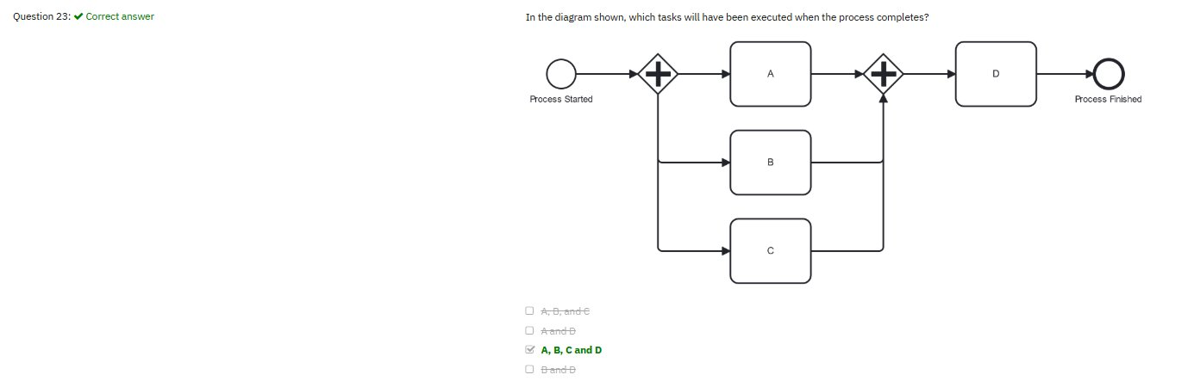
✗ A, B, and C
✗ A and B
✔ A, B, C and D
✗ B and D
✔ Correct Answer: A, B, C and D
Explanation: The first Parallel Gateway (+) splits into THREE parallel paths: A, B, and C all execute simultaneously. The second Parallel Gateway (+) synchronizes — it waits for ALL three tokens (A, B, C) before proceeding. Only when all three complete does D execute, followed by the end event. Therefore ALL four tasks — A, B, C, and D — are executed every time the process runs.

Q24. What are the main characteristics of process collaboration in BPMN?
✔ Manage responsibilities with pools and the communication with messages
✗ Manage responsibilities with lanes in pools, communication with signals and errors
✗ Use messages and signals to orchestrate lanes in a pool
✗ With collaboration the task collaborates to make the process reusable, performant and efficient
✔ Correct Answer: Manage responsibilities with pools and the communication with messages
Explanation: A BPMN Collaboration diagram uses: (1) Pools to represent separate participants/organizations, each owning their own independent process, and (2) Message Flows (dashed arrows) to show communication between pools. Lanes are internal subdivisions within a single pool and don't communicate via messages. Signals are broadcasts (not collaboration-specific). Reusability is achieved by Call Activities, not collaboration.

Q25. A company generates invoices tracked, updated, and referenced multiple times across payment processing, client inquiries, and financial reporting. Which BPMN symbol is best suited?
✗ Data object
✗ Knowledge base
✗ Object tracker
✔ Data store
✔ Correct Answer: Data store
Explanation: A Data Store (cylinder/database symbol) represents persistent data that exists BEYOND a single process instance and can be accessed/updated by multiple processes. Data Objects only live within one process instance and don't persist. 'Knowledge base' and 'Object tracker' are not standard BPMN elements. The scenario's keywords — 'tracked', 'updated', 'referenced multiple times', 'multiple processes' — all point to a Data Store.

