**1. Create one pipeline**

**Creating Scripted pipeline**

1. New item -> give name -> select pipeline -> ok

2. Advanced project options -Select pipeline script and add the below script

pipeline {

agent any

tools {

maven 'maven'

}

stages {

stage ('git clone')

{

steps {

git 'https://github.com/Aisirihs/jenkins-maven.git'

}

}

stage ('compile')

{

steps {

sh "mvn compile"

}

}

stage ('test')

{

steps {

sh "mvn test"

}

}

stage ('package')

{

steps {

sh "mvn package"

}

}

stage ('install')

{

steps {

sh "mvn install"

}

}

}

}

Click on apply and save

3. Click on build now

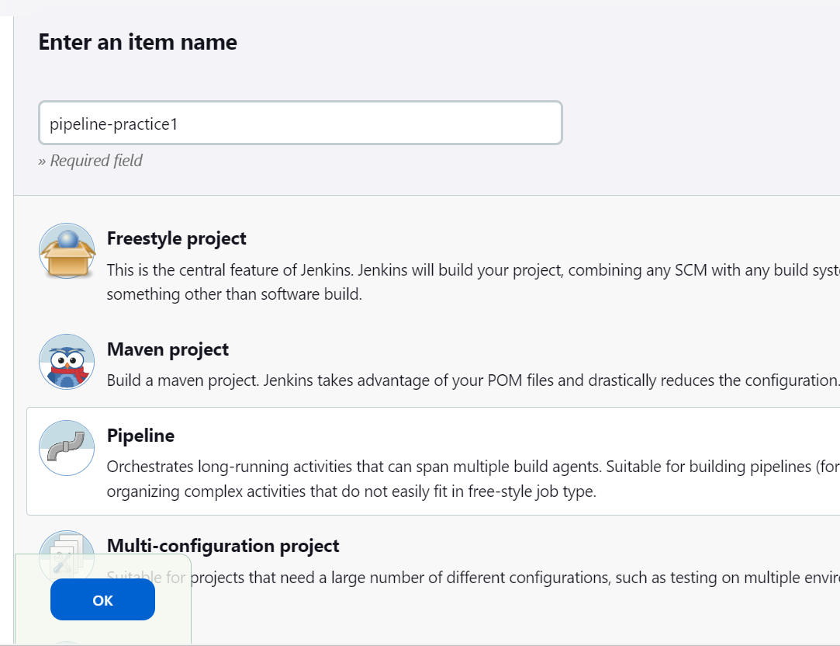

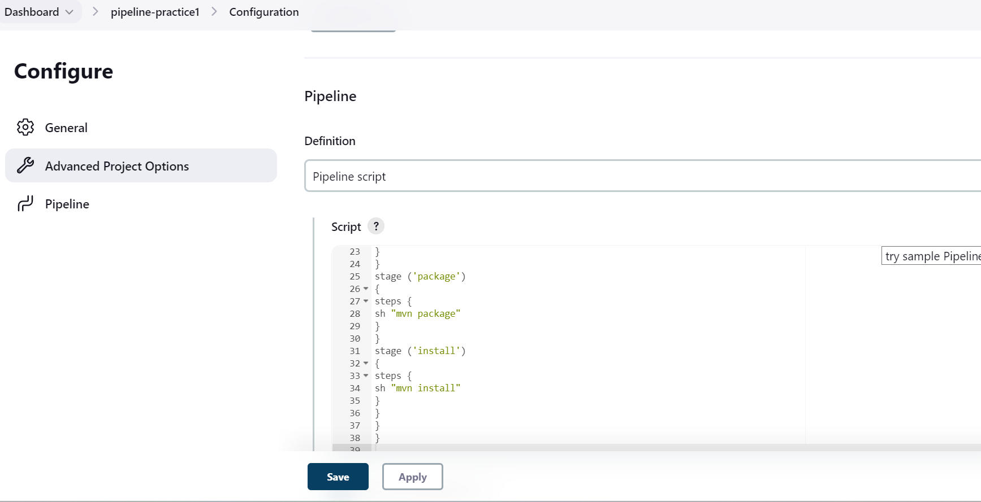

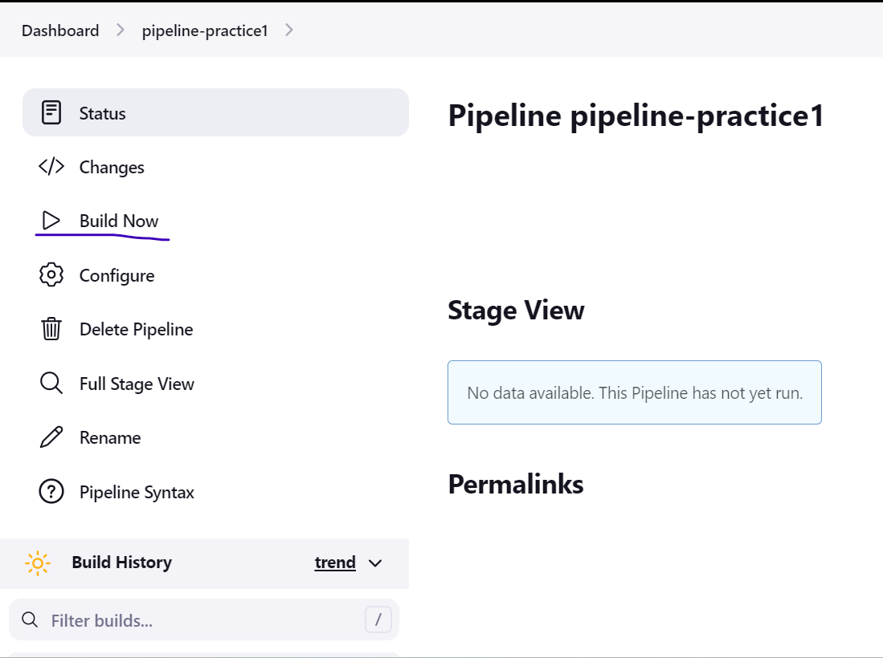

Build is success

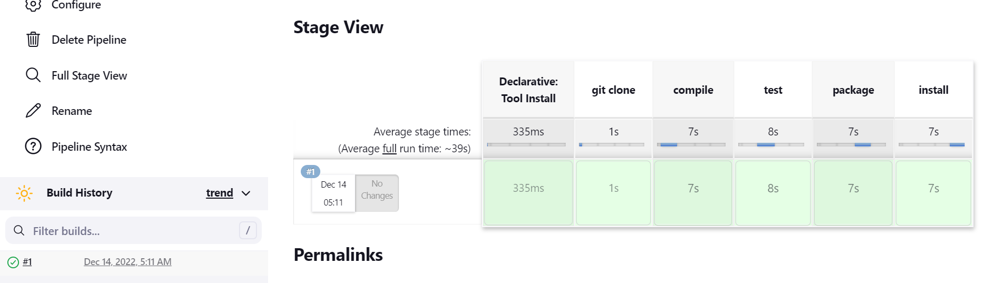

**Creating pipeline from SCM**

1. Create one file named jenkinsfile in github and add the below script

pipeline {

agent any

tools {

maven 'maven'

}

stages {

stage ('compile')

{

steps {

sh "mvn compile"

}

}

stage ('test')

{

steps {

sh "mvn test"

}

}

stage ('package')

{

steps {

sh "mvn package"

}

}

stage ('install')

{

steps {

sh "mvn install"

}

}

}

}

2. Go to Jenkins -New item -> give name -> select pipeline -> ok

3. Advanced project options -> select pipeline script from scm -> SCM-select git -> paste the git repo url -> script path – give filename(jenkinsfile)

Apply and save

4. click on build now

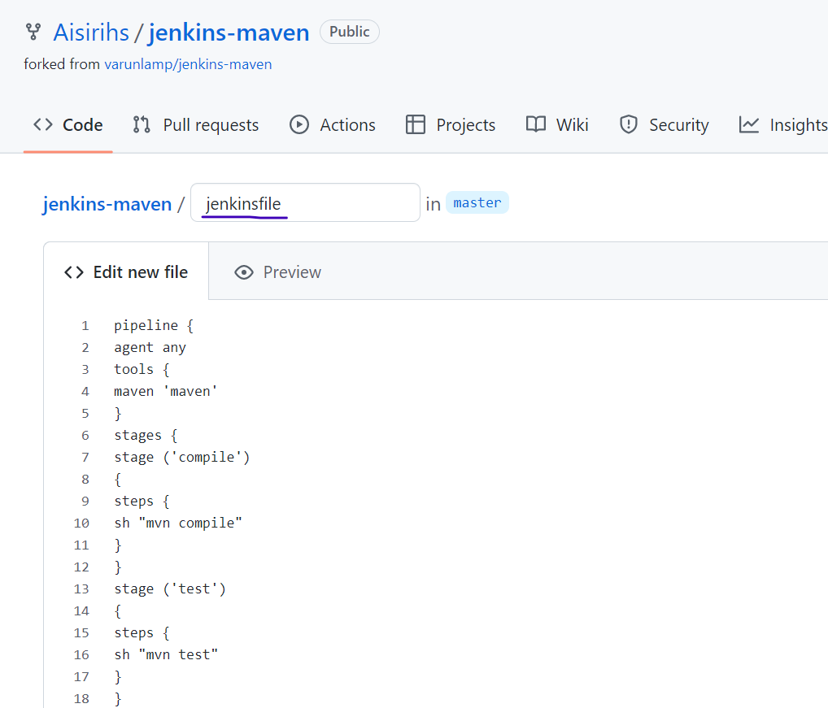

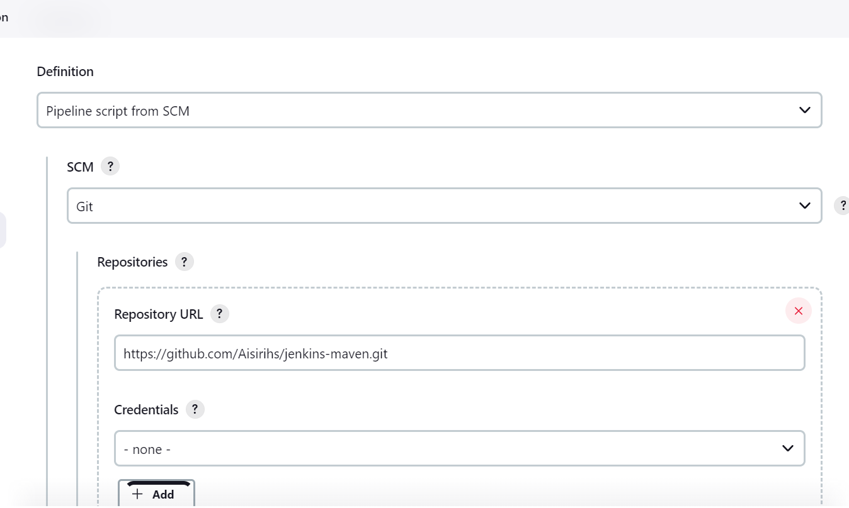

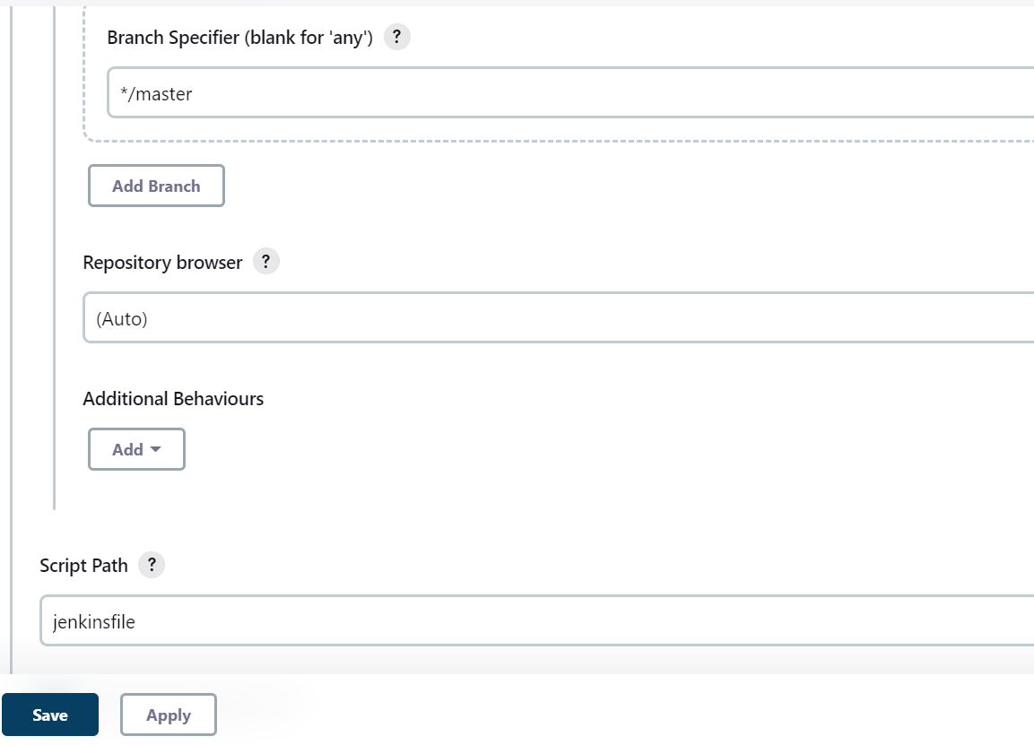

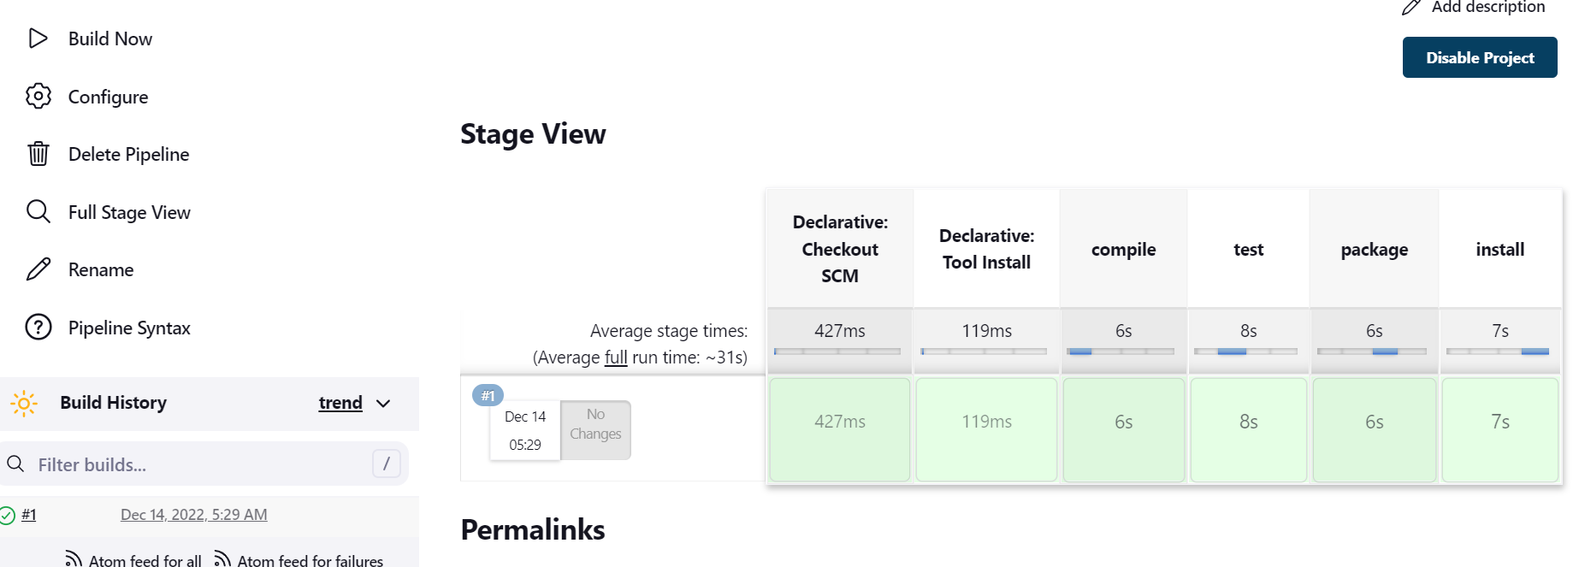

**2. Create a test engineer role and attach the roles**

**roles(permissions):- only read the jobs**

1. Install plugin (Role based authorization strategy plugin )

Dashboard -> manage plugins ->Search and select Role based authorization strategy

2. Manage Jenkins -> Security -> Manage users -> Create user – give all the user credentials

3. Manage Jenkins -> Security -> Configure global security -> Authorization -> role based strategy

Apply and save

3. Manage Jenkins -> Security -> Manage and Assign Roles -> manage roles -> Role to add -test engineer – click on add

Select read permission for jobs

Apply and save

4. Assign roles -> user/group to add – give username – Apply and save

5. Now logout from Jenkins and login with the username u given and check

