Supporting Information
Higher alcohols synthesis from syngas over CoCu/SiO₂ catalysts: dynamic structure and the role of Cu

Junjie Suª, Zhengpai Zhangª, Donglong Fuª, Da Liuª, Xin-Chao Xuª, Bianfang Shiª, Xu Wang^{b}, Rui Si^{b}, Zheng Jiang^{b}, Jing Xuª and Yi-Fan Hanª*

ª State Key Laboratory of Chemical Engineering, East China University of Science and Technology, Shanghai 200237, China
^{b} Shanghai Synchrotron Radiation Facility, Shanghai Institute of Applied Physics, Chinese Academy of Sciences, Shanghai 201204, People’s Republic of China

* Corresponding author phone: (+86) 21-64251928; fax: (86) 21-64251928;
E-mail: yifanhan@ecust.edu.cn

- Analytic method
  - Analytic method for gaseous products
The gaseous products such as paraffins, olefins, carbon dioxide and unreacted feed gas(H₂, N₂ and CO) were analyzed using an online gas chromatograph using Ar as carrier gas. A capillary column (HP-Plot Al₂O₃/S) connected to aflame ionization detector (FID) was used to analyze hydrocarbon products. Other inorganic gas was determined using two packed columns (TDX-01 and 5A molecular sieve) connected to a thermal conductivity detector (TCD). Gas-phase concentrations were calculated using absolute response factors. The relationship between peak area and the specific gas concentration could be expressed as eq.s1:
V_{i}=f_{i}*A_{i} (1)
Here, V_{i} is the volume fraction of i component, A_{i} is the peak area of i component and f_{i} is absolute response factor. The response factors were calculated by detecting the peak area of each component with known concentration as summarized in Table S1.
Table S1 Standard gas composition and absolute response factor

Component | V% | F(average)
CH₄ | 0.019 | 1.1862E-08
C₂H₆ | 0.005 | 6.1103E-09
C₂H₄ | 0.001 | 5.3430E-09
C₃H₈ | 0.002 | 3.8212E-09
C₃H₆ | 0.001 | 3.6845E-09
C₄H₁₀ | 0.002 | 2.8407E-09
C₄H₈ | 0.001 | 3.0131E-09
H₂ | 0.278 | 2.9291E-08
N₂ | 0.049 | 3.4226E-07
CO | 0.142 | 3.2489E-07
CO₂ | 0.003 | 2.4606E-07

  - Analytic method for liquid products
liquid products such as alcohols and other oxygenates were analyzed using a gas chromatograph with a capillary column (FFAP) connected to aflame ionization detector (FID) using Ar as carrier gas after collected in a condenser. The liquid product concentrations were calculated using acetone as internal standard. The relationship between peak area and the specific component concentration is expressed as eq. s2:
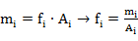 (2)
Here, m_{i} is the mass of i component, A_{i}is the peak area of i component, and f_{i} is absolute response factor.
For acetone was defined as eq. s3
f_{s}=m_{s}/A_{s} (3).
The relative response factor f_{si} was defined as eq. s4
f_{gi}=f_{i}/f_{s}=(m_{i}/A_{i})/(m_{s}/A_{s}) (4)
The relative response factor of each liquid product was summarized in Table S2.
Table S2 Relative response factors for liquid products
Substance | f_{si} | Substance | f_{si} | Substance | f_{si}
Acetone | 1.000 | Ethanol | 0.916 | Sec-butanol | 0.746
Methyl acetate | 1.289 | n-propanol | 0.896 | Pentanol | 0.618
Ethyl acetate | 1.248 | n-butanol | 0.708 | Acetic acid | 2.866
Methanol | 1.513 | isobutanol | 0.671 | -- | --
- Exclusion of the external/internal diffusion effects
2.1 Methods
The Frossling correlation[S1,S2] is used in flow around spherical particles to obtain the relation between the particle size (d_{p}) of the catalyst, mass-transfer coefficient (k_{c}), and boundary layer thickness (δ). The mass-transfer correlation is given as eq.s5:
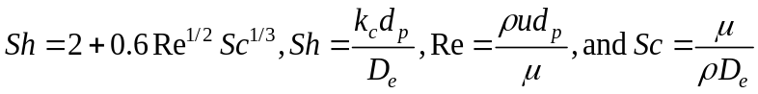 (5)
Here, k_{c} is the average mass-transfer coefficient of a reactant from the bulk flow to catalyst surface (m/s), d_{p}is the average diameter of the catalyst particle (m), D_{e} is the effective diffusivity for a binary gas mixture(m²/s), u is the free stream velocity of fluid (m/s), ρ is the gas density (kg/m³), and μ is the gas dynamic viscosity(kg·m⁻¹·s⁻¹).
The Weisz-Prater criterion (C_{WP}) is used to estimate the internal mass-transfer resistance in heterogeneous catalytic reactions[S3]. If C_{WP}<<1, there is no internal diffusion limitation, and if C_{WP}>>1, internal diffusion has an effect on the reaction. This criterion is given as follows (eq. s6):
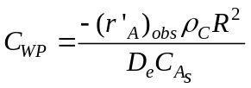 (6)
Here,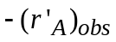 is the reaction rate per unit mass of catalyst, ρ_{C} is the catalyst density, R is the particle radius, 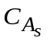is the surface concentration of reactant A, and D_{e} is effective diffusivity.
2.2 Internal and external diffusion effects
5Co2.5Cu/SiO₂ catalyst was been chosen to eliminate the effects of internal and external diffusion. The external diffusion effects were excluded through varying the boundary layer thicknesses of the catalyst external surface, which was obtained by changing gas hourly space velocity (GHSV)[S4].The reaction was carried out at 270°C, 5.0 MPa of syngas with a H₂/CO ratio of 2, catalyst particle size of 0.177 mm and GHSV= 3450, 10350 and 14900h⁻¹, respectively. Fig. S1(a) revealed that CO conversion decreased from 11.9% to 3.1% with the increased GHSV from 3450 to 14900 h⁻¹. The corresponding mass-transfer coefficient (k_{c}) was calculated and summarized in Table S3. It’s clear that the effect of flow rate on the external diffusion is negligible at above the GHSV of 10350 h⁻¹. Therefore, we conclude that the external mass transport effects can be safely precluded at above the GHSV of 14900 h⁻¹.
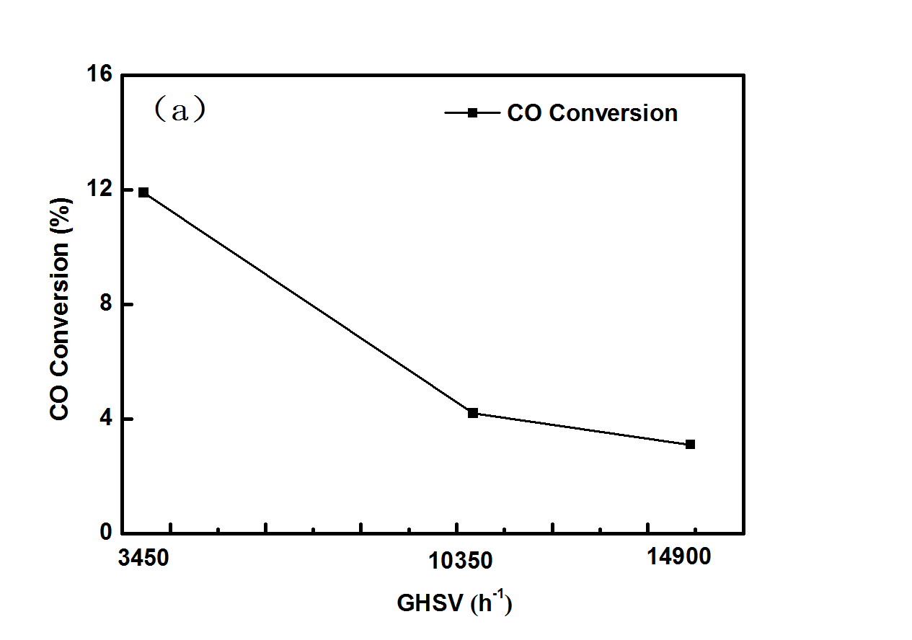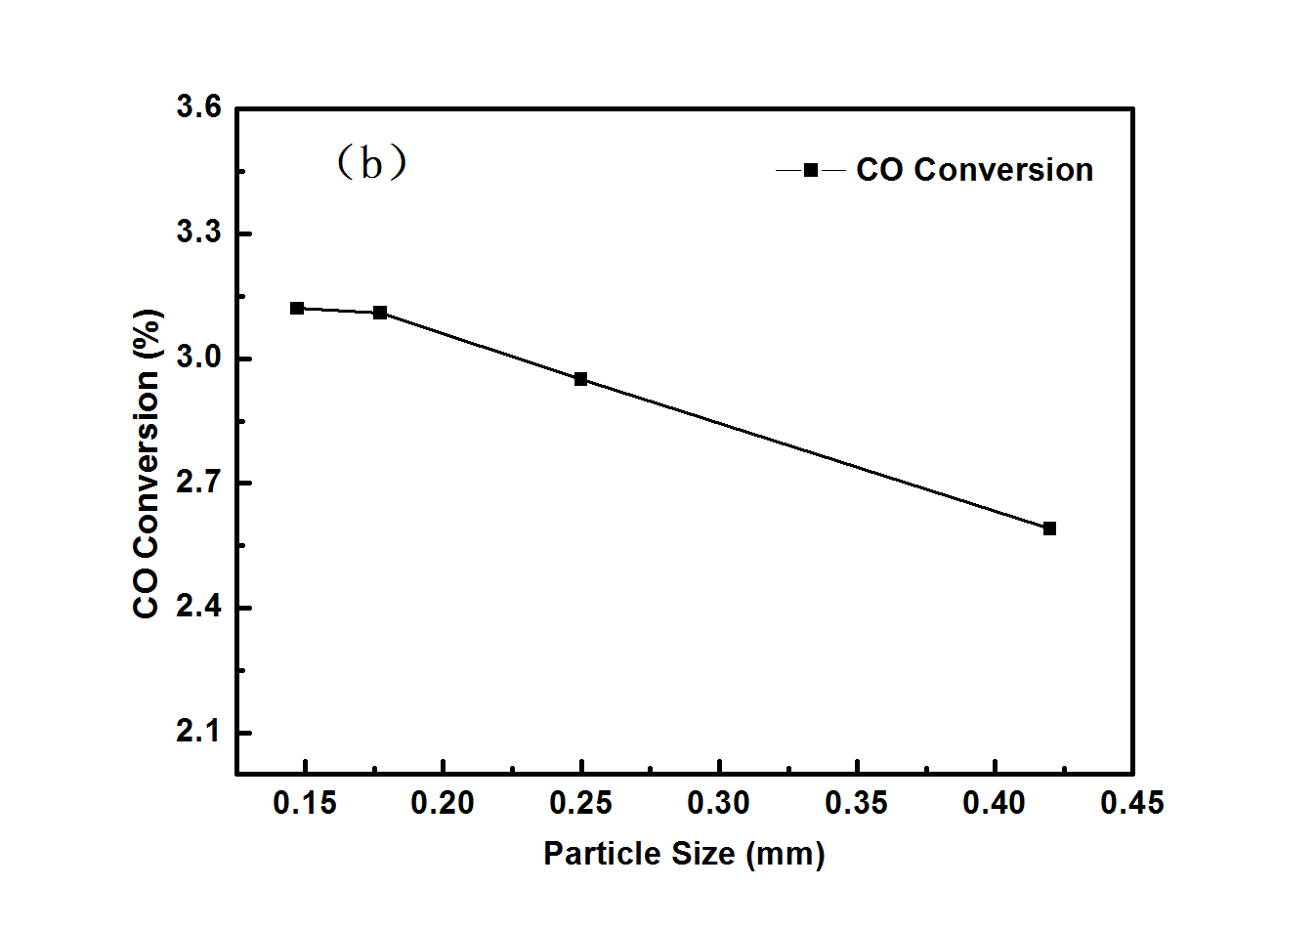
Fig.S1 (a)Dependence of CO conversion on GHSV over a 5Co2.5Cu/SiO₂ catalyst (0.177 mm) at 270 °C, 5.0 MPa, H₂/CO/N₂=6/3/1; (b) Dependence of CO conversion on a 5Co2.5Cu/SiO₂ catalyst with a size of 0.42,0.25, 0.177, and 0.147 mm, respectively, at 270 °C, 5.0 MPa, CO/H₂=1, GHSV of 3500 h⁻¹.
On the other hand, the internal diffusion effects were phased out by changing catalyst particle sizes[S4].The catalysts with different particle sizes (0.42,0.25, 0.177, and 0.147 mm) was examined at 270 °C, 5.0 MPa of syngas with a GHSV of 3500 h⁻¹ and H₂/CO ratio of 2. The results in Fig. S1(b) revealed that CO conversion increased linearly with a decrease in catalyst particle sizes at 0.42-0.177 mm, this value became constant when the particle size was smaller than 80 mesh. The Weisz-Prater criterion (C_{WP}) is usually used to estimate the internal mass-transfer resistance in heterogeneous catalytic reactions.[S3] If C_{WP}<<1, there is no internal diffusion limitation, and if C_{WP}>>1, internal diffusion has an effect on the reaction. The value of C_{WP} of 0.049 was calculated for the catalysts with an average particle diameter of 0.177 mm, indicating that the internal diffusion could be negligible.
Table S3. Effects of GHSV on the external mass-transfer diffusion
GHSV (h⁻¹) | Flow rate (ml/min) | k_{c}(m /s)
3450 | 25 | 3.04×10⁻²
10350 | 75 | 3.11×10⁻²
14900 | 108 | 3.14×10⁻²

Table S4. Crystallite size (nm) of CoCu catalysts measured by in situ XRDª.
T/°C | 5Co/SiO₂ |  |  |  | 5Co2.5Cu/SiO₂ |  |  | 5Co10Cu/SiO₂ |  |  |  |  | 5Cu/SiO₂
T/°C | Co₃O₄  (311) | CoO  (200) | Co  (111) |  | Co₃O₄^{b}  (311) | Co^{c}  (111) |  | Co₃O₄^{b}  (311) | CuO  (-111) | Co^{c}  (111) | Cu  (111) |  | CuO  (-111) | Cu₂O  (111) | Cu  (111)
30 | 15.3 | --- | --- |  | 13.4 | --- |  | 9.7 | 35.8 | --- | --- |  | 29.4 | --- | ---
100 | 15.3 | --- | --- |  | 13.4 | --- |  | 9.7 | 26.6 | --- | --- |  | 29.4 | --- | ---
200 | 15.3 | --- | --- |  | 12.0 | --- |  | 4.7 | 25.7 | --- | 21.1 |  | 29.4 | --- | ---
300 | --- | 7.9 | 15.7 |  | --- | 7.3 |  | --- | --- | 7.9 | 26.4 |  | 22.3 | 17.6 | 40.2
350 | --- | 4.81 | 16.0 |  | --- | 8.4 |  | --- | --- | 7.9 | 28.1 |  | --- | --- | 40.2
400 | --- | 4.81 | 16.0 |  | --- | 8.4 |  | --- | --- | 7.5 | 35.2 |  | --- | --- | 44.5
1h | --- | 4.80 | 16.0 |  | --- | 8.4 |  | --- | --- | 7.5 | 36.7 |  | --- | --- | 44.5
2h | --- | 4.80 | 16.0 |  | --- | 8.4 |  | --- | --- | 7.5 | 36.7 |  | --- | --- | 44.5
ª The calculation of the crystal size using the Scherrer method.
^{b} The mixed CoCu spinal structure is identified by Co3O4 phase.
^{c} The Cu modification on the Co phase in CoCu catalysts.
Table S5. Performance of CO hydrogenation over CoCu catalystsª
Catalysts | Conv. | Selectivity, carbon based /% |  |  |  |  |  | r_{CO}/10⁻⁵
Catalysts | % | CH₄ | HC_{S} | CH₃OH | C₂-C₅OH | ROH | CO₂ |  | mol·g_{Co}⁻¹·s⁻¹
5Co/SiO₂ | 11.75 | 50.90 | 92.41 | 3.84 | 1.60 | 5.44 | 2.03 |  | 27.70
5Co2.5Cu/SiO₂ | 2.03 | 45.39 | 85.52 | 7.74 | 4.15 | 11.88 | 2.14 |  | 4.80
5Co10Cu/SiO₂ | 1.37 | 43.59 | 85.85 | 7.16 | 3.90 | 11.06 | 2.27 |  | 3.23
5Cu/SiO₂ | 0.05 | 25.97 | 57.41 | 38.05 | 0.87 | 38.93 | 3.10 |  | ---
5Co/SiO₂^{b} | 2.30 | 49.64 | 91.19 | 4.44 | 1.82 | 6.26 | 2.10 |  | 27.72

a: Reaction conditions：200mg catalysts, P=5.0 MPa, T=533 K, Reaction time=20 h, H₂/CO/N₂=6/3/1, GHSV=14900 h⁻¹.
b: Reaction conditions：40mg catalysts diluted in 160mg SiO₂, P=5.0 MPa, T=533 K, Reaction time=20 h, H₂/CO/N₂=6/3/1, GHSV=14900 h⁻¹.

Table S6. Performance of CO hydrogenation over CoCu catalysts.
Catalysts |  | Reaction time  /h | Conv. | Selectivity, carbon based /%
 |  | Reaction time  /h | % | CH₄ | HC_{S} | CH₃OH | C₂-C₅OH | ROH | CO₂
5Co2.5Cu/SiO₂ | 10 |  | 2.24 | 45.58 | 85.02 | 7.62 | 4.55 | 12.17 | 2.08
5Co2.5Cu/SiO₂ | 20 |  | 2.03 | 45.39 | 85.52 | 7.74 | 4.15 | 11.88 | 2.14
5Co/SiO₂^{b} | 10 |  | 2.74 | 49.77 | 91.34 | 4.40 | 1.73 | 6.13 | 2.22
5Co/SiO₂^{b} | 20 |  | 2.30 | 49.64 | 91.19 | 4.44 | 1.82 | 6.26 | 2.10

a: Reaction conditions：200mg catalysts, P=5.0 MPa, T=533 K, H₂/CO/N₂=6/3/1, GHSV=14900 h⁻¹.
b: Reaction conditions：40mg catalysts diluted in 160mg SiO₂, P=5.0 MPa, T=533 K, H₂/CO/N₂=6/3/1, GHSV=14900 h⁻¹.
- Fitting results of kinetic data
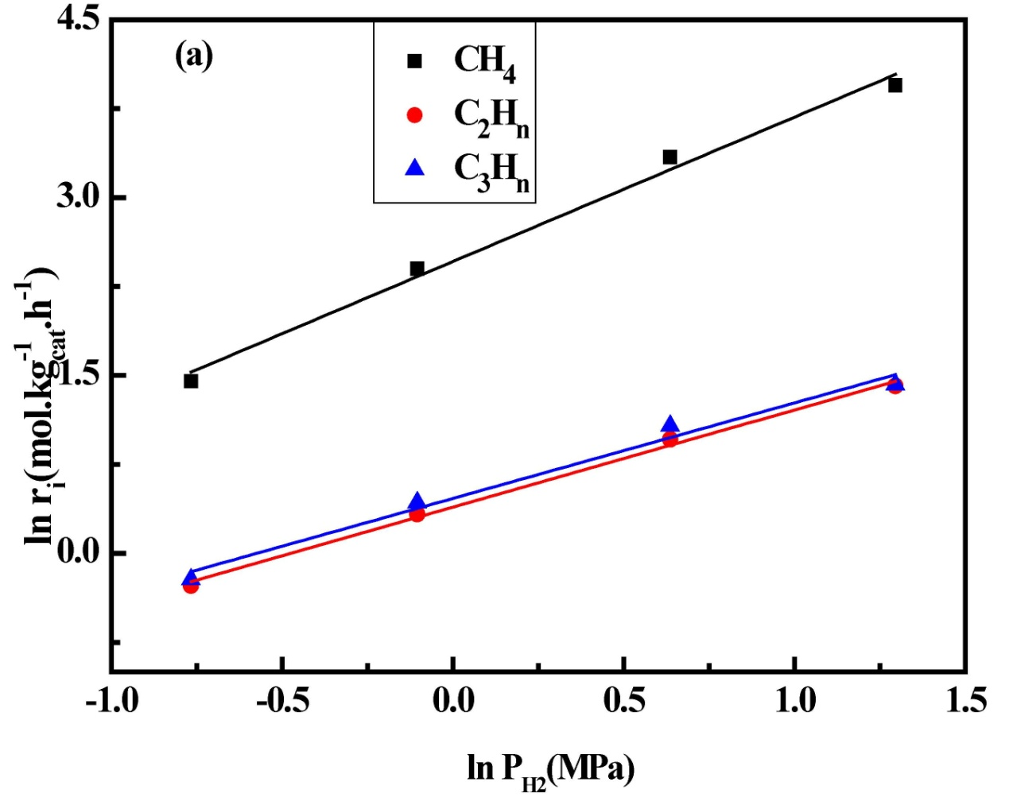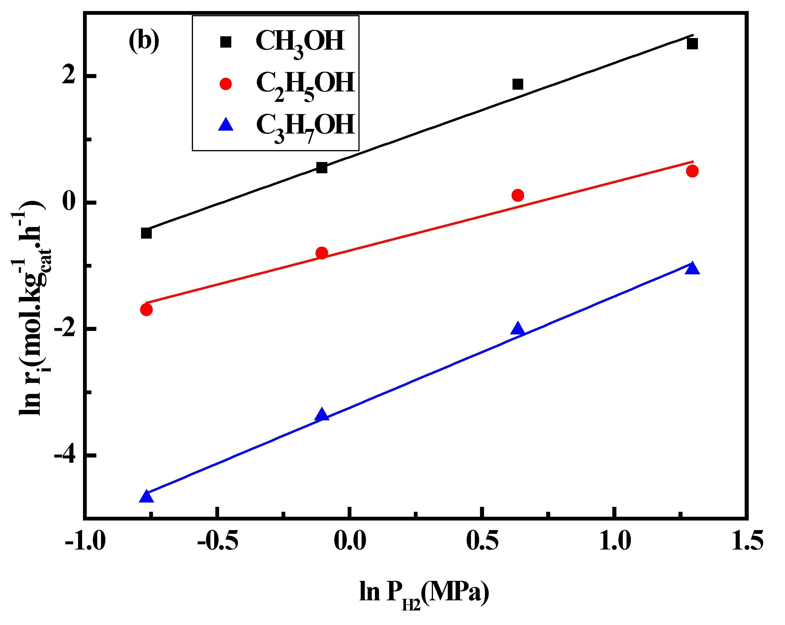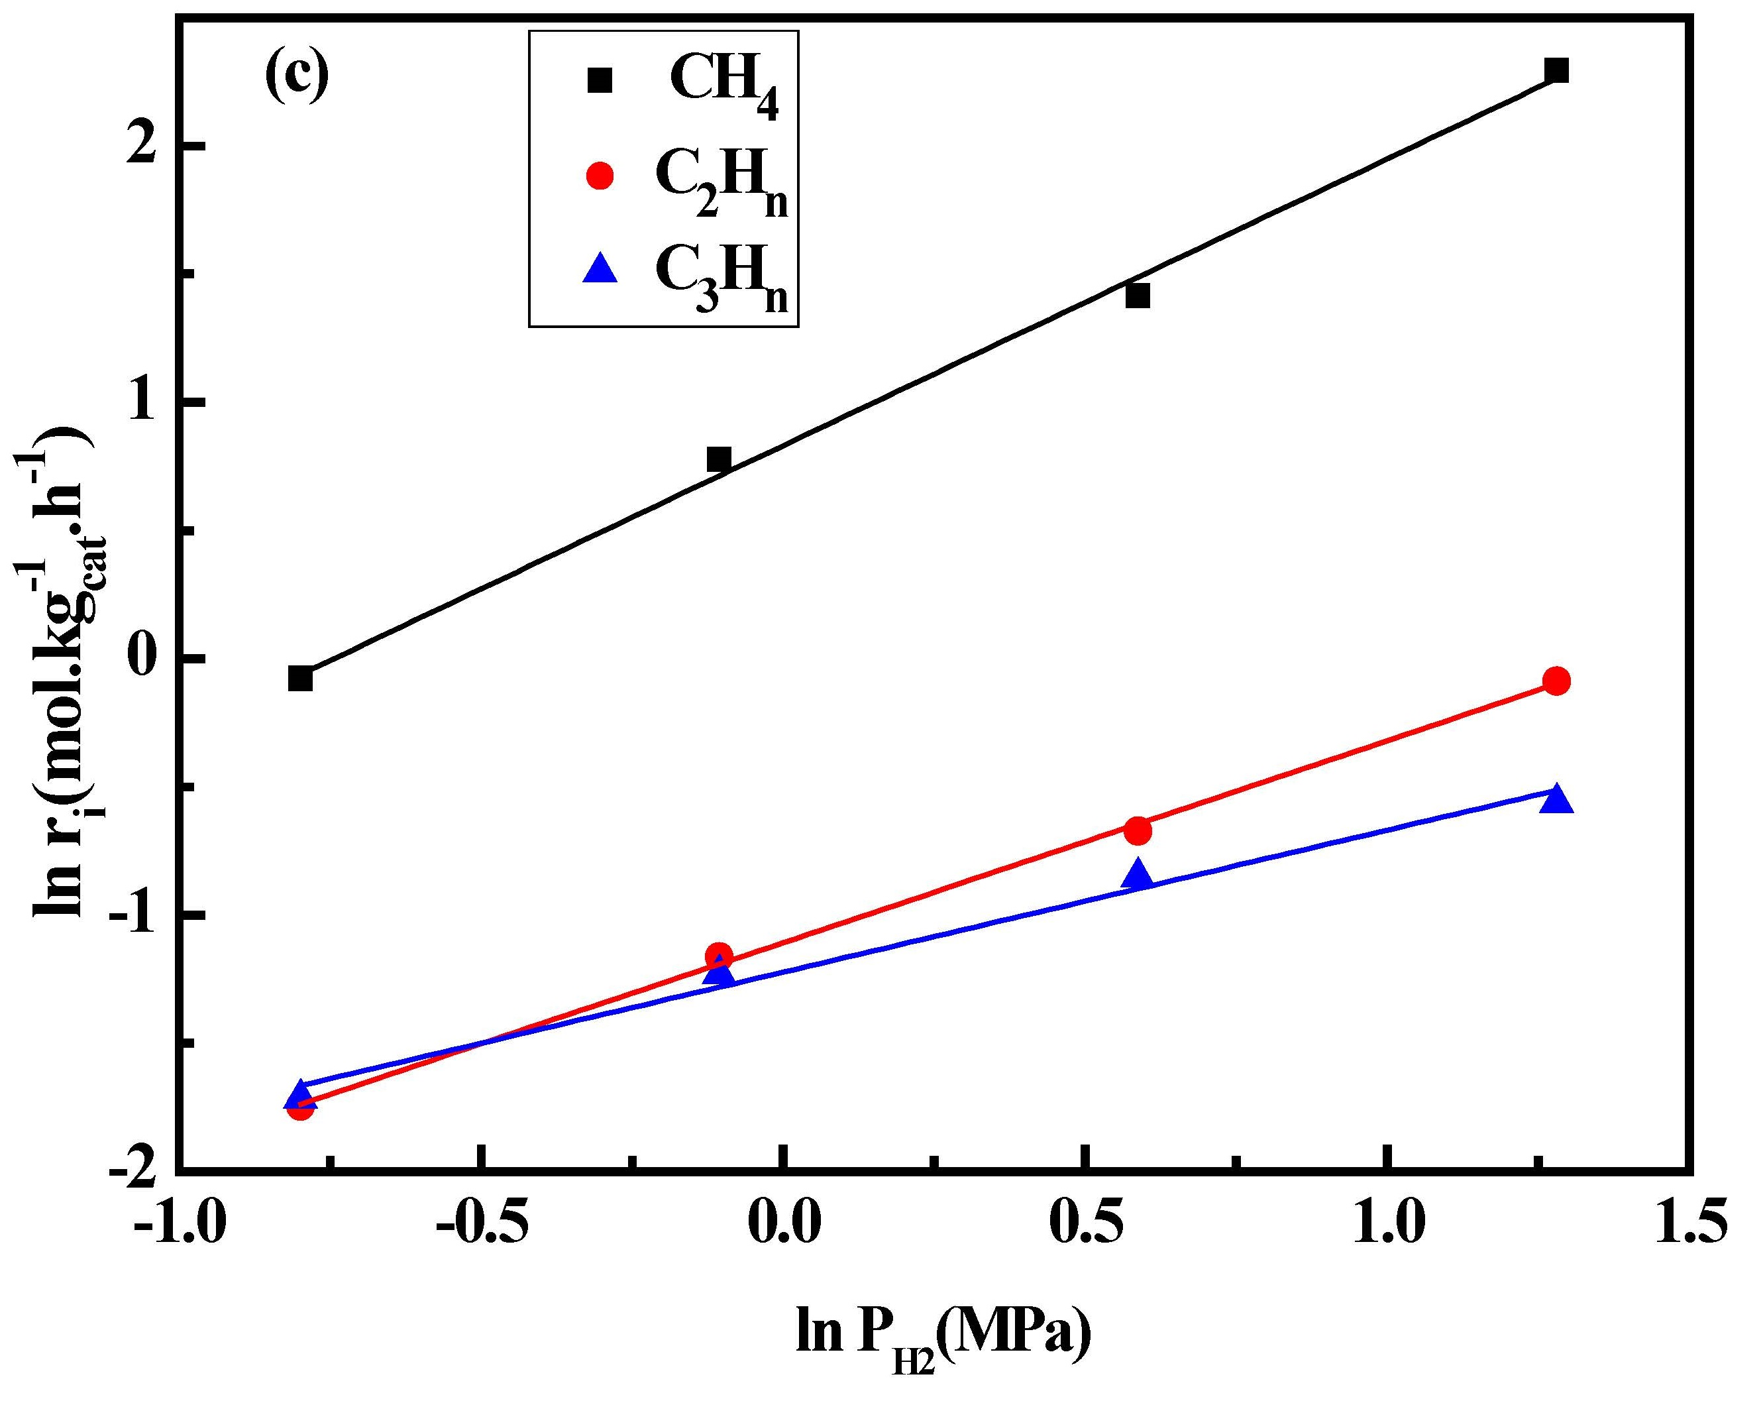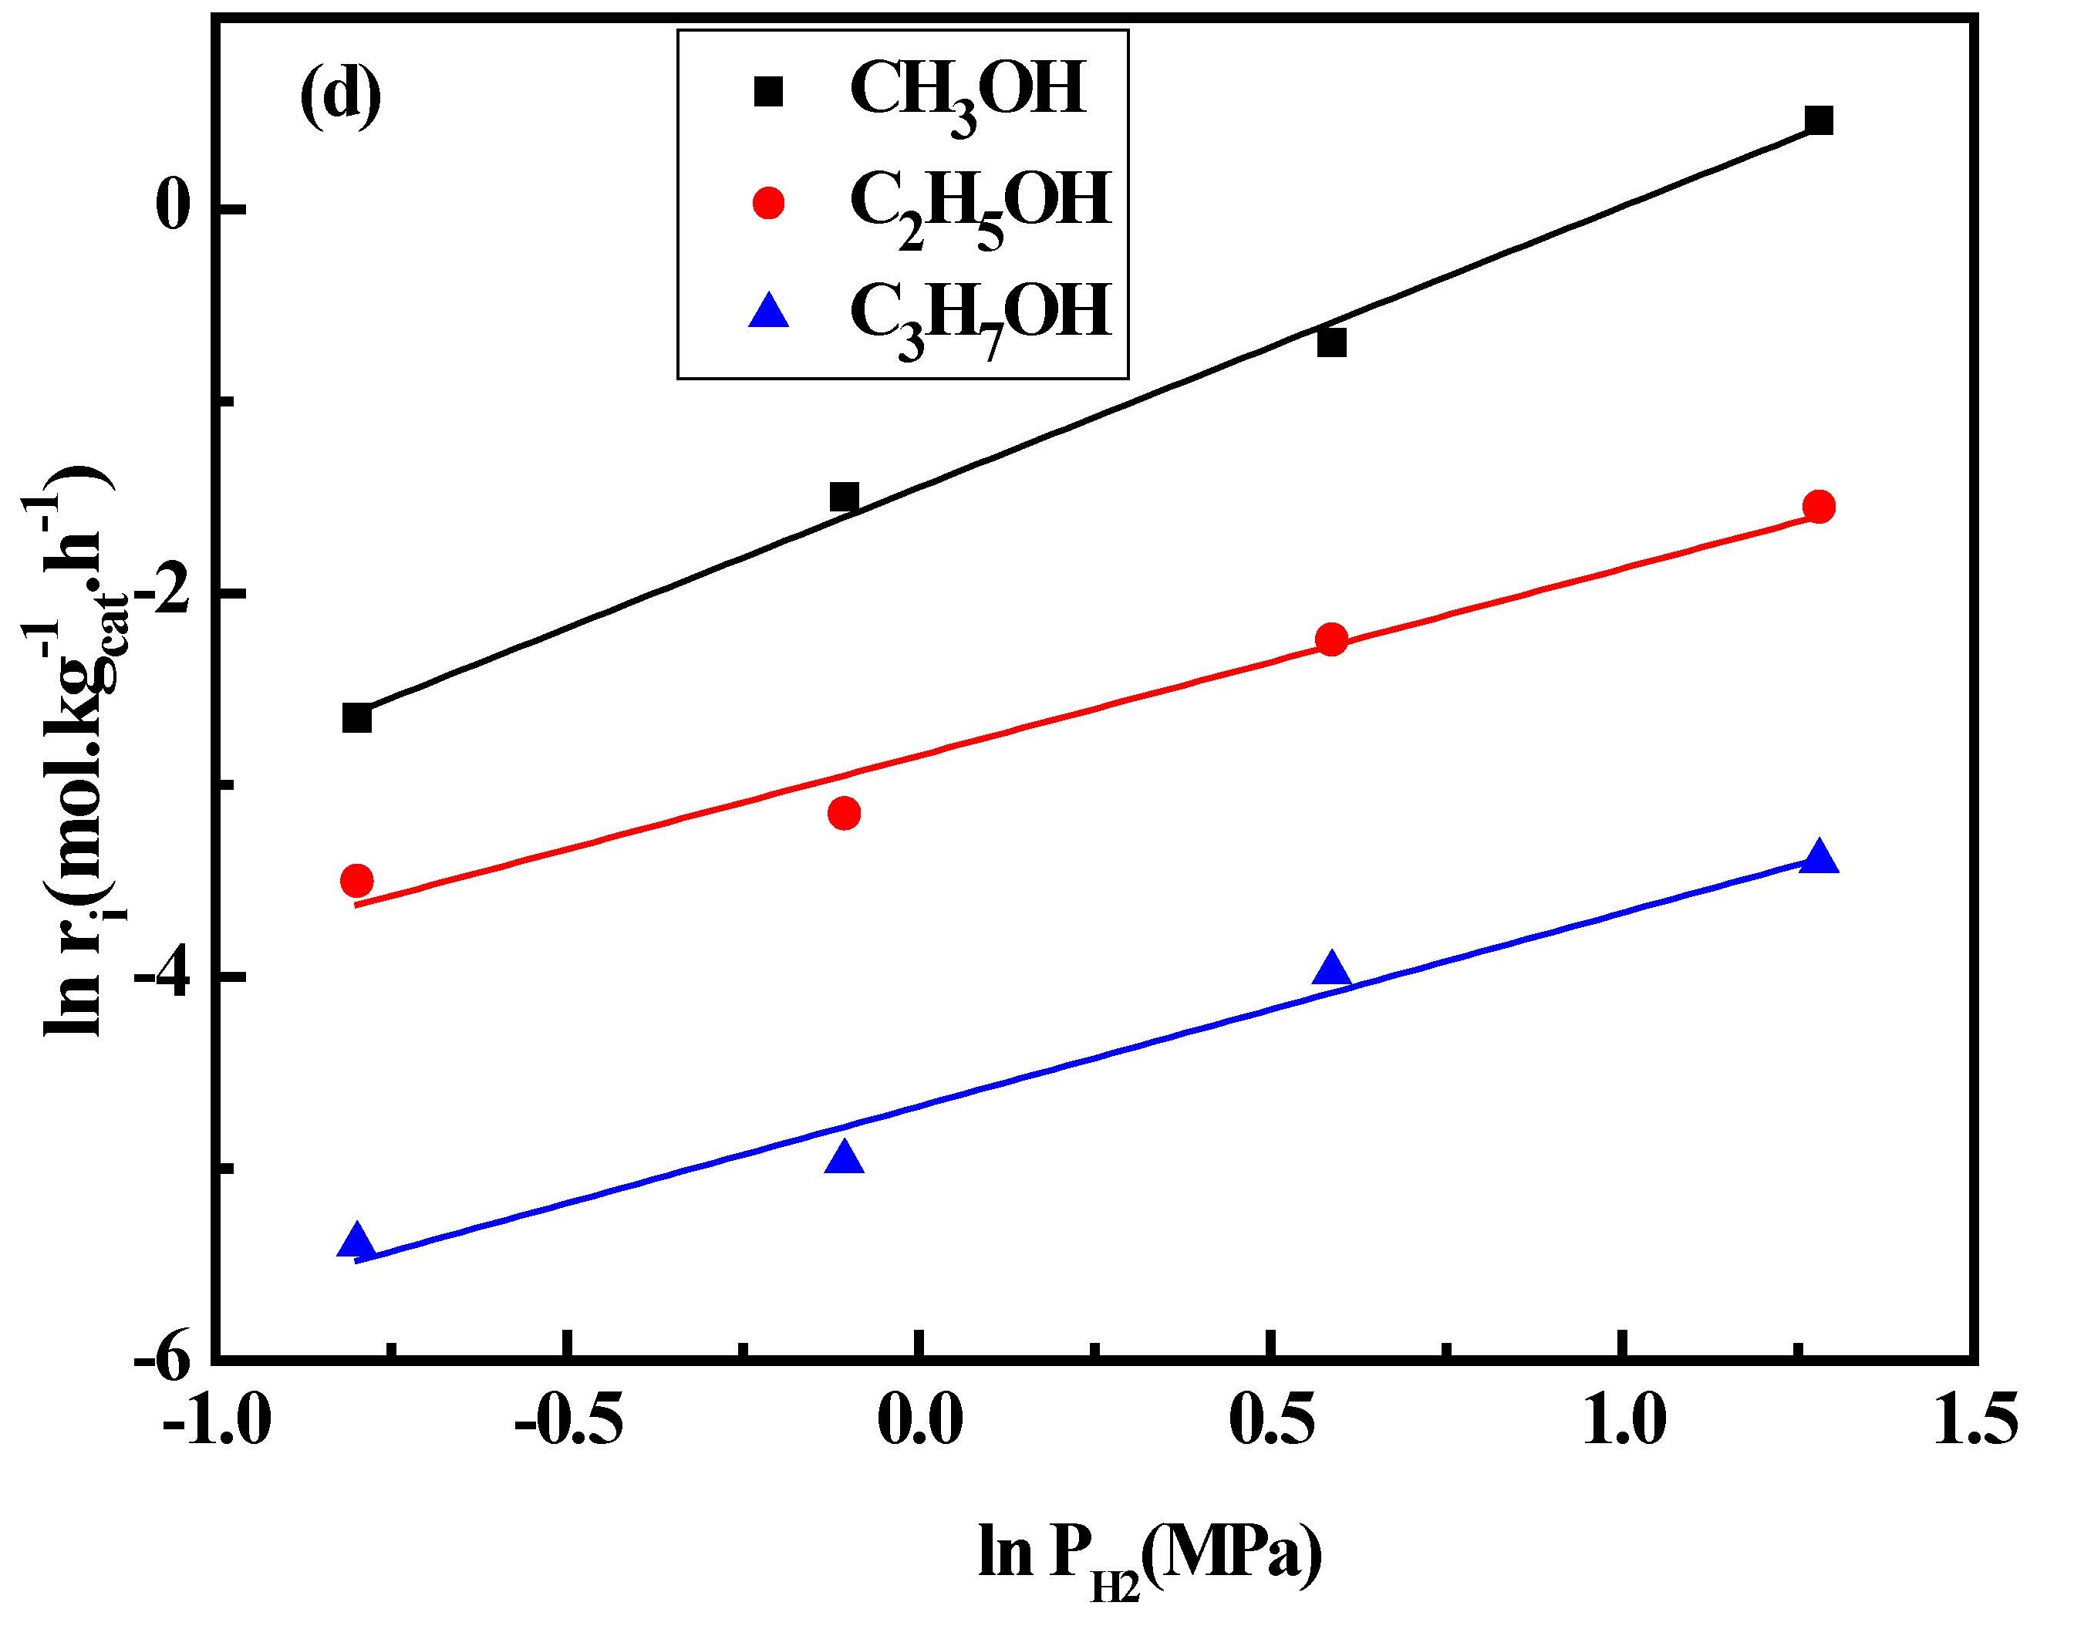
Fig.S2 Dependence of formation rate of (a) hydrocarbons over 5Co/SiO₂; (b) alcohols over 5Co/SiO₂; (c) hydrocarbons over 5Co2.5Cu/SiO₂; (d) alcohols over 5Co2.5Cu/SiO₂ on partial pressure of H₂.
Reaction conditions: P=5.0 MPa, P_{CO} =0.9 MPa, GHSV=14900 h⁻¹, t=20 h, T=260 °C.
.

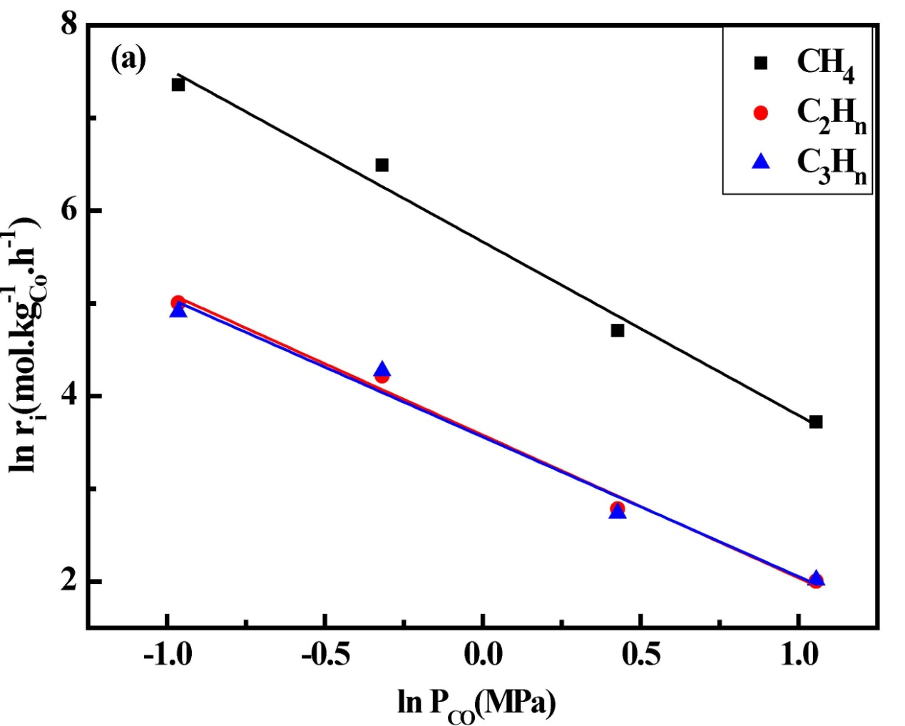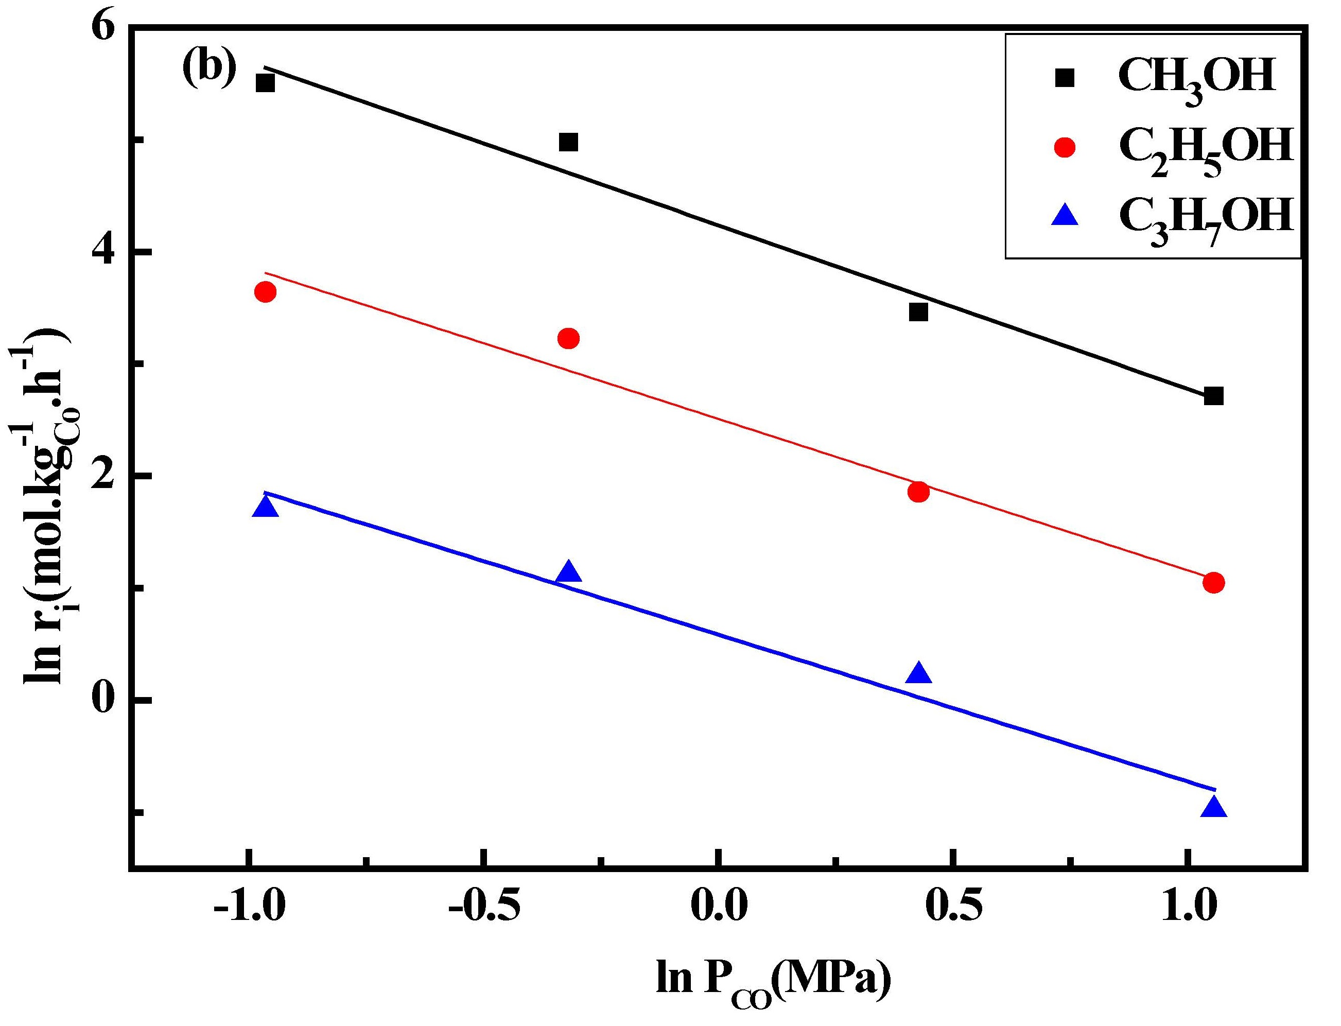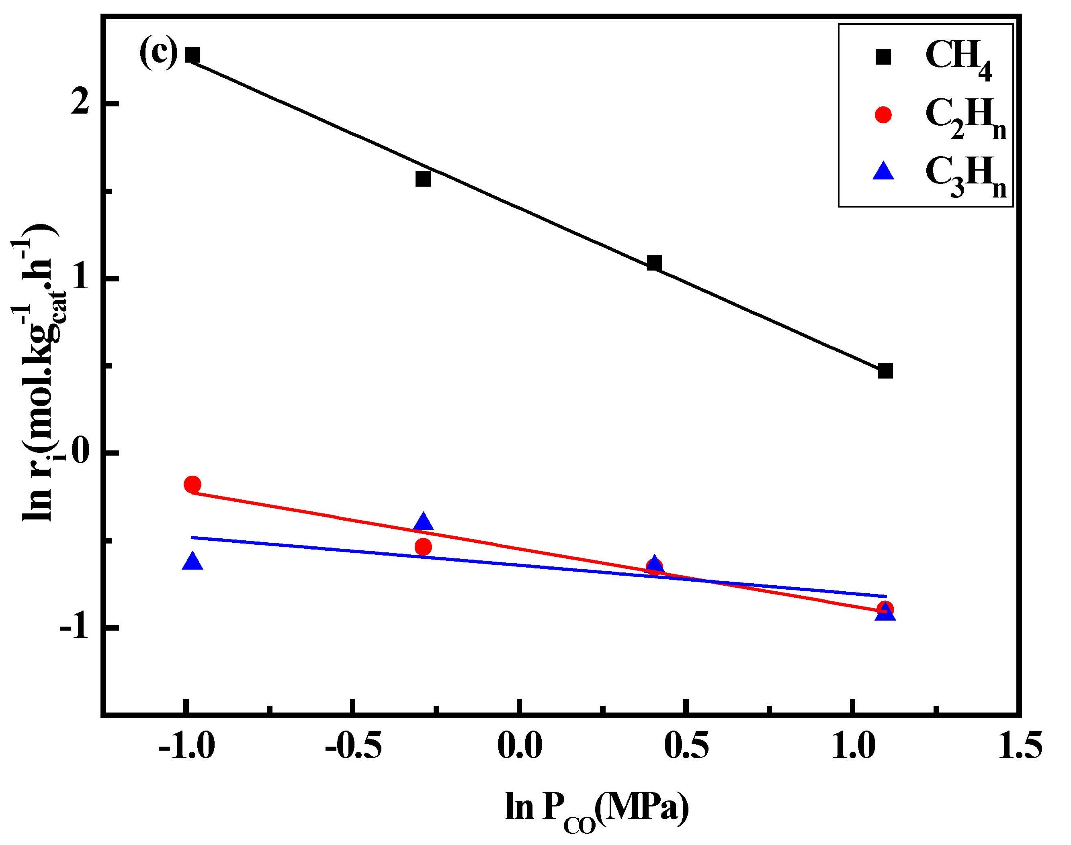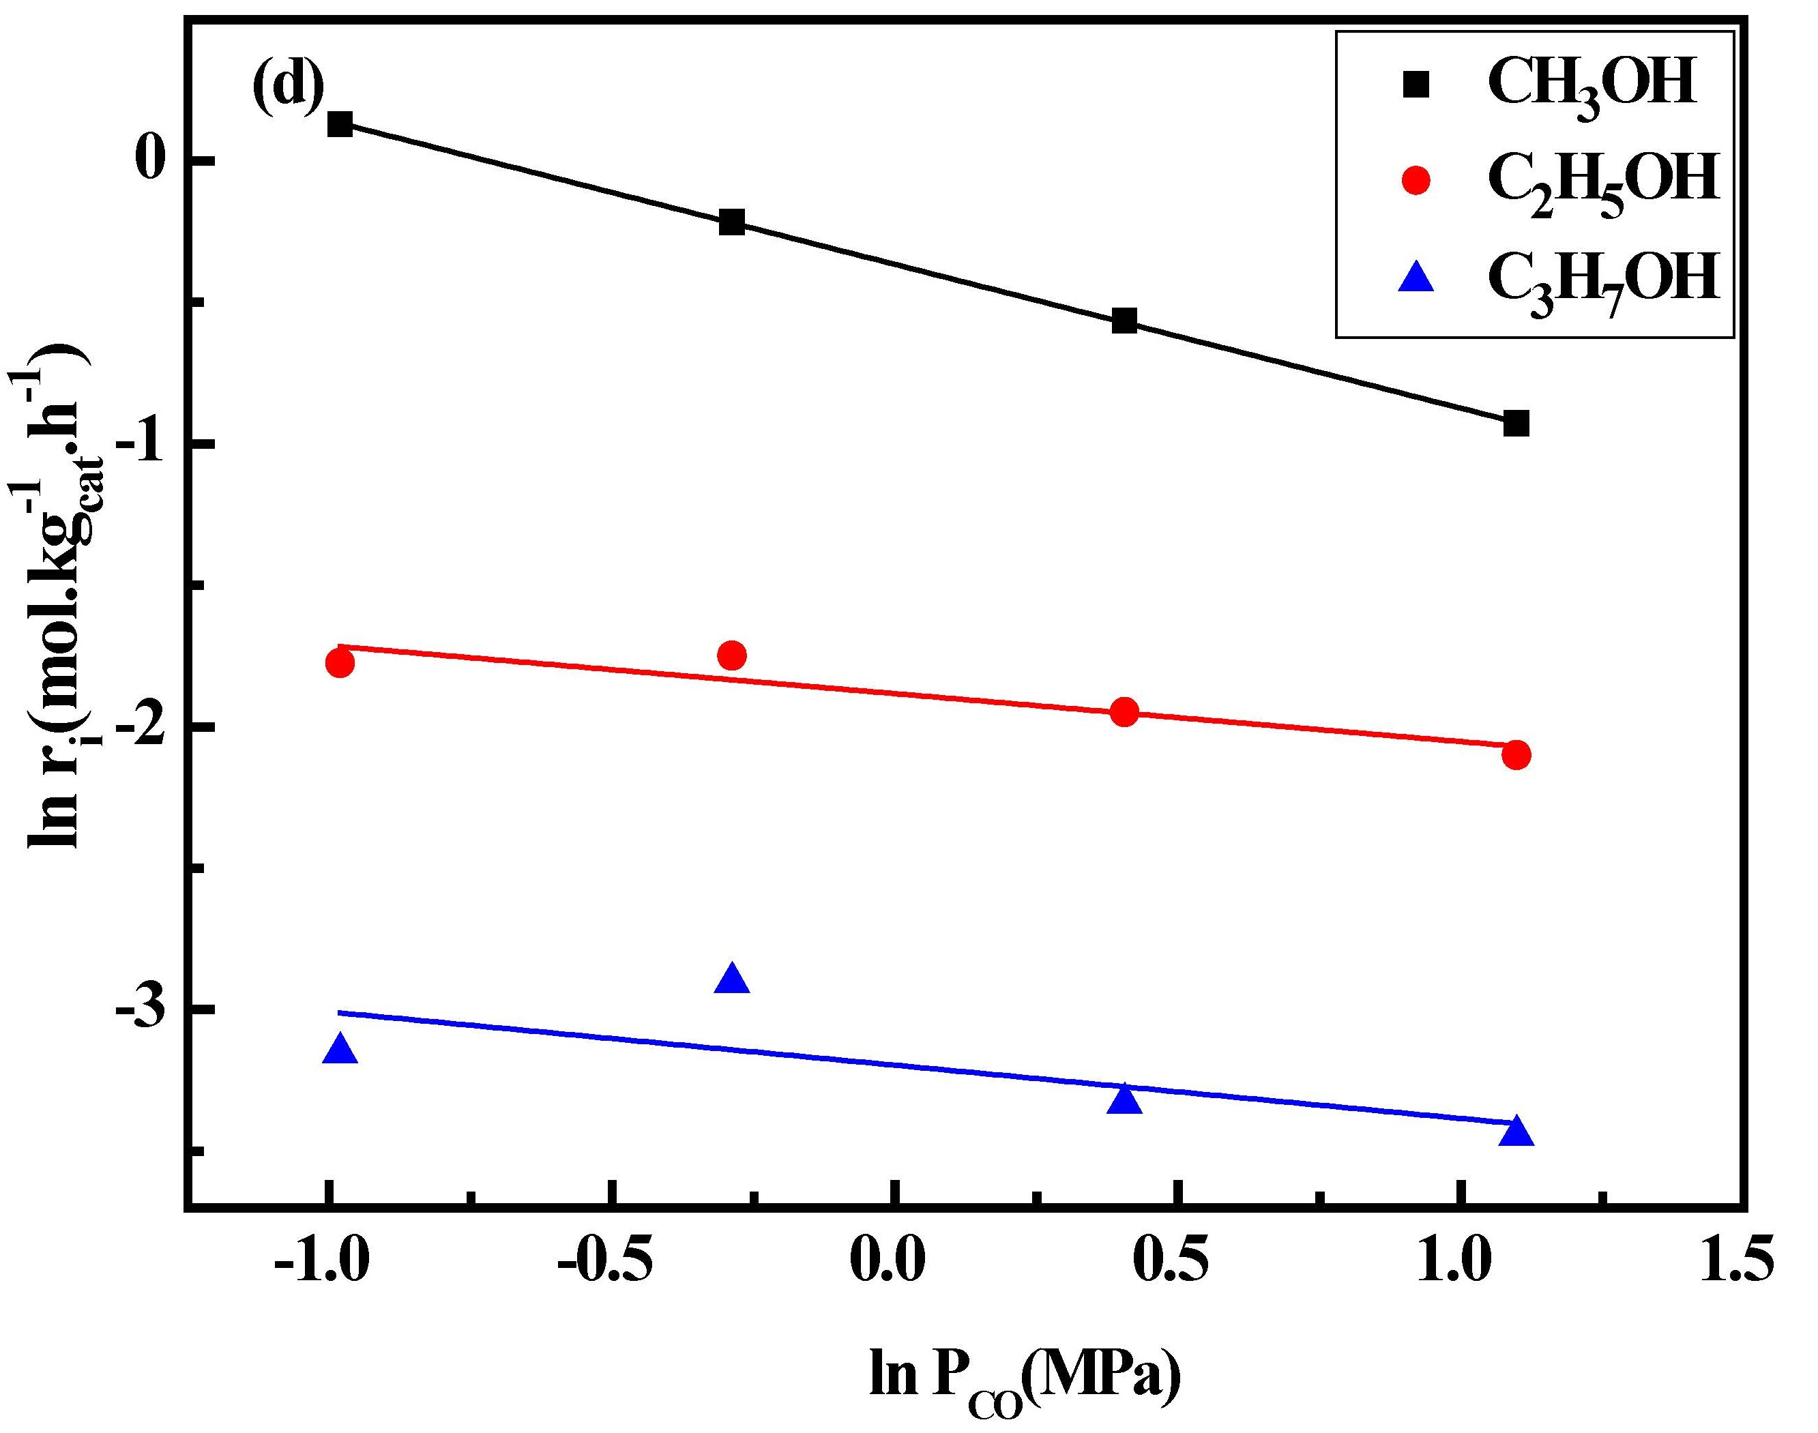
Fig.S3 Dependence of formation rate (a) hydrocarbons over 5Co/SiO₂; (b) alcohols over 5Co/SiO₂; (c) hydrocarbons over 5Co2.5Cu/SiO₂; (d) alcohols over 5Co2.5Cu/SiO₂ on partial pressure of CO.
Reaction conditions: P=5.0 MPa, P_{H2}=1.5 MPa, GHSV=14900 h⁻¹, t=20 h, T=260 °C.
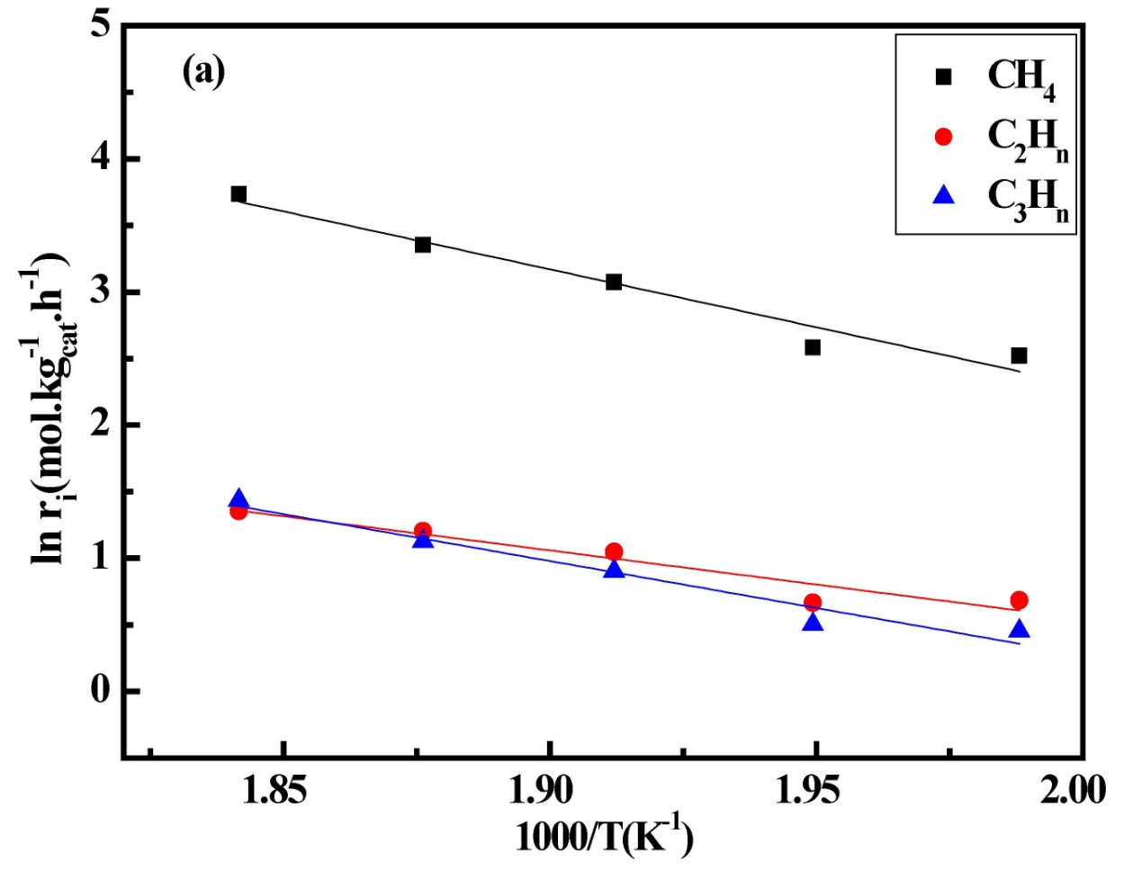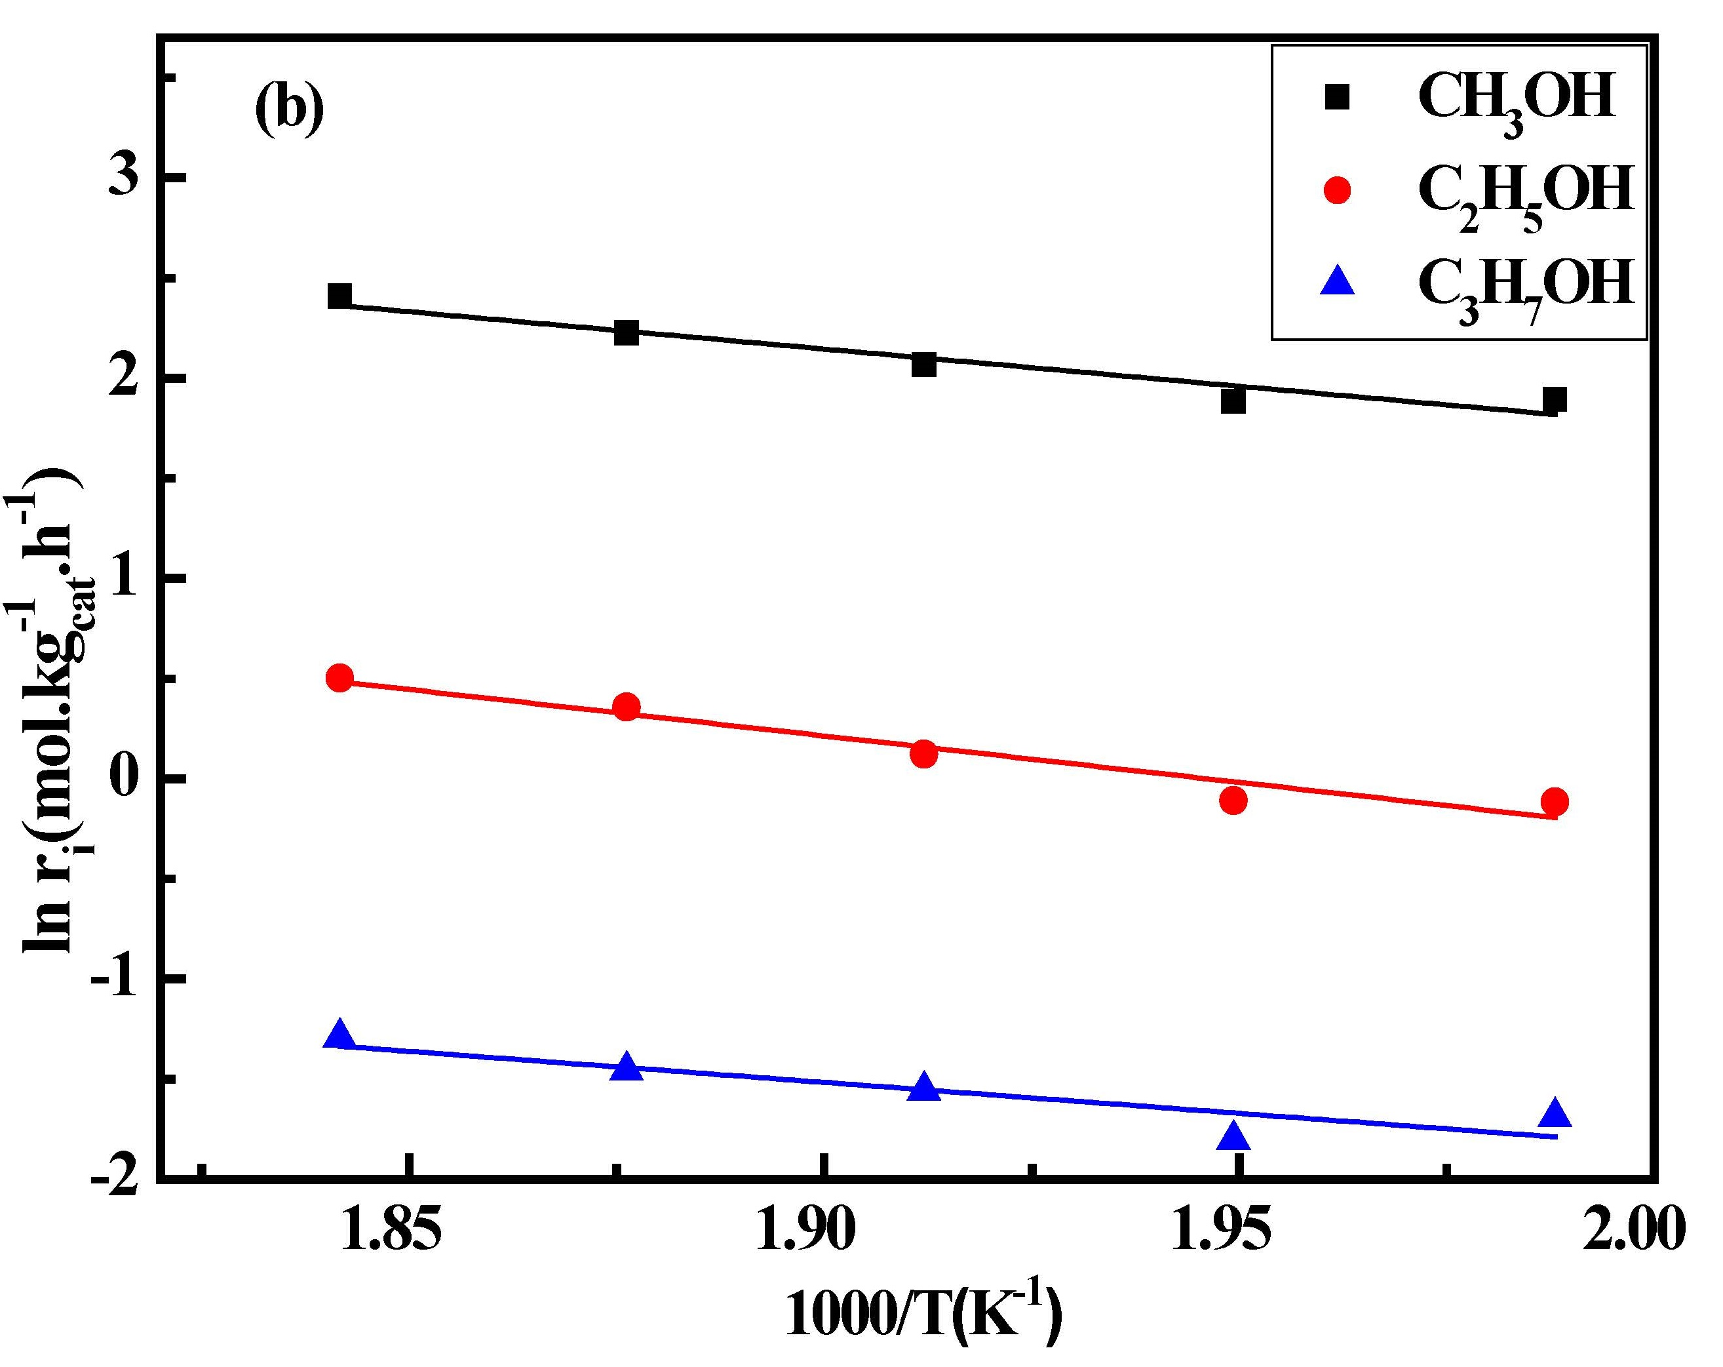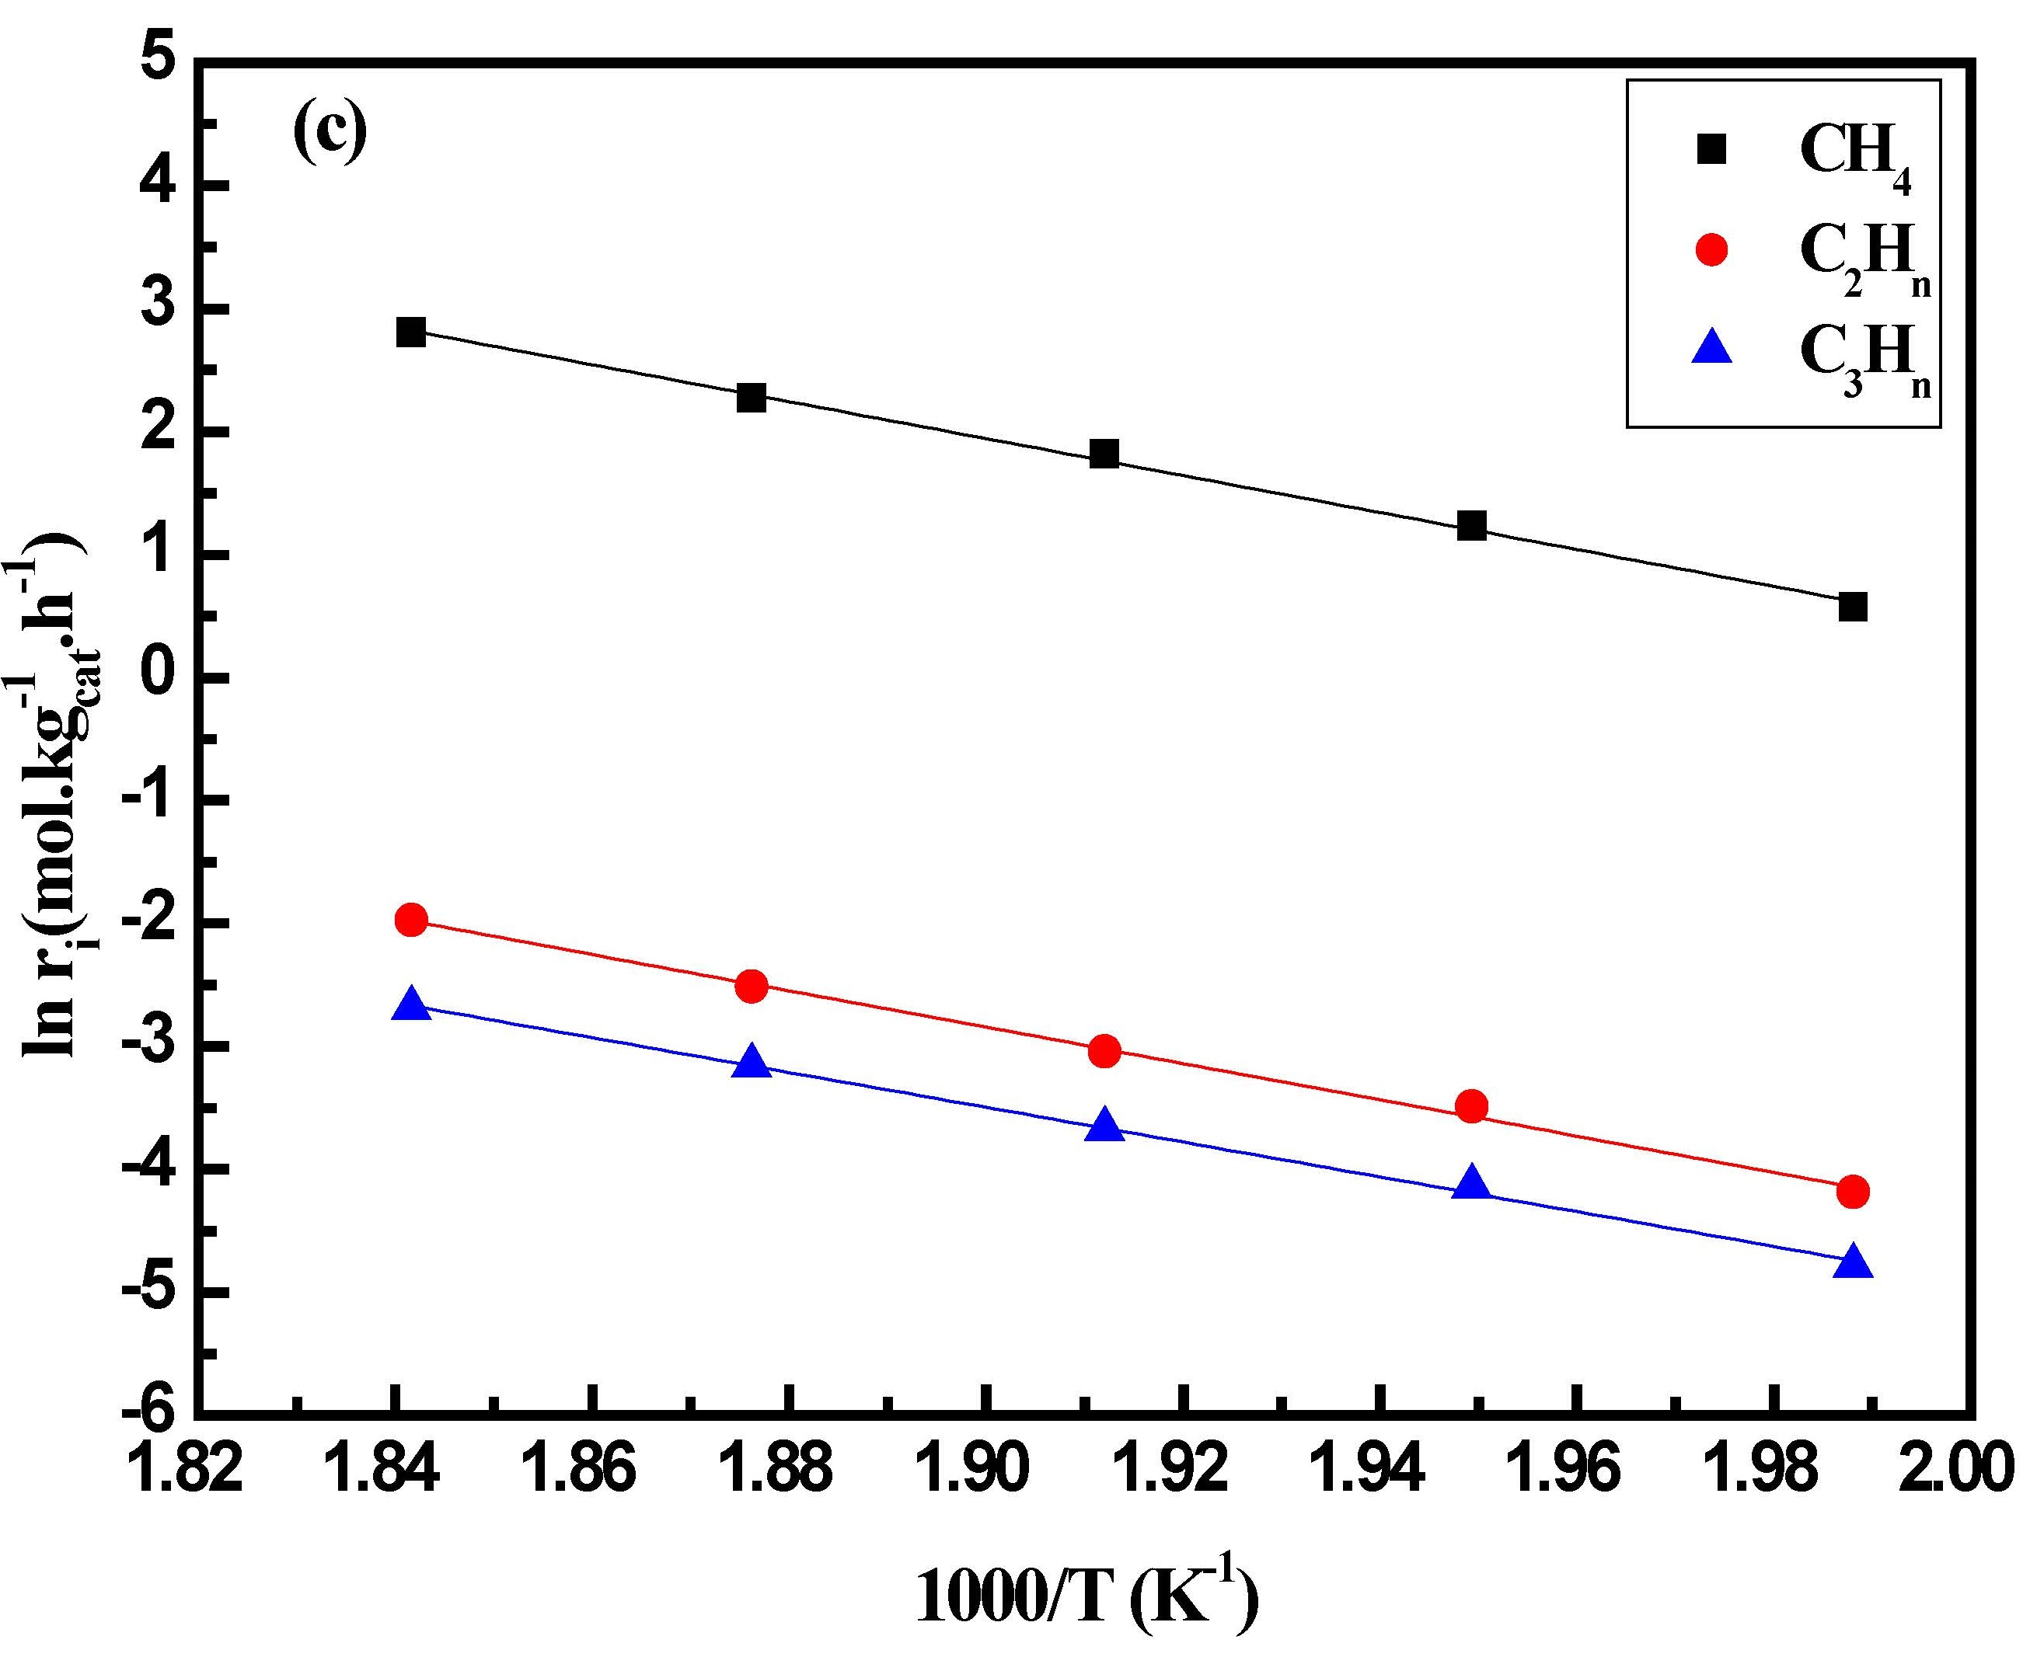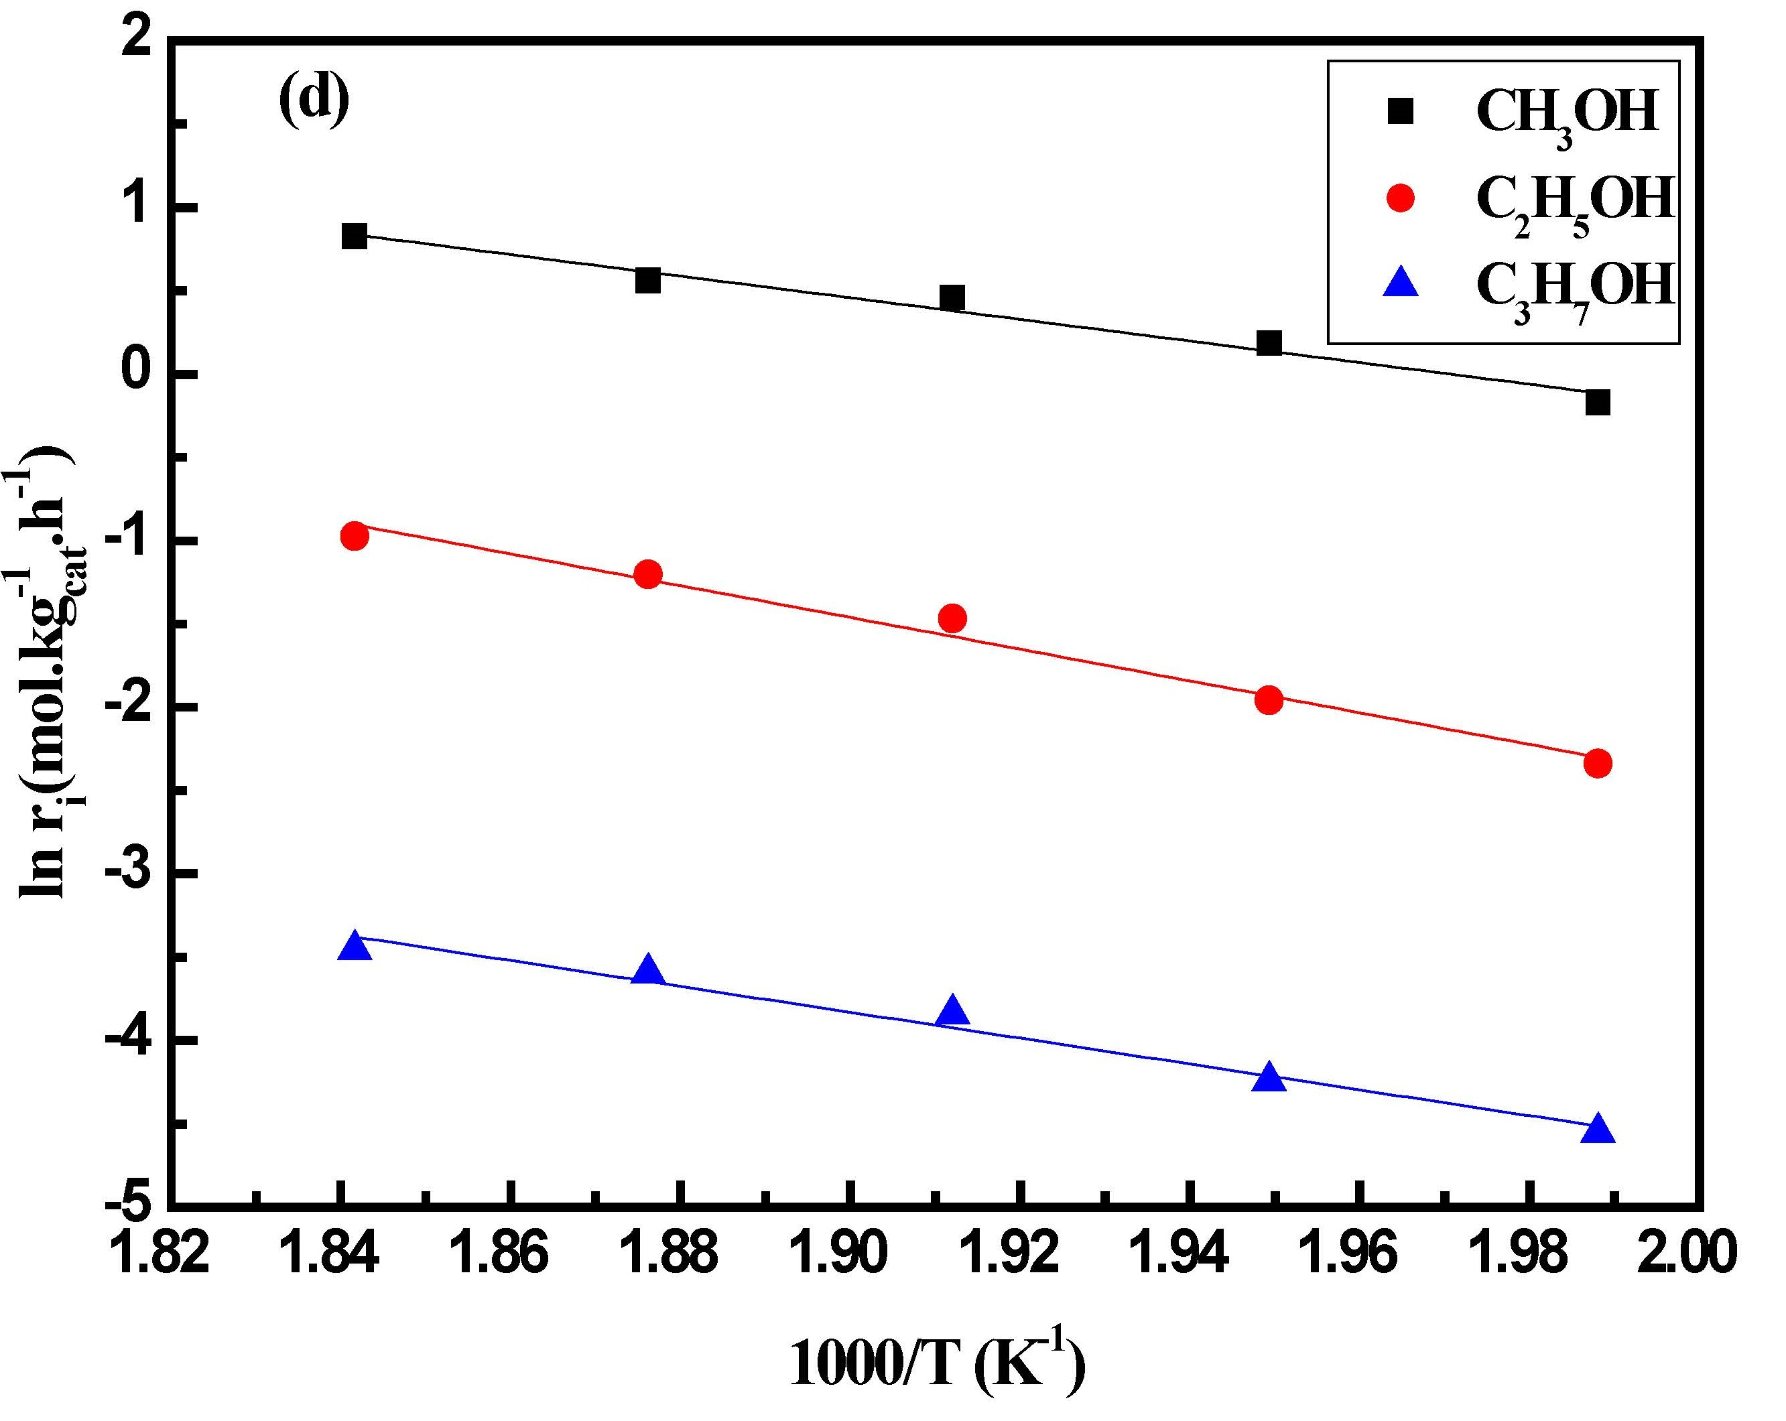
Fig. S4. Arrhenius diagrams of (a) hydrocarbons over 5Co/SiO₂; (b) alcohols over 5Co/SiO₂; (c) hydrocarbons over 5Co2.5Cu/SiO₂; (d) alcohols over 5Co2.5Cu/SiO₂.
Reaction conditions: P=5.0 MPa, H₂/CO/N₂=6/3/1, GHSV=14900 h⁻¹, t=20 h, T=230-270 °C.

Literature Cited
S1 V. R. Surisetty, A. K. Dalai. Energ. Fuel,24 (2010) 814.
S2 N.Frossling, Gerlands Beitr.Geophys. 52 (1938) 170.
S3 P. B.Weisz, C.D.Prater,Adv. Catal.6 (1954) 143.
S4 Weikang Yuan, Kaihong Zhu. Analysis of Chemical Reaction Engineering. Shanghai: East China University of Science and Technology, 1994.

