1. Please remove testimonials section from about us page. These testimonials are static and not manageable from backend. There is no option to manage the content of the about us page from Backend>>Manage Frontend Pages.– We will modify this.
2. When we click on “Attempt Free Test”, user is redirected to “My Program” section which is incorrect. It should go to program details page like below where all the free test are listed. User can start the free test from here. – We will modify it as per discussion

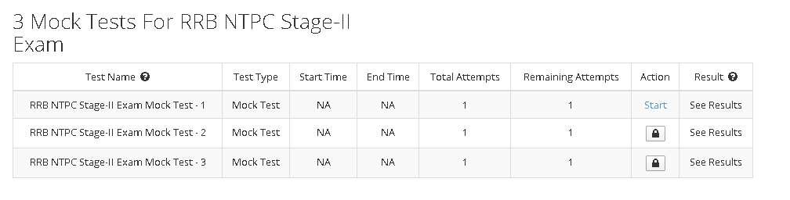

1. I have created new institute by my name “Rohit-Institute” and created two coupons. I have given one coupon to fellow team mate (shiv) who have applied it successfully. But I can see nine students in my account which are not related to me and I can’t see the shiv name in the students list. –We will check this at our end

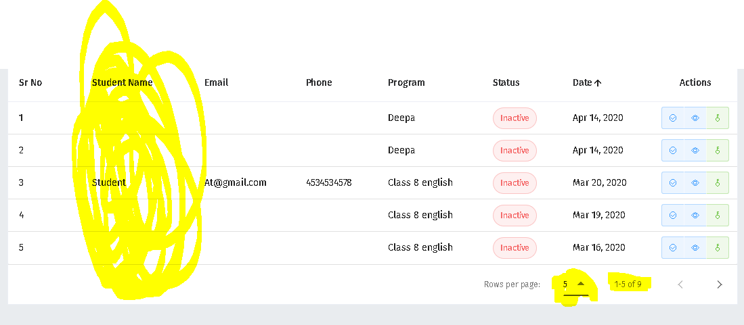

1. In student login, graphs are not correct. I have given one test and my score is 8/8 but graph showing my score as 27.25 and topper score as 72.5 with average of 10.5. How can topper score and average marks are more than total marks. – (We will check it at our end)

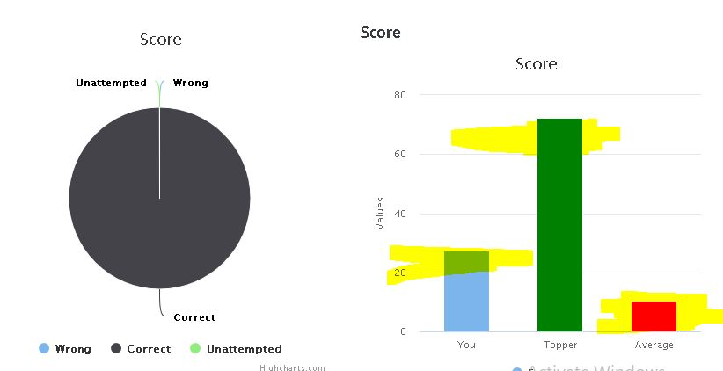

1. (% Marks) section chapter wise, skill wise, difficulty wise, should not be same. Please refer to the live website. - (Can you explain what we need to do In this?) – We will check this at our end

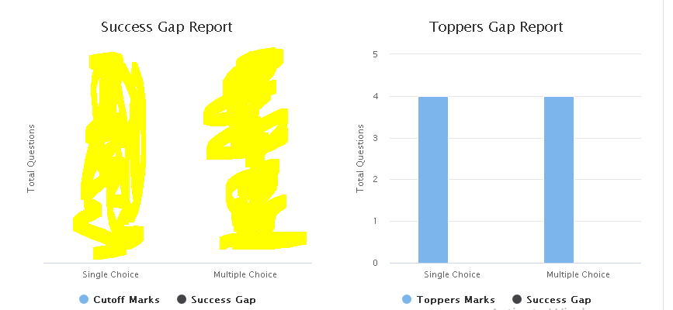

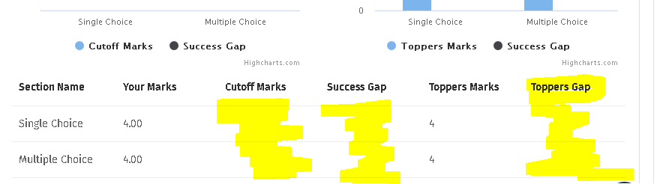

Correct calculations is given in below image.

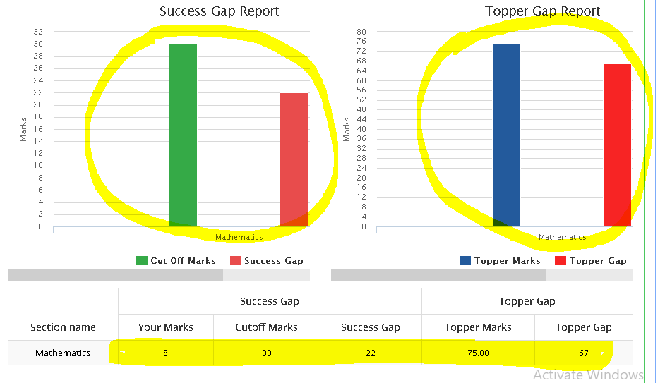

1. Please show selected test papers first in edit program list when we edit the program so we can see the all the added test papers first instead of searching. – (We are currently doing it on a predefined sequence basis, now making change in it will require unnecessary effort from team end) – We will check timeframe for this and will update.

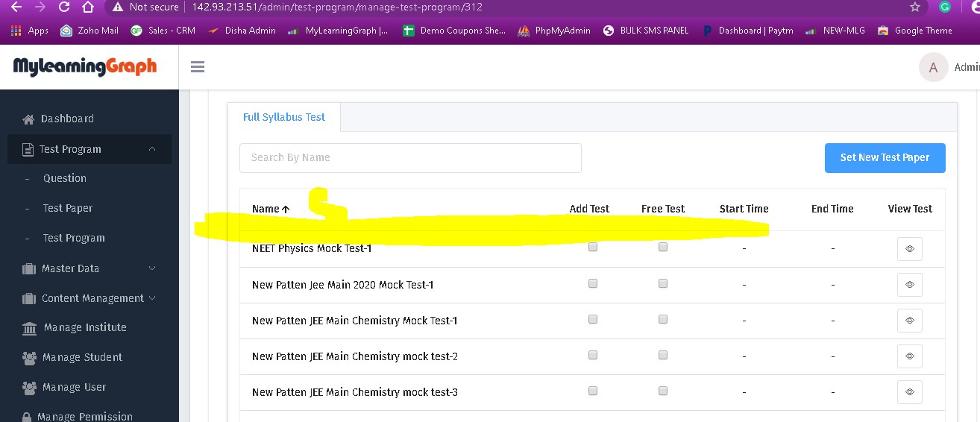

1. Please only show test type where test are available instead of showing the test type with blank and NA data. – We will check this if we can hide it.

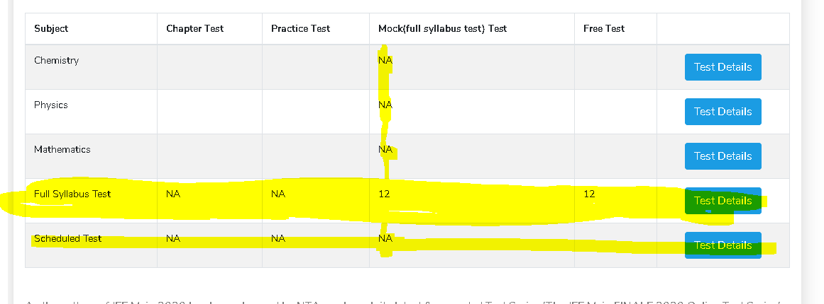

In the above program we should give only “Full Syllabus test” and remove Chemistry, physics, and mathematics.

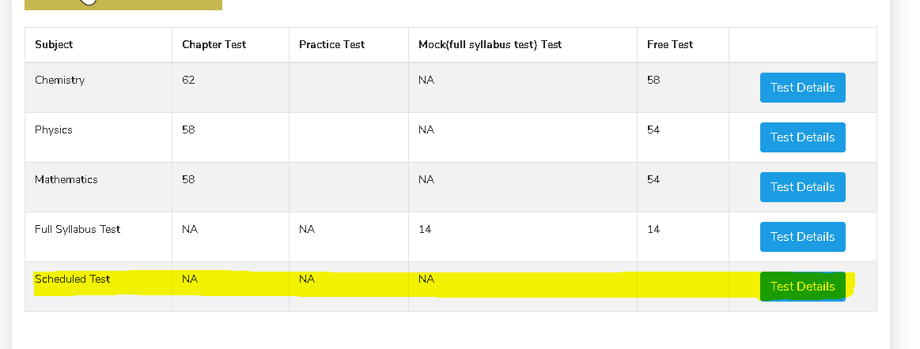

In the above program we have chapter test and free tests in chemistry, physics, and mathematics. But there is no scheduled test so we can remove it.

1. Please make the first name, last name, mobile number, and email mandatory in user account. Once user login in their account then they must enter these mandatory details before accessing any test programs. – We will make this change
2. Please give all the test programs in the categories under “Select Your Goal”. – (This wasn’t in scope)- We will change it
3. How can we add/update the list of Popular Test series on the homepage? Please explain the working. – (You had explained that we need to show whichever series have most test taken will be shown here, we had implemented it as per your direction.) – We will verify it.
4. When I have tried to add new video in the backend it give www.youtube.com refused to connect. Error. – ( Check your internet connection) – We will Check with embedded Link
5. Please give option to multiple select in manage coupon in backend so we can select multiple coupons and delete them. – (We will make changes in this)
6. Please show expiry date of the coupon in backend>>Manage Coupon. Also give option to update the expiry date of multiple coupons at once. - (We will check it and make changes.)
7. Please give two more filter option in Type (Self/institute) and Source (Institute name, disha books, amazon, and seo promotion) filter option along with the search, category, date in manage students section. Please change Institute heading to “Source”. – (This wasn’t part of current scope) – Change the text from institute to Source
8. Please confirm that the yearly data is calculating from (April to March) which is the basis of session. – (This wasn’t shared to us earlier, it will require extra effort now) – Just change it to March to April month.
9. Please give option of order type (B2B and B2C) in manage order section. Also give institute name if its institute order. – (Will make changes as per discussion)
10. Please add “You are a” dropdown with 4 options (User, Parent, Teacher, and Institute) in contact us form in homepage and contact us page. Please use same fields in each form like (Full Name, Email, Phone Number, You are a (dropdown), and message. – (We will make it mendatory for a user to fill these details and they won’t be able to navigate in the system )
11. Top ten program selling on monthly and year basis is missing in dashboard program section.
12. Top ten test attempted on monthly and year basis is missing in dashboard program section.
13. Top 5 course category in which maximum registration on monthly and yearly basis is missing in program section.