1. Please remove testimonials section from about us page. These testimonials are static and not manageable from backend. There is no option to manage the content of the about us page from Backend>>Manage Frontend Pages. - DONE
2. Please give option to manage the content of following pages- Cancellation policy, Intellectual Property and process flow.
3. Remove testimonials section from why-mlg page. - DONE
4. Please give option to manage the address in contact us page. Also make sure that once we change the address in contact us page then the footer address should be auto-updated.

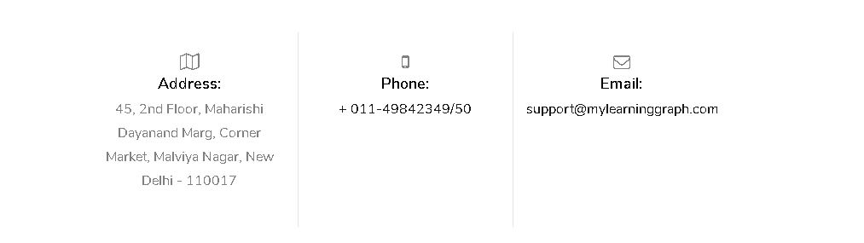

1. Please specify the email on which contact us form and “Send your message” enquiries are going. - DONE
2. Please add captcha code in contact us form. - DONE
3. When we click on “Attempt Free Test”, user is redirected to “My Program” section which is incorrect. It should go to program details page like below where all the free test are listed. User can start the free test from here. - DONE

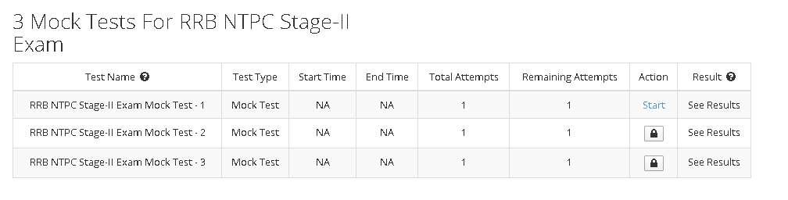

1. I cannot download the students data in excel file. It give server error.
2. I have created new institute by my name “Rohit-Institute” and created two coupons. I have given one coupon to fellow team mate (shiv) who have applied it successfully. But I can see nine students in my account which are not related to me and I can’t see the shiv name in the students list. - DONE

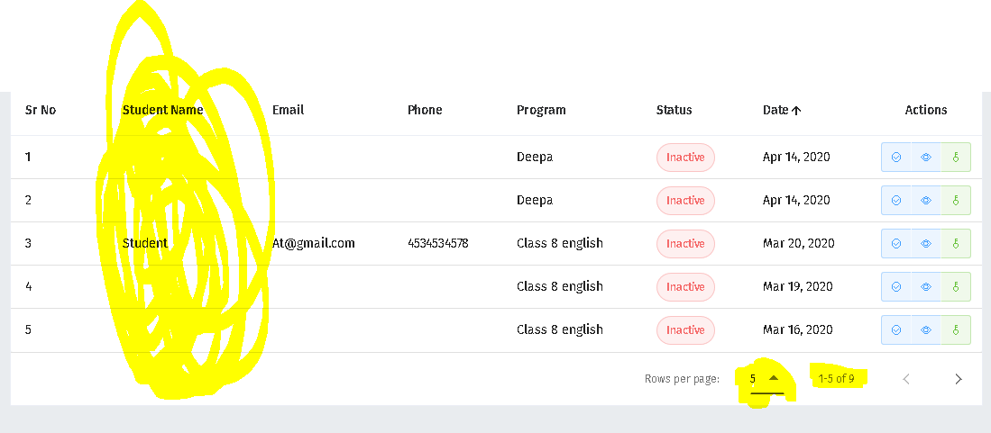

1. In student login, graphs are not correct. I have given one test and my score is 8/8 but graph showing my score as 27.25 and topper score as 72.5 with average of 10.5. How can topper score and average marks are more than total marks. - DONE

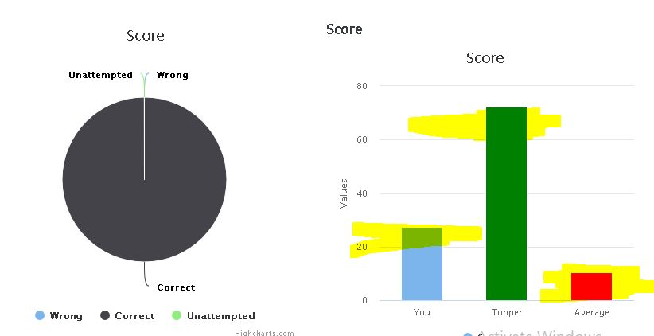

1. Please use green colour for correct answer, red colour for wrong answer in all the report sections (wherever applicable). - DONE
2. Explanations for the questions are not coming in questions wise report.
3. Latest added program should come first in the program list of user account. - DONE
4. I have two different questions in the test but is showing as single questions with two tabs. Please check.

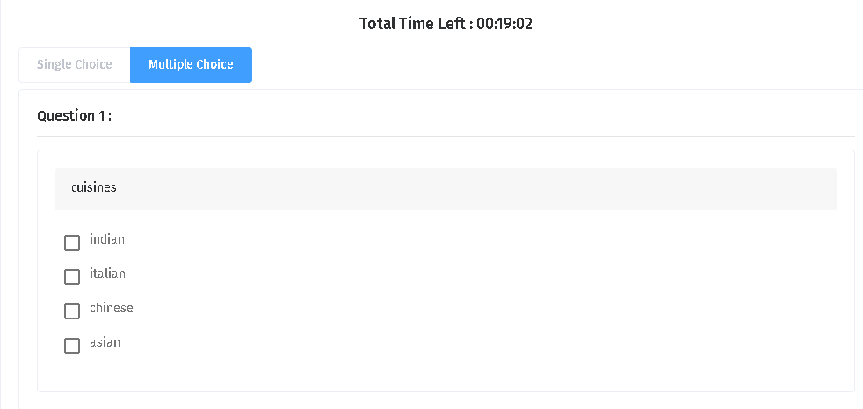

1. Mark for review option is not working. - DONE
2. When I choose any question for Revision, Unable to answer, and important question in details report section then it added in the question bank. But when you see the results from report card then these selected options are not there in question list. Also the question are not there in the question bank once we refresh the page. - DONE
3. (% Marks) section chapter wise, skill wise, difficulty wise, should not be same. Please refer to the live website. - DONE
4. Success gap chart is blank. And topper gap should be Topper gap minus user number. But the topper gap is not calculated in below image. - DONE

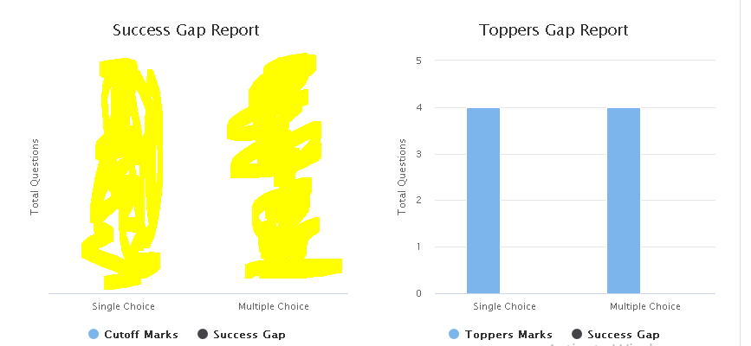

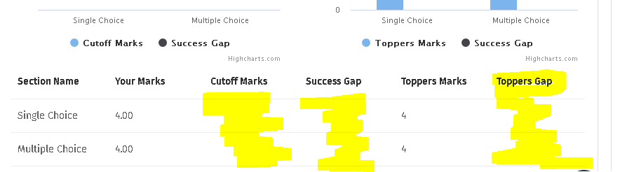

Correct calculations is given in below image.

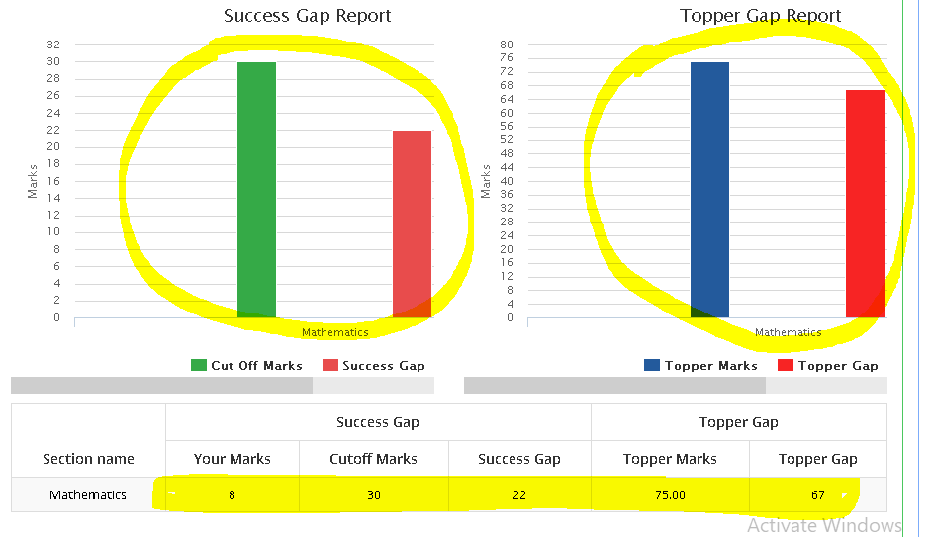

1. In the explanation pop up please show (Question, options, answer and then explanations). Currently questions and options are given with correct mark. Please refer below image and use in every explanation pop up wherever applicable. - DONE

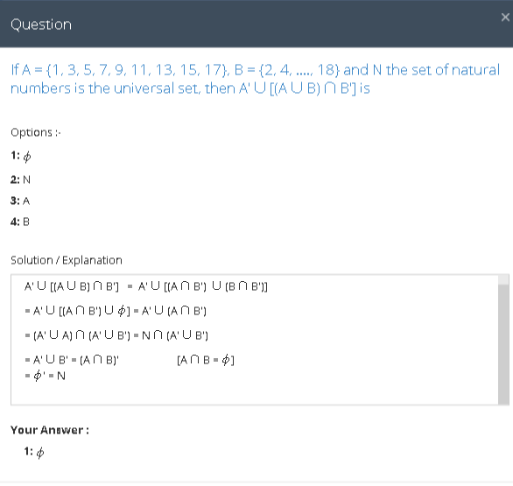

1. Please show total save time below the time saver option like this – (You saved 44 minutes 30 seconds.) - DONE
2. Please use (% of students) in the questions wise report.

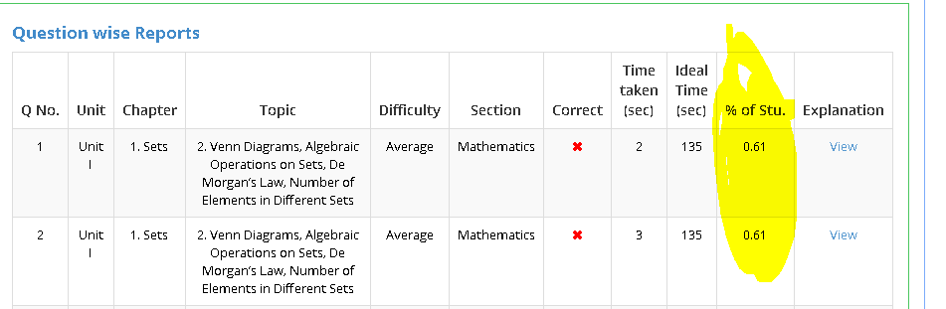

1. I’m getting maths processing error while testing. Please check below image.

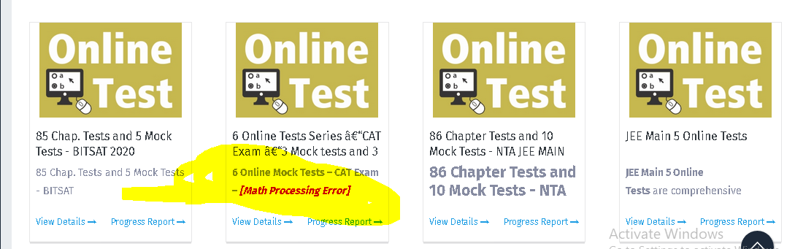

1. Please show selected test papers first in edit program list when we edit the program so we can see the all the added test papers first instead of searching.

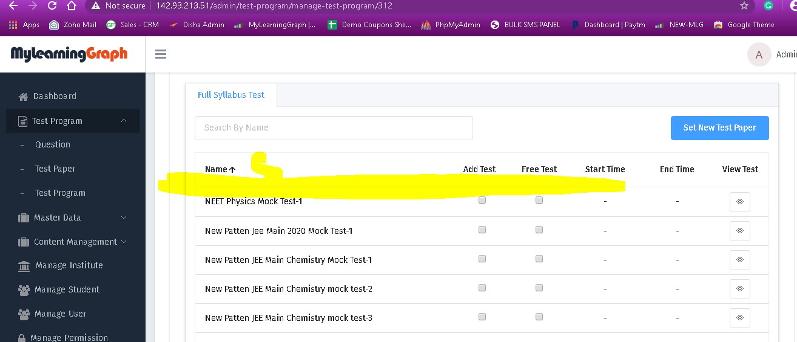

1. Please only show test type where test are available instead of showing the test type with blank and NA data.

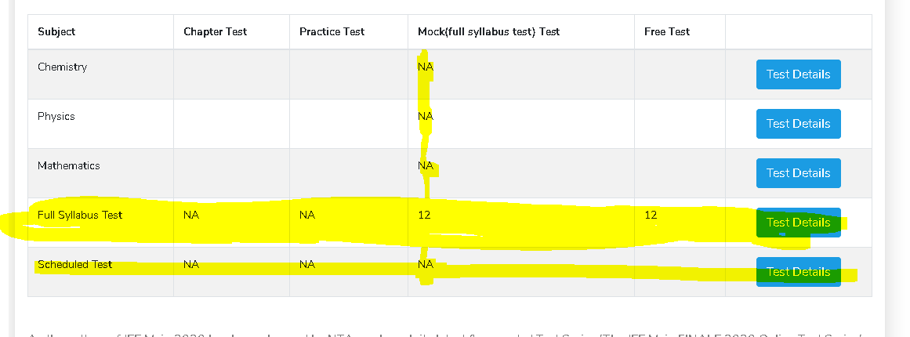

In the above program we should give only “Full Syllabus test” and remove Chemistry, physics, and mathematics.

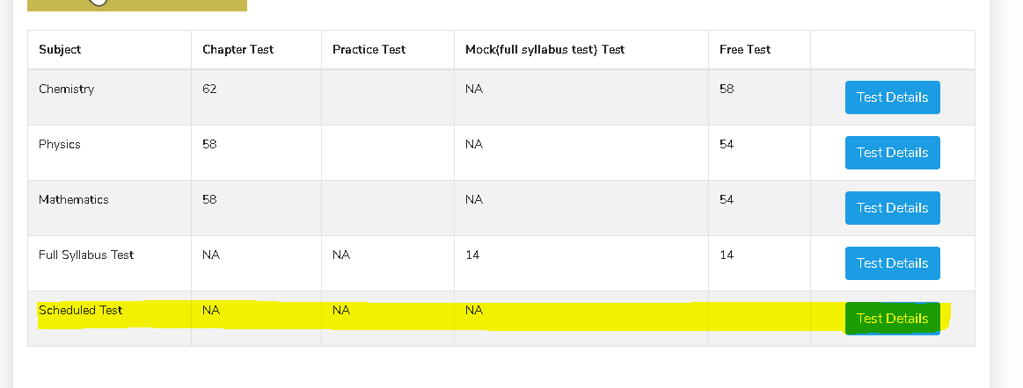

In the above program we have chapter test and free tests in chemistry, physics, and mathematics. But there is no scheduled test so we can remove it.

1. When we click on program in institute account then it show “Data Not Found” error in the header and program name is also missing. - DONE

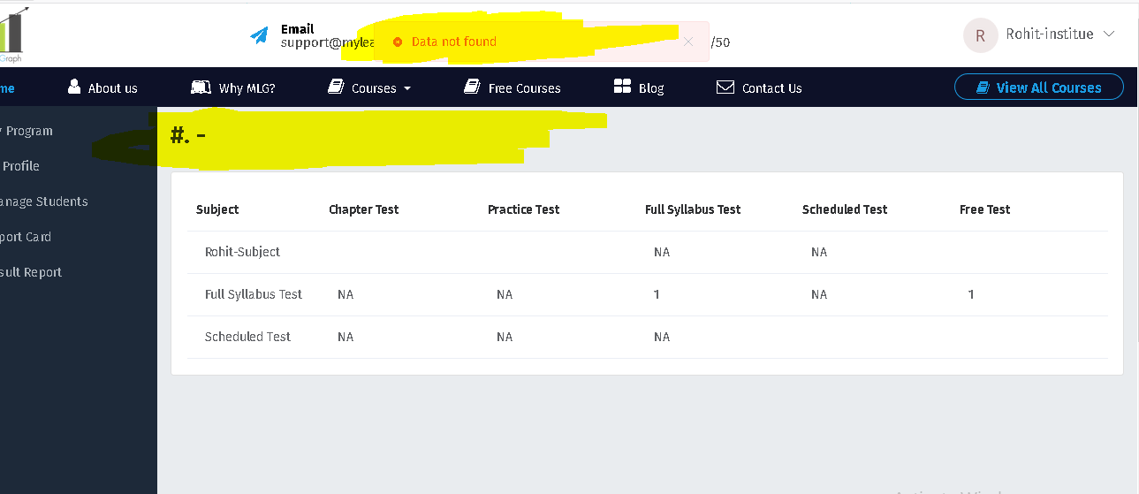

1. Please give complete details of the program in “Result Report” section like **Total Question, Max score, Avg. score, Avg%, Total Students, Student Attempted.** - DONE

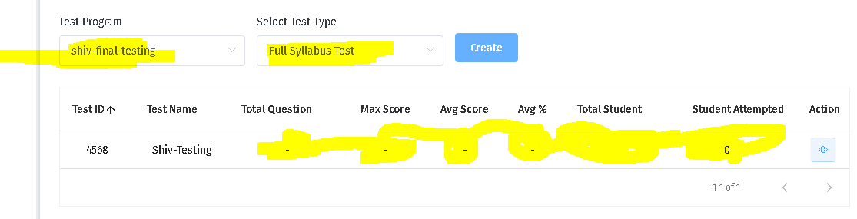

1. I can’t see the student name “Rohit” in my student list who have given the test and it showing in “Result Report” section.
2. Please show complete data test program attempted by students. - DONE

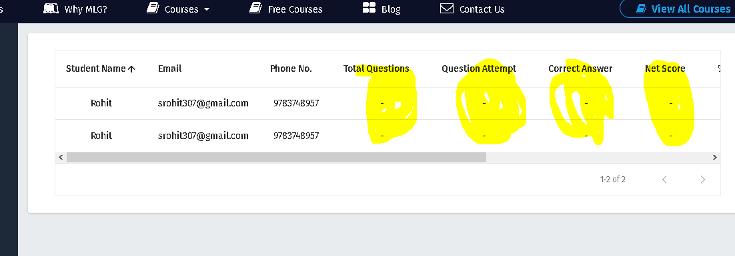

1. In report card section, average marks, highest marks, and lowest marks should not be same.

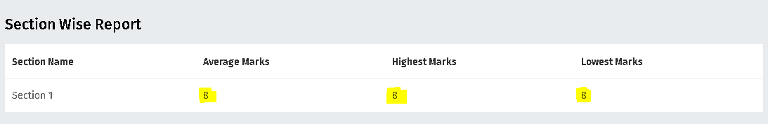

1. When I tried to create banner in manage institute by adding logo, banner and other details in backend then it’s not working. I have added different logo and banner and information but once I downloaded the file it show dummy content. Also the design is poor like header part where user can’t see the links properly. Please check below images. - DONE

Below content is added by me

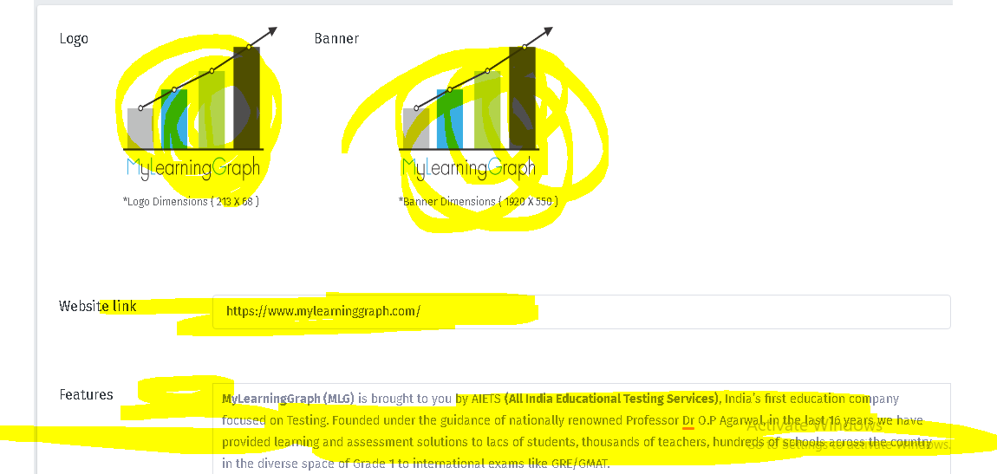

But when I download the index file it show dummy content like below image.

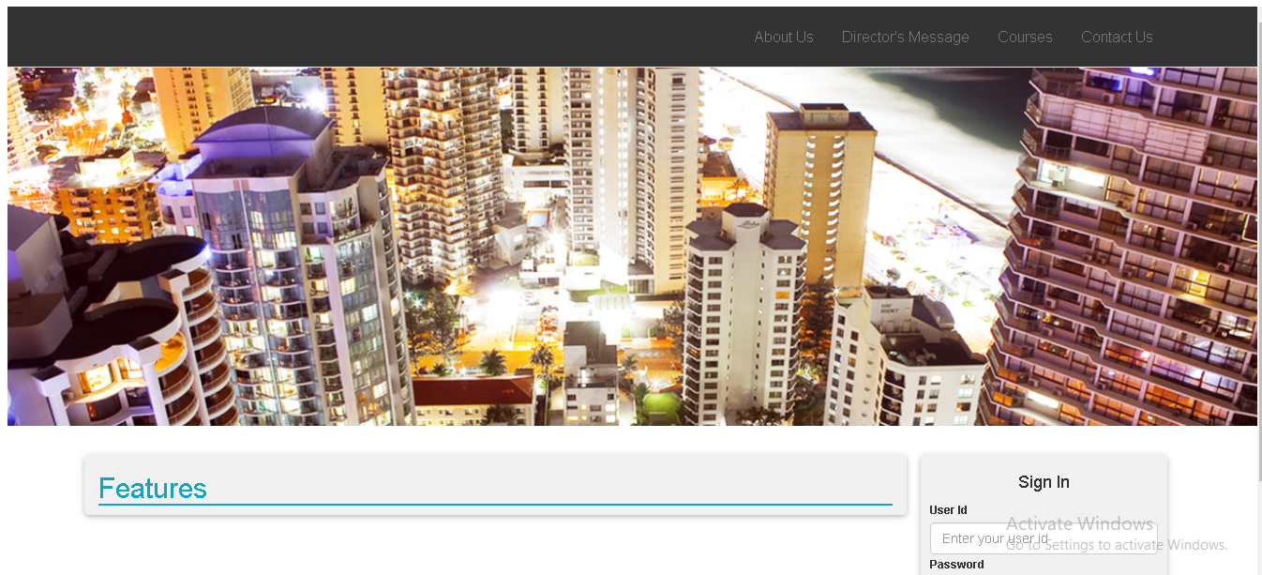

1. Please make the first name, last name, mobile number, and email mandatory in user account. Once user login in their account then they must enter these mandatory details before accessing any test programs. - DONE
2. Please give option to manage the content of features on the homepage.
3. Please give all the test programs in the categories under “Select Your Goal”. - DONE
4. How can we add/update the list of Popular Test series on the homepage? Please explain the working. - DONE
5. When I have tried to add new video in the backend it give www.youtube.com refused to connect. Error. - DONE
6. When I tried to create the coupon then they are not auto downloading in excel file same as live website. - DONE
7. Please give option to multiple select in manage coupon in backend so we can select multiple coupons and delete them. - DONE
8. Please show expiry date of the coupon in backend>>Manage Coupon. Also give option to update the expiry date of multiple coupons at once. - DONE
9. When I try to search the coupon from search bar then it’s not working. I have tried to search the coupon “DLNFD8W7TVYX8UL” by entering “dln” but it’s not working. - DONE
10. Please give option to change the status of order from “unsuccessful” to “Successful” so that if the money is deducted from person account then we can give access to the program to the user by changing the status. Once we change the status then person will get access to all the test and none of the test is locked.
11. Please show minimum 50 rows in each table and give option to view 100, 500, 1000 and all in each section because we have data in thousands.
12. Please show email in manage user role. - DONE
13. When we try to add new test paper the (+) sign say “Add Program”. Please change it to “add test Paper”. - DONE
14. Please change the “Default Institute” name to specific institute name in students list.
15. Once we try to filter the data according to date then if we want to filter the data again then we are unable to change the dates in manage students and manage order section. Please give option to fixed the to and from date and ok button before the data is updated. - DONE

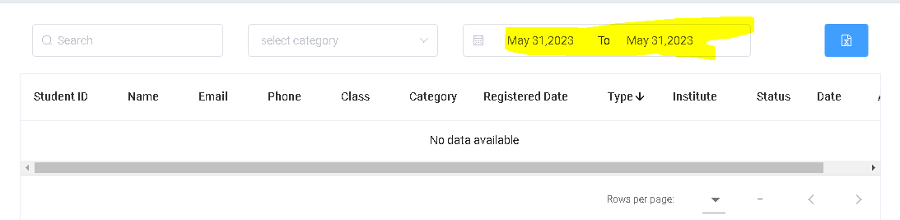

1. Please give two more filter option in Type (Self/institute) and Source (Institute name, disha books, amazon, and seo promotion) filter option along with the search, category, date in manage students section. Please change Institute heading to “Source”. - DONE
2. Please confirm that the yearly data is calculating from (April to March) which is the basis of session. - DONE
3. Please give option of order type (B2B and B2C) in manage order section. Also give institute name if its institute order. - DONE
4. Top ten program selling on monthly and year basis is missing in dashboard program section. - DONE Top ten test attempted on monthly and year basis is missing in dashboard program section. - DONE
5. Top 5 course category in which maximum registration on monthly and yearly basis is missing in program section. - DONE
6. Please add “You are a” dropdown with 4 options (User, Parent, Teacher, and Institute) in contact us form in homepage and contact us page. Please use same fields in each form like (Full Name, Email, Phone Number, You are a (dropdown), and message. - DONE
7. Top ten program selling on monthly and year basis is missing in dashboard program section. - DONE
8. Top ten test attempted on monthly and year basis is missing in dashboard program section. - DONE
9. Top 5 course category in which maximum registration on monthly and yearly basis is missing in program section. - DONE