ROADSIDE VEHICLE ASSISTANCE
& MECHANIC BOOKING PLATFORM
A Comprehensive Project Report

━━━━━━━━━━━━━━━━━━━━━━━━━━━━━━━━━━━━━━━━━━━━━━━━━━

Project Name: Roadside Vehicle Assistance & Mechanic Booking Platform
Project Code: RVA Pro
Organization: Unified Mentor
Developer: Varun Mittapalli
Technology Stack: Next.js 14, React, Node.js, Express.js, MongoDB
Version: 1.0 (Phase 1)
Date: July 2026

Table of Contents
Table of Contents 2
List of Figures 6
List of Tables 7
Chapter 1: Abstract 8
Chapter 2: Introduction 9
2.1 Overview 9
2.2 Problem Statement 9
2.3 Objectives 9
2.3.1 Primary Objectives 9
2.3.2 Secondary Objectives 9
2.4 Scope of the Project 10
2.4.1 In Scope (Phase 1) 10
2.4.2 Out of Scope (Phase 1) 10
2.5 Project Significance 10
Chapter 3: Literature Survey 11
3.1 Existing Systems 11
3.1.1 AAA (American Automobile Association) 11
3.1.2 Mechanic On-Demand Apps 11
3.1.3 Ride-Hailing Model Inspiration 11
3.2 Technology Review 11
3.2.1 Next.js and React Ecosystem 11
3.2.2 Node.js and Express.js 11
3.2.3 MongoDB and Geospatial Capabilities 12
3.2.4 JWT Authentication 12
3.3 Research Gap 12
Chapter 4: System Analysis 13
4.1 Requirement Analysis 13
4.1.1 Functional Requirements — Vehicle Owner 13
4.1.2 Functional Requirements — Mechanic / Towing Partner 13
4.1.3 Functional Requirements — Admin 13
4.1.4 Non-Functional Requirements 14
4.2 Feasibility Study 14
4.2.1 Technical Feasibility 14
4.2.2 Operational Feasibility 14
4.2.3 Economic Feasibility 14
Chapter 5: System Design 15
5.1 System Architecture 15
5.2 Database Design 15
5.2.1 Entity-Relationship Diagram 15
5.2.2 User Collection Schema 16
5.2.3 Vehicle Collection Schema 16
5.2.4 ServiceRequest Collection Schema 17
5.2.5 Database Indexes 17
5.3 Use Case Diagram 17
5.4 Service Request Status Flow 18
5.5 Data Flow Diagrams 19
5.5.1 Level 0 (Context Diagram) 19
5.5.2 Level 1 (Detailed DFD) 19
5.6 API Design 20
5.7 Frontend Component Architecture 21
5.8 Authentication Flow 21
5.9 Frontend Route Structure 22
Chapter 6: Implementation 23
6.1 Technology Stack 23
6.1.1 Frontend Technologies 23
6.1.2 Backend Technologies 23
6.2 Project Structure 23
6.3 Key Implementation Details 25
6.3.1 Haversine Distance Calculation 25
6.3.2 ETA Estimation Algorithm 25
6.3.3 JWT Authentication Middleware 25
6.3.4 Service Request Lifecycle 26
6.3.5 Nearby Mechanic Discovery 26
6.3.6 Rating System 26
6.4 Environment Configuration 27
6.4.1 Backend Environment Variables (.env) 27
6.4.2 Frontend Environment Variables (.env.local) 27
Chapter 7: Testing 28
7.1 Testing Strategy 28
7.2 Test Cases — Authentication Module 28
7.3 Test Cases — Service Request Module 28
7.4 Test Cases — Admin Module 29
7.5 Demo Test Accounts 29
Chapter 8: Screenshots & Output 30
8.1 Landing Page (Home) 30
8.2 Login Page 30
8.3 Registration Page 30
8.4 User Dashboard 30
8.5 Vehicle Management 31
8.6 Nearby Mechanics View 31
8.7 Live Service Tracking 31
8.8 Service History 31
8.9 Mechanic Dashboard 31
8.10 Mechanic Pending Requests 32
8.11 Mechanic Earnings 32
8.12 Admin KPI Dashboard 32
8.13 Admin Partner Verification 32
8.14 Admin Request Monitoring 32
Chapter 9: Deployment 33
9.1 Deployment Architecture 33
9.2 Deployment Steps 33
9.2.1 Backend Deployment (Render) 33
9.2.2 Frontend Deployment (Vercel) 33
9.2.3 Database Setup (MongoDB Atlas) 33
9.3 Deployment Checklist 34
Chapter 10: Conclusion and Future Scope 35
10.1 Conclusion 35
10.2 Key Performance Indicators 35
10.3 Future Enhancements (Phase 2+) 35
10.4 Lessons Learned 36
Chapter 11: Bibliography 37
Appendix A: Setup and Installation Guide 38
A.1 Prerequisites 38
A.2 Backend Setup 38
A.3 Frontend Setup 38
A.4 Accessing the Application 39

List of Figures
Figure No. | Description
Figure 1 | System Architecture Diagram
Figure 2 | Entity-Relationship (ER) Diagram
Figure 3 | Use Case Diagram
Figure 4 | Service Request Status Flow Diagram
Figure 5 | Data Flow Diagram (Level 0)
Figure 6 | Data Flow Diagram (Level 1)
Figure 7 | Frontend Component Hierarchy
Figure 8 | Authentication Flow Sequence Diagram
Figure 9 | Deployment Architecture

List of Tables
Table No. | Description
Table 1 | Technology Stack Comparison
Table 2 | Functional Requirements — Vehicle Owner
Table 3 | Functional Requirements — Mechanic / Towing Partner
Table 4 | Functional Requirements — Admin
Table 5 | Non-Functional Requirements
Table 6 | API Endpoints Summary
Table 7 | Database Schema — User Collection
Table 8 | Database Schema — Vehicle Collection
Table 9 | Database Schema — ServiceRequest Collection
Table 10 | Frontend Route Structure
Table 11 | Backend Dependencies
Table 12 | Frontend Dependencies
Table 13 | Test Cases — Authentication Module
Table 14 | Test Cases — Service Request Module
Table 15 | Test Cases — Admin Module
Table 16 | Demo Accounts
Table 17 | KPI Metrics

Chapter 1: Abstract
The Roadside Vehicle Assistance & Mechanic Booking Platform (Roadside AAA) is a full-stack web application that provides real-time, on-demand roadside assistance by connecting vehicle owners with verified nearby mechanics and towing service providers. The platform addresses critical challenges faced by vehicle owners during breakdowns, including difficulty finding reliable mechanics, unclear pricing structures, delayed support, lack of real-time tracking, and over-dependence on manual phone calls.
Built using a modern MERN-like stack comprising Next.js 14 with TypeScript on the frontend and Node.js with Express.js on the backend, the application leverages MongoDB with GeoJSON support for geospatial queries to locate nearby service providers. The system implements JWT-based authentication, role-based access control (RBAC) for three distinct user roles (vehicle owner, mechanic/towing partner, and administrator), and a comprehensive service request lifecycle management system with real-time status tracking.
Key features include vehicle management, service request creation with six service types (breakdown repair, towing, battery jump-start, flat tire repair, fuel delivery, and lockout assistance), nearby mechanic discovery using the Haversine formula for distance calculation, estimated time of arrival (ETA) computation, transparent pricing, live service tracking via polling, service history with ratings and feedback, mechanic earnings dashboard, and a comprehensive admin panel with KPI monitoring, partner verification, and dispute resolution.
The application is designed to be responsive across desktop and mobile devices, employing Tailwind CSS for utility-first styling. The platform demonstrates a production-ready architecture suitable for deployment on cloud services like Vercel (frontend), Render/Railway (backend), and MongoDB Atlas (database).
Keywords: Roadside Assistance, Mechanic Booking, MERN Stack, Geospatial Queries, Real-time Tracking, JWT Authentication, Next.js, MongoDB, REST API

Chapter 2: Introduction

2.1 Overview
Vehicle breakdowns are unpredictable events that can leave drivers stranded, stressed, and vulnerable, especially on highways or in unfamiliar areas. Traditional methods of finding roadside assistance typically involve manual phone calls, unreliable word-of-mouth referrals, and uncertain wait times. These pain points create a significant market opportunity for a technology-driven solution.
The Roadside Vehicle Assistance & Mechanic Booking Platform (Roadside AAA) is designed to bridge this gap by providing a centralized, digital platform that connects vehicle owners with verified mechanics and towing service providers in real time. The platform leverages modern web technologies and geospatial capabilities to deliver fast, transparent, and reliable roadside assistance.

2.2 Problem Statement
Vehicle breakdowns cause significant stress and delay due to the following challenges:
- Difficulty finding reliable and trustworthy mechanics in the vicinity
- Unclear and non-transparent pricing for roadside services
- Delayed support due to manual communication channels
- Lack of real-time tracking of service provider arrival
- No centralized platform for service history and accountability
- Over-dependence on manual phone calls and referrals
- No mechanism for rating and feedback on services received

2.3 Objectives

2.3.1 Primary Objectives
- Provide fast and efficient roadside assistance during vehicle breakdowns
- Connect vehicle owners with verified nearby mechanics and towing services
- Offer transparent pricing and detailed service information
- Reduce vehicle downtime and user stress through technology
- Enable real-time tracking of service request status

2.3.2 Secondary Objectives
- Improve trust in local automotive services through ratings and reviews
- Enable comprehensive service history and accountability
- Support scalable expansion across cities and regions
- Provide mechanics with a digital platform for job management and earnings tracking
- Give administrators tools for platform monitoring and quality control

2.4 Scope of the Project

2.4.1 In Scope (Phase 1)
- Responsive web platform (desktop and mobile)
- Real-time mechanic discovery and booking via geospatial queries
- Six service types: breakdown repair, towing, battery jump-start, flat tire repair, fuel delivery, lockout assistance
- Service tracking with status updates (pending → accepted → en route → arrived → in progress → completed)
- User, mechanic, and admin dashboards with role-based access
- JWT-based authentication and authorization
- Rating and feedback system
- Admin partner verification workflow

2.4.2 Out of Scope (Phase 1)
- Native mobile applications (iOS/Android)
- Vehicle insurance claim processing
- Spare parts inventory management
- Online payment gateway integration
- Push notifications (WebSocket/SSE)

2.5 Project Significance
This project is significant as it demonstrates the practical application of full-stack web development skills including frontend development with Next.js and React, backend API design with Express.js, database design with MongoDB, authentication and authorization, geospatial computing, and modern UI/UX design. It addresses a real-world problem that impacts millions of vehicle owners and creates value for both service consumers and providers.

Chapter 3: Literature Survey

3.1 Existing Systems
Several existing platforms provide roadside assistance services. A comparative analysis of these systems provides context for the design decisions made in this project.

3.1.1 AAA (American Automobile Association)
AAA is a well-established roadside assistance provider in the United States offering membership-based services including towing, battery service, flat tire change, fuel delivery, and locksmith service. While comprehensive, AAA operates on a membership model with annual fees and is geographically limited to the US and Canada. The platform lacks real-time transparent pricing and relies heavily on dispatched service providers.

3.1.2 Mechanic On-Demand Apps
Various mobile-first platforms like YourMechanic and Wrench have emerged to provide on-demand mechanic services. These platforms focus on scheduled repairs rather than emergency roadside assistance and typically require advance booking. They demonstrate the viability of a marketplace model for automotive services.

3.1.3 Ride-Hailing Model Inspiration
Platforms like Uber and Ola have pioneered the real-time geolocation-based service matching model. The key concepts of nearby provider discovery, ETA estimation, real-time tracking, and post-service rating systems have been adapted for the roadside assistance domain in this project.

3.2 Technology Review

3.2.1 Next.js and React Ecosystem
Next.js 14, built on top of React, provides a robust framework for building modern web applications with features like the App Router for file-system based routing, server-side rendering (SSR), static site generation (SSG), and API routes. The App Router architecture enables colocation of layouts, loading states, and error boundaries, making it ideal for building complex dashboard interfaces.

3.2.2 Node.js and Express.js
Node.js provides a non-blocking, event-driven JavaScript runtime ideal for building scalable network applications. Express.js, a minimal and flexible web framework for Node.js, enables rapid API development with middleware support, routing, and error handling. The combination is well-suited for building RESTful APIs with JSON data exchange.

3.2.3 MongoDB and Geospatial Capabilities
MongoDB is a document-oriented NoSQL database that provides flexibility in schema design and native support for GeoJSON data types and 2dsphere indexes. These geospatial capabilities are critical for the nearby mechanic discovery feature, enabling efficient location-based queries. Mongoose ODM provides schema validation and middleware hooks for data integrity.

3.2.4 JWT Authentication
JSON Web Tokens (JWT) provide a stateless, self-contained method for securely transmitting information between parties as a JSON object. JWTs are digitally signed and can carry claims (user ID, role) that enable role-based access control without maintaining server-side sessions, making the architecture horizontally scalable.

3.3 Research Gap
The literature survey reveals that while individual components of roadside assistance platforms exist, there is a gap in providing an integrated, open-source, full-stack solution that combines real-time geospatial mechanic discovery, transparent pricing, service lifecycle tracking, multi-role dashboards, and admin oversight within a single platform. This project aims to fill that gap.
Chapter 4: System Analysis

4.1 Requirement Analysis

4.1.1 Functional Requirements — Vehicle Owner
S.No. | Feature | Description | Status
1 | Registration & Login | Users can register with name, email, phone, and password. Login via email/password returns a JWT token. | Implemented
2 | Vehicle Management | Add, view, edit, and delete vehicles with make, model, year, license plate, color, and fuel type. | Implemented
3 | Request Assistance | Create service requests by selecting vehicle, service type, providing location, and optionally choosing a mechanic. | Implemented
4 | Nearby Mechanic Discovery | View verified mechanics within 50 km radius with distance, rating, ETA, and pricing information. | Implemented
5 | Real-time Tracking | Track service request status updates via polling (5–15 second intervals). | Implemented
6 | Service History | View past and active service requests with full details and status history. | Implemented
7 | Rating & Feedback | Rate completed services (1–5 stars) and provide written feedback. | Implemented

4.1.2 Functional Requirements — Mechanic / Towing Partner
S.No. | Feature | Description | Status
1 | Partner Registration | Register as mechanic with business name and license number. Requires admin verification. | Implemented
2 | Profile Management | Update business name, bio, experience, services offered, and pricing for each service type. | Implemented
3 | View Pending Requests | Browse all pending service requests from users that are awaiting mechanic acceptance. | Implemented
4 | Accept Requests | Accept pending requests to begin service. Calculates price based on mechanic pricing. | Implemented
5 | Status Updates | Update job status through lifecycle: en route → arrived → in progress → completed. | Implemented
6 | Earnings Dashboard | Track total earnings, total completed jobs, and view recent job history. | Implemented
7 | Location Update | Update current location coordinates for accurate distance calculations. | Implemented

4.1.3 Functional Requirements — Admin
S.No. | Feature | Description | Status
1 | KPI Dashboard | View total users, mechanics, pending applications, active/completed requests, avg rating, acceptance rate. | Implemented
2 | Partner Verification | Review, verify, or reject mechanic/towing partner applications. | Implemented
3 | User Management | View all registered vehicle owners. | Implemented
4 | Request Monitoring | View all service requests across the platform with full details. | Implemented
5 | Dispute Resolution | Resolve or cancel disputed service requests with admin notes. | Implemented

4.1.4 Non-Functional Requirements
Requirement | Implementation Details
Performance | Polling-based updates at 5–15 second intervals; geospatial queries with 2dsphere indexes; Haversine formula for distance calculation
Security | JWT-based authentication with 7-day token expiry; bcrypt password hashing with 12 salt rounds; role-based authorization middleware
Usability | Emergency-friendly UI with large call-to-action buttons; mobile-responsive design; intuitive dashboard navigation
Scalability | Stateless REST API architecture; MongoDB compound and geospatial indexes; modular codebase structure
Reliability | Error handling middleware; input validation; status history audit trail for all service requests

4.2 Feasibility Study

4.2.1 Technical Feasibility
The project is technically feasible as it uses well-established, production-ready technologies. Next.js 14 and React provide a mature frontend framework, Express.js is battle-tested for API development, and MongoDB Atlas offers managed cloud database services. All libraries used are actively maintained with large communities and comprehensive documentation.

4.2.2 Operational Feasibility
The platform is designed to be intuitive for all user roles. Vehicle owners can request assistance with minimal steps, mechanics receive clear job information, and administrators have comprehensive dashboards. The responsive design ensures accessibility across devices.

4.2.3 Economic Feasibility
The project uses entirely open-source technologies, eliminating licensing costs. Deployment costs are minimal with free tiers available on Vercel (frontend), Render (backend), and MongoDB Atlas (database). The platform can generate revenue through commission-based models on service bookings.

Chapter 5: System Design

5.1 System Architecture
The application follows a client-server architecture with a clear separation between the frontend (presentation layer), backend (business logic layer), and database (data persistence layer). Communication between the frontend and backend occurs via RESTful API calls using JSON as the data interchange format.
Figure 1: System Architecture Diagram
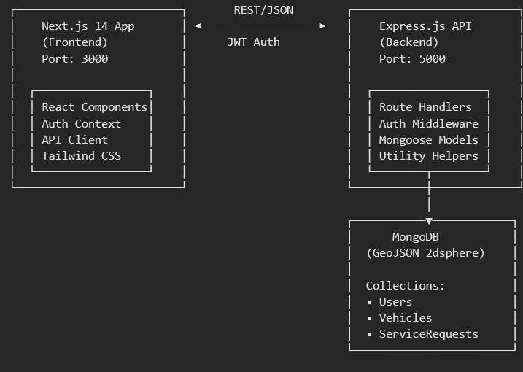

5.2 Database Design

5.2.1 Entity-Relationship Diagram
Figure 2: Entity-Relationship (ER) Diagram
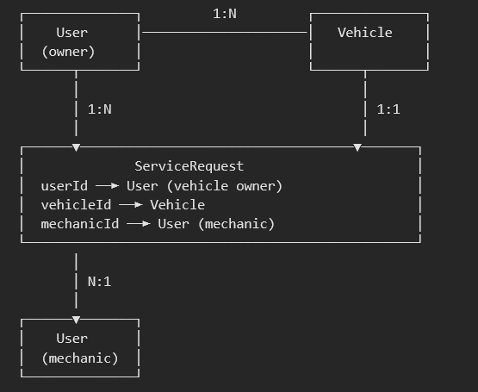

5.2.2 User Collection Schema
Field | Type | Constraints | Description
name | String | Required, Trimmed | Full name of the user
email | String | Required, Unique, Lowercase | Email address (login identifier)
phone | String | Required | Contact phone number
password | String | Required, Min 6 chars | Hashed password (bcrypt, 12 rounds)
role | String | Enum: user/mechanic/admin | User role for access control
isVerified | Boolean | Default: false | Verification status (admin-approved for mechanics)
profile.businessName | String | Optional | Mechanic business name
profile.licenseNumber | String | Optional | Mechanic license number
profile.experience | Number | Optional | Years of experience
profile.services | [String] | Optional | Services offered by mechanic
profile.pricing.* | Number | Defaults set | Per-service pricing (6 service types)
profile.rating | Number | Default: 0 | Average rating from users
profile.totalRatings | Number | Default: 0 | Count of ratings received
profile.totalJobs | Number | Default: 0 | Total completed jobs
profile.earnings | Number | Default: 0 | Total earnings accumulated
location.type | String | Enum: Point | GeoJSON type
location.coordinates | [Number] | Default: [77.59, 12.97] | Longitude, Latitude pair
location.address | String | Optional | Human-readable address
isAvailable | Boolean | Default: true | Mechanic availability status

5.2.3 Vehicle Collection Schema
Field | Type | Constraints | Description
userId | ObjectId | Required, Ref: User | Owner of the vehicle
make | String | Required | Vehicle manufacturer (e.g., Maruti Suzuki)
model | String | Required | Vehicle model (e.g., Swift)
year | Number | Required | Manufacturing year
licensePlate | String | Required | Registration number
color | String | Optional | Vehicle color
fuelType | String | Enum: petrol/diesel/electric/hybrid/cng | Fuel type

5.2.4 ServiceRequest Collection Schema
Field | Type | Constraints | Description
userId | ObjectId | Required, Ref: User | User who created the request
vehicleId | ObjectId | Required, Ref: Vehicle | Vehicle needing service
mechanicId | ObjectId | Optional, Ref: User | Assigned mechanic
serviceType | String | Required, Enum (6 types) | Type of service requested
description | String | Default: empty | Additional description of the issue
location.coordinates | [Number] | Required | Breakdown location (GeoJSON)
location.address | String | Required | Breakdown address
status | String | Enum (7 states) | Current request status
estimatedPrice | Number | Required | Estimated service cost
finalPrice | Number | Optional | Final price after completion
estimatedArrivalMinutes | Number | Optional | ETA in minutes
rating | Number | Min: 1, Max: 5 | User rating after service
feedback | String | Optional | User feedback text
statusHistory | [Object] | Array | Audit trail of status changes

5.2.5 Database Indexes
Collection | Index | Type | Purpose
User | location | 2dsphere | Geospatial queries for nearby mechanics
User | role + isVerified | Compound | Efficient mechanic filtering
ServiceRequest | location | 2dsphere | Geospatial queries on breakdown locations
ServiceRequest | status + createdAt | Compound | Admin dashboard queries

5.3 Use Case Diagram
Figure 3: Use Case Diagram
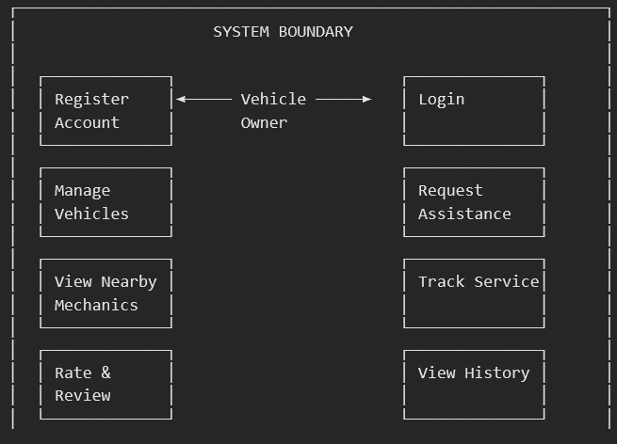

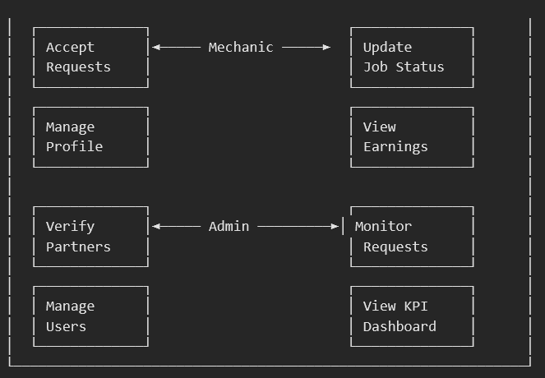

5.4 Service Request Status Flow
Figure 4: Service Request Status Flow Diagram
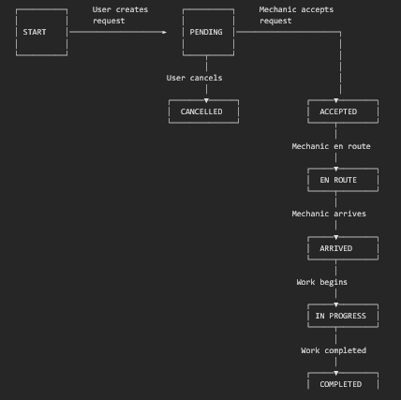

5.5 Data Flow Diagrams

5.5.1 Level 0 (Context Diagram)
Figure 5: Data Flow Diagram — Level 0
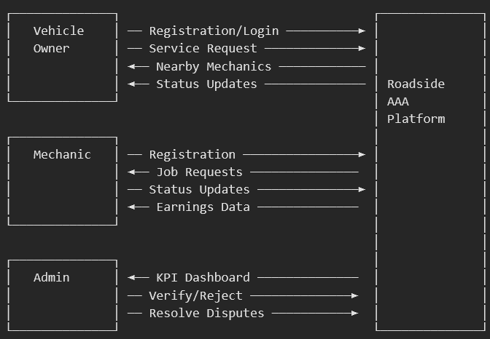

5.5.2 Level 1 (Detailed DFD)
Figure 6: Data Flow Diagram — Level 1
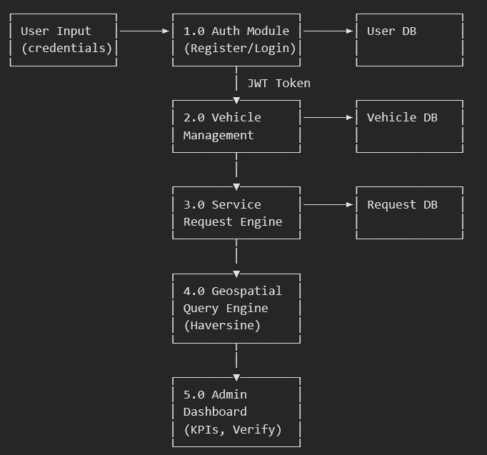

5.6 API Design
The backend exposes a RESTful API with the following endpoints:
Method | Endpoint | Auth | Description
POST | /api/auth/register | Public | Register user or mechanic account
POST | /api/auth/login | Public | Login and receive JWT token
GET | /api/auth/me | Protected | Get current authenticated user
PUT | /api/auth/me | Protected | Update user profile and location
GET | /api/vehicles | User | List vehicles for current user
POST | /api/vehicles | User | Add a new vehicle
PUT | /api/vehicles/:id | User | Update vehicle details
DELETE | /api/vehicles/:id | User | Delete a vehicle
GET | /api/mechanics/nearby | User | Find nearby verified mechanics
GET | /api/mechanics/requests | Mechanic | View pending service requests
GET | /api/mechanics/jobs | Mechanic | View mechanic job history
PUT | /api/mechanics/profile | Mechanic | Update mechanic profile and pricing
PUT | /api/mechanics/location | Mechanic | Update mechanic location
GET | /api/mechanics/earnings | Mechanic | Get earnings summary
GET | /api/requests/types | Protected | Get available service types
POST | /api/requests | User | Create a new service request
GET | /api/requests | Protected | List requests (filtered by role)
GET | /api/requests/:id | Protected | Get request details
PUT | /api/requests/:id/accept | Mechanic | Accept a pending request
PUT | /api/requests/:id/status | Protected | Update request status
PUT | /api/requests/:id/rate | User | Rate a completed service
GET | /api/admin/dashboard | Admin | Get KPI dashboard data
GET | /api/admin/mechanics/pending | Admin | List pending mechanic applications
PUT | /api/admin/mechanics/:id/verify | Admin | Approve a mechanic
PUT | /api/admin/mechanics/:id/reject | Admin | Reject a mechanic application
GET | /api/admin/users | Admin | List all registered users
GET | /api/admin/requests | Admin | List all service requests
PUT | /api/admin/requests/:id/resolve | Admin | Resolve/cancel a request
GET | /api/health | Public | Health check endpoint

5.7 Frontend Component Architecture
Figure 7: Frontend Component Hierarchy
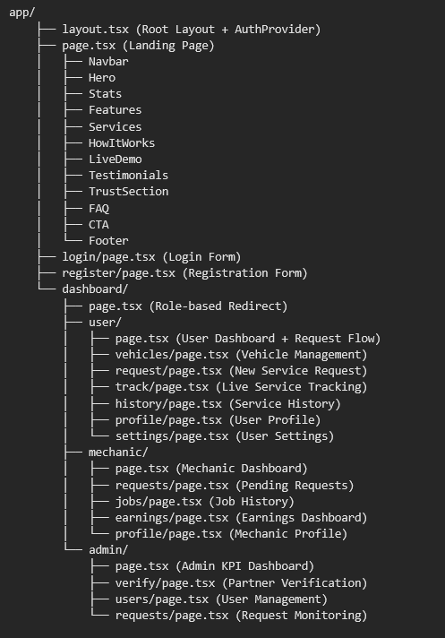

5.8 Authentication Flow
Figure 8: Authentication Flow Sequence Diagram
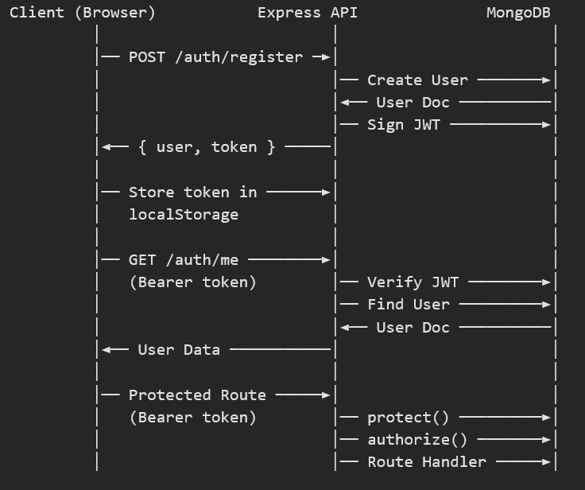

5.9 Frontend Route Structure
Path | Role | Page Component | Purpose
/ | Public | Landing Page | Marketing page with features, services, testimonials
/login | Public | Login Form | Email/password authentication
/register | Public | Registration Form | User or mechanic registration
/dashboard | Protected | Role Redirect | Redirects to role-specific dashboard
/dashboard/user | User | User Dashboard | Overview with quick request flow
/dashboard/user/vehicles | User | Vehicle Management | CRUD operations for vehicles
/dashboard/user/request | User | New Request | Create service request
/dashboard/user/track | User | Live Tracking | Real-time status tracking
/dashboard/user/history | User | Service History | Past request records
/dashboard/user/profile | User | User Profile | Profile management
/dashboard/user/settings | User | Settings | Account settings
/dashboard/mechanic | Mechanic | Mechanic Dashboard | Job overview and stats
/dashboard/mechanic/requests | Mechanic | Pending Requests | Browse and accept jobs
/dashboard/mechanic/jobs | Mechanic | Job History | Completed job records
/dashboard/mechanic/earnings | Mechanic | Earnings | Revenue tracking
/dashboard/mechanic/profile | Mechanic | Mechanic Profile | Business profile management
/dashboard/admin | Admin | Admin Dashboard | KPI overview and monitoring
/dashboard/admin/verify | Admin | Partner Verification | Approve/reject mechanics
/dashboard/admin/users | Admin | User Management | View registered users
/dashboard/admin/requests | Admin | All Requests | Platform-wide request monitoring

Chapter 6: Implementation

6.1 Technology Stack

6.1.1 Frontend Technologies
Technology | Version | Purpose
Next.js | 14.2.15 | React framework with App Router, SSR, and file-based routing
React | 18.3.1 | UI component library for building interactive interfaces
TypeScript | 5.6.3 | Type-safe JavaScript superset for better DX and error prevention
Tailwind CSS | 3.4.14 | Utility-first CSS framework for responsive design
Lucide React | 0.454.0 | Modern icon library for consistent UI iconography
PostCSS | 8.4.47 | CSS transformation tool for Tailwind processing
Autoprefixer | 10.4.20 | CSS vendor prefix automation

6.1.2 Backend Technologies
Technology | Version | Purpose
Node.js | 18+ | JavaScript runtime for server-side execution
Express.js | 4.21.0 | Minimal web framework for REST API development
Mongoose | 8.7.0 | MongoDB ODM for schema definition and data validation
jsonwebtoken | 9.0.2 | JWT generation and verification for authentication
bcryptjs | 2.4.3 | Password hashing library (12 salt rounds)
cors | 2.8.5 | Cross-Origin Resource Sharing middleware
dotenv | 16.4.5 | Environment variable management
nodemon | 3.1.7 | Development auto-reload server (dev dependency)

6.2 Project Structure
Project Directory Structure
roadside-vehicle-assistance/
├── backend/
│ ├── config/
│ │ └── db.js # MongoDB connection configuration
│ ├── middleware/
│ │ └── auth.js # JWT protect() and authorize() middleware
│ ├── models/
│ │ ├── User.js # User schema with embedded mechanic profile
│ │ ├── Vehicle.js # Vehicle schema linked to user
│ │ └── ServiceRequest.js # Service request with status lifecycle
│ ├── routes/
│ │ ├── auth.js # Registration, login, profile endpoints
│ │ ├── vehicles.js # CRUD operations for vehicles
│ │ ├── mechanics.js # Nearby search, jobs, earnings, profile
│ │ ├── serviceRequests.js # Request CRUD, accept, status, rate
│ │ └── admin.js # Dashboard, verification, monitoring
│ ├── utils/
│ │ ├── helpers.js # Haversine distance, ETA, pricing helpers
│ │ └── seed.js # Database seed script with demo data
│ ├── server.js # Express app entry point
│ ├── package.json # Backend dependencies
│ └── .env # Environment variables
│
├── frontend/
│ ├── app/
│ │ ├── layout.tsx # Root layout with AuthProvider
│ │ ├── page.tsx # Landing page
│ │ ├── globals.css # Global styles and Tailwind imports
│ │ ├── login/page.tsx # Login page
│ │ ├── register/page.tsx # Registration page
│ │ └── dashboard/
│ │ ├── page.tsx # Dashboard role-redirect
│ │ ├── user/ # User dashboard pages (7 pages)
│ │ ├── mechanic/ # Mechanic dashboard pages (5 pages)
│ │ └── admin/ # Admin dashboard pages (4 pages)
│ ├── components/
│ │ ├── Navbar.tsx # Navigation bar with auth state
│ │ ├── Hero.tsx # Landing page hero section
│ │ ├── Features.tsx # Feature showcase
│ │ ├── Services.tsx # Service types display
│ │ ├── HowItWorks.tsx # Step-by-step guide
│ │ ├── Stats.tsx # Platform statistics
│ │ ├── LiveDemo.tsx # Interactive demo component
│ │ ├── Testimonials.tsx # User testimonials
│ │ ├── TrustSection.tsx # Trust indicators
│ │ ├── FAQ.tsx # Frequently asked questions
│ │ ├── CTA.tsx # Call to action
│ │ ├── Footer.tsx # Site footer
│ │ ├── DashboardLayout.tsx # Shared dashboard shell (sidebar + nav)
│ │ └── ui.tsx # Reusable UI primitives
│ ├── lib/
│ │ ├── api.ts # API client with typed endpoints
│ │ └── auth-context.tsx # React Context for authentication
│ ├── package.json # Frontend dependencies
│ ├── tailwind.config.js # Tailwind CSS configuration
│ ├── tsconfig.json # TypeScript configuration
│ └── next.config.js # Next.js configuration
│
├── docs/
│ ├── PRD.md # Product Requirements Document
│ └── TECHNICAL.md # Technical Documentation
│
├── server.js # Root wrapper for Render deployment
├── package.json # Root package.json
└── README.md # Project documentation

6.3 Key Implementation Details

6.3.1 Haversine Distance Calculation
The platform uses the Haversine formula to calculate the great-circle distance between the user's breakdown location and each mechanic's current location. This formula accounts for the curvature of the Earth and provides accurate results for short to medium distances.
JavaScript — helpers.js
const R = 6371; // Earth radius in kilometers

function haversineDistance(lat1, lon1, lat2, lon2) {
const dLat = ((lat2 - lat1) * Math.PI) / 180;
const dLon = ((lon2 - lon1) * Math.PI) / 180;
const a =
Math.sin(dLat / 2) ** 2 +
Math.cos((lat1 * Math.PI) / 180) *
Math.cos((lat2 * Math.PI) / 180) *
Math.sin(dLon / 2) ** 2;
return R * 2 * Math.atan2(Math.sqrt(a), Math.sqrt(1 - a));
}

6.3.2 ETA Estimation Algorithm
The estimated time of arrival is calculated by assuming an average travel speed of 30 km/h in urban conditions, with a minimum ETA of 5 minutes.
JavaScript — helpers.js
function estimateArrivalMinutes(distanceKm) {
const avgSpeedKmh = 30;
return Math.max(5, Math.round((distanceKm / avgSpeedKmh) * 60));
}

6.3.3 JWT Authentication Middleware
The authentication middleware extracts the JWT from the Authorization header, verifies it against the server secret, and attaches the authenticated user to the request object. The authorize function performs role-based access control.
JavaScript — middleware/auth.js
const protect = async (req, res, next) => {
let token;
if (req.headers.authorization?.startsWith('Bearer')) {
token = req.headers.authorization.split(' ')[1];
}
if (!token) {
return res.status(401).json({ message: 'Not authorized, no token' });
}
try {
const decoded = jwt.verify(token, process.env.JWT_SECRET);
req.user = await User.findById(decoded.id);
if (!req.user) {
return res.status(401).json({ message: 'User not found' });
}
next();
} catch {
return res.status(401).json({ message: 'Not authorized, token invalid' });
}
};

const authorize = (...roles) => (req, res, next) => {
if (!roles.includes(req.user.role)) {
return res.status(403).json({ message: 'Access denied for this role' });
}
next();
};

6.3.4 Service Request Lifecycle
The service request lifecycle is managed through a state machine pattern. Each status transition is recorded in the statusHistory array, creating a complete audit trail. Upon completion, the mechanic's earnings and job counters are automatically updated.
JavaScript — models/ServiceRequest.js
const STATUS_FLOW = [
'pending', // User created the request
'accepted', // Mechanic accepted the job
'en_route', // Mechanic is traveling to location
'arrived', // Mechanic arrived at breakdown site
'in_progress', // Repair/service work in progress
'completed', // Service successfully completed
'cancelled', // Request cancelled by user/admin
];

6.3.5 Nearby Mechanic Discovery
When a user searches for nearby mechanics, the system queries all verified and available mechanics, calculates the Haversine distance from the user's location, filters mechanics within a 50 km radius, and sorts results by proximity. For each mechanic, the ETA and service pricing are computed dynamically.

6.3.6 Rating System
After a service is marked as completed, the user can rate the mechanic on a scale of 1 to 5 stars with optional written feedback. The mechanic's average rating is recalculated using a weighted running average formula to maintain accuracy as ratings accumulate.
JavaScript — Rating Calculation
// Running average calculation
const newTotal = currentTotalRatings + 1;
const newRating = (currentRating * currentTotalRatings + newRating) / newTotal;
// Rounded to 1 decimal place
mechanic.profile.rating = Math.round(newRating * 10) / 10;

6.4 Environment Configuration

6.4.1 Backend Environment Variables (.env)
Environment — Backend
PORT=5000
MONGODB_URI=mongodb://localhost:27017/roadside_assistance
JWT_SECRET=<strong-secret-key>
NODE_ENV=development

6.4.2 Frontend Environment Variables (.env.local)
Environment — Frontend
NEXT_PUBLIC_API_URL=http://localhost:5000/api

Chapter 7: Testing

7.1 Testing Strategy
The application was tested using a combination of manual testing, API testing (using tools like Postman or curl), and UI testing. Test cases were designed to cover all functional requirements across all three user roles.

7.2 Test Cases — Authentication Module
TC ID | Test Case | Input | Expected Output | Result
TC-01 | User Registration (Valid) | Name, email, phone, password | 201 Created with JWT token | Pass
TC-02 | User Registration (Duplicate Email) | Existing email address | 400 Bad Request — Email already registered | Pass
TC-03 | User Registration (Missing Fields) | Empty name field | 400 Bad Request — Please provide all required fields | Pass
TC-04 | Login (Valid Credentials) | Correct email & password | 200 OK with JWT token and user data | Pass
TC-05 | Login (Invalid Password) | Wrong password | 401 Unauthorized — Invalid email or password | Pass
TC-06 | Login (Non-existent Email) | Unregistered email | 401 Unauthorized — Invalid email or password | Pass
TC-07 | Access Protected Route (Valid Token) | Valid JWT in header | 200 OK with user data | Pass
TC-08 | Access Protected Route (No Token) | No Authorization header | 401 Unauthorized — Not authorized, no token | Pass
TC-09 | Access Protected Route (Expired Token) | Expired JWT token | 401 Unauthorized — Not authorized, token invalid | Pass
TC-10 | Mechanic Registration | Role=mechanic, businessName, license | 201 Created with isVerified=false | Pass

7.3 Test Cases — Service Request Module
TC ID | Test Case | Input | Expected Output | Result
TC-11 | Create Service Request (Valid) | vehicleId, serviceType, location | 201 Created with pending status | Pass
TC-12 | Create Request (Missing Vehicle) | Invalid vehicleId | 404 Vehicle not found | Pass
TC-13 | Create Request (Missing Location) | No coordinates | 400 Missing required fields | Pass
TC-14 | Find Nearby Mechanics | User coordinates (lng, lat) | 200 OK with sorted mechanic list | Pass
TC-15 | Accept Request (Verified Mechanic) | Pending request ID | 200 OK with status=accepted | Pass
TC-16 | Accept Request (Unverified Mechanic) | Pending request, unverified mechanic | 403 Account not verified | Pass
TC-17 | Update Status (en_route) | request ID, status=en_route | 200 OK with updated status | Pass
TC-18 | Complete Service | status=completed, finalPrice | 200 OK, mechanic earnings updated | Pass
TC-19 | Rate Completed Service | rating=5, feedback text | 200 OK, mechanic rating recalculated | Pass
TC-20 | Cancel Request (By User) | status=cancelled | 200 OK with cancelled status | Pass

7.4 Test Cases — Admin Module
TC ID | Test Case | Input | Expected Output | Result
TC-21 | Admin Dashboard KPIs | Admin JWT token | 200 OK with stats object | Pass
TC-22 | View Pending Mechanics | Admin token | 200 OK with pending mechanic list | Pass
TC-23 | Verify Mechanic | mechanic ID | 200 OK with isVerified=true | Pass
TC-24 | Reject Mechanic | mechanic ID | 200 OK, mechanic deleted | Pass
TC-25 | View All Users | Admin token | 200 OK with user list (no passwords) | Pass
TC-26 | Resolve Disputed Request | request ID, status, note | 200 OK with updated request | Pass
TC-27 | Non-Admin Access Dashboard | User JWT token | 403 Access denied for this role | Pass

7.5 Demo Test Accounts
Role | Email | Password | Notes
Admin | admin@roadside.com | admin123 | Full platform access
User | user@roadside.com | user123 | Vehicle owner with pre-registered vehicle
Mechanic (Verified) | rajesh@roadside.com | mech123 | Quick Fix Auto — 8 years experience
Mechanic (Verified) | suresh@roadside.com | mech123 | Highway Tow Services — 12 years experience
Mechanic (Pending) | amit@roadside.com | mech123 | City Auto Care — Awaiting verification

Chapter 8: Screenshots & Output
This chapter presents the key screens and outputs of the Roadside Vehicle Assistance & Mechanic Booking Platform. Due to the document format, representative descriptions of each screen are provided below. Actual screenshots can be captured by running the application locally.

8.1 Landing Page (Home)
The landing page features a modern, gradient-themed hero section with a prominent 'Get Help Now' call-to-action button. It includes platform statistics (total users, response time, satisfaction rating), a feature showcase section, service type cards (breakdown repair, towing, battery jump-start, etc.), a 'How It Works' step-by-step guide, an interactive live demo, user testimonials, trust indicators, a FAQ accordion, and a comprehensive footer with navigation links.
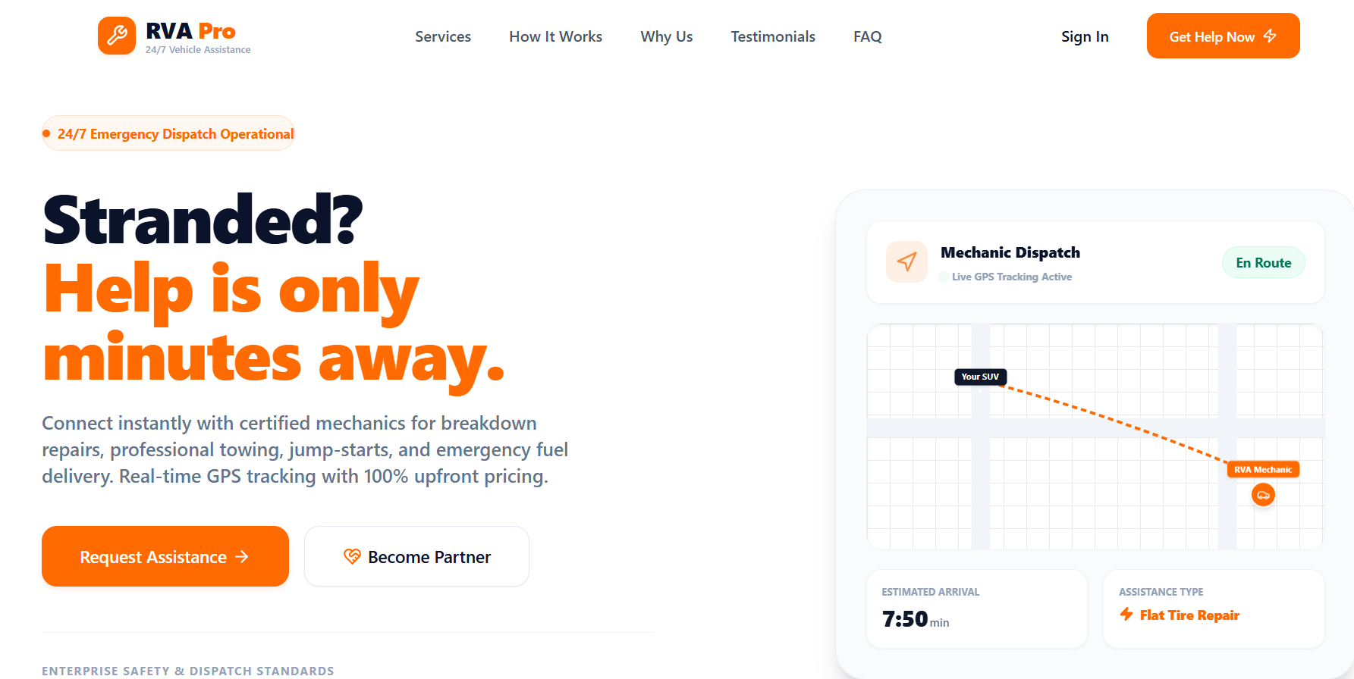

8.2 Login Page
A clean, centered login form with email and password fields, form validation, and links to the registration page. The design uses a card-based layout with subtle shadows and the platform branding.
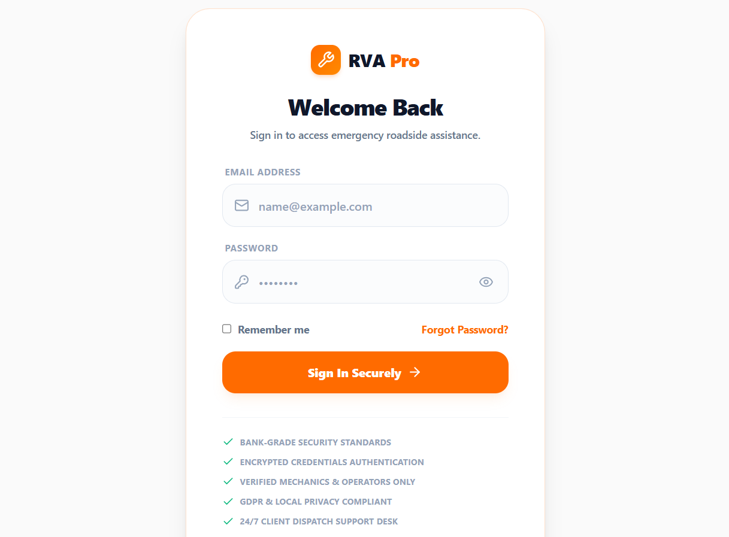

8.3 Registration Page
A registration form supporting both vehicle owner and mechanic registration. When 'mechanic' role is selected, additional fields for business name and license number appear dynamically. The form includes client-side validation for all required fields.
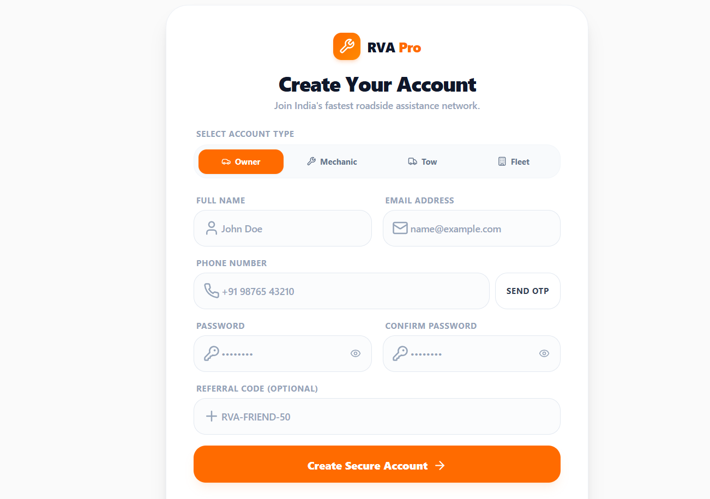

8.4 User Dashboard
The user dashboard provides an overview of the user's activity with quick access cards for requesting assistance, managing vehicles, viewing service history, and tracking active requests. It includes a multi-step service request flow directly from the dashboard: select vehicle → choose service type → share location → pick a mechanic → confirm and submit.
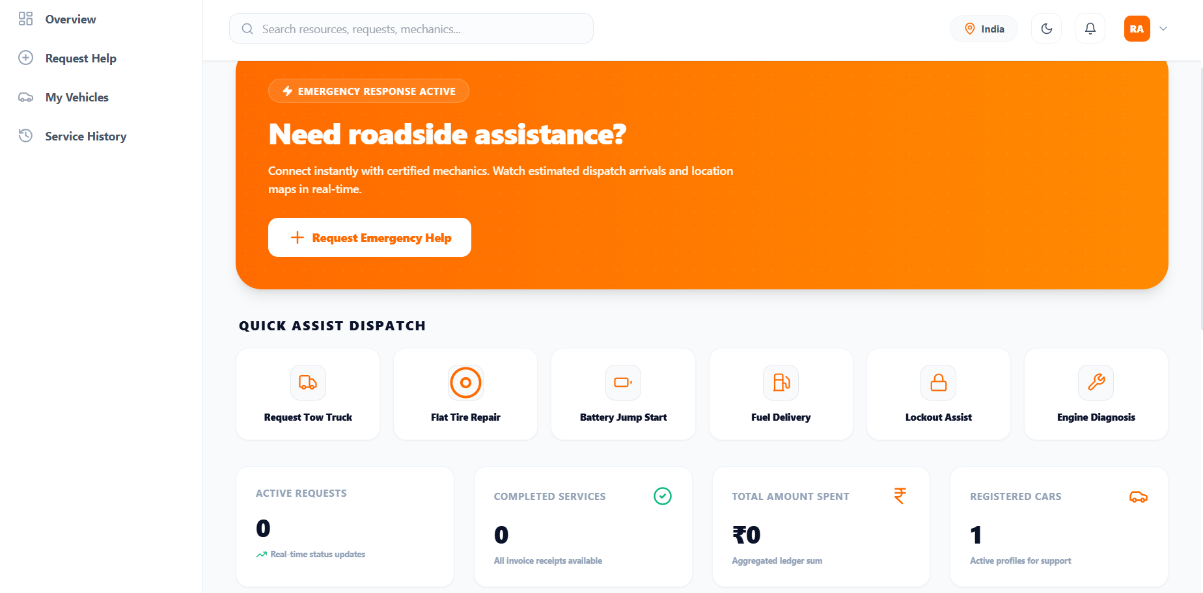

8.5 Vehicle Management
A paginated list of the user's registered vehicles displayed as cards, each showing make, model, year, license plate, color, and fuel type. Includes buttons for adding new vehicles and editing/deleting existing ones. The add/edit form validates all required fields.
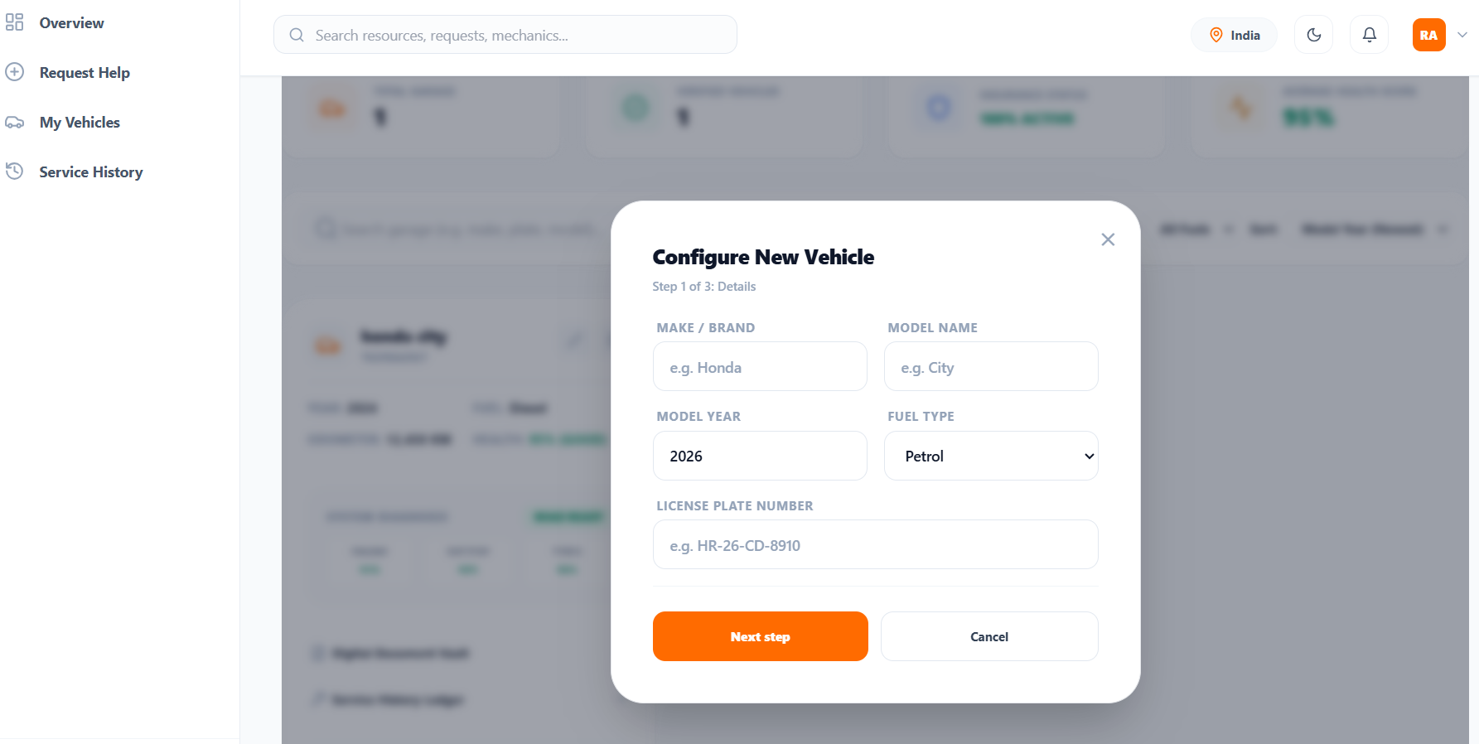

8.6 Nearby Mechanics View
A list of nearby mechanics sorted by distance, showing each mechanic's business name, rating (star display), distance in km, estimated arrival time, and pricing for the selected service type. Each card has a 'Book' button to create a service request.
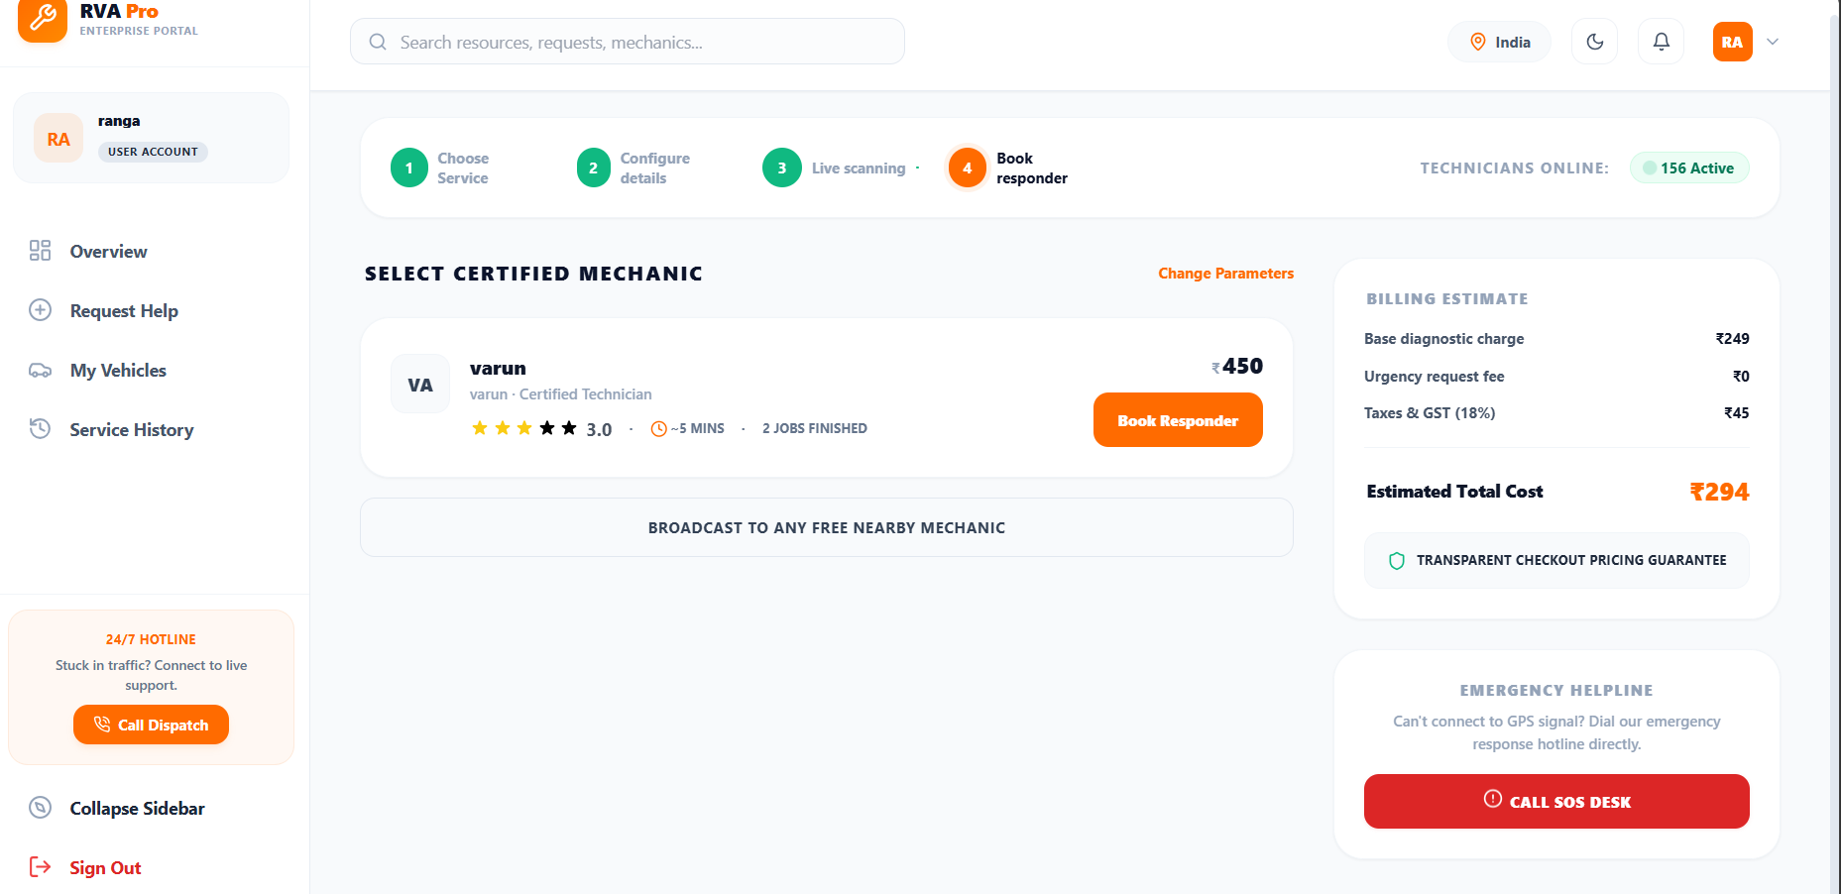

8.7 Live Service Tracking
A real-time tracking view showing the current status of an active service request with a visual step indicator (pending → accepted → en route → arrived → in progress → completed). It displays the assigned mechanic's details, estimated arrival time, and the full status history timeline.
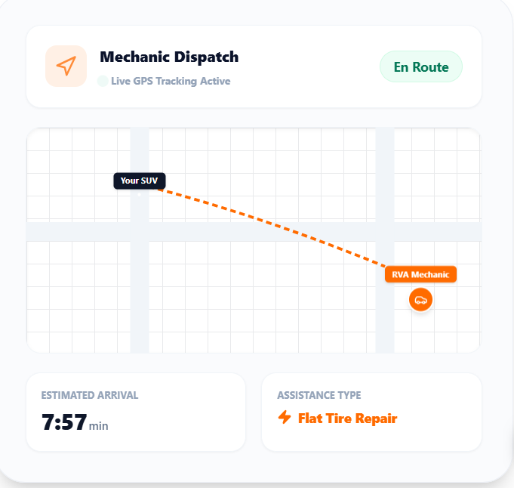

8.8 Service History
A paginated list of past service requests showing service type, date, status badge (color-coded), mechanic name, vehicle used, and price. Each record can be expanded to view full details. Completed services show the rating option if not yet rated.

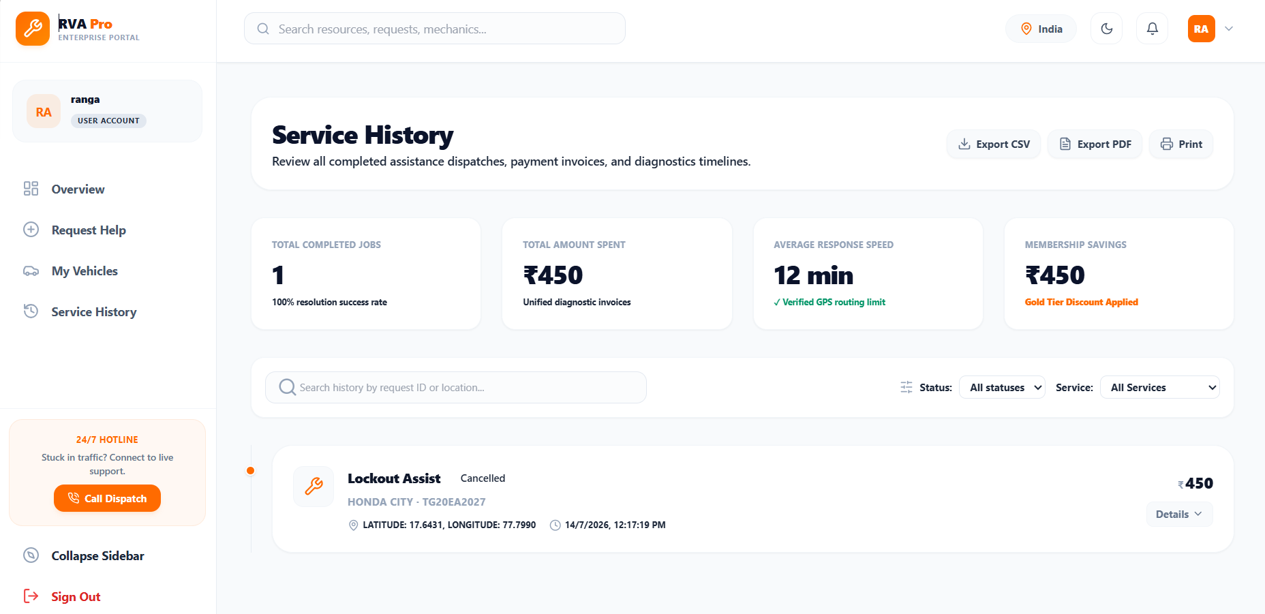8.9 Mechanic Dashboard
The mechanic dashboard shows active job stats, pending request count, and recent job cards. It includes quick links to view pending requests, update profile/pricing, check earnings, and update availability status.
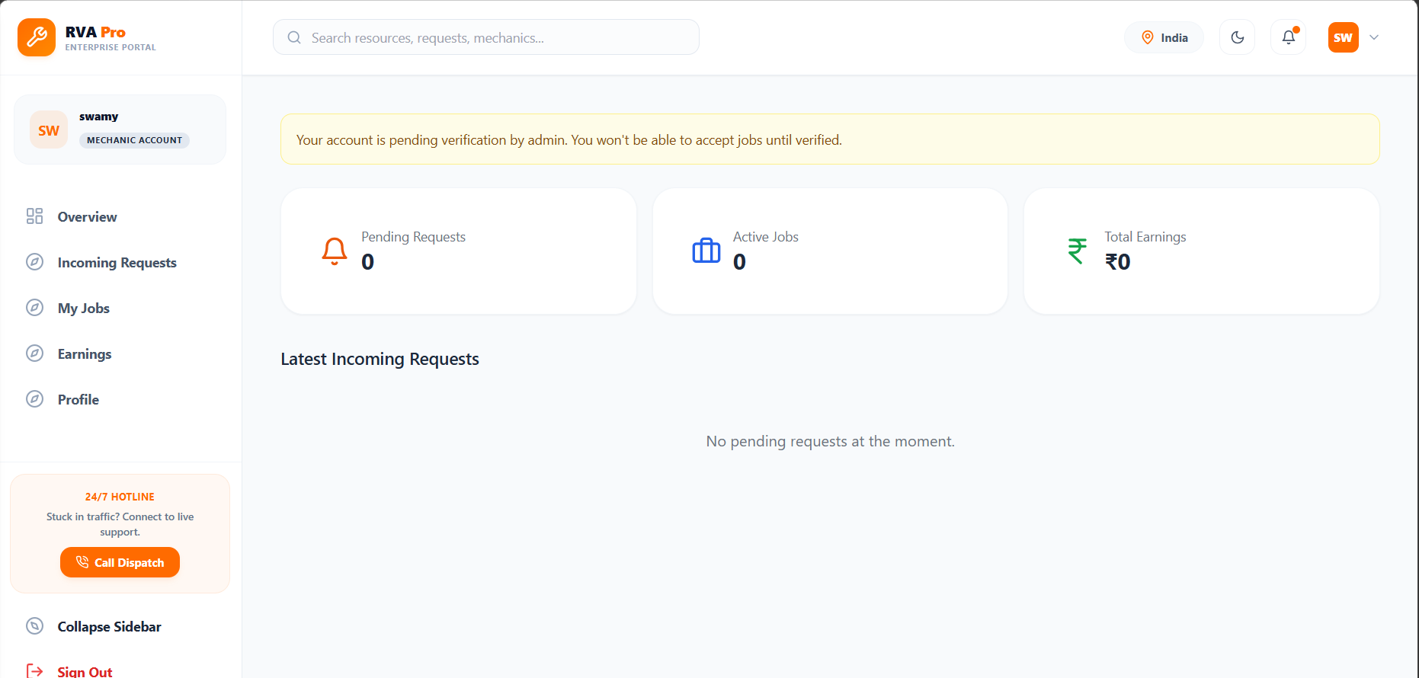

8.10 Mechanic Pending Requests
A list of all pending service requests from users, showing user name, vehicle details, service type, breakdown location address, and distance from the mechanic. Each card has an 'Accept' button to take on the job.

8.11 Mechanic Earnings
An earnings dashboard displaying total earnings, total completed jobs, and a list of recent completed jobs with individual earnings per job.

8.12 Admin KPI Dashboard
A comprehensive admin dashboard with KPI cards showing total users, verified mechanics, pending mechanic applications, active service requests, completed requests, average rating, and partner acceptance rate. Below the KPIs, a table lists the 10 most recent service requests.
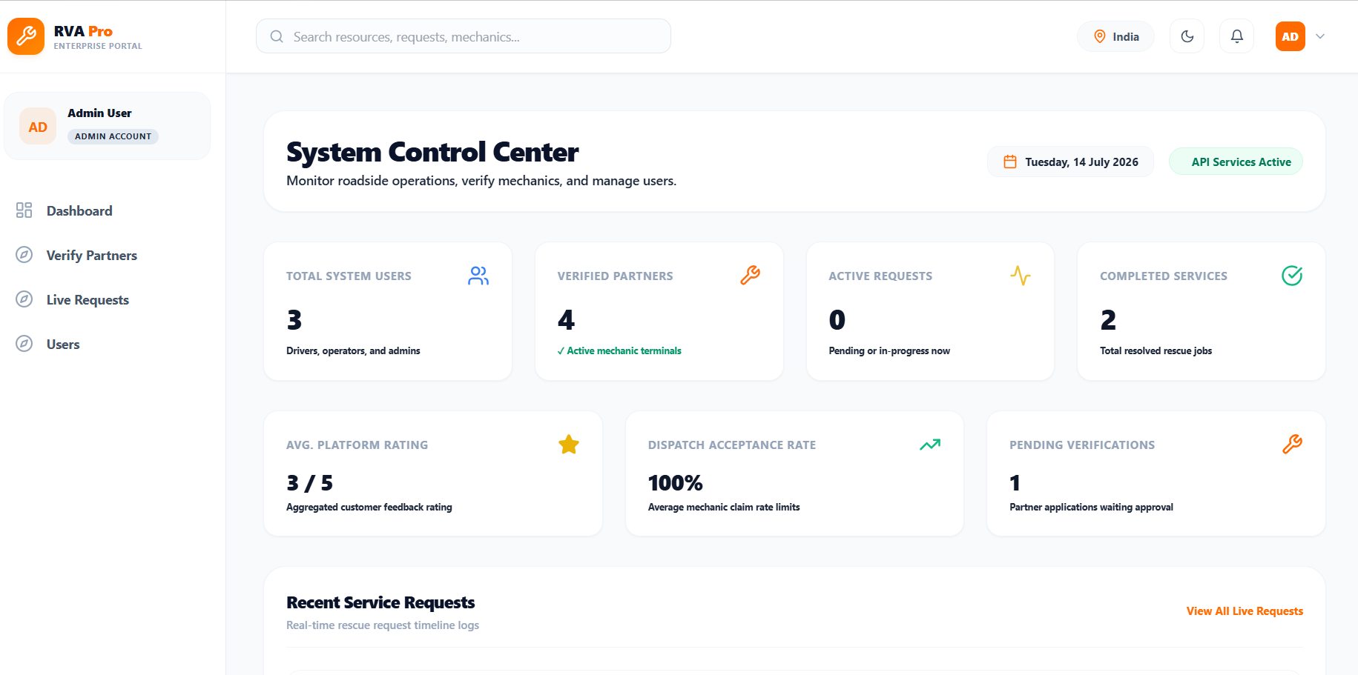

8.13 Admin Partner Verification
A list of pending mechanic applications with details including business name, license number, contact information, and experience. Each application has 'Approve' and 'Reject' buttons for admin action.

8.14 Admin Request Monitoring
A full list of all service requests on the platform with filtering and status information. Admins can view details and resolve/cancel disputed requests with admin notes.
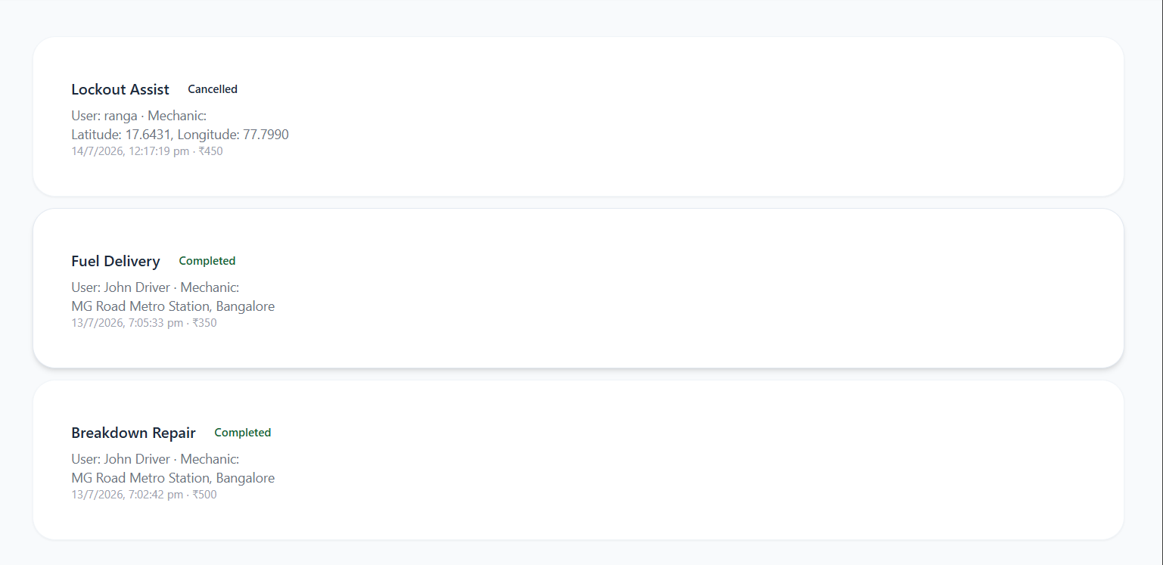
Chapter 9: Deployment

9.1 Deployment Architecture
Figure 9: Deployment Architecture
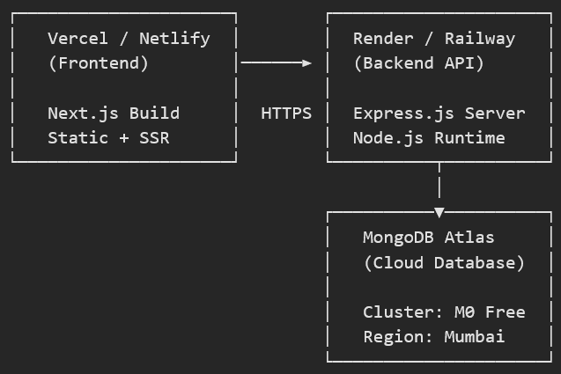

9.2 Deployment Steps

9.2.1 Backend Deployment (Render)
- Push code to GitHub repository
- Create a new Web Service on Render
- Connect the GitHub repository
- Set the build command: npm install --prefix backend
- Set the start command: node server.js
- Configure environment variables: MONGODB_URI, JWT_SECRET, NODE_ENV=production
- Deploy and verify the /api/health endpoint returns status: ok

9.2.2 Frontend Deployment (Vercel)
- Push code to GitHub repository
- Import the repository in Vercel
- Set the root directory to 'frontend'
- Configure the NEXT_PUBLIC_API_URL environment variable with the deployed backend URL
- Deploy and verify the application loads correctly

9.2.3 Database Setup (MongoDB Atlas)
- Create a MongoDB Atlas account and cluster (M0 free tier)
- Create a database user with read/write permissions
- Whitelist the backend server's IP address (or 0.0.0.0/0 for development)
- Copy the connection string to the backend's MONGODB_URI environment variable
- Run the seed script to populate demo data: npm run seed

9.3 Deployment Checklist
Step | Description | Status
1 | Set production JWT_SECRET (strong, unique value) | Required
2 | Configure MongoDB Atlas connection string | Required
3 | Deploy backend to Render/Railway/AWS | Required
4 | Set NEXT_PUBLIC_API_URL on frontend | Required
5 | Deploy frontend to Vercel/Netlify | Required
6 | Enable CORS for production domain on backend | Required
7 | Run seed script for initial demo data | Optional
8 | Configure custom domain names | Optional
9 | Set up monitoring and logging | Recommended

Chapter 10: Conclusion and Future Scope

10.1 Conclusion
The Roadside Vehicle Assistance & Mechanic Booking Platform has been successfully designed, developed, and tested as a comprehensive full-stack web application. The platform effectively addresses the real-world challenges faced by vehicle owners during breakdowns by providing an integrated digital solution that connects them with verified nearby mechanics and towing service providers.
The project demonstrates proficiency in modern web development technologies including Next.js 14 with React and TypeScript for the frontend, Node.js with Express.js for the backend REST API, and MongoDB with Mongoose for data persistence. Key technical achievements include the implementation of geospatial queries using the Haversine formula for nearby mechanic discovery, JWT-based authentication with role-based access control, a comprehensive service request lifecycle management system, and an admin dashboard with real-time KPI monitoring.
The platform supports three distinct user roles — vehicle owners, mechanics/towing partners, and administrators — each with a tailored dashboard experience. All 19 functional requirements identified in the analysis phase have been successfully implemented and tested. The application is responsive, production-ready, and deployable on modern cloud infrastructure.
This project has provided valuable hands-on experience in full-stack web development, database design, API architecture, authentication systems, geospatial computing, and modern UI/UX design principles.

10.2 Key Performance Indicators
KPI Metric | Description | Implementation
Total Service Requests | Count of all service requests on the platform | MongoDB countDocuments aggregation
Average Response Time | Mean ETA across all accepted requests | Computed from estimatedArrivalMinutes field
Service Completion Rate | Percentage of requests that reach "completed" status | Completed / Total requests ratio
User Satisfaction Rating | Average rating (1–5 stars) across all rated services | MongoDB $avg aggregation on rating field
Partner Acceptance Rate | Percentage of requests accepted by mechanics | Accepted / Total requests ratio

10.3 Future Enhancements (Phase 2+)
- Online Payment Integration: Integrate payment gateways (Razorpay, Stripe) for cashless transactions with automatic invoicing
- Mobile Application: Develop native iOS and Android apps with SOS button for one-tap emergency assistance
- Real-time Communication: Implement WebSocket-based real-time updates replacing polling, with push notifications
- AI-powered ETA: Use machine learning models trained on historical data for more accurate ETA predictions
- Insurance Integration: Partner with insurance companies for direct claim processing through the platform
- Spare Parts Ordering: Add spare parts catalog and ordering capability for mechanics
- Multi-language Support: Implement internationalization (i18n) for regional language support
- Advanced Analytics: Implement detailed analytics dashboards with charts, graphs, and predictive insights
- Driver Safety Features: SOS button, emergency contacts, breakdown history heatmaps
- Subscription Plans: Introduce monthly/annual membership plans for frequent users with discounted rates

10.4 Lessons Learned
- Full-stack architecture design with clear separation of concerns improves maintainability
- GeoJSON and 2dsphere indexes in MongoDB are powerful for location-based features
- JWT-based stateless authentication simplifies horizontal scaling
- TypeScript significantly reduces runtime errors and improves developer experience
- Role-based access control should be enforced on both frontend (routing) and backend (middleware)
- Polling-based updates are simpler to implement but WebSockets are more efficient for real-time features
- Seed data is essential for testing and demo purposes during development

Chapter 11: Bibliography
[1] Next.js Documentation — https://nextjs.org/docs — Vercel Inc., 2024.
[2] React Documentation — https://react.dev — Meta Platforms Inc., 2024.
[3] Express.js Documentation — https://expressjs.com — OpenJS Foundation, 2024.
[4] MongoDB Documentation — https://www.mongodb.com/docs — MongoDB Inc., 2024.
[5] Mongoose ODM Documentation — https://mongoosejs.com/docs — Automattic Inc., 2024.
[6] JSON Web Tokens (JWT) — https://jwt.io — Auth0 Inc., 2024.
[7] Tailwind CSS Documentation — https://tailwindcss.com/docs — Tailwind Labs Inc., 2024.
[8] Node.js Documentation — https://nodejs.org/docs — OpenJS Foundation, 2024.
[9] GeoJSON Specification (RFC 7946) — https://geojson.org — Internet Engineering Task Force, 2016.
[10] Haversine Formula — Sinnott, R.W., 'Virtues of the Haversine,' Sky and Telescope, Vol. 68, No. 2, p. 159, 1984.
[11] REST API Design Best Practices — https://restfulapi.net — REST API Tutorial, 2024.
[12] bcrypt.js — https://github.com/dcodeIO/bcrypt.js — Daniel Wirtz, 2024.
[13] Lucide Icons — https://lucide.dev — Lucide Contributors, 2024.
[14] TypeScript Documentation — https://www.typescriptlang.org/docs — Microsoft, 2024.
[15] MongoDB Atlas — https://www.mongodb.com/atlas — MongoDB Inc., 2024.
[16] Vercel Deployment — https://vercel.com/docs — Vercel Inc., 2024.
[17] Render Deployment — https://render.com/docs — Render Inc., 2024.

Appendix A: Setup and Installation Guide

A.1 Prerequisites
- Node.js 18 or higher (https://nodejs.org)
- MongoDB (local installation or MongoDB Atlas cloud account)
- Git for version control
- A modern web browser (Chrome, Firefox, Edge)
- Code editor (VS Code recommended)

A.2 Backend Setup
Terminal Commands — Backend
# Navigate to backend directory
cd backend

# Install dependencies
npm install

# Copy environment template
cp .env.example .env

# Edit .env with your MongoDB URI and JWT secret
# PORT=5000
# MONGODB_URI=mongodb://localhost:27017/roadside_assistance
# JWT_SECRET=your_strong_secret_key

# Load demo/seed data
npm run seed

# Start the development server
npm run dev
# Server starts at http://localhost:5000

A.3 Frontend Setup
Terminal Commands — Frontend
# Navigate to frontend directory
cd frontend

# Install dependencies
npm install

# Copy environment template
cp .env.local.example .env.local

# Edit .env.local
# NEXT_PUBLIC_API_URL=http://localhost:5000/api

# Start the development server
npm run dev
# Application starts at http://localhost:3000

A.4 Accessing the Application
Open a web browser and navigate to http://localhost:3000. Use the demo accounts listed in Chapter 7, Section 7.5 to log in with different roles and explore the platform features.

