Rapid prototyping and ASIC design M.S.V.VARUN

Assignment -3 K00379544

1. Please design a module and verify the usage of for loop in the Modelsim.

What is the values of a and b after the end loop? Please provide the vhdl code and screenshot of the simulation result.

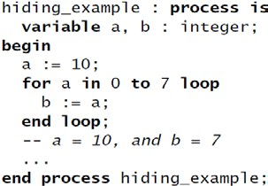

Ans 1)

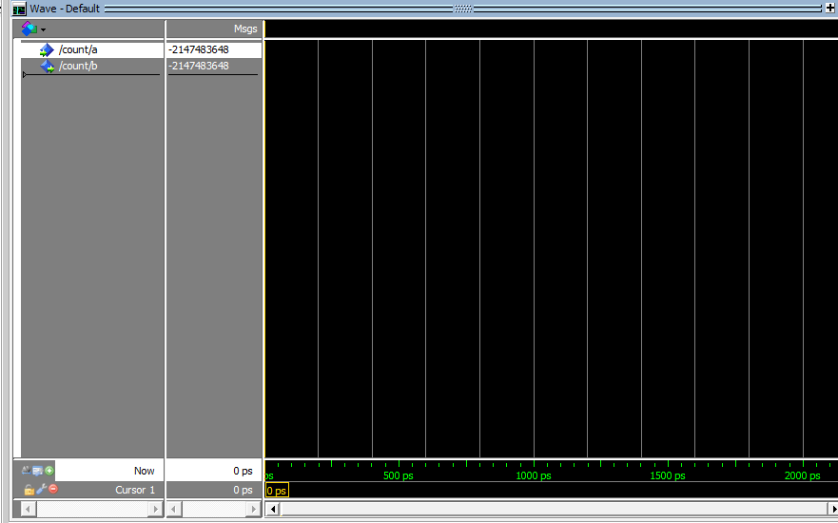

entity ct is

port ( a : in integer;

b : out integer );

end entity ct;

architecture fixed_length_series of ct is

begin

summation : process is

variable a : integer:=10;

variable b : integer;

begin

a:=10;

for a in 0 to 7 loop

b:=a;

wait;

end process summation;

end architecture fixed_length_series;

2. Please design a module and verify the usage of conditional variable assignment in the Modelsim.

Whether this conditional variable assignment can be used in the process? Please provide the vhdl code and screenshot of the simulation result.



Ans 2 )

--declaration

entity addsub is

port (a,b : in real;

mode : in string;

result : out real);

end entity addsub;

--architecture

architecture behav of addsub is

begin process is

begin

result:= a - b when mode = subtract else a + b;

end process ;

end architecture behav;

--test bench

entity test_addsub is

end entity test_addsub;

architecture behavioral of test_addsub is

signal a,b,result: real;

signal mode: string;

begin

ass: entity work.addsub(behav)

port map (a,b,result,mode);

abc : process is

begin

a<='5';

b<='2';

mode<='subtract';

wait for 20 ns;

end process abc;

end architecture behavioral;

--

** Error: E:/Study/TAMUK/TAMUK/2 SEM/ASIC/Modelsim/hw3p2.vhd(13): (vcom-1441) CONDITIONAL VARIABLE ASSIGNMENT is not defined for this version of the language.

3. Please design a module and verify the usage of selected variable assignment in the Modelsim.

Whether this selected variable assignment can be used in the process? Please provide the vhdl code and screenshot of the simulation result.

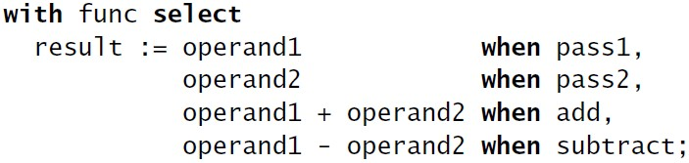

Ans 3)

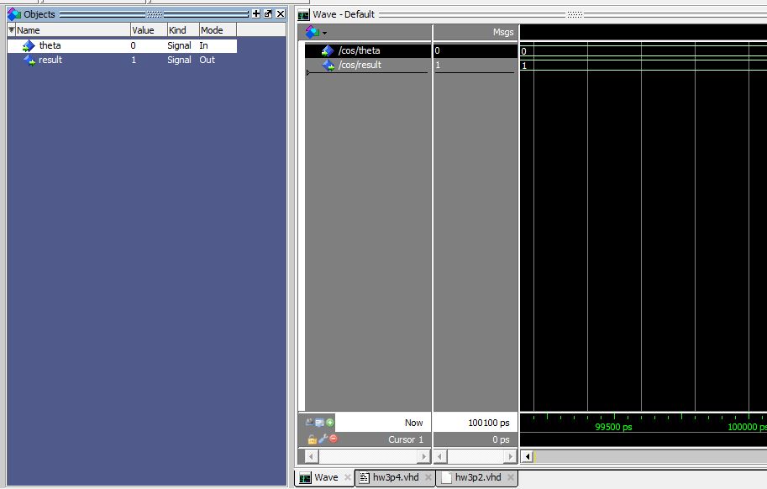library ieee;

use ieee.std_ulogic_1164.all;

entity hw3_1 is

port(

pass1, pass2, add, subtract: in string;

result: out real);

end entity hw3_1;

architecture behavioral of hw3_1 is

begin

Proc_hw3_1: process is

variable operand1: real;

variable operand2: real;

begin

with func select

result:= operand1 when pass1,

operand2 when pass2,

operand1+operand2 when add,

operand1-operand2 when subtract;

end process Proc_hw3_1;

end architecture behavioral;

--

* Error: C:/altera/13.0sp1/HW3_1VarAs.vhd(17): Signal "result" cannot be target of variable assignment statement.

`

4. Please design a module and verify the usage of for loop in the Modelsim.

Whether n should be defined as a variable or constant? Please provide the vhdl code and screenshot of the simulation result.

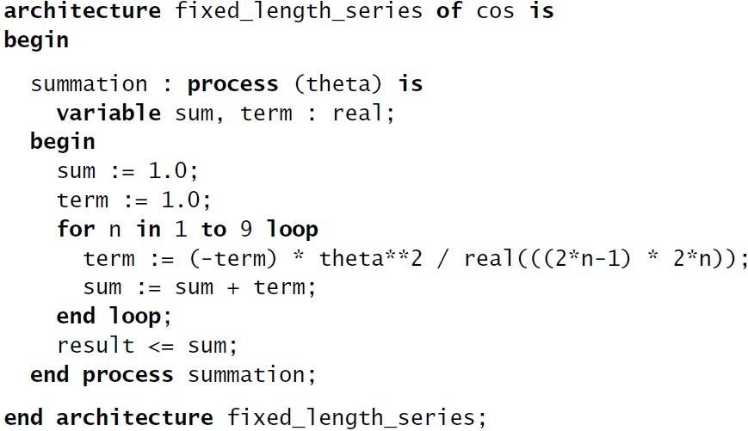

Ans 4)

entity cos is

port ( theta : in real; result : out real );

end entity cos;

architecture fixed_length_series of cos is

begin

summation : process (theta) is

variable sum, term, n : real;

begin

sum := 1.0;

term := 1.0;

for n in 1 to 9 loop

term := (-term) * theta**2 / real(((2*n-1) * 2*n));

sum := sum + term;

end loop;

result <= sum;

end process summation;

end architecture fixed_length_series;