# **Labfinder UI Documentation - Varun Mokarala**

## **1. Home Page (URL**: http://localhost:3000/)

* **Description**: This is the main landing page of the Labfinder application. It serves as the entry point for users, offering navigation options to other parts of the application.

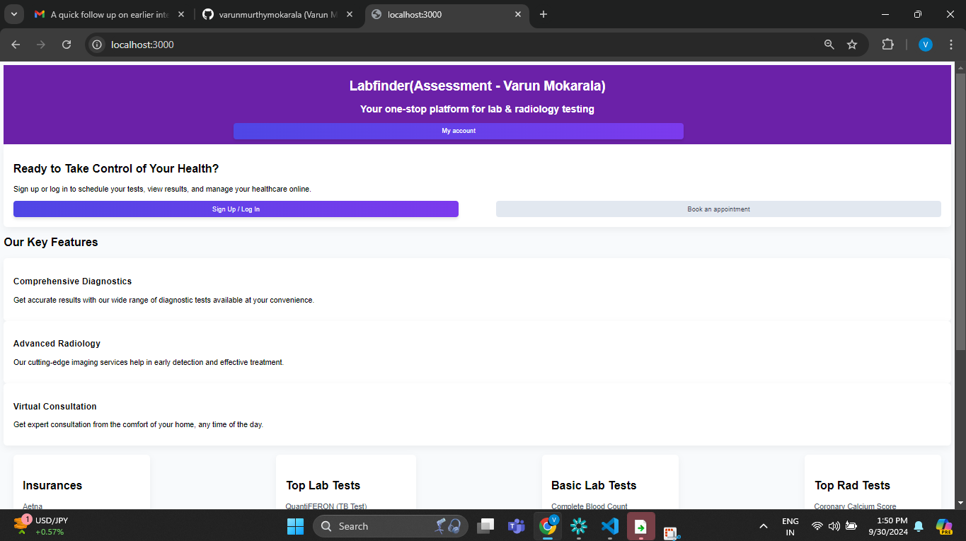

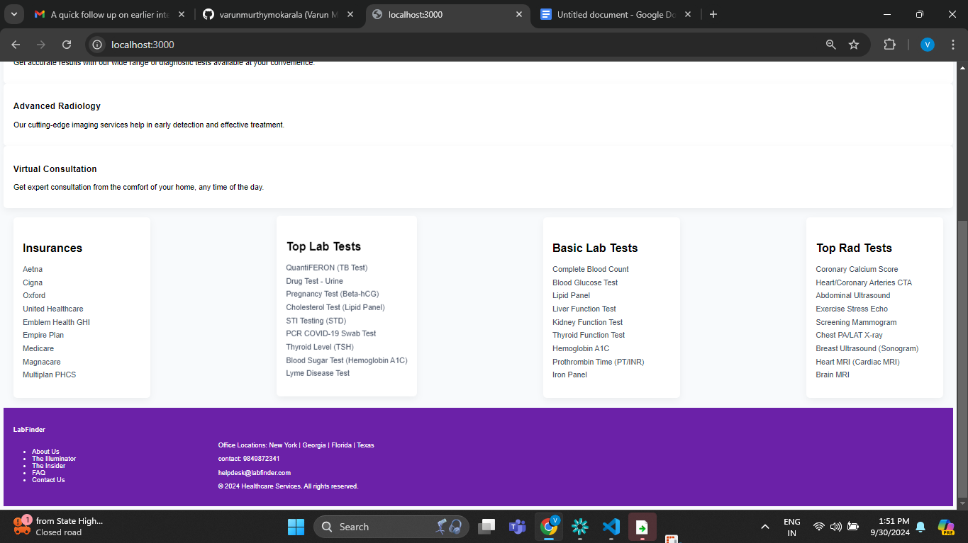

### **2.1 Login Page URL: http://localhost:3000/login**

* **Purpose**: Allows existing users to log in using their credentials.
* **Elements**:
  + Username/Email Field: Input box for the user’s email or username.
  + Password Field: Password input box.
  + Login Button: Submits the form and authenticates the user.

### **2.2 Register Option**

* **Elements**:
  + Register Button: Redirects to the registration page.

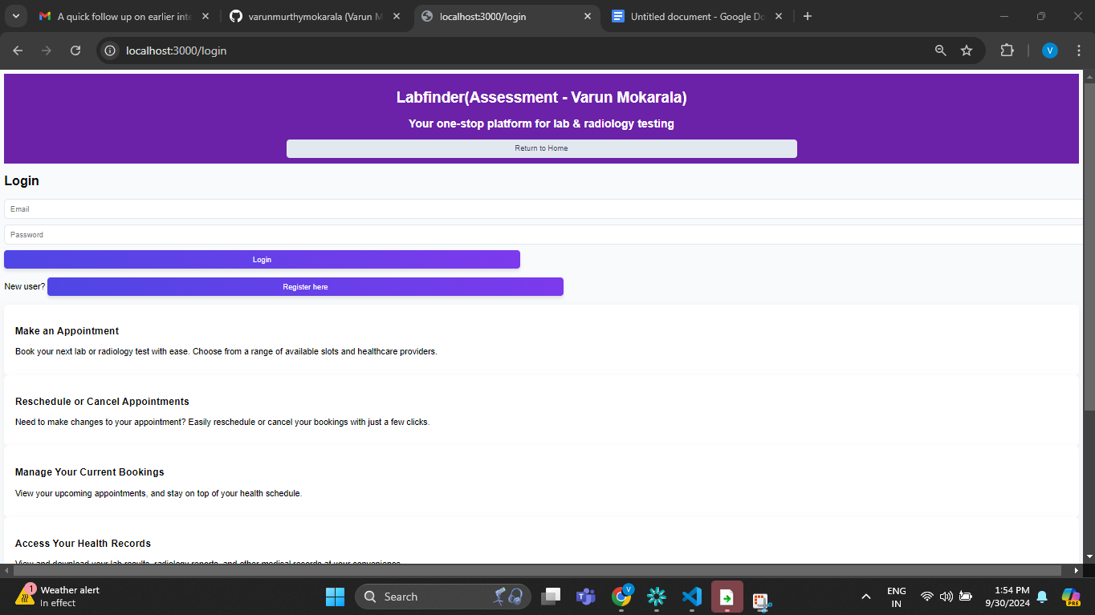

### **3.1 Providers List Section URL: http://localhost:3000/providersInfo**

* **Purpose**: Lists all available providers in a structured format.
* **Elements**:
  + Provider Cards: Each card contains the provider’s name, address, and contact information.

### **3.2 Provider Details Section**

* **Purpose**: Displays detailed information for a selected provider.

3.1

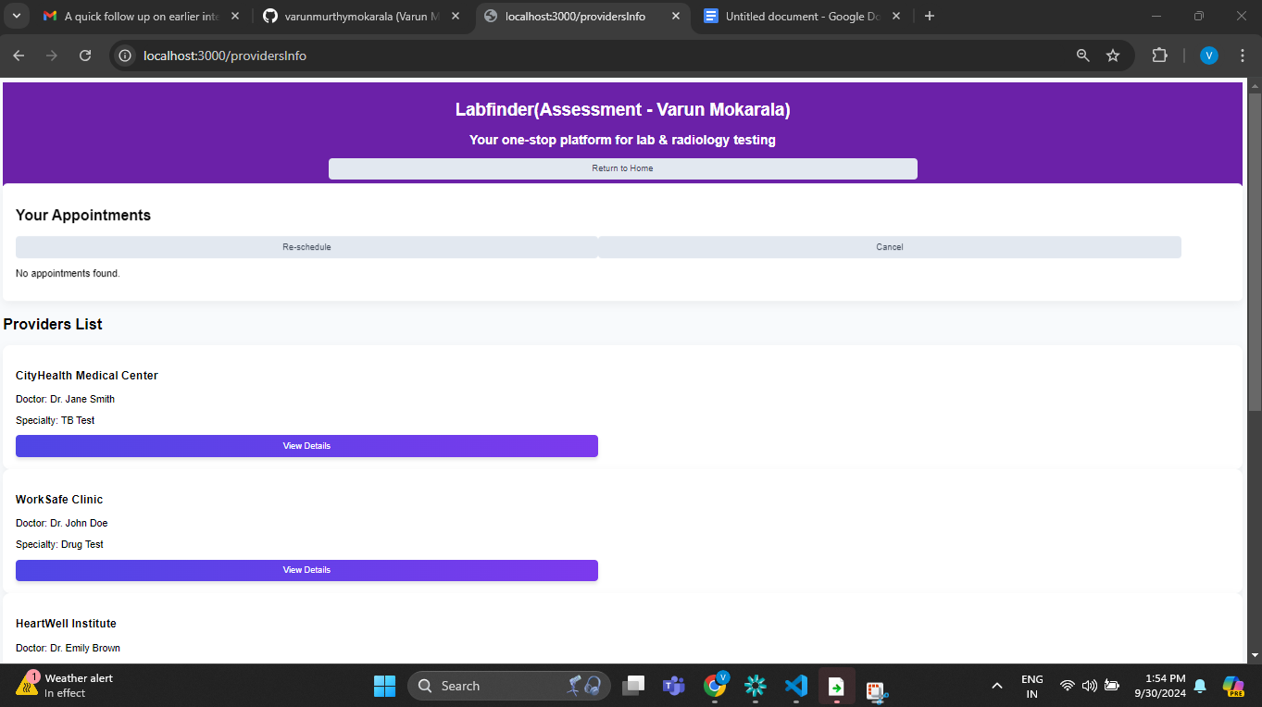

3.2

