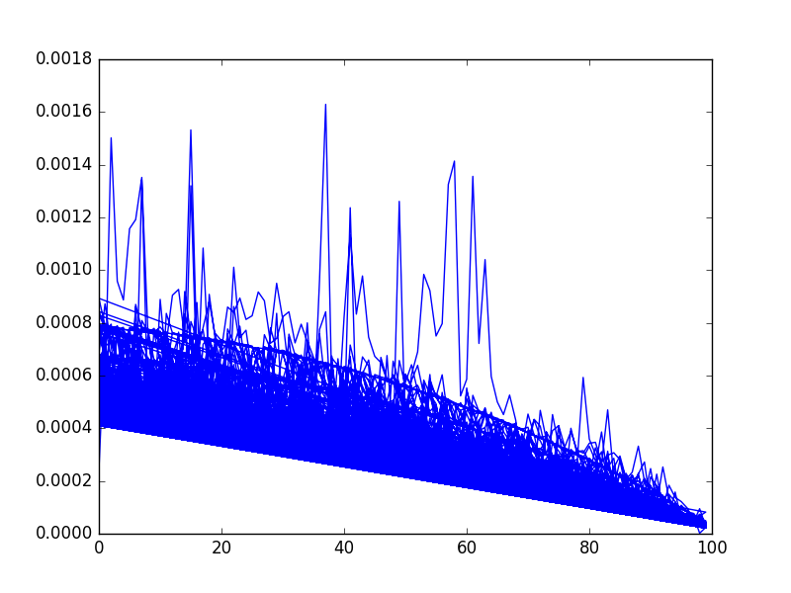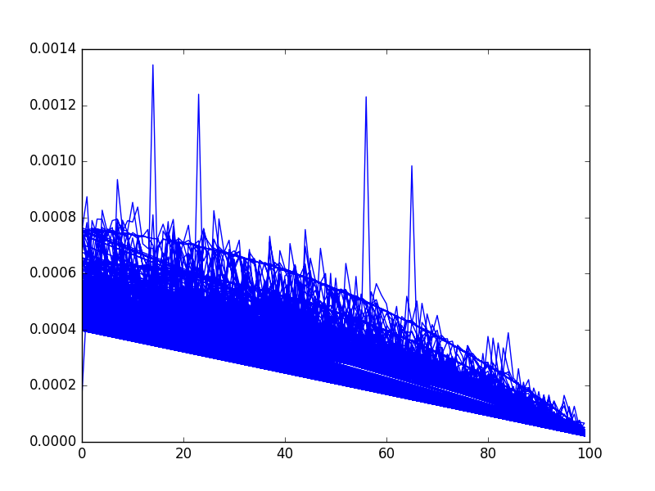

import random

import matplotlib.pyplot as plt

import numpy as np

import time

def insertionSort(alist,start,end):

#for index in range(1,len(alist)):

for index in range(start+1,end):

currentvalue = alist[index]

position = index

while position>0 and alist[position-1]>currentvalue:

alist[position]=alist[position-1]

position = position-1

alist[position]=currentvalue

def quickSort2(alist,k):

quickSortHelper2(alist,0,len(alist)-1,k)

def quickSort1(alist,k):

quickSortHelper(alist,0,len(alist)-1,k)

def quickSortHelper(alist,first,last,k):

if first<last:

if last - first < k:

insertionSort(alist,first,last+1)

else:

splitpoint = partition(alist,first,last)

quickSortHelper(alist,first,splitpoint-1,k)

quickSortHelper(alist,splitpoint+1,last,k)

def quickSortHelper2(alist,first,last,k):

if first<last:

if last - first < k:

return

else:

splitpoint = partition(alist,first,last)

quickSortHelper2(alist,first,splitpoint-1,k)

quickSortHelper2(alist,splitpoint+1,last,k)

def partition(alist,first,last):

pivotvalue = alist[first]

leftmark = first+1

rightmark = last

done = False

while not done:

while leftmark <= rightmark and alist[leftmark] <= pivotvalue:

leftmark = leftmark + 1

while alist[rightmark] >= pivotvalue and rightmark >= leftmark:

rightmark = rightmark -1

if rightmark < leftmark:

done = True

else:

temp = alist[leftmark]

alist[leftmark] = alist[rightmark]

alist[rightmark] = temp

temp = alist[first]

alist[first] = alist[rightmark]

alist[rightmark] = temp

return rightmark

#k = 4

alist = random.sample(xrange(1000), 100)

alist2 = alist

#x_axis = list(range(1,100))

x_axis = []

y_axis = []

x_axis2 = []

y_axis2 = []

'''

for i in range(1,1000):

for k in xrange(100):

x_axis.append(k)

start = time.time()

quickSort1(alist,k)

overhead = time.time() - start

y_axis.append(overhead)

'''

for i in range(1,1000):

for k in xrange(100):

x_axis2.append(k)

start = time.time()

quickSort2(alist,k)

insertionSort(alist2,0,len(alist2))

overhead = time.time() - start

y_axis2.append(overhead)

print(x_axis2)

print(y_axis2)

plt.plot(x_axis2,y_axis2)

#plt.plot(x_axis,y_axis)

plt.show()