**Lab4 Report**

**Running Mahout Application:**

We have got movie recommendation data which consists of two files var.dat and movie.info files.

Var.dat file contains data of 100 users and the movies id they have watched.

Movie.info file contains the movie id and its name.

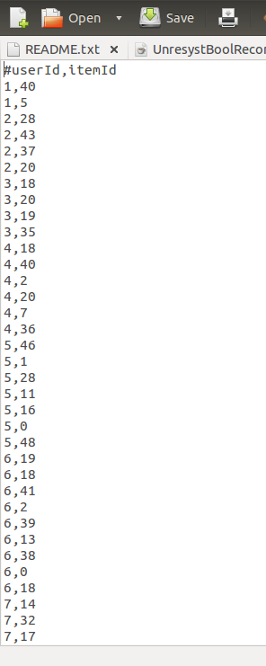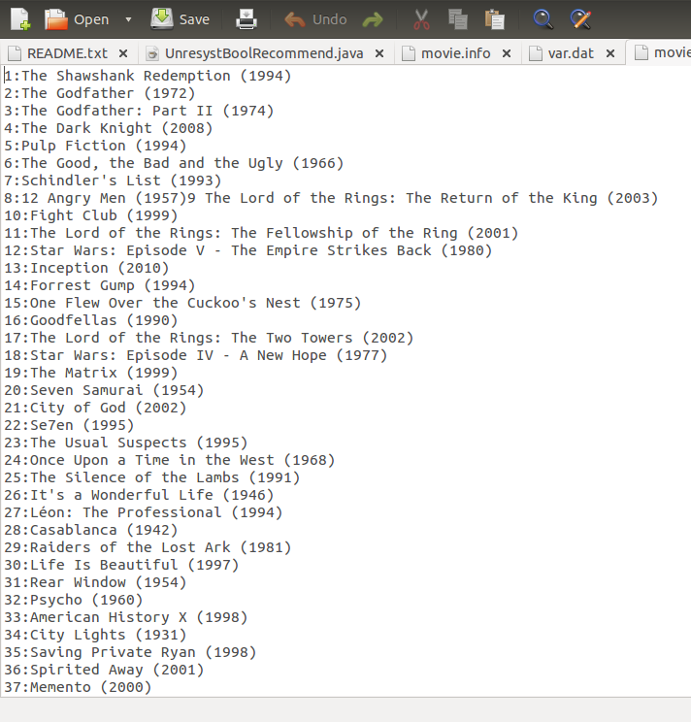

I have modified the recommendation algorithm from tutorial 8 and run mahout application

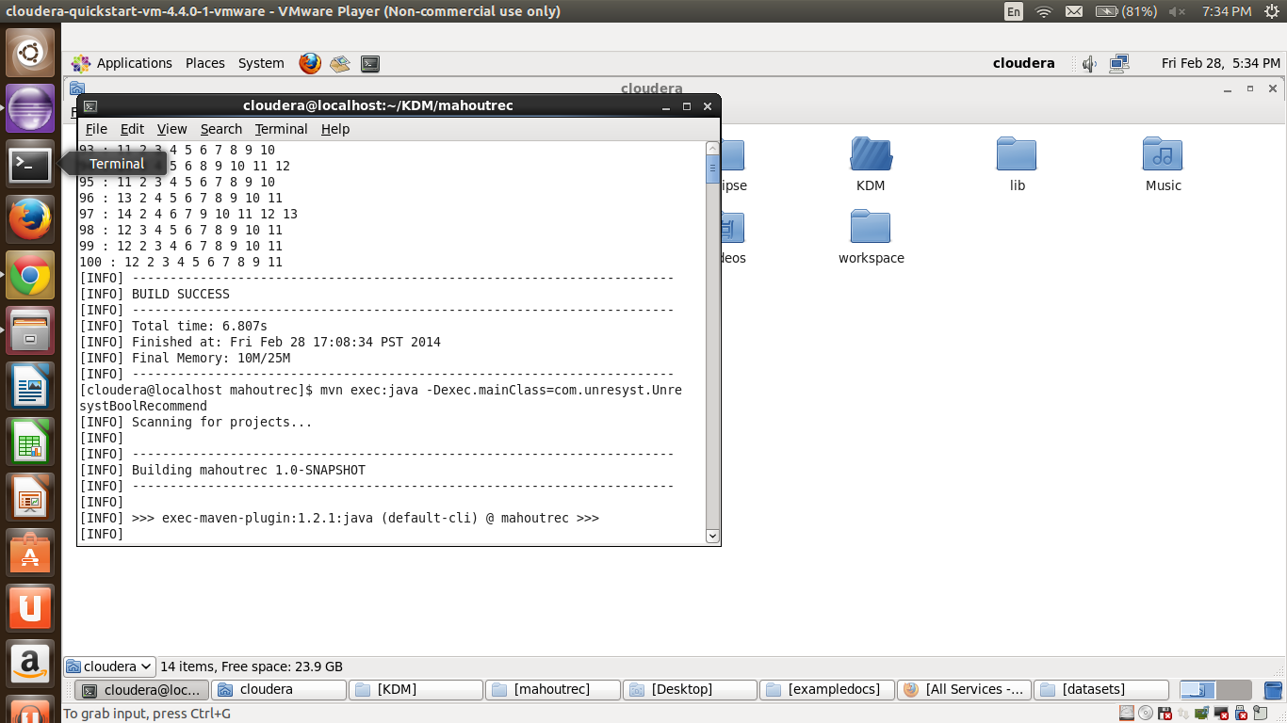

After running mahout application using mvn we store the result to a file

which has list of users and its recommended movies list.

**Pushing Data to Solr:**

After successfully running recommendation algorithm on movie data I have pushed the result of recommendations to solr using curl cmd

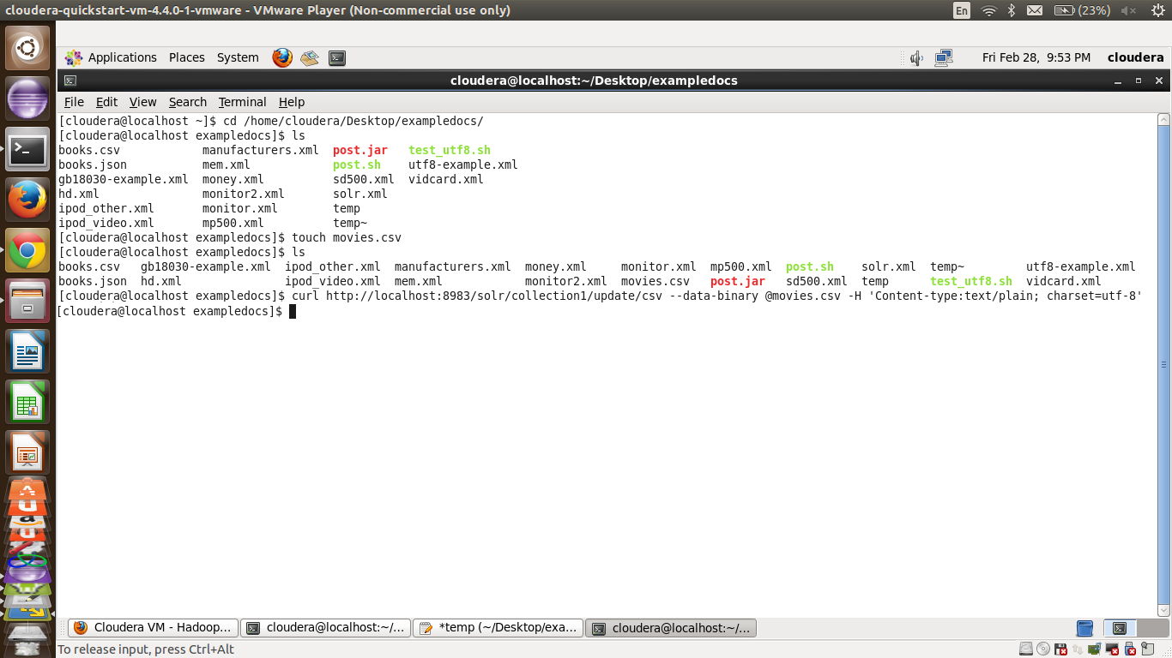

**Creating Android Application:**

I have created an Android application which contains two screens first screen has a list of all users

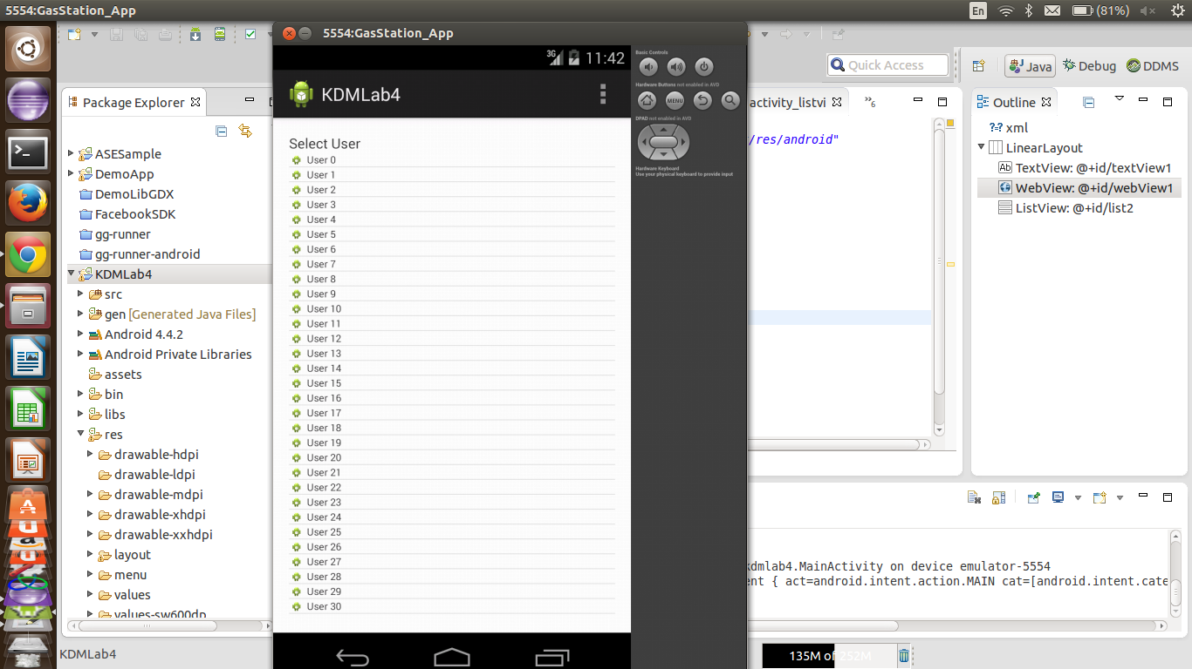

on clicking of any user we will call the solr rest webservices and get the results and show the results in next screen.

