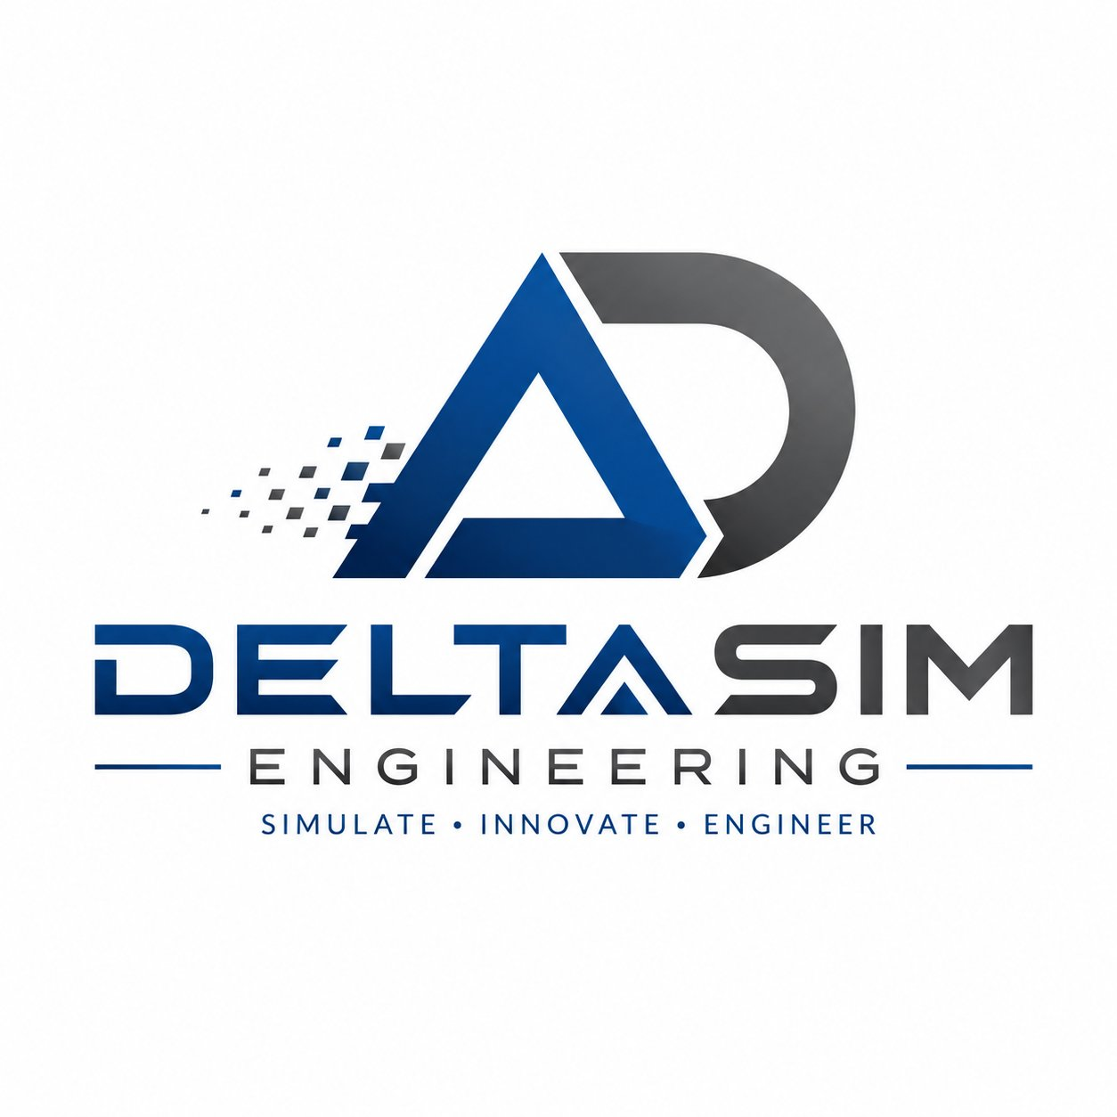

DELTASIM ENGINEERING
SIMULATE • INNOVATE • ENGINEER

COMPANY PROFILE & CAPABILITIES DOCUMENT
Mechanical Design | Simulation | Prototyping | Optimization

Confidential — For Client Use Only | 2025

1. EXECUTIVE OVERVIEW

DeltaSim Engineering is a forward-thinking engineering solutions firm dedicated to delivering precision-driven, end-to-end mechanical engineering services. Anchored by the philosophy of Simulate · Innovate · Engineer, the company combines advanced computational tools with hands-on engineering expertise to help clients bring high-performance products to market faster, smarter, and with greater confidence.

From early-stage concept design through detailed analysis, prototyping, and production optimization, DeltaSim Engineering serves as a trusted technical partner across industries including aerospace, automotive, industrial equipment, consumer products, and energy. The firm's multidisciplinary team leverages world-class Computer-Aided Engineering (CAE) platforms to reduce development costs, minimize risk, and accelerate innovation cycles.

500+  Projects Completed | 15+  Industries Served | 98%  Client Satisfaction | 10+  Years Experience

2. COMPANY BACKGROUND & MISSION

Our Story
DeltaSim Engineering was founded by a team of mechanical engineers and simulation specialists who shared a common vision: to bridge the gap between theoretical engineering models and real-world, manufacturable products. Recognizing that most product failures can be predicted and prevented through rigorous simulation and analysis, the founders built DeltaSim around a culture of precision, accountability, and continuous innovation.

Mission Statement
"To empower organizations with cutting-edge engineering simulation, innovative mechanical design, and rigorous analytical expertise — enabling them to build better products, solve complex challenges, and achieve breakthrough performance outcomes."

Core Values
- Precision — Every design, model, and analysis is executed to the highest standard of engineering accuracy.
- Innovation — We continuously explore new methodologies and technologies to stay ahead of industry demands.
- Integrity — Transparent communication, realistic deliverables, and honest technical guidance in all engagements.
- Collaboration — We work as an extension of our clients' teams, aligning deeply with their goals and timelines.
- Excellence — Commitment to quality at every stage of the project lifecycle, from scoping to final delivery.

3. CORE SERVICE OFFERINGS

DeltaSim Engineering provides a comprehensive suite of mechanical engineering services designed to cover every phase of product development. The following table outlines our key competencies:

Service Area | Description / Capabilities
Mechanical Design | 3D CAD modeling, assembly design, GD&T, tolerance stack-up analysis, design for manufacturability (DFM), and design for assembly (DFA) using CATIA, SolidWorks, and NX.
Structural Analysis (FEA) | Linear and nonlinear finite element analysis for static, dynamic, fatigue, and fracture assessments using ANSYS Mechanical and Abaqus.
Computational Fluid Dynamics | Internal/external flow analysis, thermal management, aerodynamic optimization, and conjugate heat transfer simulations using ANSYS Fluent and OpenFOAM.
Thermal Analysis | Steady-state and transient thermal studies, heat dissipation modeling, thermal stress analysis, and electronic cooling optimization.
Multi-Body Dynamics | Kinematic and dynamic simulation of mechanisms, linkages, and assemblies using Adams and RecurDyn to predict loads, motion, and performance.
Topology & Design Optimization | Weight reduction, topology optimization, parametric design of experiments (DOE), and response surface methodology to maximize structural efficiency.
Prototyping Support | Engineering support for rapid prototyping, additive manufacturing, CNC machining specifications, and prototype validation test planning.
Failure Analysis & Troubleshooting | Root-cause analysis of mechanical failures, fatigue crack propagation studies, warranty investigation support, and corrective design recommendations.
Product Validation & Testing | Development of test plans, instrumentation guidance, correlation of simulation models to physical test data, and regulatory compliance support.

4. INDUSTRIES SERVED

DeltaSim Engineering's expertise spans a wide range of sectors, enabling clients to benefit from cross-industry insights and proven simulation methodologies adapted to their unique engineering environments:

- Aerospace & Defence — Structural integrity, fatigue life, aeroelasticity, and thermal protection systems.
- Automotive & Transportation — Crashworthiness, NVH analysis, powertrain components, and lightweighting solutions.
- Industrial Machinery & Equipment — Rotating machinery, pressure vessels, conveyor systems, and heavy equipment design.
- Energy & Power Generation — Turbine components, pipeline stress analysis, heat exchangers, and wind/solar structures.
- Medical Devices — Implant biomechanics, device stress analysis, fatigue under cyclic loading, and FDA submission support.
- Consumer Products & Electronics — Structural durability, drop testing simulation, thermal management, and packaging.
- Oil & Gas — Subsea equipment, riser systems, pressure vessel integrity, and corrosion-fatigue analysis.
- Construction & Civil Infrastructure — Structural steel connections, composite structures, and vibration analysis.

5. CAE TOOLS & TECHNOLOGIES

DeltaSim Engineering maintains proficiency in an extensive portfolio of industry-leading simulation and design tools, ensuring our team can meet client requirements across a broad spectrum of engineering domains:

CAD & Design | FEA / Structural | CFD / Thermal | Optimization
• SolidWorks  • CATIA V5/V6  • Siemens NX  • AutoCAD  • Creo Parametric | • ANSYS Mechanical  • Abaqus FEA  • NASTRAN  • HyperMesh  • LS-DYNA | • ANSYS Fluent  • OpenFOAM  • Star-CCM+  • ANSYS CFX  • Icepak | • ANSYS Workbench  • OptiStruct  • modeFRONTIER  • MATLAB/Python  • Adams MBD

6. PROJECT DELIVERY METHODOLOGY

DeltaSim Engineering follows a structured, phase-gated project management methodology that ensures consistent quality, schedule adherence, and client alignment at every stage of an engagement:

Phase 1 — Discovery & Scoping
We begin every engagement with a thorough technical discovery process. Our engineers review client requirements, existing designs, boundary conditions, and performance targets to define a detailed project scope, deliverables list, and timeline.
Phase 2 — Geometry & Model Preparation
CAD geometry is reviewed, cleaned, and adapted for simulation. Meshing strategies are defined and validated to balance computational efficiency with result accuracy. Material properties and loading conditions are documented and agreed upon with the client.
Phase 3 — Simulation & Analysis
Simulations are executed according to the agreed methodology. Intermediate results are reviewed internally for quality assurance before any client-facing reporting. Sensitivity studies are conducted where applicable to quantify the influence of key input parameters.
Phase 4 — Post-Processing & Reporting
Results are systematically post-processed and communicated through detailed engineering reports including contour plots, graphs, tables, and executive summaries. Reports are authored to support both technical reviewers and executive stakeholders.
Phase 5 — Design Recommendations & Iteration
Engineering insights are translated into actionable design recommendations. Where required, design iterations are conducted in close collaboration with client engineering teams to converge on optimized, validated solutions.
Phase 6 — Delivery & Knowledge Transfer
Final deliverables — including simulation models, reports, and design data — are formally handed over to the client. Knowledge transfer sessions are conducted to ensure client teams can build on the work independently.

7. WHY CHOOSE DELTASIM ENGINEERING

- End-to-End Capability — A single partner for design, simulation, optimization, and validation reduces coordination overhead and accelerates timelines.
- Domain Depth — Our engineers carry advanced degrees and decades of hands-on experience in specific engineering domains, not generalists.
- Software-Agnostic Approach — We select the best tool for each problem, rather than being constrained to a single software platform.
- Scalable Engagement Models — From short-duration task orders to multi-year embedded partnerships, we adapt to client engagement needs.
- Confidentiality & IP Protection — Robust NDAs, data security protocols, and professional discretion are standard on every engagement.
- Rapid Mobilization — Project initiation within 5 business days of scope confirmation, with dedicated project leads assigned from day one.
- Results-Oriented Culture — Every analysis is performed with a focus on actionable engineering conclusions, not just data generation.
- Industry-Standard Reporting — Reports comply with applicable engineering standards (ASME, ISO, FEA best practice guidelines).

8. CONTACT & ENGAGEMENT

To discuss your engineering challenge, request a proposal, or schedule a technical consultation, please reach out through the following channels:

Company | DeltaSim Engineering
Services | Mechanical Design, CAE Simulation, Prototyping & Optimization
Website | www.deltasimengineering.com
Email | info@deltasimengineering.com
Phone | +91-7889231302
LinkedIn

DeltaSim Engineering — Precision at the Core of Every Design

© 2025 DeltaSim Engineering. All Rights Reserved. This document is confidential and intended for authorized recipients only.

