|  |
| --- |
| *\\samba1\vpandey\dcengr\Desktop\School_of_Engineering_Red_Logo.jpgCOEN 379: Advanced DesIGN & ANALYSIS OF ALGORITHM* |
| *Project* |
| *Rabin \_ Karp Fingerprint : A randomized approach to Pattern Matching problem* |
|  |
| ***Aaraadhya Nara, Himanshu Gupta & Varun Pandey*** |
| ***5/10/2015*** |

|  |
| --- |
| ***The project documentation contains following sub-sections: -*** |
| 1. C:\Users\Varun\Downloads\qr_code(1)\qr_code_without_logo.jpg*Universe outside Rabin Karp* 2. *Details of Rabin-Karp Algorithms* 3. *Mathematical Analysis* 4. *References* |

**Some Important Notations**

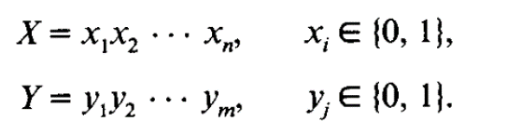

n <= m

Hp(X) = ap(r) = ϕ p(X(r)) = H(X) mod p

Hp(Y) = bp(r) = ϕ p(Y(r)) = H(Y) mod p

S = {p | p is prime and p <= M} in the range [1, M]

π (u) denotes the number of primes <= 2u



**Universe Outside Rabin Karp Algorithm: -**

Three Algos: -

1. Naïve Algorithm
2. KMP
3. Boyers et. al.

* Comparison based deterministic algorithms
* Requires preprocessing except Naive Algorithm
* Stores portions of text Y in main memory
* Offline Algorithms
* Require O(n) registers to store table of pointers
* Same theoretical time bounds as the previous algorithms, but fewer number of registers
* Simple and conceptually easy to program
* Better than previous algorithms for long patterns.
* Applicable to patterns involving multi-dimensional rectangular array of symbols or even irregularly shaped arrangements of symbol
* Faster because randomized algorithm

**Rabin Karp Algorithm: -**

* Convert the String Comparison to an Arithmetic problem.
* Convert the pattern(X) of length n and Text of length(y) into Binary strings.
* Calculate the integer value and then compare the integers.

Stream of Text

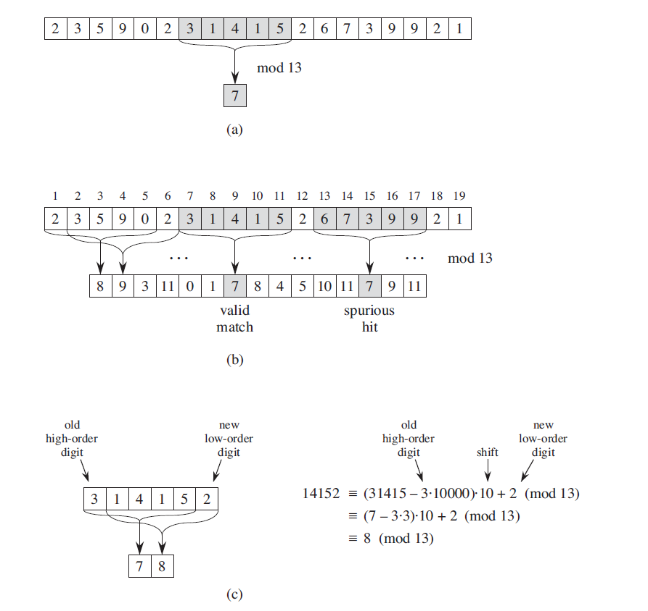

31415

Pattern to search

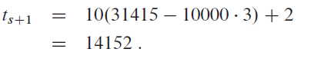

|  |  |  |
| --- | --- | --- |
| Algorithm 1 | Algorithm 2 | Algorithm 3 |
| * Online * Uses k Randomly generated primes at a time | * Not Online * Not Requires one to one pattern checking on HIT * Considers only 1 prime | * Not Online * Not Requires one to one pattern checking on HIT * Considers a new prime every time we get a bad seed |

**Mathematical Analysis**

Expected Number of Trials to get the prime is ln M. The time to perform each primality test is O ((log M) 2) if we use Solovay and Strassen.

**Lemma 1:**

$$If u≥ 29, then the product of the primes≤ u is > 2^{u}$$

Proof: - Rosser and Schoenfeld in their paper stated that the

$$\prod_{p =all prime < u}{p}≥e^{(u-2.05282\sqrt{u})}$$

$$Equating this to 2^{u} and by taking log at both sides, we get u \sim 44$$

**Corollary 1:**

$$If u ≥29 and a ≤2^{u},then a has fewer than π(u) different prime divisor$$

$$Proof: - \\ Can be proven by contradiction. Let’s try a different approach \\ Let’s assume a has \left\{ q_{1}q_{2}q_{3}q_{4}. . . . q_{r} \right\} prime divisors. \\ The product of all prime divisors a≥2^{r}. But since a≤2^{u}, r <u and thus, a must have lesser than π(u) prime divisors.$$

In short, we are saying here that if we can upper bound a power of 2 say u, then the number can have at most u - 1 prime divisors. We will use this later to proofs by counting the number of possible prime divisors

$$Lemma 2$$

$$– By Rosser et. al.$$

$$For u ≥17,$$

$$\frac{u}{\ln{u}} ≤π\left(u\right)< 1.25506 \frac{u}{\ln{u}}$$

**Central Theorem:**

Remember, we have a bucket of Primes and you have to pick bad primes

$$If Algorithm 2 or Algorithm 3 is executed with S =\left(p \right|p≤ M and p prime), then, for every instance\{ ( X(r), Y(r)) ,r ϵ R\}, \\ the probability that a false match occurs is$$

$$≤\frac{π\left(nt\right)}{π\left(M\right)} provided nt≥ 29.$$

For a **fixed $\{( X(r), Y(r)) ,$ $r ϵ R\},$**  a single false can occur if –

$H_{p}(X_{(r)}) = H_{p}(Y_{(r)})$

$But, X_{(r)} ≠ Y_{(r)}$

This also means that,

**p |**

Literally translated to “p completely divides the quantity $H_{p}\left(X_{\left(r\right)}\right)- H_{p}(Y_{(r)})$”

So, for 1 run of algorithm, for a single false match,

$$p | \prod_{r | X_{(r)} ≠ Y_{(r)}}{|H_{p}\left(X_{\left(r\right)}\right)- H_{p}(Y_{(r)})|}$$

For each r, $\left|H_{p}\left(X_{\left(r\right)}\right)- H_{p}\left(Y_{\left(r\right)}\right)\right|< 2^{n}$ assuming that we are considering only binary alphabets. Max difference between the $H_{p}\left(X_{\left(r\right)}\right)= H_{p}\left(Y_{\left(r\right)}\right) could be no more than 2^{n}$

Cosnsidering t shifts and we have maximum difference possible on each iteration,

$$\prod_{r | X_{(r)} ≠ Y_{(r)}}{|H_{p}\left(X_{\left(r\right)}\right)- H_{p}(Y_{(r)})|}< 2^{nt}$$

By corollary 1, this product has < $π\left(nt\right)$ and it is for these primes will the false hit is expected. Total prime to choose from is at most $π\left(M\right)$. Therefore, the probability that false match will be –

$$P_{r}[False Hit]≤\frac{π\left(nt\right)}{π\left(M\right)} for nt, M>29$$

This proves for how many primes out of M, a false match could occur. It does NOT give any idea about the entire run of the algorithm

QED

**Extension of Central Theorem**

If Algo 1 is executed, the

$$P_{r}\left[False Hit\right]≤{\left[\frac{π\left(nt\right)}{π\left(M\right)}\right]}^{k}$$

Why? We are picking k random independent prime, so probability of false match is equal to

$P_{r}\left[False Hit\right]= \left(\frac{π\left(nt\right)}{π\left(M\right)}\right) \left(\frac{π\left(nt\right)}{π\left(M\right)}\right)\left(\frac{π\left(nt\right)}{π\left(M\right)}\right)…\left(\frac{π\left(nt\right)}{π\left(M\right)}\right)$… k times

YET! This wouldn’t provide the tight bound. Why? Because here we are considering that all of the primes resulted in false match. This may not happen – only 1 position out of t choices may have a false match. So probability that one of the hash is a false hit is

$\left|H_{p}\left(X_{\left(r\right)}\right)- H_{p}\left(Y_{\left(r\right)}\right)\right|< 2^{n}$,

**So, # of choice for prime dividing this value at every position of r is $π\left(n\right)$**

$$P_{r}\left[Single False Hit\right]≤ {\left[\frac{π\left(n\right)}{π\left(M\right)}\right]}^{k}$$

Therefore, the probability that one of the primes result in false match at every for one run of the algorithm is,

$P_{r}\left[False Hit\right]≤ {\left[\frac{π\left(n\right)}{π\left(M\right)}\right]}^{k}+ {\left[\frac{π\left(n\right)}{π\left(M\right)}\right]}^{k}+{\left[\frac{π\left(n\right)}{π\left(M\right)}\right]}^{k}+…+{\left[\frac{π\left(n\right)}{π\left(M\right)}\right]}^{k}$…t times

$$=t{\left[\frac{π\left(n\right)}{π\left(M\right)}\right]}^{k}$$

**What is a good value of M?**

1. Large enough
2. Must support register operation
3. Good balance
4. Must support the Ram Model

How about if we take $M = nt^{2}$

With choice of largest number, we can have overflow operation at ${({nt}^{2})}^{2}$ which requires $4(log h + log m)$ bits. This is in order of number of bits require to

Applying Lemma 2,

$$\frac{π\left(nt\right)}{π\left(nt^{2}\right)} ≤1.25506\frac{nt*ln\left(nt^{2}\right)}{nt^{2}* ln\left(nt\right)}= 1.25506\frac{1}{t}⟦\frac{ln\left(n\right)+2ln\left(t\right)}{ln\left(n\right)+ln\left(t\right)}⟧≤\frac{2.53}{t}$$

This is good because it gives us a good probability to work with, depending only upon the available number of shifts.

Example: - Consider n = 250, t = 4000, M = nt2 = 4x109 < 232. Then, for any p <= M, the bits required to store p is less than 32. So it can be stored in a register. Applying above formula, the probability of false match < 1000-1. For algo 1, if k = 4, Pr ≤ 2 x 10-22.

**Storage Requirement**

p is drawn from M ≤ nt2. So will require $<4\left(\log{n}+\log{t}\right) bits$

Following are the operations needed for RK.

* 4 Fetch
* 3 Add
* 3 Compare
* 2 Subtraction
* 1 store

Hash computation is in constant time from Hr-1 to Hr.

Algo 1 requires (4k + 2) Registers

Algo 2, 3 requires 6 Registers

**Why use a prime?** Cormen et. al. says in their book,

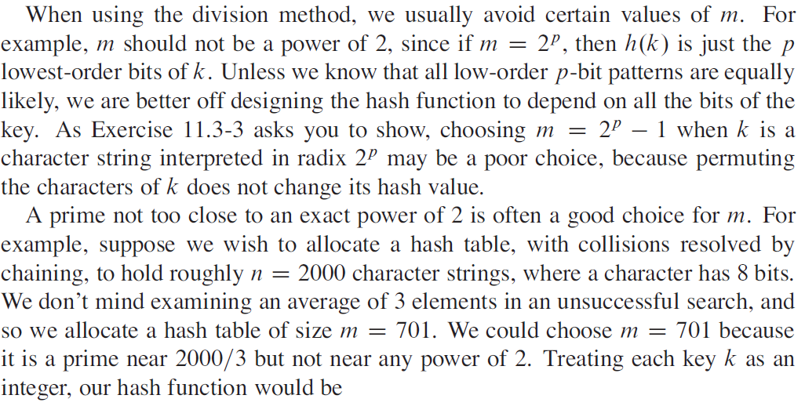

**Expected Time Spend in detecting the False Match:**

Algorithm 1 is real-time. So the complexity is O(m). Algorithm 2 & 3 requires confirmation and thus, the complexity is O(m+n).

1. Time taken if HIT – O(n)
2. Time taken if MISS – O(n)
3. Probability of false match Pr [collision] = $\frac{2.53}{m-n+1}$
4. Maximum number of false match possible = m-n+1

So the expected time spend on detecting a false match is

$$O\left(n\right) \frac{2.53}{m-n+1} \left(m-n+1\right)=O(n)$$

Thus the complexity of Rabi Karp Algorithm is *O(m+n)*

**References:**

1. Karp, Richard M., and Michael O. Rabin. "Efficient randomized pattern-matching algorithms." *IBM Journal of Research and Development* 31.2 (1987): 249-260.
2. Gusfield, Dan. *Algorithms on strings, trees and sequences: computer science and computational biology*. Cambridge university press, 1997.
3. Thomas H. Cormen et al. *Introduction to Algorithms*. 3nd edition. McGraw-Hill Higher Education, 2001. ISBN: 0070131511
4. Gonnet, Gaston H., and Ricardo A. Baeza-Yates. "An analysis of the Karp-Rabin string matching algorithm." *Information Processing Letters* 34.5 (1990): 271-274.
5. Barkley Rosser, J., and Lowell Schoenfeld. "Approximate formulas for some functions of prime numbers." *Illinois Journal of Mathematics* 6 (1962): 6z-9z.
6. Góngora-Blandón, Mario, and Miguel Vargas-Lombardo. "State of the art for string analysis and pattern search using cpu and gpu based programming." *Journal of Information Security* 3.04 (2012): 314.
7. Aronovich, Lior, et al. "The design of a similarity based deduplication system." *Proceedings of SYSTOR 2009: The Israeli Experimental Systems Conference*. ACM, 2009.
8. Some discrete youtube videos and articles.