Personal Portfolio Website
Complete Project Documentation

1. Project Description
This project is a fully responsive and accessible personal portfolio website developed using HTML5, CSS3, and JavaScript. It showcases personal profile, skills, projects, and contact information in a clean and modern interface. The website follows semantic HTML standards, responsive design principles, and accessibility guidelines to ensure usability across all devices and browsers.

2. Objective
The main objective of this project is to create a professional online presence that allows recruiters, teachers, and clients to quickly understand the developer’s skills, experience, and projects.

3. Problem Statement
Many students lack a professional platform to present their technical skills and projects. This project provides a centralized, easy-to-maintain personal website that can be shared online.

4. Technologies Used
• HTML5 – Structure and semantic layout
• CSS3 – Styling, Flexbox, Grid, responsiveness
• JavaScript – Interactivity and validation
• VS Code – Development environment
• GitHub Pages – Hosting

5. System Requirements
Operating System: Windows / Linux / macOS
Browser: Chrome / Edge / Firefox
Internet connection for hosting
Text Editor: VS Code

6. Folder Structure
portfolio/
├── index.html
├── style.css
├── script.js
├── images/
└── resume.pdf

7. Setup Instructions
1. Download the project folder.
2. Open the folder in VS Code.
3. Open index.html in a browser or use Live Server.
4. Modify content and images.
5. Upload to GitHub and enable GitHub Pages.

8. Features
• Responsive layout
• Dark mode toggle
• Mobile navigation menu
• Contact form validation
• Smooth animations
• Accessibility support
• SEO optimized

9. Accessibility Implementation
• Alt attributes for images
• ARIA labels for navigation
• Keyboard accessible navigation
• Proper color contrast

10. Responsive Design Strategy
Mobile-first design using Flexbox and CSS Grid. Media queries are used to adjust layouts for tablets and desktops.

11. Screenshots
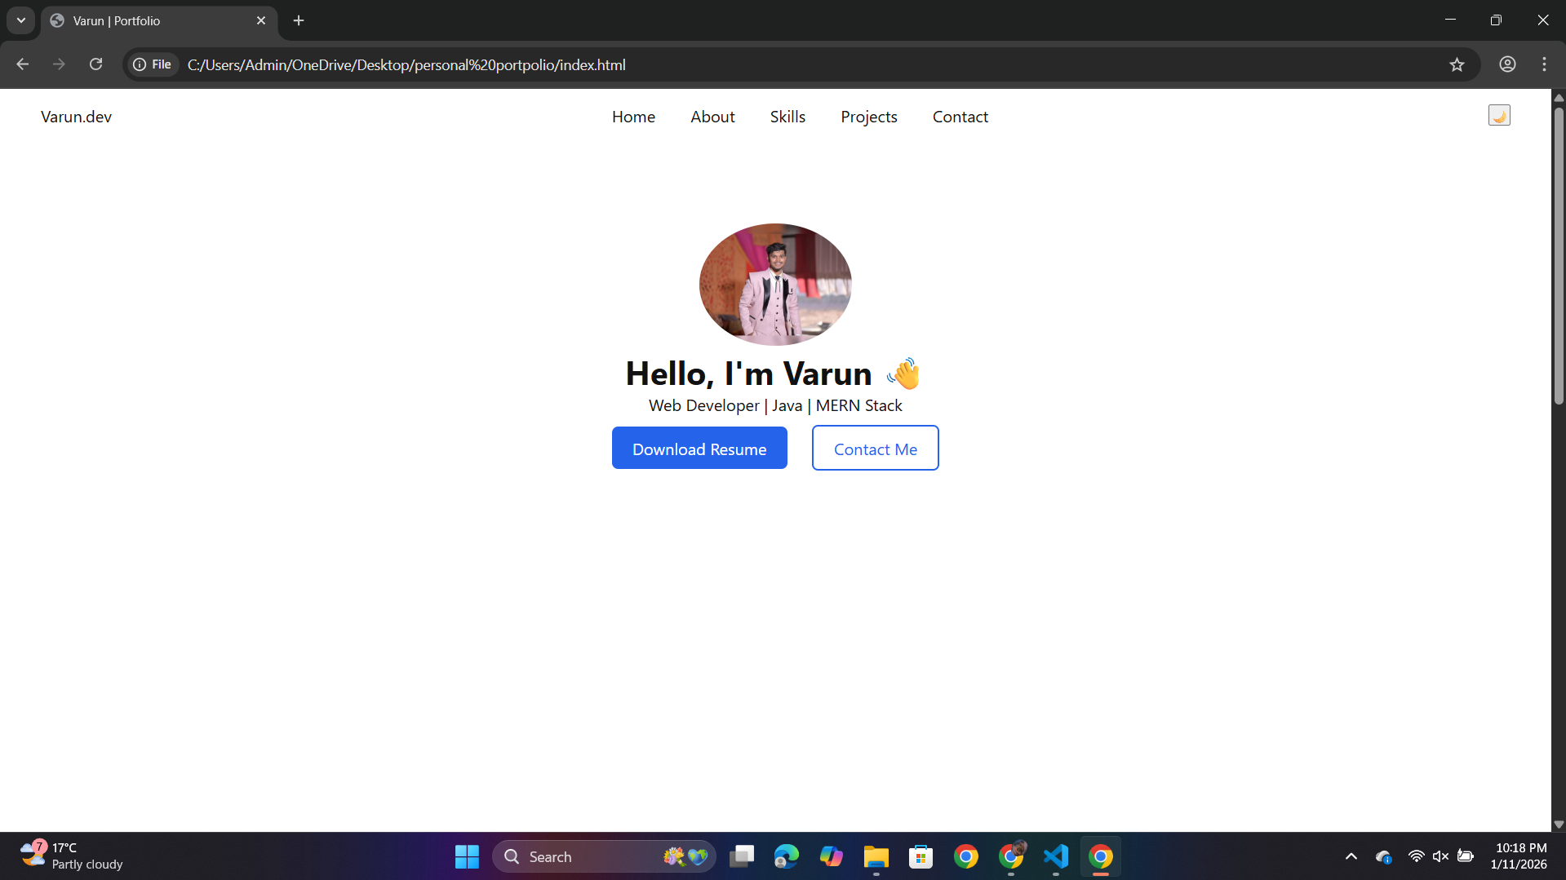
Screenshot
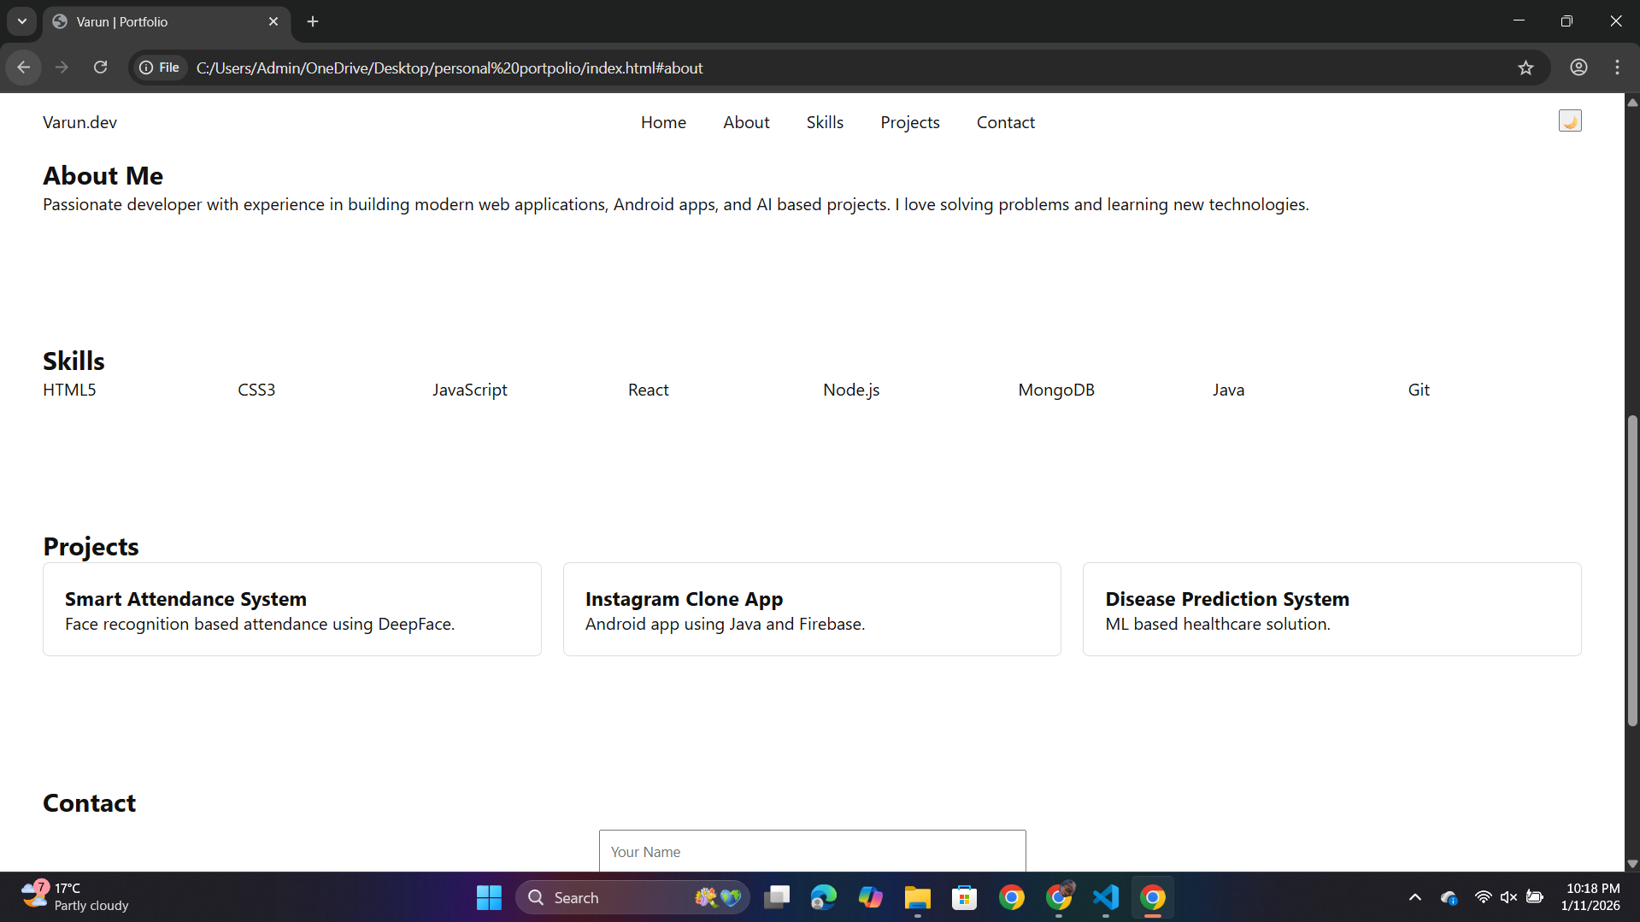
Screenshot
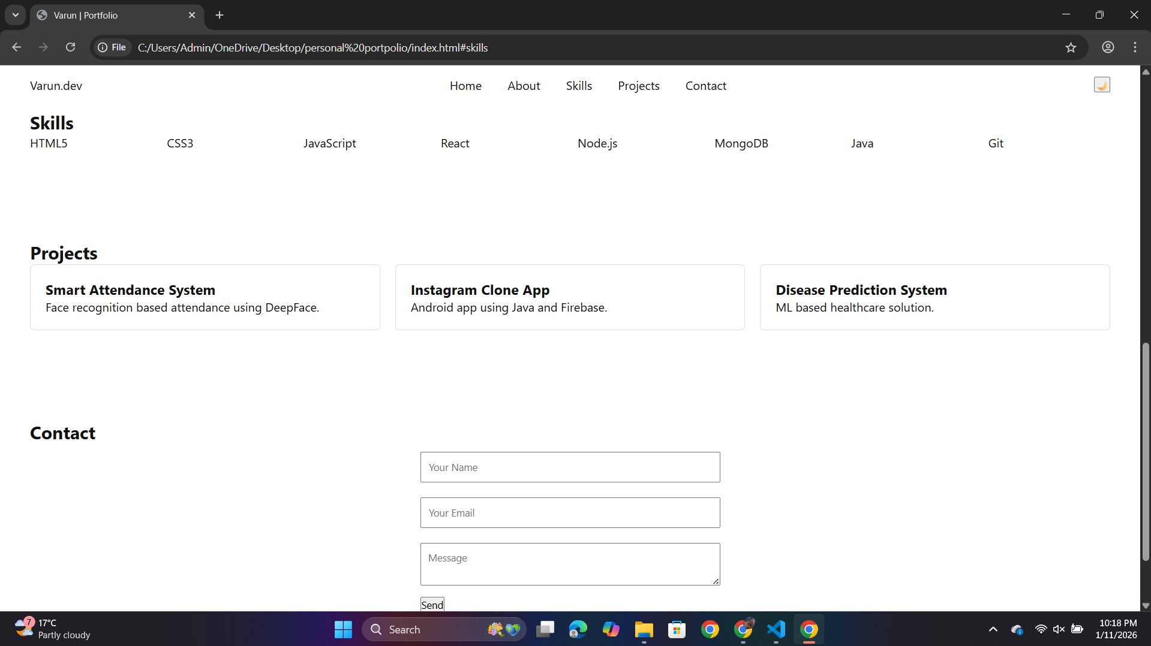
Screenshot

12. Testing
• Cross-browser testing
• Mobile responsiveness testing
• Form validation testing
• Accessibility testing

13. Future Enhancements
• Backend integration for contact form
• Blog section
• CMS support
• Advanced animations

14. Conclusion
This project demonstrates modern front-end development skills and provides a professional digital identity.

