**Computer And Information Sciences**

M.S. Project

**Varun Paul Reddy Gade**

Supervised by:

**Professor Jorge Novillo**

Dec 2023

Master of Science in Computer and Information Sciences

Department of Computer Science

State University of New York Polytechnic Institute

A project by VarunPaul Reddy Gade (U00342618),

is approved and recommended for acceptance as a final project in partial fulfillment of the requirements for the degree of Master of Science in Computer and Information Sciences,

SUNY Polytechnic Institute.

12/11/2023 _____________________

Professor Jorge Novillo

______________________ ______________________ Professor Chen-Fu-Chiang Professor Tarannum Zaman

STUDENT DECLARATION

I declare that this project is my own work and has not been submitted in any form for another degree or diploma at any university or other institute of tertiary education. Information derived from the published and unpublished work of others has been acknowledged in the text and a list of references is given.

*Varun Paul Reddy Gade*

Varun Paul Reddy Gade

**CineSift - AI-Based Genre Classification for Video Content**

**Varun Paul Reddy Gade(U00342618)**

Abstract:

CineSift is an advanced AI-driven tool specializing in the automated genre classification of video content, with a particular emphasis on documentaries, talk shows, and cartoons. Employing state-of-the-art object detection, face recognition, and scene analysis algorithms, CineSift meticulously analyses crucial visual elements that distinguish each genre. Its capabilities extend beyond conventional genre classification, as it adeptly identifies nuanced features like talking heads and text overlays in documentaries, stage scenery, and audience interactions in talk shows, and animated characters in cartoons.

This innovative project amalgamates these high-level criteria into a robust machine learning model, delivering substantial value to streaming platforms, content creators, and media analysts. By offering precise and efficient genre categorization, CineSift empowers content providers to enhance user experience and streamline content discovery. Its adaptability makes it an invaluable asset for media analysts seeking insights into content trends and viewer preferences. Through a seamless integration of AI, machine learning, and computer vision technologies, CineSift emerges as a pivotal solution in the evolving landscape of video content management, promising enhanced efficiency, accuracy, and scalability in genre classification.

As CineSift navigates the intricate landscape of video content, its success paves the way for future advancements in automated content analysis, positioning it as a transformative tool in the realms of entertainment and media analytics.

Table of Contents

Abstract 1

Chapter 1 INTRODUCTION 3

Chapter .1.1. Introduction 3

Chapter .1.2. Background and Motivation 3

Chapter .1.3. Objective and Scope 3

Chapter .1.4. Significance of genre classification in video content 4

Chapter .1.5. Chapter layout 5

Chapter 2 TECHNOLOGIES 6

Chapter 2.1. Artificial Intelligence 6

Chapter 2.2. Machine Learning (ML) 6

Chapter 2.3. Deep Learning 7

Chapter 2.4. Neural Networks 8

Chapter 2.5. Machine learning vs. Deep learning 10

Chapter 2.6. Deep learning vs. Neural networks 10

Chapter 2.7. Computer vision 11

Chapter 3 PYTHON LANGUAGE AND TECHNOLOGIES 14

Chapter 3.1. Programming Language 14

Chapter 3.2. Object detection 14

Chapter 3.3. Face Recognition Techniques 16

Chapter 3.4. Scene Analysis Algorithm 17

Chapter 3.5. Dataset Collection and Preprocessing 18

Chapter 4 PROJECT PIPELINE AND CODE IMPLEMENTATION 20

Chapter 4.1. Block diagram: 20

Chapter 4.2. Code implementation 20

Chapter 5 CONCLUSION 28

Chapter 5.1. Conclusion 28

Chapter 5.2. Future Scope 28

Chapter 5.3. Challenges faced. 28

Reference: 29

1. INTRODUCTION
2. Introduction

CineSift is an intuitive online platform created to streamline the task of discovering and choosing movies to watch. It consolidates ratings and reviews from well-known sources such as Rotten Tomatoes, IMDb, and Metacritic, offering a comprehensive summary of a movie's reception. This simplifies the process for users to assess the consensus and make well-informed decisions about which movies to watch, utilizing aggregated ratings from various platforms. Through this centralized platform, users can effortlessly search for specific movies, compare ratings, and explore new films, ultimately streamlining the movie selection process.

1. Background and Motivation

The main aim of CineSift is to create a platform that would simplify the process of finding movies for French movie fans and introduce them to new films they may not have been aware of.

The main objective of CineSift is to provide French movie fans with a comprehensive and user-friendly resource for discovering and locating movies. The creators of the website strongly believe that movies are a powerful art form that can enhance people's lives, and they strive to make it as effortless as possible for individuals to find and enjoy the movies they will truly appreciate.

Since its inception, CineSift has garnered positive feedback from French movie fans and has experienced steady growth. It now boasts a large and active community of users, making it a popular destination for French movie enthusiasts of all ages. The creators of CineSift are committed to continuously enhancing and expanding the website, constantly seeking new ways to make it even more valuable to French movie fans.

1. Objective and Scope

The primary objectives of the CineSift project are four-fold. Firstly, it aims to provide a user-friendly and comprehensive platform for discovering and locating movies. Secondly, it seeks to promote French cinema by providing information on French movies, directors, and actors. Thirdly, it aims to create a community of French movie enthusiasts who can share their passion for movies with each other. Lastly, it endeavours to make movies accessible to everyone by providing information on how to find and watch movies legally.

At present, the CineSift project is limited to French cinema and does not offer information on movies from other countries. However, the team is considering expanding the site to include information on international cinema in the future.

The CineSift team is constantly working to enhance the site and make it more valuable to French movie fans. Some of the team's future plan includes adding more information on French movies, directors, and actors, creating a forum for users to discuss movies, developing a mobile app for CineSift, and translating the site into other languages.

The CineSift team is committed to making CineSift the ultimate resource for French movie fans. With the assistance of its users, the team is confident that CineSift will continue to grow and improve in the years ahead.

1. Significance of genre classification in video content

Genre classification is crucial for managing and finding video content and is essential for organizing extensive libraries and facilitating efficient exploration. It forms basis for applications like:

* **Content recommendations**: By accurately classifying videos into specific genres, personalized content recommendations can be provided to users, tailored to their unique preferences and interests.
* **Content filtering**: The implementation of genre classification in content filtering systems allows for the restriction of access to inappropriate or age-restricted material. This ensures that users are presented with content that is appropriate for their age and preferences.
* **Video search** Efficient video search and retrieval is made possible through effective genre classification, allowing users to swiftly find videos that align with their interests. This classification system enables users to locate specific types of videos based on their preferences, enhancing the overall search experience.
* **Analysing and comprehending content**: Categorizing genres offers valuable insights into the overall structure and features of video content, contributing to a deeper understanding of user preferences and trends.
* **Targeted marketing:** Genre classification allows for targeted marketing, enabling advertisers to reach specific audience segments based on their video consumption patterns.
* **Summarizing and indexing videos**: Genre classification can guide the video summarization and indexing processes, extracting key information and generating concise descriptions tailored to each genre.
* **Content moderation and copyright protection:** Genre classification can aid content moderation efforts by identifying potentially harmful or copyrighted material, safeguarding users and ensuring compliance with copyright laws.
* **Organizing educational content:** Genre classification plays a crucial role in organizing educational content, making it easier for students and educators to locate relevant learning materials.
* **Entertainment and leisure:** Genre classification enhances the entertainment and leisure experience, allowing users to effortlessly navigate through vast video libraries and discover content that matches their mood and preferences.
* **Personalized video curation:** Genre classification facilitates personalized video curation, creating customized playlists and collections based on user preferences and interests.

1. Chapter layout

In forth coming chapter (Chapter 2) we will investigate Artificial Intelligence (AI), Deep Learning (DL) and Neural Networks (NN).

What is computer vision? Its Hierarchy also the differentiation between Image processing and Computer vison.

Let’s also look how Computer vision has taken over almost all industries, Applications of computer vision.

Chapter 3 is dedicated to understanding about the programming language and detailing about the Python libraries used for project development.

Chapter 4 deals with the building of pipeline for the project and coding part.

Chapter 5 explains the future scope and conclusion.

1. TECHNOLOGIES
2. Artificial Intelligence

The concept of AI can be traced back to ancient times, particularly in Greek mythology, where the idea of machines and mechanical men was contemplated. An example of this is Talos. The year 1950 marked the beginning of artificial intelligence, which has an important role to play in AI's history.

During this period, Alan Turing developed a test to determine if a computer could demonstrate intelligent behaviour like a human's. Turing acknowledged the challenges in defining and devising this renowned test.

AI exhibits several features, such as advanced web search engines like Google Search, devices capable of understanding human speech like Siri and Alexa, and recommender systems employed by platforms like YouTube, Amazon, and Netflix.

Artificial intelligence encompasses various forms of learning. The simplest form is trial and error, where a computer program solves a problem and stores the solution for future reference when encountering the same problem.

1. Machine Learning (ML)

Through the application of statistical techniques, algorithms are educated to categorize, forecast, and extract valuable insights from endeavours in data mining. These insights serve as guides for decision-making across diverse applications and businesses, significantly impacting essential growth metrics. The demand for data scientists is bound to rise as the volume of big data continues its upward trajectory. Their expertise becomes essential in identifying pertinent business queries and the corresponding data necessary for resolution. TensorFlow and PyTorch stand out as widely adopted frameworks, expediting the development of machine learning algorithms.[1]

Types of Machine Learning

**• Supervised learning:** Supervised learning involves training an algorithm using labelled data, where each data point has an output or label. Algorithms learn from this labelled data to make predictions or inferences about new unlabelled data. Examples of supervised learning include logistic regression, natural language processing (NLP), and image classification.

**• Unsupervised Learning**: Unsupervised learning is training an algorithm on unlabelled data, meaning that the meaning of the data is not defined or specified. Algorithms must identify patterns and structures in data without the help of labels or instructions. Examples of unsupervised learning processes include clustering, edge reduction, and anomaly detection.

**• Reinforcement Learning:** Reinforcement learning is a process in which an algorithm learns by trial and error and receives feedback in the form of rewards or punishments based on its performance. The algorithm adjusts its behaviour to maximize costs and improve time efficiency. Examples of reinforcement learning applications include robotics and games.

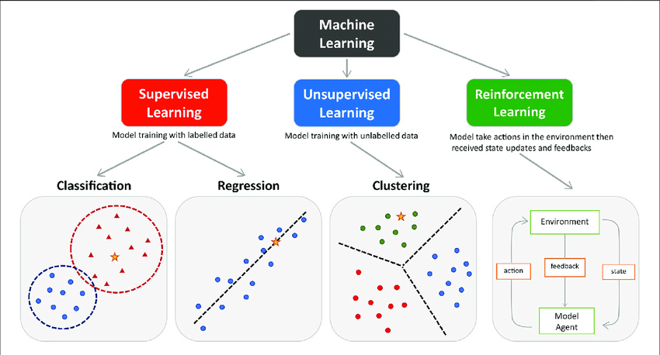

**Figure**: Types of Machine learning[3]

1. Apart from the primary categories mentioned, machine learning encompasses various subfields. Deep learning, for instance, entails training neural networks with multiple layers of interconnected nodes. Another subfield, transfer learning, involves leveraging knowledge acquired from one task to enhance performance in a different task.
2. Deep Learning

Deep learning constitutes a component of artificial intelligence that mimics the mechanisms of the human brain in handling data and forming patterns to facilitate decision-making. It functions as a subdivision of machine learning within AI, utilizing layered neural networks to simulate the decision-making processes observed in humans.

How does Deep Learning work?

Deep Learning utilizes layered neural networks for the analysis of data. These hierarchical neural networks share similarities with the human brain, as the neuron codes are interconnected. They have the ability to process data nonlinearly by incorporating successive layers of additional information into each layer, facilitated by the hierarchical structure.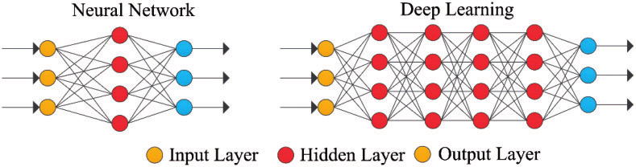

Figure: Different layers in Neural Network and Deep Learning [4]

Deep learning Applications

Few real time applications that use deep learning are Self driving cars, Voice controlled assistance etc.,

* **Self-Driving Cars**: Self-Driving cars that can capture the images around process the data, then it will decide which operation needs to be incorporated. Accordingly, actions are performed.
* **Voice Controlled Assistance**: Best example for this is the Alexa, which needs no explanation as it has become part of daily activities.
* **Automatic Machine Translations**: Conversion of one language to another are done using deep learning. Example preferred language subtitles for a Movie.
* **Automatic Image Caption Generation**: When an image is uploaded based on image a caption is generated below the image.

1. Neural Networks

Neural networks is a subset of machine learning that draws inspiration from the operations of the human brain. These networks consist of interconnected nodes, often referred to as "neurons," organized into layers. The data processing within these networks involves taking inputs through the input layer, undergoing transformations in hidden layers, and generating outputs from the output layer.[6] Each neuron performs a basic mathematical operation, incorporating inputs from other neurons with assigned weights. These weighted inputs undergo combination, adding a bias term, and pass through an activation function to generate an output. The network's weights and biases are adjusted during training through backpropagation, optimizing its performance for a specific task.

Types of Neural Network

Neural networks find widespread applications in tasks like speech recognition, image identification, natural language processing, and predictive analytics. They have demonstrated remarkable success in tackling complex challenges, such as excelling in playing games like Go and accurately recognizing objects in images. Neural networks come in various types, each characterized by its distinct architecture and training methodology. Some common types of neural networks include:

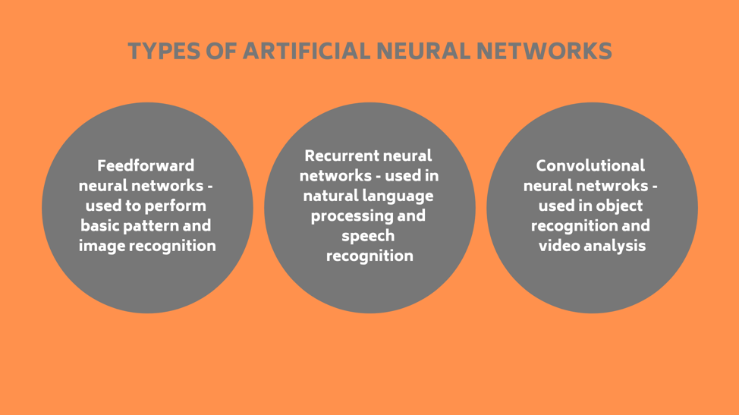

Figure: Types of Artificial Neural Networks [5]

* Convolutional neural networks:
* Generative adversarial networks
* Recurrent neural networks
* Feedforward Neural Network

**Feedforward neural networks (FNN):** In feedforward neural networks, information flows in an unidirectional manner, progressing from the input layer to the output layer. These networks find frequent application in tasks such as image recognition and classification.

**Recurrent neural networks (RNN)**: Recurrent neural networks enable bidirectional data flow, enabling the network to grasp sequential patterns in data. They find common use in applications like NLP and speech recognition (SR).

**Convolutional neural networks (CNN)**: Convolutional neural networks is developed to handle grid-like data, particularly images. They employ a method known as convolution to detect patterns and features within the input data.

**Generative adversarial networks:** Generative adversarial networks is made up of two components: a discriminator network that seeks to distinguish between produced and actual data, and a generator network that creates new data.

While neural networks have demonstrated significant efficacy across various applications, it's important to note that they can pose computational challenges and demand substantial amounts of data for effective training. Despite these considerations, their capacity to grasp intricate patterns and relationships within data underscores their value as a valuable tool in the realm of machine learning.

Neural Network Architecture

Neural network architecture pertains to the arrangement and connections of artificial neurons or nodes within a neural network. Conceptually, a neural network can be envisioned as a sequence of interconnected "boxes" responsible for receiving input, processing it, and generating output. These boxes, referred to as nodes or artificial neurons, are structured into layers. The neural network consists of layers of internally connected nodes or artificial neurons, and there are three primary types of layers:[20]

• Input layer: Input data is received by input layer.

• Hidden layers: These layers conduct computations on the input data, generating outputs.

• Output layer: The output layer produces the ultimate output of the network.

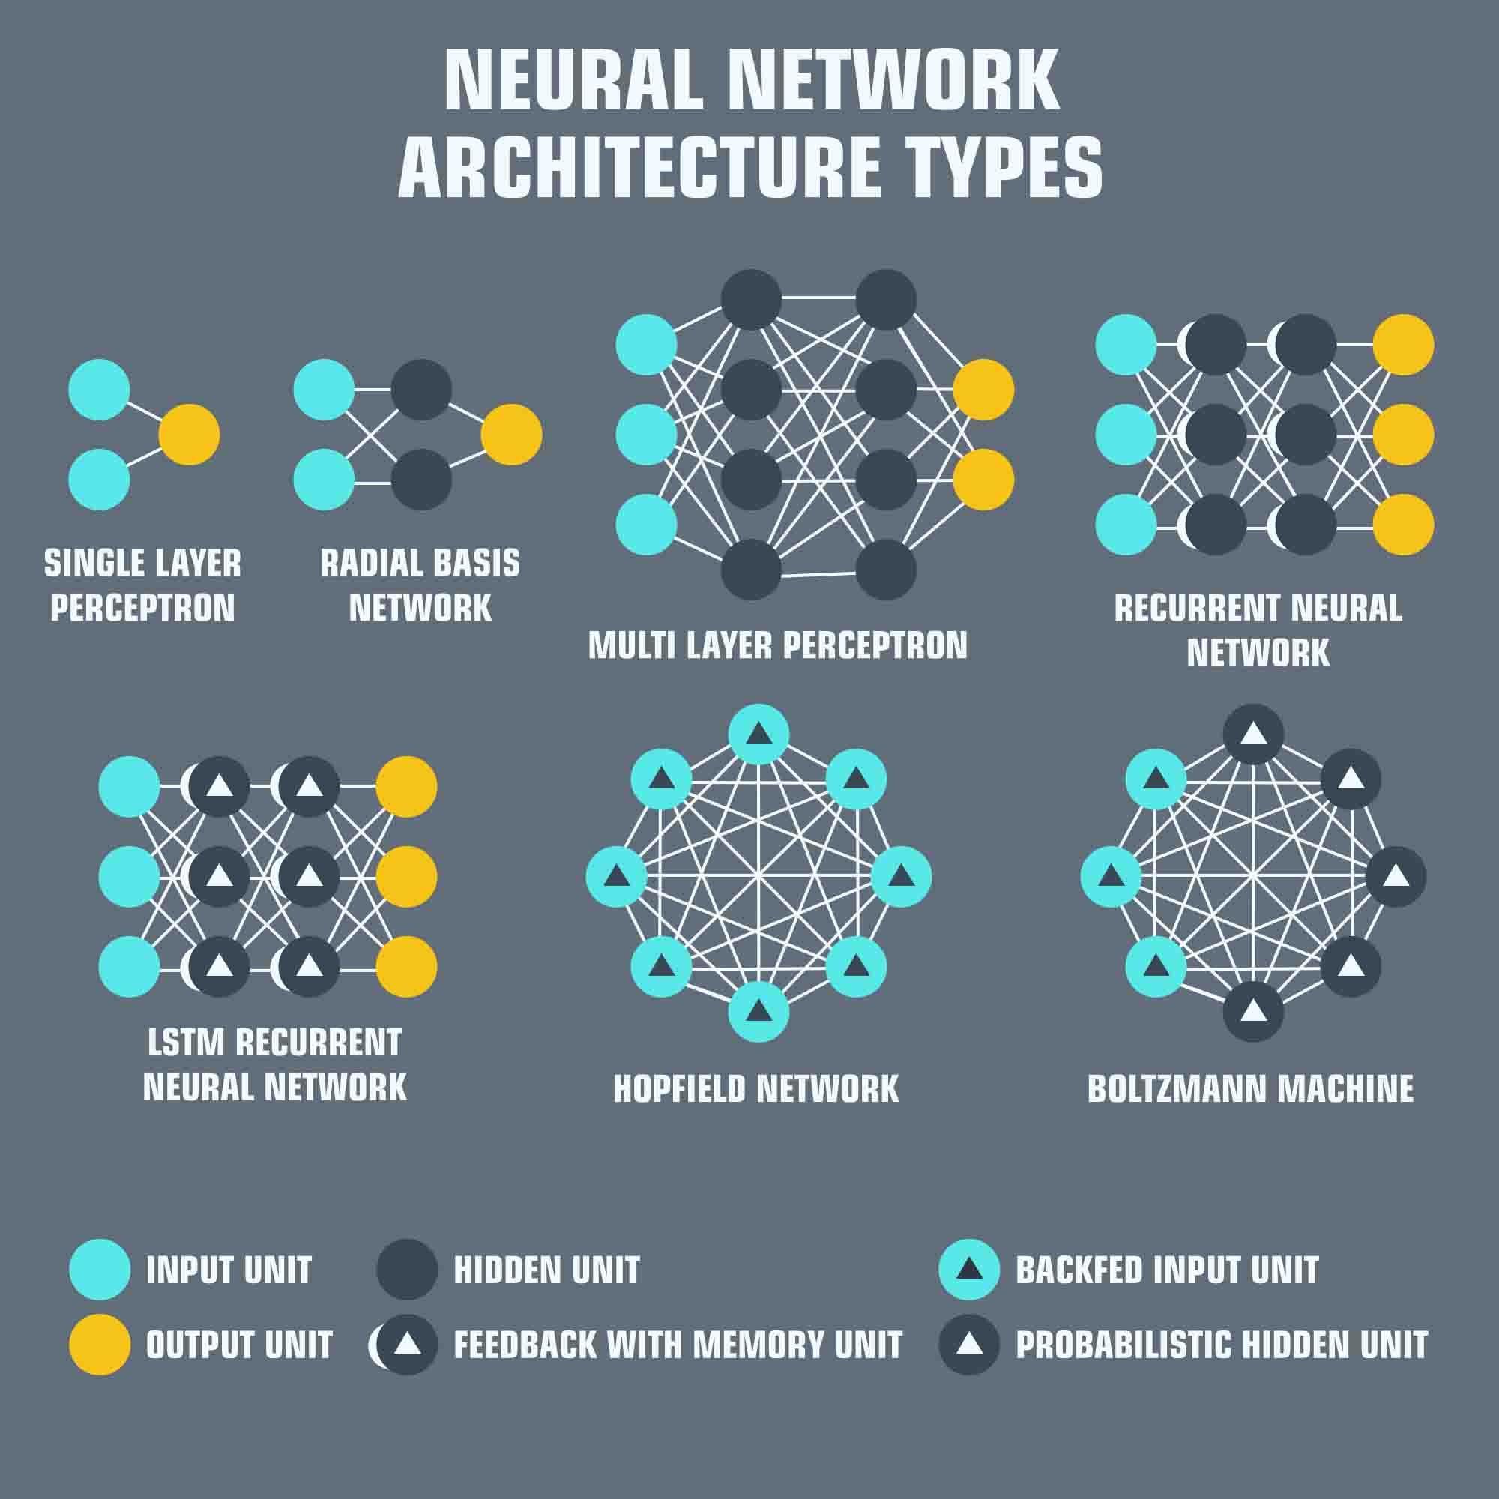

Figure: Neural Network Architecture types[7]

1. Machine learning vs. Deep learning

Differentiating between deep learning (DL) and machine learning (ML) is crucial, as these terms are frequently used interchangeably.

Neural networks fall under the umbrella of machine learning, and within neural networks, deep learning constitutes a subfield. It's noteworthy that both neural networks and deep learning are subfields of artificial intelligence.

Their approaches to learning are where the two vary most from one another. In addition to processing labelled datasets, deep machine learning is also capable of processing unstructured data and automatically identifying the characteristics that divide it into several groups. This enables the utilization of bigger data sets and lessens the requirement for human interaction.

1. Deep learning vs. Neural networks

Classical, or "non-deep", machine learning depend on heavily on human involvement for learning. In this approach, human specialists are responsible for determining the set of features that help in understanding the distinctions between different data inputs. This often requires structured data to facilitate the learning process.

Neural networks, or artificial neural networks (ANNs), are composed of multiple layers of interconnected nodes. Each node, representing an artificial neuron, is endowed with a weight and a threshold. Activation occurs when a node's output surpasses a predetermined threshold, leading to the transmission of data to the next layer of the network. Conversely, if the output falls below the threshold, no data is forwarded to the subsequent layer.

The term "deep" in deep learning specifically refers to the number of layers in a neural network. A neural network is considered deep if it has more than three layers, encompassing both the input and output layers. In contrast, a neural network with only three layers is categorized as a simple neural network.

The impact of deep learning and neural networks extends across diverse fields, including natural language processing, computer vision, and speech recognition. Their contributions have significantly expedited advancements in these domains.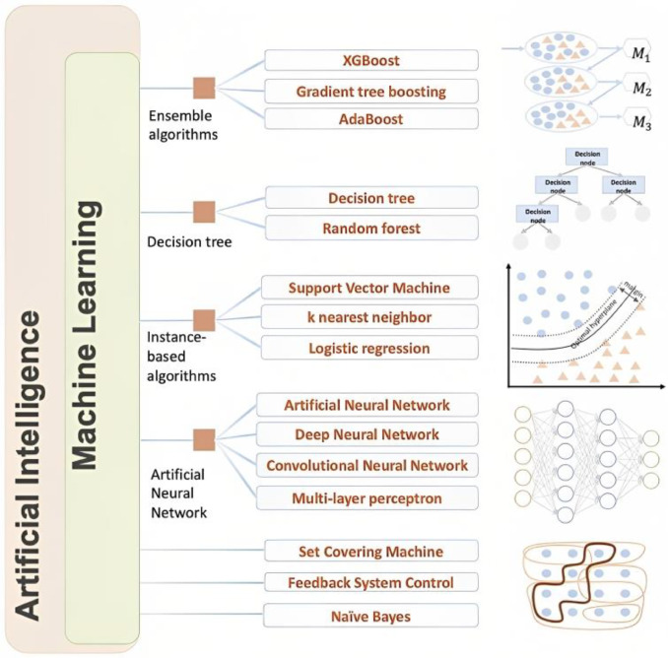  
**Figure**: AI, ML, NN [2]

1. Computer vision

The objective of the computer science field known as computer vision within artificial intelligence (AI) is to enable robots to understand and make informed decisions using visual data. The goal is to emulate and improve upon the capabilities of the human visual system in comprehending and interpreting the visual surroundings. This entails creating algorithms and models capable of analyzing images and videos, extracting pertinent information, and utilizing that information to make decisions or predictions.

Key components of computer vision include:

* **Image Acquisition**: The process of obtaining images or video frames through cameras, sensors, or other imaging devices.
* **Image Processing**: Manipulating and enhancing raw images to improve their quality or extract relevant features. This may involve tasks such as filtering, noise reduction, and image enhancement.
* **Feature Extraction**: Identifying and extracting important features from images, such as edges, corners, shapes, and textures.
* **Object Recognition**: The capacity to identify and classify objects or patterns present in an image or video, which can encompass methods such as object detection, classification, and localization.
* **Scene Understanding**: Analysing the overall context of a scene, including relationships between objects, spatial information, and the understanding of the scene's content.
* **Machine Learning**: Utilizing machine learning techniques, including deep learning, to enable computers to learn from data and improve their ability to perform tasks like image recognition and object detection.

Applications of computer vision in video analysis[14]

Computer Vision, as a component of AI, enables machines or devices to extract pertinent information by gathering data from their surroundings in the form of images and videos. This information is then utilized to make informed decisions or take appropriate actions.

Through Machine Learning, there is no need to write each line of code into the vision applications physically. Rather, the developers modify features and smaller applications that could recognize explicit patterns in pictures.

Due to increased accessibility and advancements in hardware and distributed computing resources, both Deep Learning and Deep Neural Networks have transitioned from theoretical concepts to practical applications.[8]

Computer Vision operations:

* **Image receiving:** Images are obtained in real-time through pictures or video formats.
* **Image processing:** Deep Learning models process the obtained image.
* **Image understanding:** The object of which the image was taken, gets identified or classified.

**Some tasks of Computer Vision are:** To get certain information from the input image the various applications of Computer Vision are based on a certain number of tasks that can be directly used to form the base for further analysis.

**Figure**: Computer Vision Tasks [8]

**Image recognition:** Computer Vision is about to decide whether the image contains an object or not. This task can be solved with some types of recognition.

* Identification
* Selection
* Examination

**Image retrieval:** Images recaptured from a large database using a query by image content. Like image brackets and face identification problems, it focuses on spanning huge image collections via approximate styles.

**Image restoration:** Using prior knowledge of declamation events, image restoration works to recreate or restore a deteriorated image. In Image restoration technique to recover the original image by modelling the declination and applying the inverse process

**Object recognition:** Object recognition, a computer vision technology, aids in identifying items in images or videos. It serves as a crucial outcome for both Deep Learning and Machine Learning algorithms. When individuals seek to analyze a photo or view a video, they can easily identify elements such as people, objects, scenes, and visual details.

**Semantic Segmentation:** Semantic Segmentation is a technique that associates every pixel in an image with a specific class label. This method is predominantly employed in autonomous driving and medical applications. Pascal VOC serves as a benchmark dataset for evaluating segmentation tasks.

**Video tracking:** It involves monitoring the position of target objects in every frame of a video sequence, utilizing stationary or mobile cameras.

The features of Video tracking are:

* Change detection.
* Gaussian Mixture model
* Object tracking using templates.
* Tracking by feature detection

1. PYTHON LANGUAGE AND TECHNOLOGIES
2. Programming Language

Python is an open-source, easy to read, general purpose programming language and powerful. It is an interpreted language, which does not need to be compiled to run. A programmer can focus on what to do instead of how to do because it is a high-level language. When compared to any other languages Python will take less time to write a program.

Guido Van Rossum created Python in the late 1980s while working at the National Research Institute for Mathematics and Computer Science in the Netherlands.

1. Object detection

One kind of computer vision task is object detection, which is finding and categorizing items in an image or video clip. The aim is to locate the items of interest, draw bounding boxes around them, and provide a class label to every object that is found. This task is fundamental to various applications, including image understanding, video analysis, and autonomous systems.

Key aspects of object detection include:

* **Localization**: Determining the spatial coordinates of an object within an image, typically represented by a bounding box. The bounding box specifies the object's position and may include information such as the object's width, height, and orientation.
* **Classification:** Assigning a label or category to the object contained within the bounding box. This step involves recognizing the type or class of the object, such as a person, car, or cat.

Object Detection Algorithms[9][22]:

1. **YOLO (You Only Look Once):** YOLO, or You Only Look Once, is an object detection algorithm designed for real-time applications. It partitions an image into a grid and predicts bounding boxes and class probabilities for each grid cell concurrently. Recognized for its speed and precision, YOLO is well-suited for applications that demand rapid and accurate object detection.
2. **Faster R-CNN (Region-based Convolutional Neural Network):** Faster R-CNN is an object detection algorithm with a two-stage process. It employs a region proposal network (RPN) to create potential bounding box proposals and subsequently classifies and refines these proposals. While achieving notable accuracy, Faster R-CNN might have a slower processing speed compared to YOLO.
3. **SSD (Single Shot Multi box Detector):** SSD, or Single Shot MultiBox Detector, is an object detection algorithm designed for real-time applications. It creates bounding box proposals with various scales and aspect ratios for each feature map layer. Notably, SSD predicts multiple bounding boxes and class scores in a single pass through the network.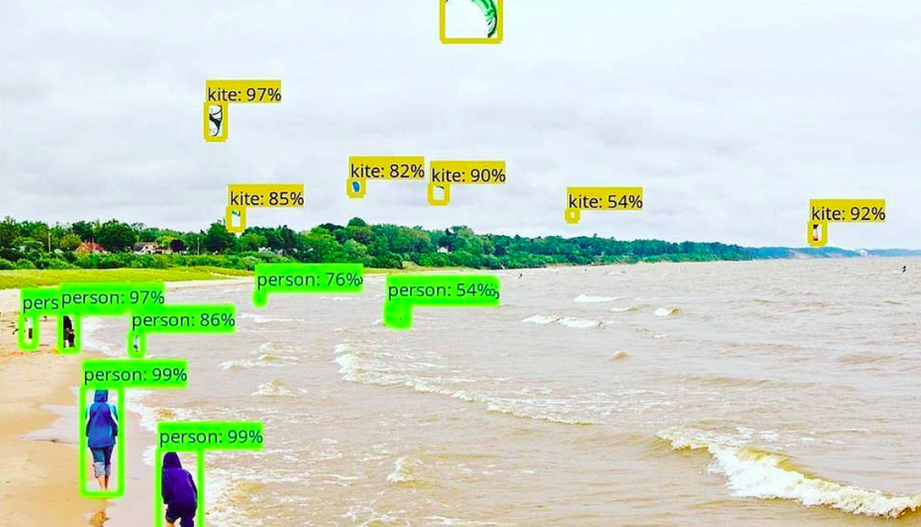

**Figure**: Detecting objects in images of convolutional neural network [10]

Object detection can be categorized into two primary approaches:

Two-Stage Detectors:

* In this approach, detectors initially suggest regions of interest (ROIs) within the image by employing techniques such as selective search or region proposal networks (RPNs).
* Following the proposal stage, the suggested regions undergo a classification and refinement process to ultimately derive the accurate bounding boxes and corresponding class labels.
* Instances of two-stage detectors include Faster R-CNN (Region-based Convolutional Neural Network) and R-FCN (Region-based Fully Convolutional Networks).

One-Stage Detectors:

* These detectors directly anticipate bounding boxes and class labels, eliminating the necessity for a distinct region proposal stage.
* They are frequently faster in processing but may compromise a degree of precision when compared to two-stage detectors.

Object detection finds application in various fields, such as:

* **Autonomous Vehicles:** Detection and tracking of pedestrians, other vehicles, and obstacles to ensure secure navigation.
* **Surveillance**: Detecting and monitoring objects or individuals in security camera footage.
* **Medical Imaging**: Locating and analyzing specific structures or anomalies in medical images.
* **Retail**: Automating inventory management and monitoring customer behavior.
* **Augmented Reality**: Recognizing and interacting with real-world objects in AR applications.

Convolutional neural networks (CNNs), one of the main developments in deep learning, have greatly increased the precision and effectiveness of object identification systems, making them essential parts of many computer vision solutions.

1. Face Recognition Techniques

* **Eigenfaces**: Eigenfaces stands as a traditional face recognition approach rooted in principal component analysis (PCA). It characterizes faces by expressing them as linear combinations of principal components, utilizing these representations for recognition.
* **LBPH (Local Binary Pattern Histogram):** LBPH is a face recognition method centered on texture, extracting local binary patterns from facial images. It captures the pixel relationships with their neighbors, forming histograms for recognition.
* **DeepFace**: DeepFace utilizes deep learning methodologies, specifically deep neural networks, for face recognition. Its robustness in handling variations in pose, lighting, and expression makes it effective in real-world scenarios.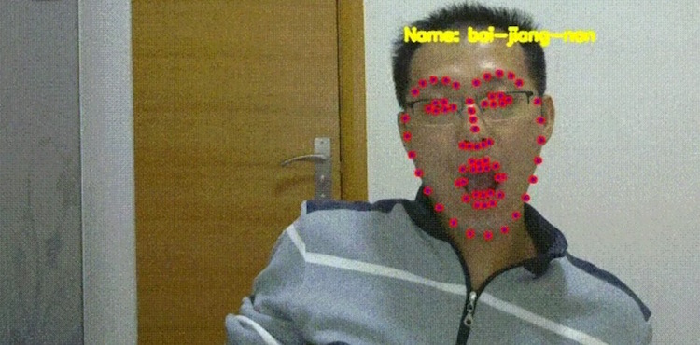

**Figure**:face recognition by boi-jiang-nart[12]

[11] The development of a real-time face recognition algorithm involves the integration of TensorFlow, OpenCV, MTCNN, and Facenet. OpenCV2 is utilized for face detection, Facenet handles face embedding, and MTCNN contributes to the detection process. Additionally, a classifier is applied for face recognition. The inspiration for this algorithm's creation draws from the concepts introduced by OpenFace.

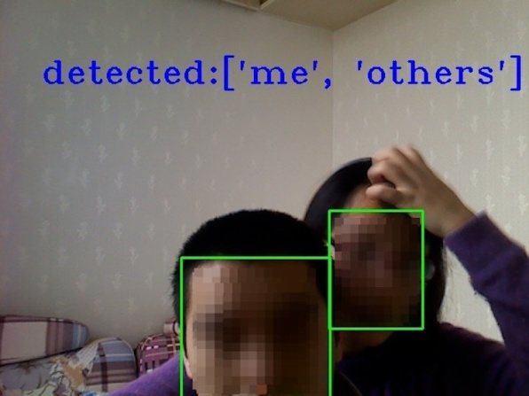

Figure: Real time face recognition[13]

1. Scene Analysis Algorithm

Leveraging artificial intelligence (AI), scene analysis proves to be a potent tool for the identification of objects, pattern recognition, and anomaly detection in images. Its wide-ranging applications encompass fields such as surveillance, security monitoring, medical imaging, autonomous driving, and robotics. This article delves into the core aspects of AI-powered scene analysis, covering the advantages of AI utilization, the significance of computer vision, deep learning methodologies, image segmentation, algorithms for object recognition and detection, advanced image recognition systems, challenges encountered, real-time applications, and the prospective evolution of AI within the domain of scene analysis.



Figure: Scene analysis algorithm by AI[15]

Benefits of AI in Scene Algorithm are:

The integration of Artificial Intelligence (AI) in scene analysis is revolutionizing our interaction with the environment. AI empowers individuals and organizations to extract valuable insights from their data, facilitating more accurate decision-making and ultimately improving business outcomes.

A primary advantage of employing AI for scene analysis is the rapid processing of large volumes of textual and visual data. In contrast to traditional methods like manual image processing, AI-based solutions can swiftly identify items within an image and draw inferences about the activities depicted. This capability enables a deeper understanding of complex scenarios that would have otherwise required a significant amount of time or proven challenging to analyze manually.

Furthermore, automation is a key benefit of using AI for scene analysis. Leveraging robust algorithms, AI systems can automate various tasks that previously depended on human intervention, such as object recognition and classification. This potential for automation translates to faster decision-making in real-time scenarios, particularly in applications like security surveillance or medical diagnosis, where speed is of paramount importance.

Scene Analysis Algorithms:

* **Semantic Segmentation:** Semantic segmentation involves categorizing every pixel in an image into predefined classes, offering a comprehensive understanding of the scene. Convolutional Neural Networks (CNNs), including U-Net and SegNet, are frequently employed in semantic segmentation tasks.
* **CNNs for Scene Recognition**: Convolutional Neural Networks are widely applied to scene recognition tasks. They learn hierarchical features from images, enabling the model to recognize complex scene patterns. Notable architectures include VGGNet, ResNet, and Inception.
* **Spatial Pyramid Pooling (SPP):** SPP is used in scene analysis to handle images of varying sizes. It divides the input image into spatial bins and pools features from each bin independently, allowing the model to capture spatial information effectively.

1. Dataset Collection and Preprocessing

The initial stage in the machine learning pipeline involves gathering data to train the ML model. The accuracy of predictions made by ML systems is contingent on the quality of the training data. During the data collection process, various challenges may arise, such as inaccurate data, missing data, data imbalance, and data bias. To tackle these issues, different methods can be applied, including utilizing pre-cleaned datasets, web crawling and scraping, generating private data, and creating custom datasets. Furthermore, data pre-processing is essential to convert raw data and images into a format compatible with the machine learning algorithm.[17]

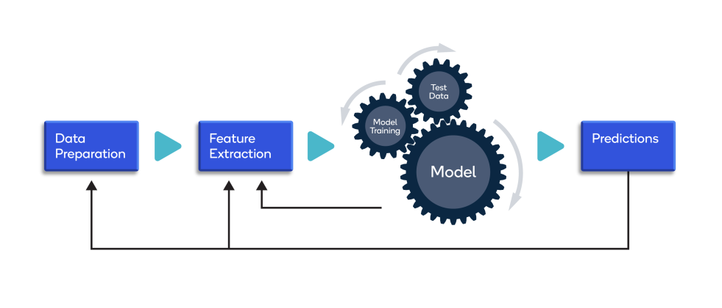

**Figure**: Pre-processing various techniques[18]

Pre-processing encompasses various techniques and procedures:

* **Data cleansing**: Utilizing both manual and automated approaches, these techniques remove inaccuracies in the added or classified data.
* **Data imputation**: Most machine learning frameworks offer methods and APIs to address or fill in missing data. Common techniques involve imputing missing values with standard deviation, mean, median, or using k-nearest neighbors (k-NN) based on the data in the respective field.
* **Oversampling**: To tackle bias or imbalance in the dataset, generating additional observations/samples is possible through methods like repetition, bootstrapping, or the Synthetic Minority Over-Sampling Technique (SMOTE). These additional samples are then incorporated into the under-represented classes.
* **Data integration**: Merging multiple datasets enables obtaining a more extensive corpus, helping overcome incompleteness in a single dataset.
* **Data normalization**: The memory and processing requirements during training iterations are influenced by the size of a dataset. Normalization reduces the size by diminishing the order and magnitude of the data.

1. PROJECT PIPELINE AND CODE IMPLEMENTATION
2. Block diagram:

The below is the block diagram for the project. Once the video is fed into the system it basically takes first 10 frames of the ever 2 seconds of the images asses the activity on the video and provides the result.

1. Code implementation
2. Importing Libraries: The code initiates by importing essential libraries, which encompass OpenCV for video processing, TensorFlow and Keras for deep learning, and additional utility libraries such as tqdm and seaborn. A computer screen shot of a program

   Description automatically generated
3. Data Pre-processing: The code defines functions for pre-processing video frames, reading video files, and creating a generator class (*FrameGenerator*) to load and preprocess videos from a specified dataset folder.

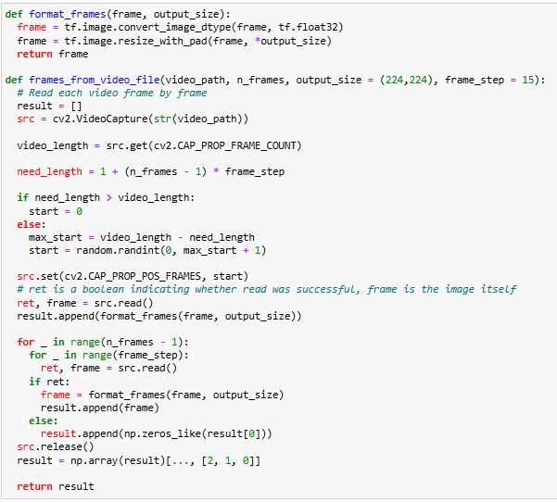

Class for pulling each video from the dataset folder and preprocess it

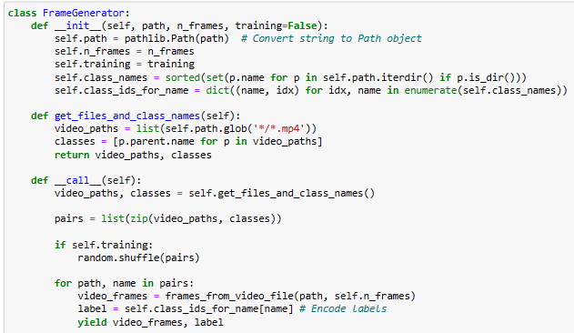

1. Initializing Variables: Sets up variables such as the number of frames per video (*n_frames*) and batch size for training.

1. Custom Model Layers Creation: Defines custom layers for the 3D convolutional model, including Conv2Plus1D for spatial and temporal decomposition, ResidualMain for residual connections, and others.

HEIGHT = 224

WIDTH = 224

class Conv2Plus1D(keras.layers.Layer):

# ... (implementation details)

class ResidualMain(keras.layers.Layer):

# ... (implementation details)

class Project(keras.layers.Layer):

# ... (implementation details)

def add_residual_block(input, filters, kernel_size):

# ... (implementation details)

class ResizeVideo(keras.layers.Layer):

# ... (implementation details)

1. Model Creation: Constructs the video classification model using the custom layers and the Keras Functional API. The model consists of multiple residual blocks with 3D convolutional layers.

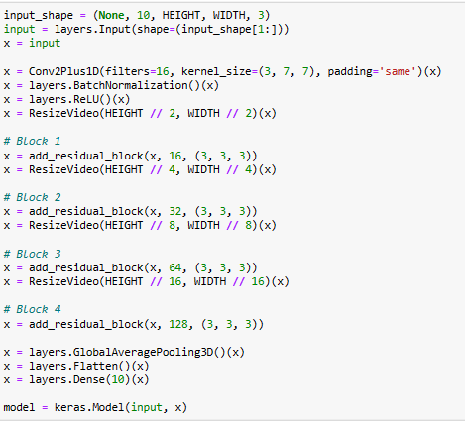

This section constructs the video classification model using the custom layers and the Keras Functional API. It sets up the input shape, defines the model architecture, compiles the model, and visualizes the model structure.

1. Training: Compiles and trains the model using the training dataset (*train_ds*) and validates on a separate dataset (*val_ds*).The variable 'history' contains the stored historical data of the training.

Output:

1. Plotting Loss and Training Curves: Defines a function (plot_history) to visualize the training and validation loss and accuracy over epochs and plots them.

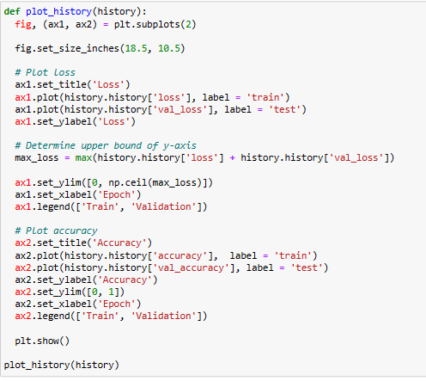

Output:

1. Evaluation: Evaluates the model on the test dataset (test_ds) and prints the loss and accuracy.

  
Output:

1. Confusion Matrix: Defines functions to generate and plot a confusion matrix based on the actual and predicted labels on the training and test datasets.

1. Calculation of Precision and Recall: Calculates precision and recall values for individual classes, derived from the confusion matrix.A screenshot of a computer code

   Description automatically generated



**Output**: {'Cartoons': 1.0, 'Documentaries': 1.0, 'Talk_show': 0.8928571428571429} {'Cartoons': 0.88, 'Documentaries': 1.0, 'Talk_show': 1.0}

1. Deployment of the Model: This section defines a process for deploying the trained model on a video file. It uses OpenCV to capture frames, preprocess them, predict the class, and display the result on each frame in real-time.

1. CONCLUSION
2. Conclusion

In conclusion, the CineSift project demonstrates the efficacy of utilizing advanced computer vision techniques, particularly 3D convolutional neural networks, for automated video genre classification. By integrating object detection, face recognition, and scene analysis algorithms, CineSift achieves robust categorization, providing valuable insights for streaming providers, content creators, and media analysts. The custom model, with its unique architecture, exhibits promising results in accurately classifying documentaries, talk shows, and cartoons.

1. Future Scope

The project's future scope involves enhancing the model's scalability to a broader range of genres and refining its adaptability to diverse cultural contexts. Additionally, exploring real-time genre adaptation based on user preferences could enrich user experience. Integration with user feedback mechanisms for continual model improvement and exploring multi-modal features for improved understanding of video content represent exciting avenues for future development.

1. Challenges faced.

Addressing potential challenges includes overcoming biases in training data, ensuring robustness to varying video qualities, and adapting the model to evolving content trends. Implementing explainable AI methodologies to enhance model interpretability and addressing privacy concerns in user data for personalized recommendations are critical considerations. Continuous efforts to stay abreast of technological advancements and user preferences will be vital for maintaining the project's relevance and effectiveness in the dynamic landscape of video content.

Reference:

1. IBM ,” What is machine learning?”,<https://www.ibm.com/topics/machine-learning>
2. Mohesen Soori, Behrooz Arezoo, “Artificial intelligence, machine learning and deep learning in advanced robotics, a review”, <https://ars.els-cdn.com/content/image/1-s2.0-S2667241323000113-gr1.jpg>
3. Frontiers in Pharmacology “Types of Machine Learning”, <https://www.researchgate.net/publication/354960266/figure/fig1/AS:1075175843983363@1633353305883/The-main-types-of-machine-learning-Main-approaches-include-classification-and.png>
4. Wanli Xing , “Layers in Neural network and Deep Learning”, <https://www.researchgate.net/profile/Wanli-Xing/publication/323784695/figure/fig5/AS:613990283628562@1523398099969/Deep-learning-diagram.png>
5. Allerin, “ Types of Neural Network”, <http://www.allerin.com/wp-blog/wp-content/uploads/2019/04/3-types-of-neural-networks-that-AI-uses.png>
6. Simon Haykin “ Neural Networks A Comprehensive foundation”, <https://cdn.preterhuman.net/texts/science_and_technology/artificial_intelligence/Neural%20Networks%20-%20A%20Comprehensive%20Foundation%20-%20Simon%20Haykin.pdf>
7. Allerin, “Neural Network Architecture types”, <http://www.allerin.com/wp-blog/wp-content/uploads/2019/04/types-of-artificial-neural-networks.jpg>
8. Virgilio.GitHub,” Introduction to Computer Vision using OpenCV and Python”, <https://virgili0.github.io/Virgilio/inferno/computer-vision/introduction-to-computer-vision.html#prerequisites>
9. Pulkit Sharma, “A Step-by-Step Introduction to the Basic Object Detection Algorithms”, <https://www.analyticsvidhya.com/blog/2018/10/a-step-by-step-introduction-to-the-basic-object-detection-algorithms-part-1/>
10. Pulkit Sharma, “A Step-by-Step Introduction to the Basic Object Detection Algorithms”, <https://cdn.analyticsvidhya.com/wp-content/uploads/2018/06/OD.png>
11. Varun Kumar, “15 Efficient Face Recognition Algorithms And Techniques”, <https://www.rankred.com/face-recognition-algorithms-techniques/>
12. Varun Kumar, “15 Efficient Face Recognition Algorithms And Techniques”, <https://www.rankred.com/wp-content/uploads/2017/11/face-everthing.jpg>
13. Varun Kumar, “15 Efficient Face Recognition Algorithms And Techniques”, <https://www.rankred.com/wp-content/uploads/2017/11/Real-Time-Face-Recognition.jpg>
14. “Exploring the Fundamentals of Scene Analysis in AI”, <https://machinemindmatters.com/posts/exploring-fundamentals-scene-analysis-ai/>
15. MachinemindMatters, “Exploring the Fundamentals of Scene Analysis in AI”, <https://machinemindmatters.com/img/exploring-fundamentals-scene-analysis-ai.jpeg>
16. Muzammil K, “Must-Have Libraries, Frameworks, and Tools for Software Development”, <https://www.aalpha.net/blog/must-have-libraries-frameworks-and-tools-for-software-development/>
17. Qualcomm,”Data collection and pre-processing techniques”, <https://developer.qualcomm.com/software/qualcomm-neural-processing-sdk/learning-resources/ai-ml-android-neural-processing/data-collection-pre-processing>
18. Qualcomm,”Data collection and pre-processing techniques”, ,<https://developer.qualcomm.com/sites/default/files/attachments/learning_resources_01-01.png>
19. MarkDaoust, “tensorflow”, <https://github.com/tensorflow/docs/tree/master/site/en/tutorials/video>
20. Github, “OpenCV”, <https://github.com/opencv/opencv>
21. Github, “tensorflow/tensorflow”, <https://github.com/tensorflow/tensorflow>
22. Arxiv, “SSD: Single Shot MultiBox Detector”, <https://arxiv.org/abs/1512.02325>