





AWS Solution Architect Training with AWS Cloud Practitioner Global Certification
Capstone Projects

Trainer: Aravindraj.G- Nminds Academy AWS Academy Certified Educator

Create an EC2 Windows Instance in AWS



VARUN PRASATH.M
CSE-Artificial Intelligence & Machine Learning,
Sri Eshwar College of Engineering,
Coimbatore.




Objective
EC2 (Elastic Compute Cloud) is a core service provided by Amazon Web Services (AWS) that enables users to rent virtual servers in the cloud to run applications, store data, or handle computational workloads.

An EC2 Windows instance is a virtual machine running the Microsoft Windows operating system on Amazon Web Services (AWS) EC2 (Elastic Compute Cloud). This allows you to run Windows-based applications, manage Windows Server configurations, and use various Microsoft software (like SQL Server, IIS, etc.) in the cloud without having to manage physical hardware.

Use Cases for EC2 Windows Instances:
- Web and Application Hosting: Run IIS web servers or other Windows- based web applications in the cloud.
- Database Servers: Host SQL Server databases with EC2 Windows instances, using RDS or EC2 for more control.
- Remote Desktop Applications: Set up RDS (Remote Desktop Services) for remote access to Windows desktops in the cloud.
- Development and Testing: Create development environments with Windows OS to test .NET or other Windows-based applications.

Used Services in AWS:


Amazon EC2





Topology

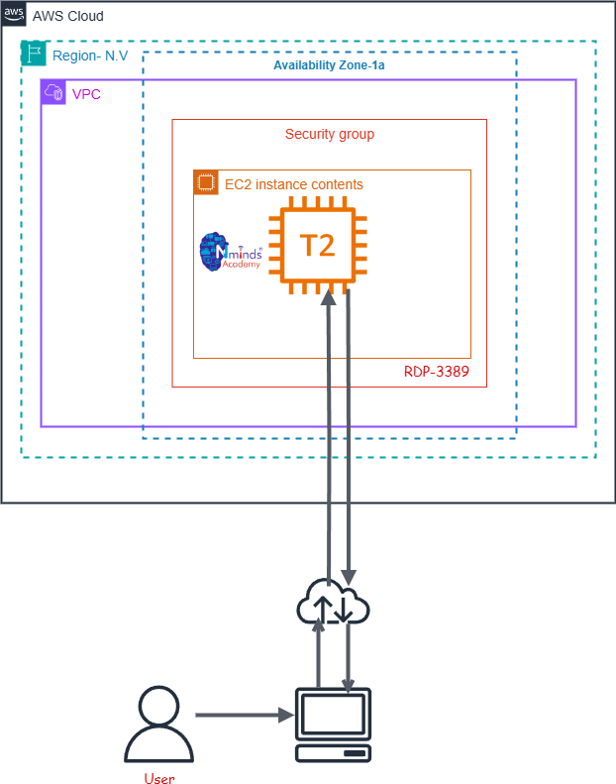





Execution Tasks:

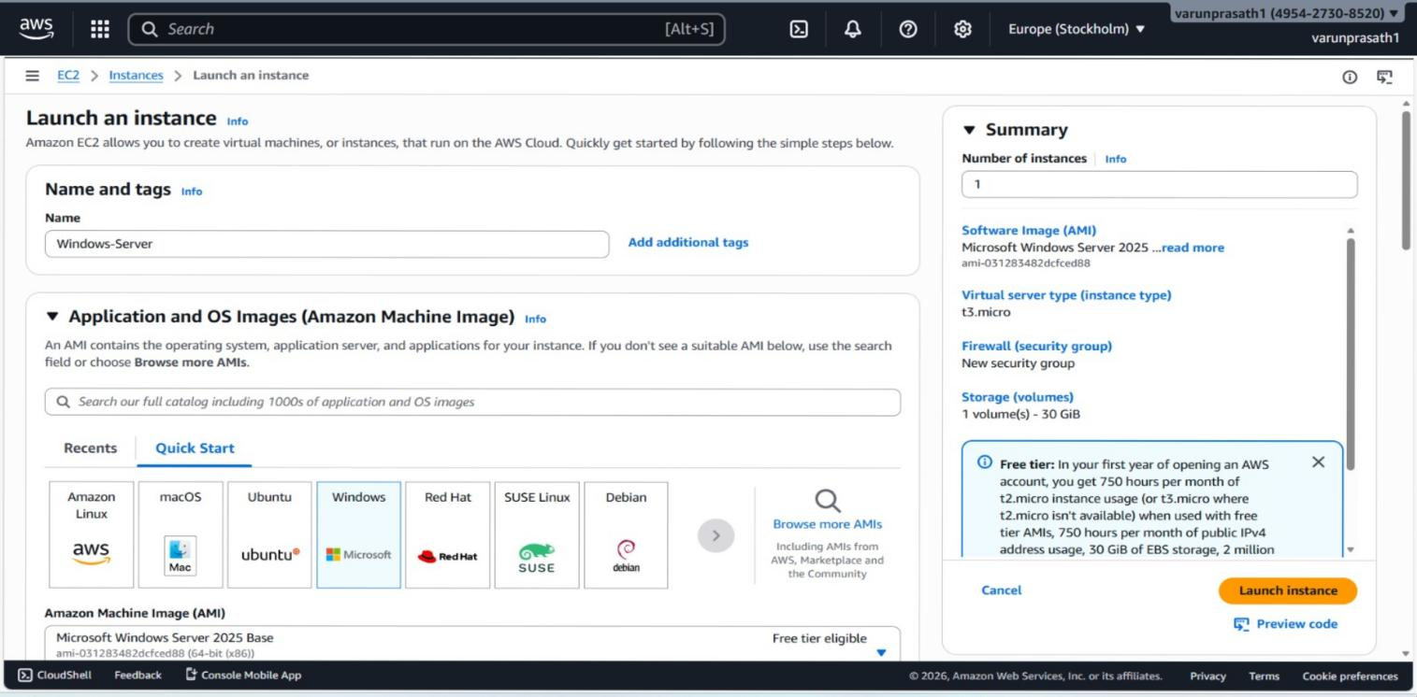

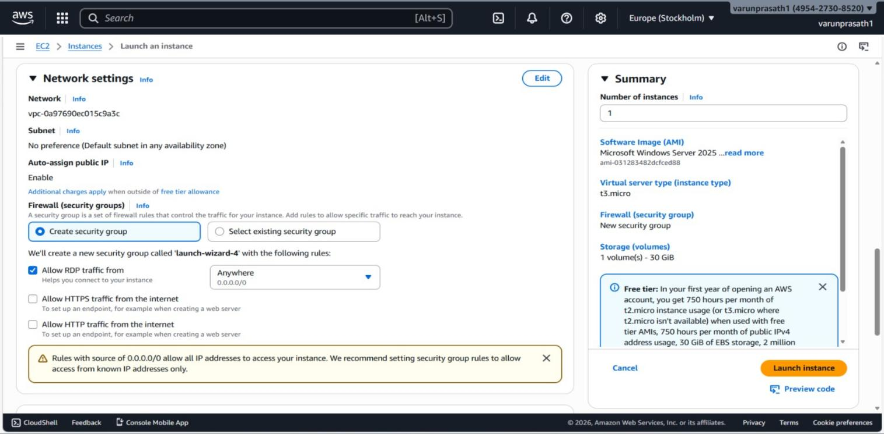

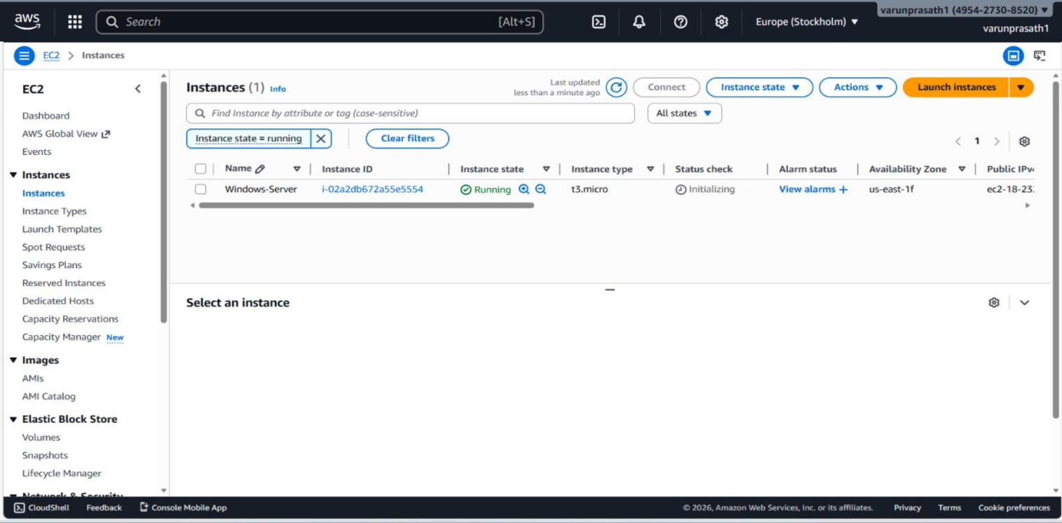

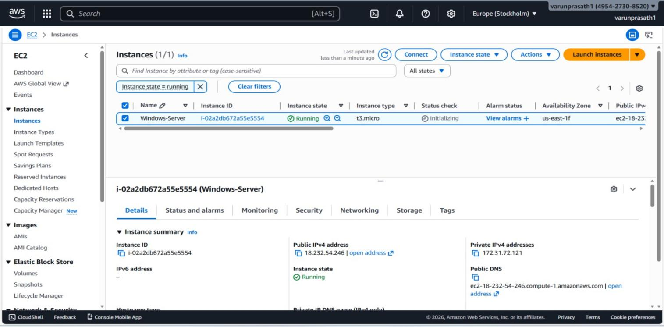











AWS Solution Architect Training with
AWS Cloud Practitioner Global Certification Training Capstone Projects

Trainer: Aravindraj.G- Nminds Academy AWS Academy Certified Educator

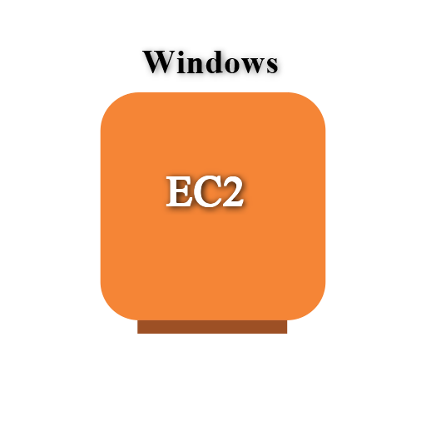

Configure IIS Webserver on Windows Server in AWS

VARUN PRASATH.M
CSE-Artificial Intelligence & Machine Learning,
Sri Eshwar College of Engineering,
Coimbatore.


Objective

An EC2 Windows instance is a virtual machine running the Microsoft Windows operating system on Amazon Web Services (AWS) EC2 (Elastic Compute Cloud). This allows you to run Windows-based applications, manage Windows Server configurations, and use various Microsoft software (like SQL Server, IIS, etc.) in the cloud without having to manage physical hardware.

IIS (Internet Information Services) is a web server software created by Microsoft for hosting websites and web applications on Windows Server operating systems. It provides a platform for building, deploying, and managing web-based applications. IIS supports multiple protocols, including HTTP, HTTPS, FTP, and more, and is tightly integrated with the Windows OS.
Common Use Cases of IIS:
  - Hosting Websites: IIS is often used by businesses and developers to host websites and web applications, particularly those built with ASP.NET.
  - Web Applications: For applications that require robust back-end support, IIS provides features like application pooling and security for web services (e.g., SOAP or RESTful APIs).
  - Secure File Sharing: IIS can be configured as an FTP server to securely share files between different locations.
  - Application Hosting in Enterprises: Many enterprise applications built on Microsoft technologies rely on IIS for deployment, such as SharePoint, Exchange Server, or Dynamics CRM.
  - API Hosting: IIS is commonly used to host APIs (e.g., RESTful services) built with .NET or other technologies.

Used Services in AWS

Used Services in Windows Server
IIS- Internet Information Services





www.nmin +91-95141 49235 NmindsAcademy
dsacademy.in
Amazon EC2





Topology

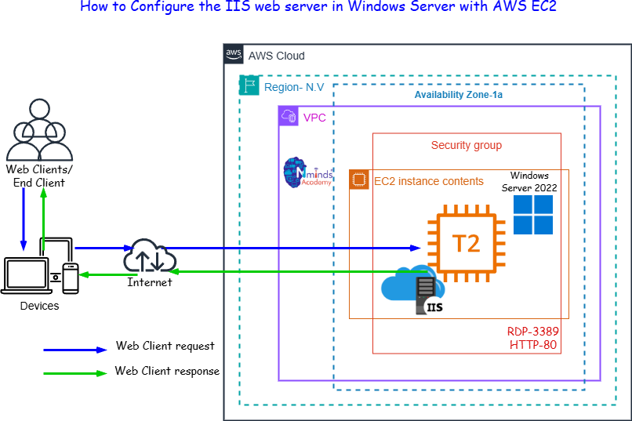





Execution Tasks:

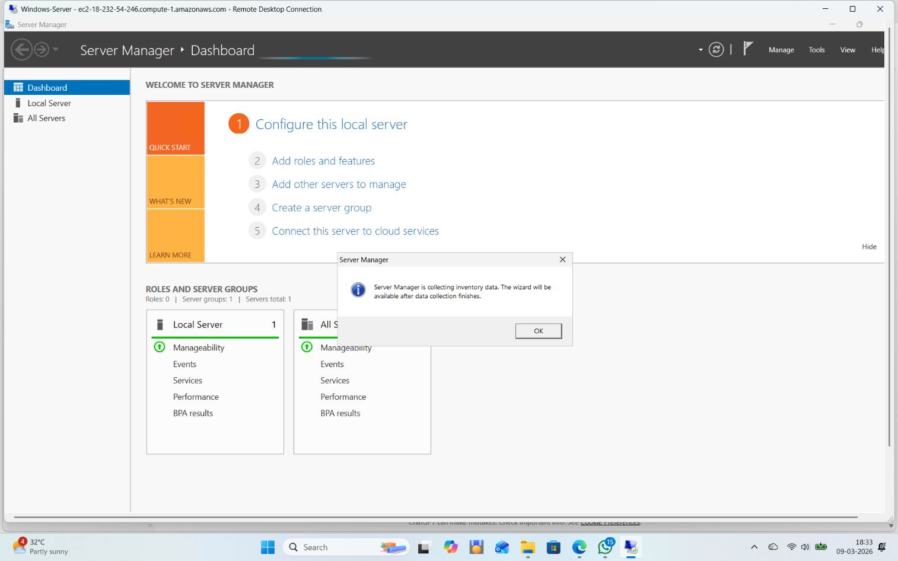

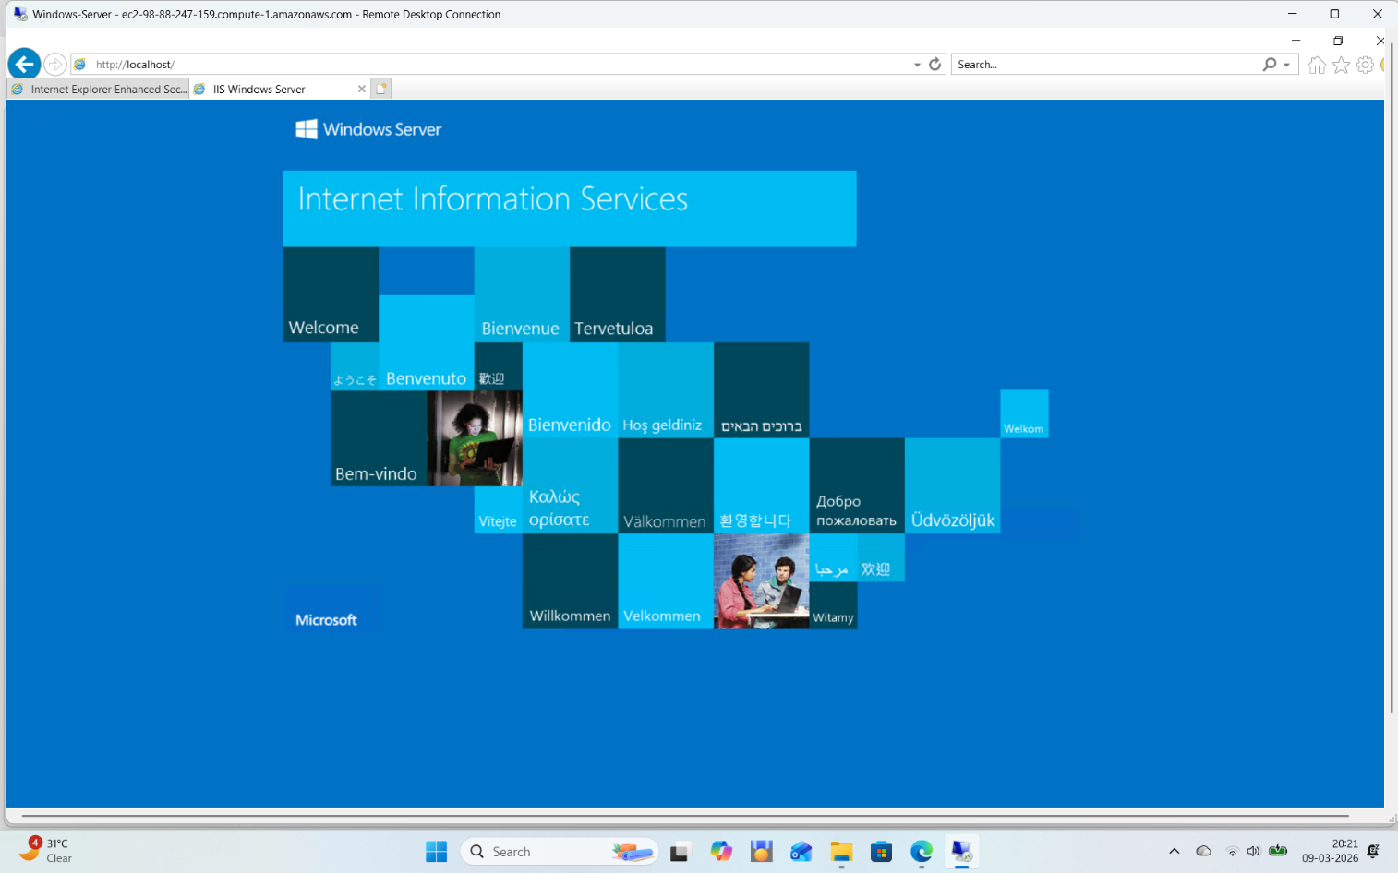







AWS Solution Architect Training with AWS Cloud Practitioner Global Certification
Capstone Projects

Trainer: Aravindraj.G- Nminds Academy AWS Academy Certified Educator




Configure Elastic IP Address to Windows Web Server in AWS

VARUN PRASATH M CSE-Artificial Intelligence & Machine Learning,
Sri Eshwar College of Engineering,
Coimbatore.





Objective

An Elastic IP (EIP) in AWS is a static, public IP address designed for dynamic cloud computing. It is associated with your AWS account and can be quickly associated or disassociated with any EC2 instance in your account. This feature is particularly useful when you need to maintain a consistent IP address for your resources, even when you stop and start EC2 instances.

Common Use Cases for Elastic IP:
- Highly Available Applications:
  - If you're running a service that requires high availability, you can use Elastic IPs to quickly reassign a static IP to a new instance if your primary instance fails, ensuring minimal downtime.
- Web Servers:
  - If you host a website and need to ensure the IP address remains the same even if the underlying EC2 instance is restarted, an Elastic IP helps maintain this consistency.
- Disaster Recovery:
  - Elastic IPs are useful for disaster recovery scenarios. If one instance goes down, you can quickly associate the EIP with a backup instance to ensure services are still accessible.
Best Practices:
  - Use Elastic IPs only when necessary: Since they come with associated costs when unused, it's a good practice to release EIPs that are no longer required.
  - Move IPs during instance failure: Instead of keeping an EIP permanently attached, use it as a failover method, reassociating it to a new instance when needed.
  - Monitor EIP Usage: Periodically review your usage to ensure you're not paying for unnecessary Elastic IP addresses.





Topology

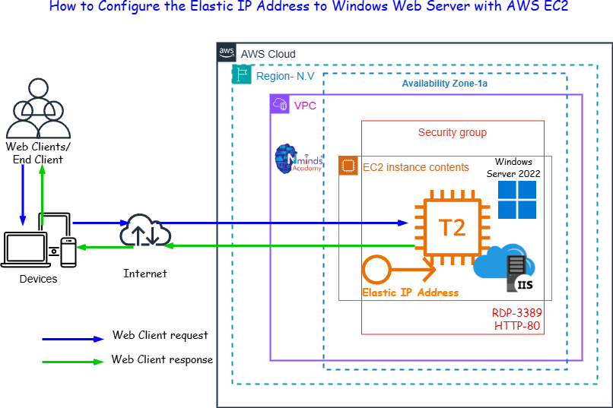

Used Services in AWS

Used Services in Windows Server
IIS- Internet Information Services


Amazon EC2


Amazon Elastic IP Address





Execution Tasks:

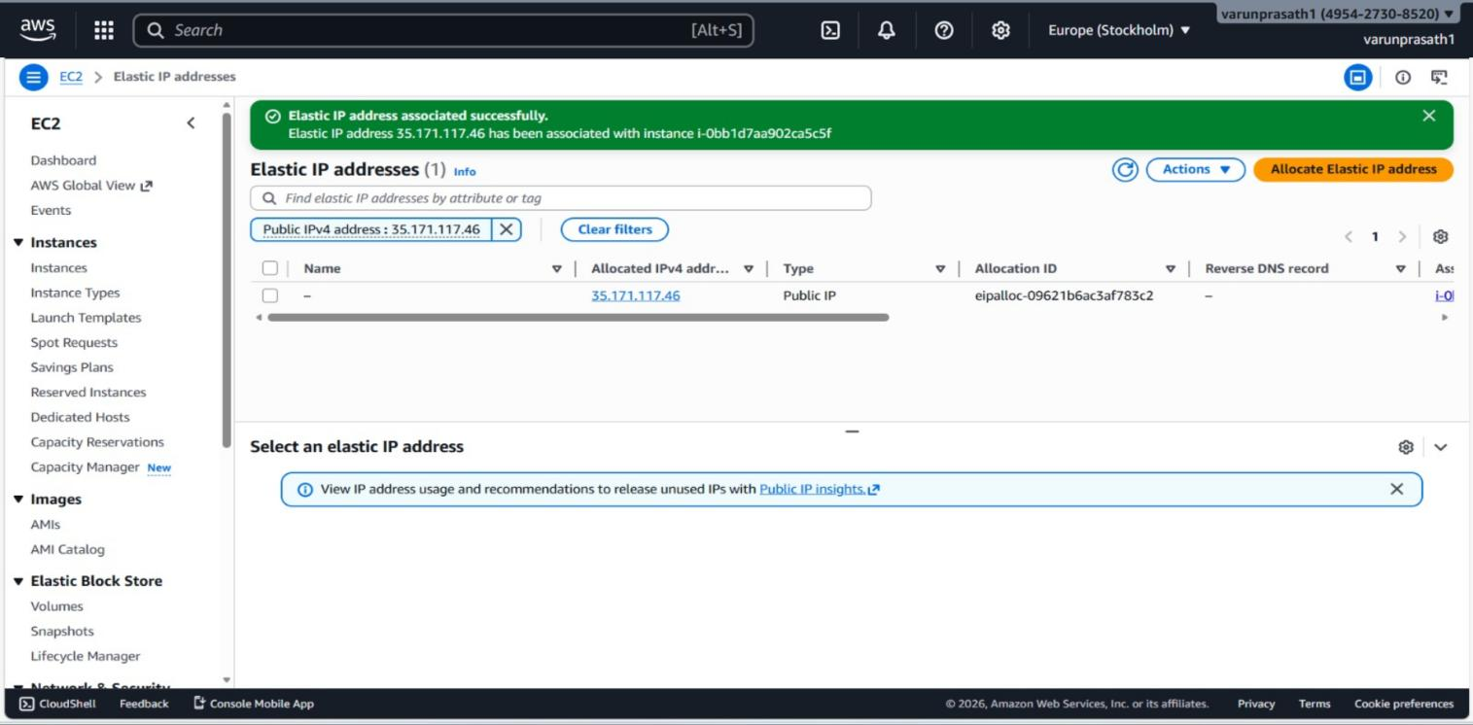








AWS Solution Architect Training with AWS Cloud Practitioner Global Certification
Capstone Projects

Trainer: Aravindraj.G- Nminds Academy AWS Academy Certified Educator

Create an EC2 Linux Instance in AWS




VARUN PRASATH M
CSE-Artificial Intelligence & Machine Learning,
Sri Eshwar College of Engineering,

Coimbatore.

Objective
EC2 (Elastic Compute Cloud) is a core service provided by Amazon Web Services (AWS) that enables users to rent virtual servers in the cloud to run applications, store data, or handle computational workloads.

An EC2 Linux instance is a virtual machine running the Linux operating system on Amazon Web Services (AWS) EC2 (Elastic Compute Cloud). This allows you to run Windows-based applications, manage Windows Server configurations, and use various Microsoft software (like SQL Server, Apache,FileServer etc.) in the cloud without having to manage physical hardware.

Use Cases for EC2 Linux Instances:
- Web and Application Hosting: Run Apache web servers or other Linux- based web applications in the cloud.
- Database Servers: Host SQL Server databases with EC2 Linux instances, using SSH or EC2 for more control.
- Remote Desktop Applications: Set up SSH (Remote Desktop Services) for remote access to Linux desktops in the cloud.
- Development and Testing: Create development environments with linux OS to test php,MySql or other Linux-based applications.

Used Services in AWS


Amazon EC2




Topology




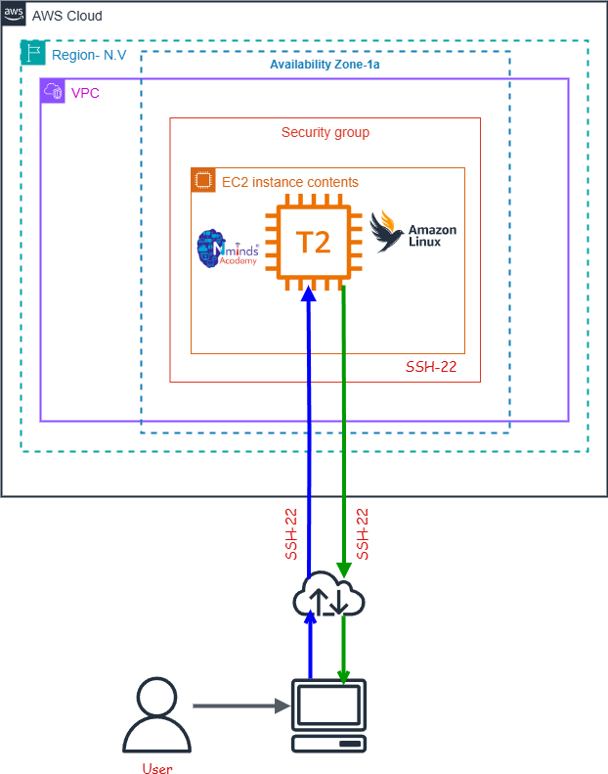





Execution Tasks:

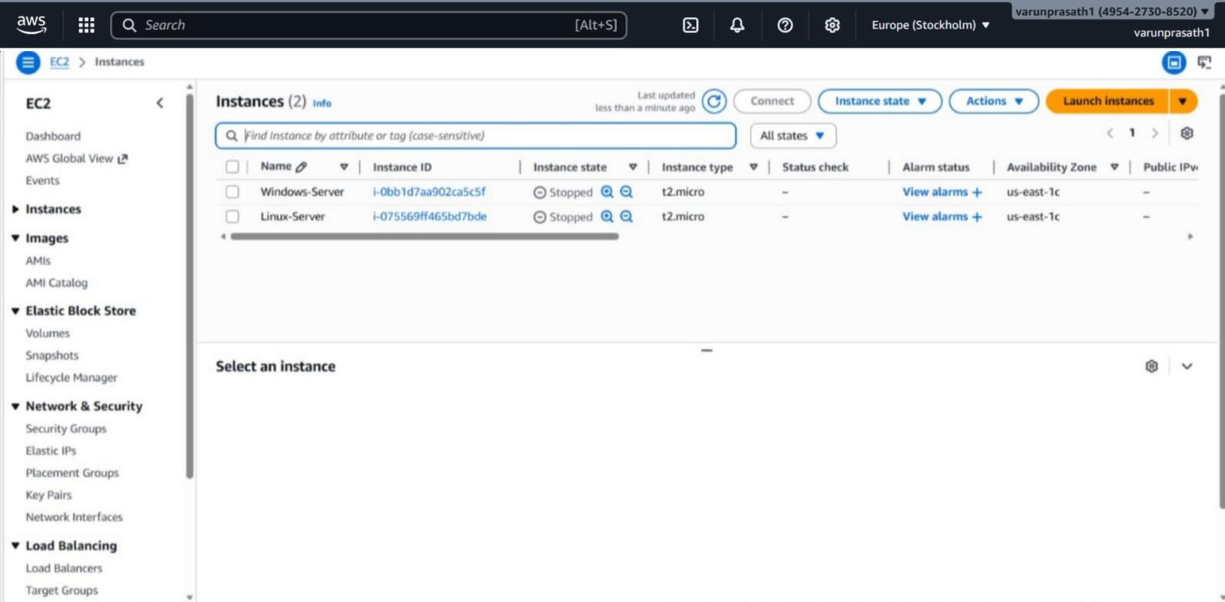






AWS Solution Architect Training with AWS Cloud Practitioner Global Certification
Capstone Projects

Trainer: Aravindraj.G- Nminds Academy AWS Academy Certified Educator

Configure Apache Web Server on Linux Instance in


AWS

VARUN PRASATH M
CSE-Artificial Intelligence & Machine Learning,
Sri Eshwar College of Engineering,
Coimbatore.

Objective
EC2 (Elastic Compute Cloud) is a core service provided by Amazon Web Services (AWS) that enables users to rent virtual servers in the cloud to run applications, store data, or handle computational workloads.

An EC2 Linux instance is a virtual machine running the Linux operating system on Amazon Web Services (AWS) EC2 (Elastic Compute Cloud). This allows you to run Windows-based applications, manage Windows Server configurations, and use various Microsoft software (like SQL Server, Apache,FileServer etc.) in the cloud without having to manage physical hardware.

Use Cases for EC2 Linux Instances:
- Web and Application Hosting: Run Apache web servers or other Linux- based web applications in the cloud.
- Database Servers: Host SQL Server databases with EC2 Linux instances, using SSH or EC2 for more control.
- Remote Desktop Applications: Set up SSH (Remote Desktop Services) for remote access to Linux desktops in the cloud.
- Development and Testing: Create development environments with linux OS to test php,MySql or other Linux-based applications.



Used Services in AWS Used Services in Linux Server

Apache Webserver
Amazon EC2





Topology

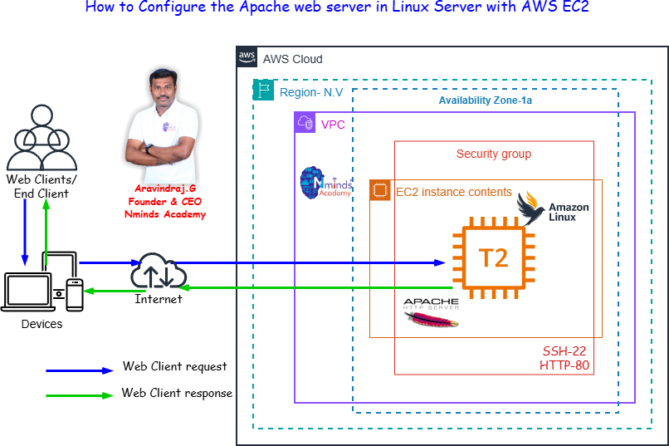




Execution Tasks:

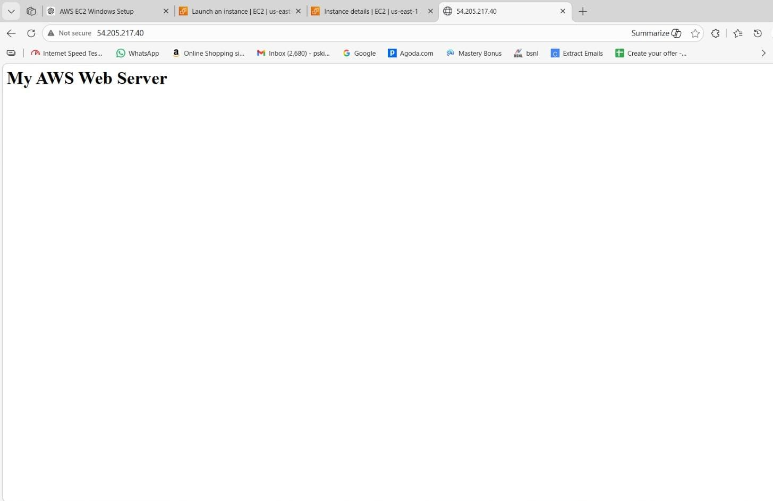







AWS Solution Architect Training with AWS Cloud Practitioner Global Certification
Capstone Projects

Trainer: Aravindraj.G- Nminds Academy AWS Academy Certified Educator

Configure Elastic IP Address to Windows Web Serverin AWS

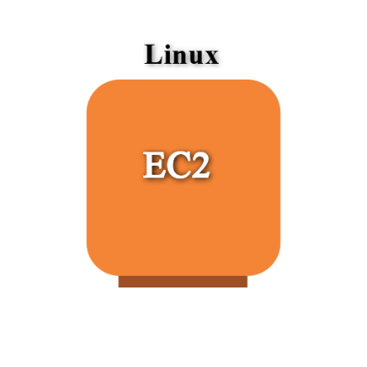


VARUN PRASATH M
CSE-Artificial Intelligence & Machine Learning,
Sri Eshwar College of Engineering,
Coimbatore.

Objective

An Elastic IP (EIP) in AWS is a static, public IP address designed for dynamic cloud computing. It is associated with your AWS account and can be quickly associated or disassociated with any EC2 instance in your account. This feature is particularly useful when you need to maintain a consistent IP address for your resources, even when you stop and start EC2 instances.

Common Use Cases for Elastic IP:
- Highly Available Applications:
  - If you're running a service that requires high availability, you can use Elastic IPs to quickly reassign a static IP to a new instance if your primary instance fails, ensuring minimal downtime.
- Web Servers:
  - If you host a website and need to ensure the IP address remains the same even if the underlying EC2 instance is restarted, an Elastic IP helps maintain this consistency.
- Disaster Recovery:
  - Elastic IPs are useful for disaster recovery scenarios. If one instance goes down, you can quickly associate the EIP with a backup instance to ensure services are still accessible.
Best Practices:
  - Use Elastic IPs only when necessary: Since they come with associated costs when unused, it's a good practice to release EIPs that are no longer required.
  - Move IPs during instance failure: Instead of keeping an EIP permanently attached, use it as a failover method, reassociating it to a new instance when needed.
  - Monitor EIP Usage: Periodically review your usage to ensure you're not paying for unnecessary Elastic IP addresses.






Amazon Elastic IP Address
Topology

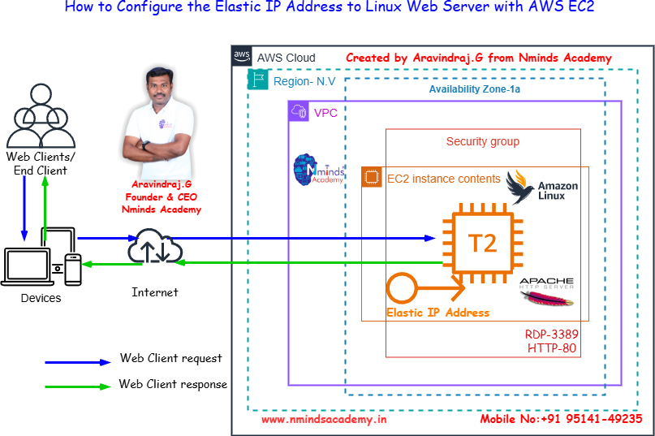


Used Services in AWS Used Services in Windows Server

Apache Webserver


Amazon EC2




Execution Tasks:

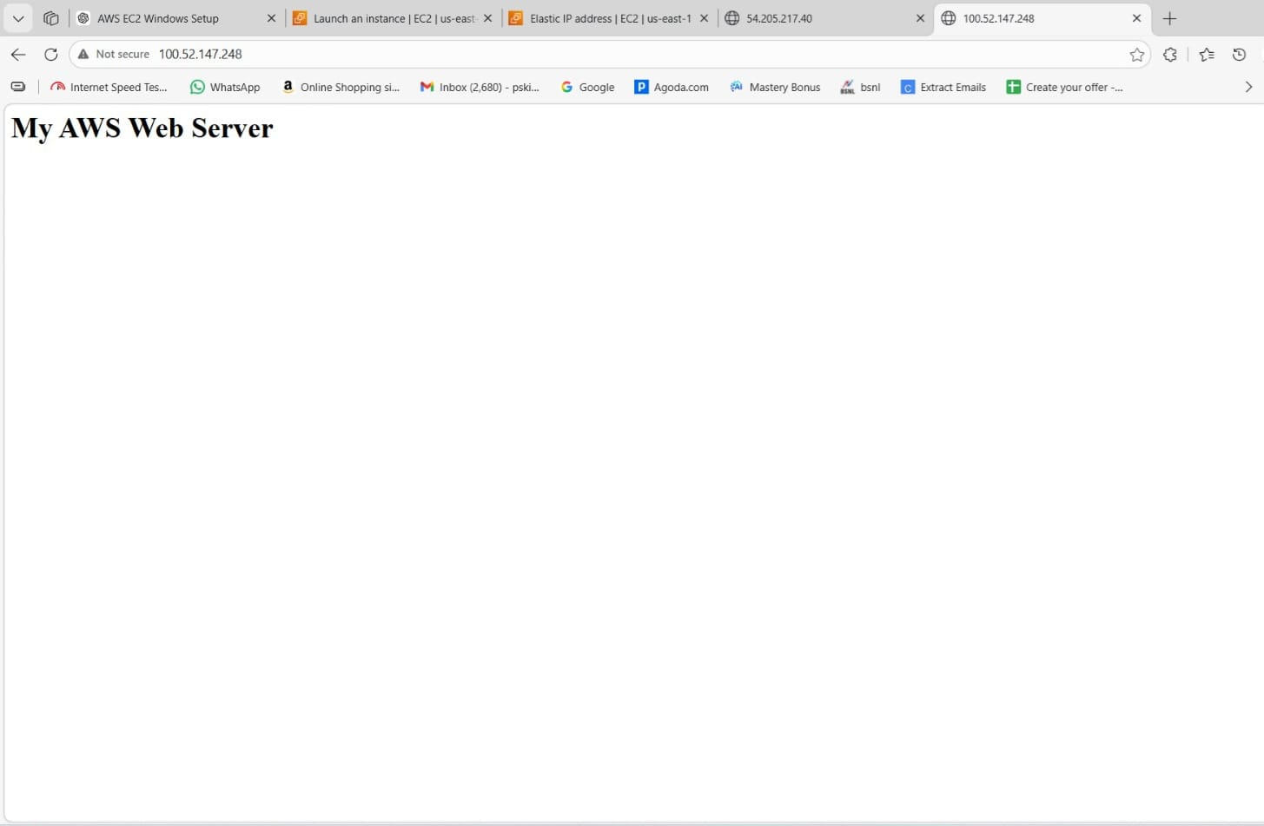







AWS Solution Architect Training with AWS Cloud Practitioner Global Certification
Capstone Projects

Trainer: Aravindraj.G- Nminds Academy AWS Academy Certified Educator

Configure SFTP to Linux Web Server in AWS




VARUN PRASATH M
CSE-Artificial Intelligence & Machine Learning,
Sri Eshwar College of Engineering,
Coimbatore.




Objective
EC2 (Elastic Compute Cloud) is a core service provided by Amazon Web Services (AWS) that enables users to rent virtual servers in the cloud to run applications, store data, or handle computational workloads.
Use Cases for EC2 Linux Instances:
- Web and Application Hosting: Run Apache web servers or other Linux- based web applications in the cloud.
- Database Servers: Host SQL Server databases with EC2 Linux instances, using SSH or EC2 for more control.
- Remote Desktop Applications: Set up SSH (Remote Desktop Services) for remote access to Linux desktops in the cloud.
- Development and Testing: Create development environments with linux OS to test php,MySql or other Linux-based applications.
SFTP- Secure File Transfer Protocol
SFTP (Secure File Transfer Protocol) is a secure network protocol that allows users to transfer files over a secure, encrypted connection. It is a more secure alternative to FTP (File Transfer Protocol) and is commonly used to upload, download, and manage files on remote servers.
Here are the key uses and advantages of SFTP:
  - File Transfer: SFTP allows secure transfer of files between a local and a remote computer over a network. It ensures that the data is encrypted during transmission, protecting it from eavesdropping or tampering.
  - File Management: Besides transferring files, SFTP also allows users to perform file management tasks such as renaming, deleting, and moving files on the remote server.
  - Secure Authentication: SFTP uses SSH (Secure Shell) for authentication, which provides a stronger level of security compared to FTP's traditional username/password system. It often supports public key authentication, adding an extra layer of security.
  - Encryption: The main advantage of SFTP over FTP is encryption. All data sent over SFTP is encrypted, ensuring that sensitive information (like passwords and files) is protected during transmission.





  - Firewall-Friendly: SFTP operates over a single port (usually port 22), making it easier to use behind firewalls and NAT (Network Address Translation) devices compared to FTP, which uses multiple ports.

Topology

Apache Webserver

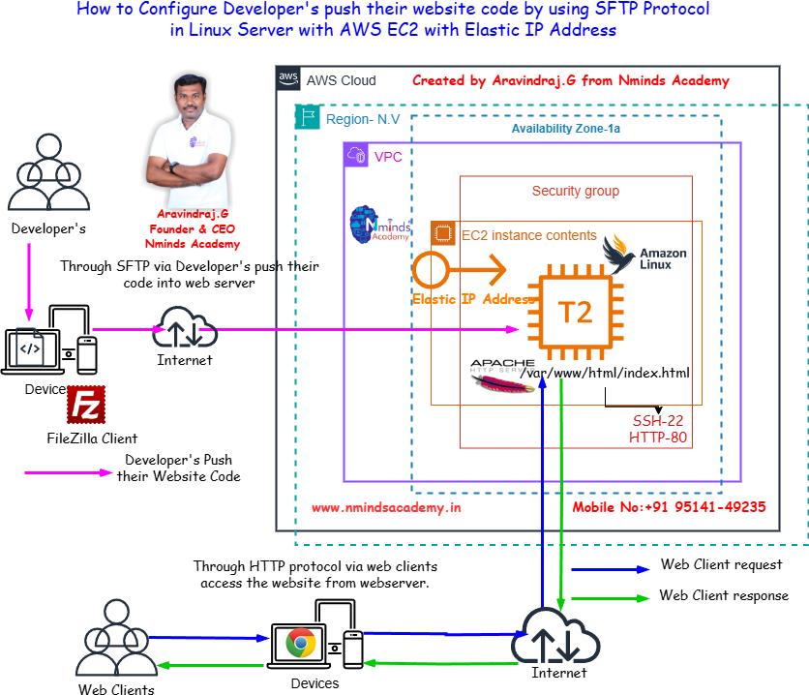
Used Services in AWS Used Services in Windows Server


Amazon EC2







Amazon Elastic IP Address

Execution Tasks:





