Task-2: Connecting Android Device with Flutter & Screen Mirroring using Scrcpy

Screenshot 1: USB Debugging Enabled
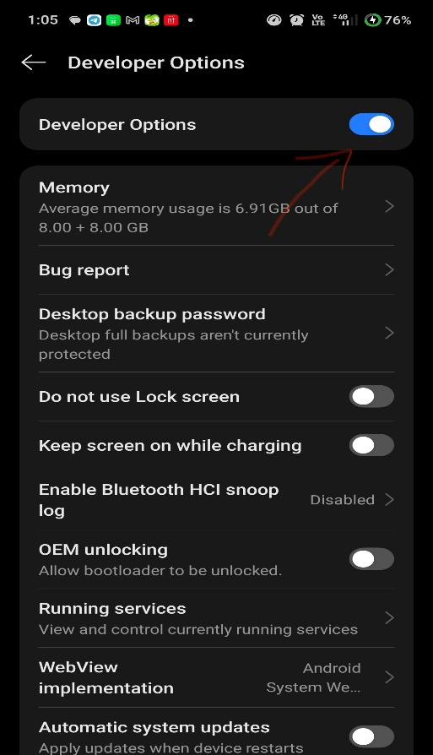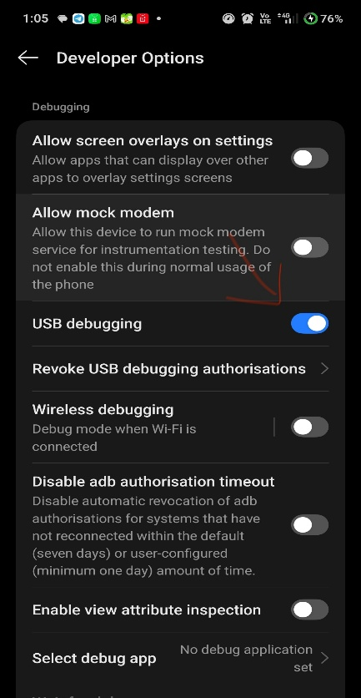
Screenshot 2: Flutter Devices Output
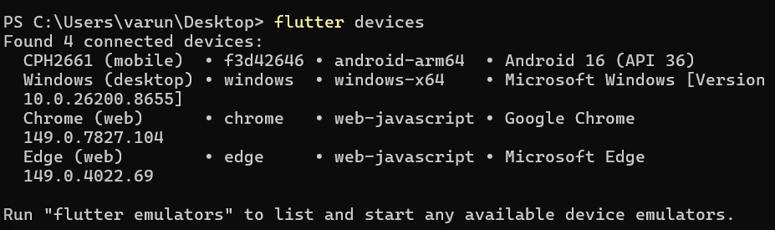
Screenshot 3: Flutter Run Successful
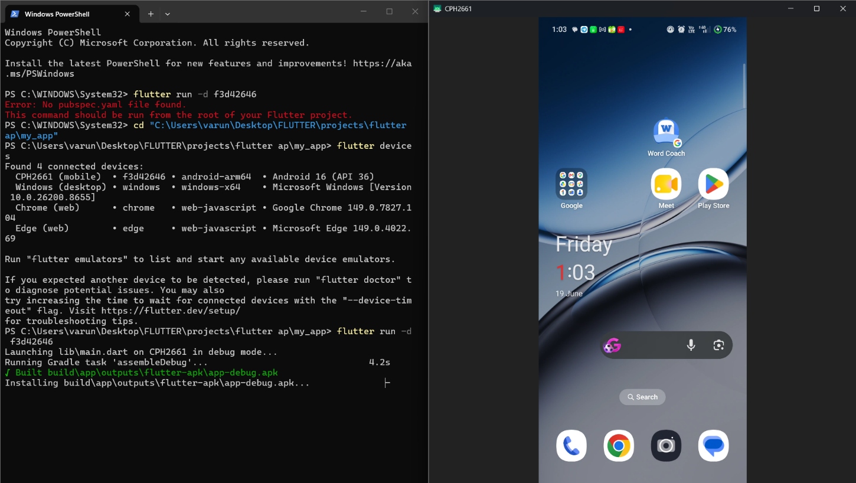

Screenshot 4: Flutter App Running on Device
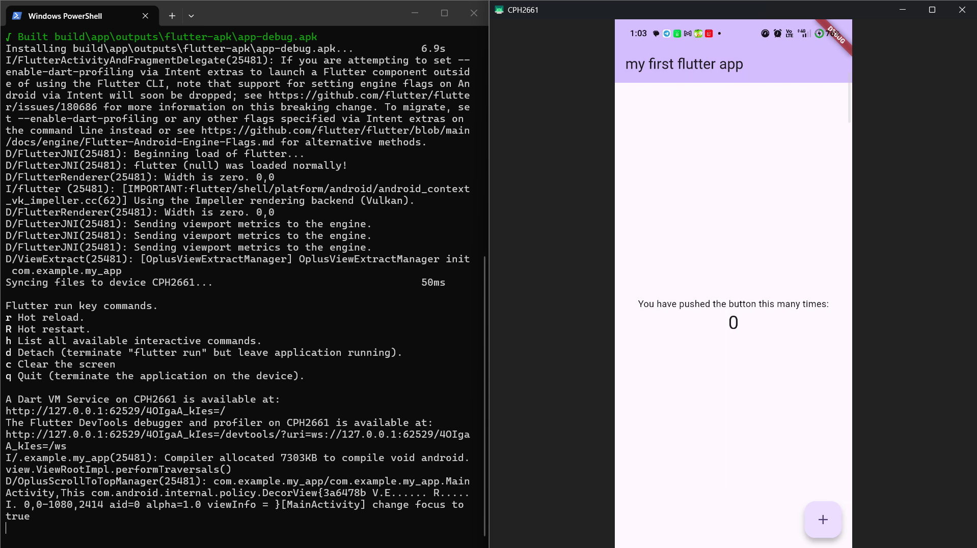
Screenshot 5: Scrcpy Screen Mirroring