|  |  |
| --- | --- |
|  |  |
| **Small Group Plan Benefits Proposal** | |

**Prepared for: «GroupName»**

**Effective Date: «EffectiveDate»**

«DateCreated»

Prepared for: «GroupName»

Effective date: «EffectiveDate»

Thank you for your interest in AvMed. Attached are the preliminary premium rates for the Group coverage you requested, as well as benefit details for each plan option. These rates are based on the information you provided and the effective date indicated above.

Choosing a health benefit plan for your employees is an important decision. With AvMed, you and your employees will receive the support you need to navigate through the health system and to make smart decisions that will help you live better today and feel better tomorrow. In addition, some plans now feature AvMed Preventive Plus, which adds 1, 2 or 3 no-cost visits to an employee’s Primary Care Physician (PCP), on top of the annual no-cost physical!

* + **3** additional free PCP visits on Platinum Plans
  + **2** additional free PCP visits on Gold Plans
  + **1** additional free PCP visit on Silver Plans

Preventive Plus is part of AvMed’s CenteredCare concept, which places the PCP at the center of the Member’s healthcare experience. As a trusted advisor, partner, health coach, navigator and collection hub for the complete medical record, CenteredCare positions the PCP at the premier vantage point.

**AvMed Group health plans feature:**

* Affordable, high-quality plans
* Essential health benefits as required by the Affordable Care Act (ACA)
* Extensive local network of doctors and hospitals
* Virtual Visits – Talk to a doctor from anywhere 24/7
* SmartShopper – Compare prices before deciding on medical procedures
* Emergency worldwide coverage
* No charge for preventative care services
* Fully-integrated Health Savings Account (HSA) administration
* A nearly 50-year tradition of award-winning service
* 24/7 online access for members to manage their accounts

AvMed strives to provide the best possible experience when choosing health care coverage for your employees and their families. I will be happy to answer any questions you may have.

Sincerely,

«PreparedBy»

«AgencyName»

«AgencyPhNo»

«PBEmail»

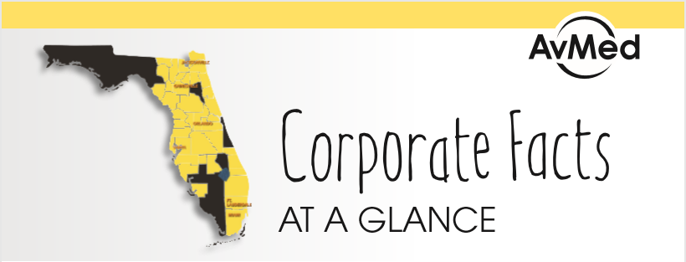

AvMed is a Florida-based health plan headquartered in Miami, with offices in Fort Lauderdale, Gainesville and Orlando and serving the Jacksonville and Tampa markets. Approximately **275,000** Members count on AvMed for their Employer Group, Medicare and Individual and Family plan coverage.

* Members have the support of nearly **600 employee Associates** and a **35,000 plus strong Provider Network**.
* AvMed transforms lives to create a **WELLfluent** world – having or striving to have a truly balanced life, rich in what matters most-health and happiness. By uniting around this sole purpose over our near-50-year history, we’re focused on servicing the needs of our Members who have made it their goal to lead a happy and healthy life. Whether you’re healthy already and trying to stay that way, or managing a chronic condition, AvMed is your lifelong partner in health.
* AvMed provides peace of mind by offering healthcare plans, online tools, value added services and solutions that deliver better service, quality, affordability and health.
* AvMed offers a variety of **affordable coverage solutions** for businesses of all sizes in most major metropolitan areas of the state, including self-funded options.*
* 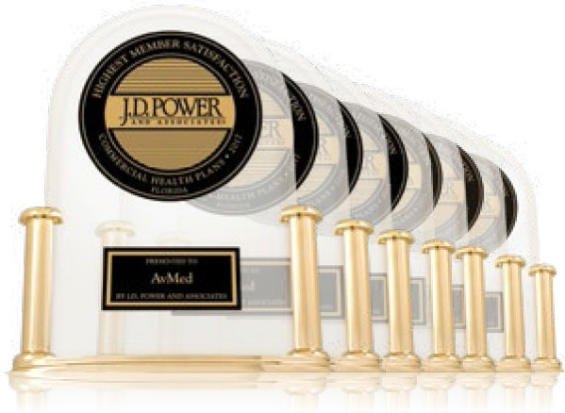J.D. Power ranked AvMed “**Highest in Member Satisfaction among Commercial Health Plans in Florida, Seven Years in a Row**.”

** AvMed’s overall score was not only the highest in the Florida region, it was seventh highest in the nation among 163 plans included in the 2018 J.D. Power Commercial Member Health Plan Study. Plus, we topped the region in four study factors: coverage and benefits, cost, provider choice and claims processing.In an annual survey of Florida physicians, AvMed consistently comes out ahead of all other plans, while **9 out of 10 say they recommend us to their patients and peers**. **

* **Year after year, AvMed receives the highest overall rating of any statewide Florida plan** in the Consumer Assessment of Health Plans Study (CAHPS®).****
* AvMed measures its performance each year against the National Healthcare Effectiveness Data and Information Set (HEDIS®), developed by NCQA. AvMed’s already strong **2017 performance improved in 71% of the commercial accreditation measures and in 27% of the measures for Medicare**.*****
* AvMed Medicare Star Power continues with the Centers for Medicare and Medicaid Services (CMS) awarding **AvMed Medicare 4 out of 5 stars** for its quality and performance.****** That’s quite an accomplishment in the competitive Medicare Advantage health plan arena.
* AvMed’s holding company, Gainesville-based SantaFe HealthCare, Inc., is a family of not-for-profit companies with more than 1,900 employee Associates. In addition to AvMed, SantaFe operates Haven of North Central Florida, Visiting Nurse Association and Hospice of the Florida Keys, and SantaFe Senior Living, which offers unique, luxury campuses in Gainesville, as well as the metropolitan areas in Miami and Naples areas.

One or more AvMed products offered in areas shaded in yellow.

** AvMed received the highest score in Florida in the J.D. Power 2012-2018 U.S. Member Health Plan Studies of customers’ satisfaction with their commer¬cial health plan. Visit jdpower.com/awards.

*** Wax Communications, 2017.

**** Highest overall rating of statewide plans reporting Health Maintenance Organization (HMO) and Point of Service (POS) product data to the National Committee for Quality Assurance (NCQA) for the Consumer Assessment of Healthcare Providers and Systems (CAHPS), CAHPS® is a registered trademark of the Agency of Healthcare Research and Quality (AHRQ).

***** HEDIS® is a registered trademark of the National Committee for Quality Assurance (NCQA).

****** Medicare evaluates plans based on a 5-star rating system. Star ratings are calculated each year and may change from one year to the next.

MP-5696 (07/18)