**Bags**

Whether you’re planning a trip or heading to the airport, we can help you find more info about traveling with bags.

Carry-on bags

You can bring one carry-on bag and one personal item for free on most flights.

Carry-on bags

Your bag must fit in the overhead bin, so it must be 9 in x 14 in x 22 in (23 cm x 35 cm x 56 cm). When measuring include the handle and wheels.

Personal item

Must fit under the seat in front of you, so they must be 9 in x 10 in x 17 in (22 cm x 25 cm x 43 cm). Common items include purses and backpacks.

In most cases you can only bring one personal item when you’re flying in Basic Economy.

Carry-on bags

You can bring one carry-on bag and one personal item for free on most domestic and international flights. But there are a few rules you’ll need to follow.

Size limits

Make sure your bags meet our size limits before you get to the airport.

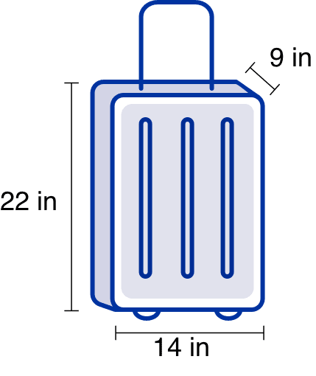

Carry-on bags

Your Carry-on bag must fit in the overhead bin, so it must be 9 in x 14 in x 22 in (23 cm x 35 cm x 56 cm). When measuring your bag, be sure to include the handle and wheels.

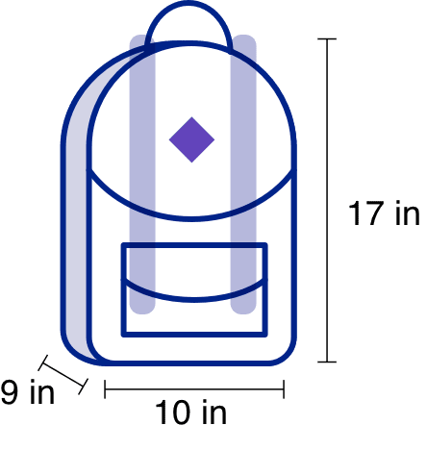

Personal items

These items must fit under the seat in front of you, so they must be 9 in x 10 in x 17 in (22 cm x 25 cm x 43 cm). Common things include purses, backpacks and laptop bags.

If you’re at the airport and not sure if your bag is the right size, you can use our bag sizers to measure your bag.

**Traveler pro tips**

You can bring a few items in addition to your carry-on bag and personal item for free.

* Jacket or coat
* Umbrella
* Things to read
* Food or other items bought at the airport
* [Mobility devices](https://www.united.com/en/us/fly/travel/accessibility-and-assistance/wheelchair-assistance.html), including wheelchairs, canes, and crutches
* [A car seat, child safety harness or stroller](https://www.united.com/en/us/fly/travel/accessibility-and-assistance/traveling-with-children.html)
* [A diaper bag and breast pump](https://www.united.com/en/us/fly/travel/accessibility-and-assistance/traveling-with-children.html) (even if you’re not traveling with your child)
* Camera

Special items

Some items have a few extra rules for how they can be packed. We also always recommend [checking with the TSA](https://www.tsa.gov/travel/security-screening/whatcanibring/all) before packing anything you’re unsure of in your carry-on.

<https://www.tsa.gov/travel/security-screening/whatcanibring/all>

* **Smart bags**

If you have a smart bag that uses lithium batteries, the batteries must be removed before they’re brought on board.

* **Liquid, gels and sprays**

The [TSA allows](https://www.tsa.gov/travel/security-screening/whatcanibring/all) you to bring liquids, gels and sprays in your carry-on bag. However, the container can be no larger than 3.4 ounces (100 mL) and must be placed inside a quart-size clear, sealable bag.

* **Powders**

The [TSA recommends](https://www.tsa.gov/travel/security-screening/whatcanibring/all) you place powders in your checked bags. But you can bring up to 12 ounces (350 mL) in your carry-on bag when you fly domestically in the U.S.

* **Musical intruments**

You can bring a small instrument on your flight in a hard case. It’ll be considered your carry-on if you place it in the overhead bin, or your personal item if you place it under the seat in front of you. [Learn more about musical instruments](https://www.united.com/ual/en/us/fly/travel/baggage/fragile.html).

**Medication, vapes, and essentials**

Always make sure you place any medication, vapes, e-cigarettes, keys and other essentials in your personal item in case your bag is gate-checked.

You can bring medical syringes on your flight as well. If you need to use your syringes during the flight, ask a flight attendant to help you dispose of them safely

* **Fragile, bulky or unusual**

If an item is too fragile or bulky to check, or you feel it needs to be handled with special care, you can [buy a ticket for it](https://www.united.com/ual/en/us/fly/travel/baggage/seat.html).

Basic Economy

For most trips you can only bring one personal item when you’re flying in Basic Economy. You can’t bring a carry-on bag unless you’re flying to South America, across the Atlantic or across the Pacific. All other bags have to be checked. Note, if you check a carry-on at your gate, you’ll be charged the standard bag fee plus an additional $25.

If you’re a MileagePlus members with Premier status, traveling with a Premier member, are the primary card member of a [qualifying* MileagePlus credit card](https://www.united.com/en/us/fly/products/united-personal-credit-cards.html) or a Star Alliance Gold member you can bring one free carry-on bag.

*The United GatewaySM Card and the United MileagePlus® Select Card do not qualify for a free carry-on bag in Basic Economy.

Link: <https://www.united.com/en/us/fly/travel/inflight/basic-economy.html>

Gate-checked bags

Sometimes a plane is too small to fit carry-on bags or runs out of overhead space quickly. In these cases, your bag will be gate-checked for free and can be picked up when you leave the plane, rather than at baggage claim. This happens most often on United Express® flights.

* If you’re flying CommutAir, you’re only allowed one personal item on the plane.
* All other United Express carriers do allow carry-on bags but have limited space.

To find out if you’re flying on United Express, view your trip in [My Trips](https://www.united.com/en/us/manageres/mytrips). In each flight segment we’ll tell you if your flight is operated by another carrier.

If your carry-on bag is bigger than our size limits or goes over the carry-on bag allowance for your ticket and has to be checked at the gate, you can pick up your bag at baggage claim when you get to your destination.