Beginning August 1st all dogs entering the United States will need additional documents and entry requirements. All new regulations are from the Centers for Disease Control and Prevention (CDC) and US Customs and Border Protection (CBP).

[For additional information please visit the CDC website.](https://www.cdc.gov/importation/dogs/index.html)

Bringing a Dog into the U.S.

At a glance

If you are bringing a dog to the U.S., starting on August 1, 2024, there are new steps you need to take. These steps depend on where your dog has been in the past 6 months.

Background

CDC strives to protect America’s families, communities, and pets by preventing the reintroduction of dog rabies into the United States. Preventing infected dogs from entering the United States is a public health priority. CDC recommends all dogs be vaccinated against dog rabies.

Recent Changes

CDC values the feedback received from various countries, industry partners, and the public. CDC simplified the process for meeting requirements for dogs arriving from dog rabies-free or low-risk countries. This means that for dogs that have been only in dog rabies-free or low-risk countries for the last 6 months, the one form you will need is the *CDC Dog Import Form*, which should take a few minutes to complete.

Requirements are based on your dog's situation

High-Risk Countries for Dog Rabies

At a glance

If a country or political unit is *not*listed below, it is *not*considered high risk for importing dog rabies into the United States. Therefore, if the country is *not*listed, CDC strongly recommends vaccination against rabies, but the additional requirements for dogs from high-risk countries to enter the United States do not apply.

These countries and political units are considered high risk for importing dog rabies into the United States.

* Afghanistan
* Algeria
* Angola
* Armenia
* Azerbaijan
* Bangladesh
* Belarus
* Belize
* Benin
* Bolivia
* Botswana
* Brazil
* Burkina Faso
* Burundi
* Cambodia
* Cameroon
* Central African Republic
* Ceuta
* Chad
* China (excluding Hong Kong, Macau, and Taiwan)
* Colombia
* Comoros
* Côte d'Ivoire (Ivory Coast)
* Cuba
* Democratic Republic of the Congo
* Djibouti
* Dominican Republic
* Ecuador
* Egypt
* El Salvador
* Equatorial Guinea
* Eritrea
* Eswatini (Swaziland)
* Ethiopia
* Gabon
* Gambia
* Georgia
* Ghana
* Guatemala
* Guinea
* Guinea-Bissau
* Guyana
* Haiti
* Honduras
* India
* Indonesia
* Iran
* Iraq
* Israel (including the West Bank and Gaza)
* Jordan
* Kazakhstan
* Kenya
* Kuwait
* Kyrgyzstan
* Laos
* Lebanon
* Lesotho
* Liberia
* Libya
* Madagascar
* Malawi
* Malaysia
* Mali
* Mauritania
* Melilla
* Moldova
* Mongolia
* Morocco (including Western Sahara)
* Mozambique
* Myanmar (Burma)
* Namibia
* Nepal
* Niger
* Nigeria
* North Korea
* Oman
* Pakistan
* Peru
* Philippines
* Qatar
* Republic of the Congo
* Russia
* Rwanda
* São Tomé and Príncipe
* Saudi Arabia
* Senegal
* Sierra Leone
* Somalia
* South Africa
* South Sudan
* Sri Lanka
* Sudan
* Suriname
* Syria
* Tajikistan
* Tanzania (Including Zanzibar)
* Thailand
* Timor-Leste
* Togo
* Tunisia
* Turkey
* Turkmenistan
* Uganda
* Ukraine
* United Arab Emirates
* Uzbekistan
* Venezuela
* Vietnam
* Yemen
* Zambia
* Zimbabwe

More info on how to bring dogs from high-risk countries: <https://www.cdc.gov/importation/dogs/foreign-vaccinated-high-risk-countries.html>

Traveling with pets

Bringing your cat or dog with you on your trip is fun, but there are some rules you’ll have to follow. If you’re looking for information on [traveling with service animals](https://www.united.com/en/us/fly/travel/accessibility-and-assistance/service-animals.html), we can also help with that.

**Getting ready**

We no longer let you check your pets through the PetSafe program. Pets can only fly in cargo when traveling with certain [active-duty military or State Department](https://www.united.com/en/us/fly/travel/trip-planning/military-pet-program.html) employees. If you plan to fly with your pet, they must be a cat or dog and stay in the cabin with you ([if there’s space available](https://www.united.com/en/us/fly/travel/traveling-with-pets.html#where-can-i-sit)).

Some destinations don’t accept pets. Be sure to double-check before your flight.

On most flights, you can bring up to 2 pets per person. You must buy 2 seats if you’re bringing 2 pets. The second seat needs to be next to your assigned seat, so you can care for both pets.

Some of our planes have limited space under the middle seat. We only allow one pet per person on these aircraft:

* A319
* A320
* A321neo
* 737-800 and 737-8 (MAX 8)
* 737-900 and 737-9 (MAX 9)

Where can I fly with my pet?

As long as your destination allows pets, you can take them with you on any flight operated by United or United Express. If you’re flying internationally, you’ll need to call 1-800-864-8331 to add a pet to your reservation. If you’re traveling on multiple airlines, including our partners, you’ll also need to check with each one to see what their pet policy is.

United does not allow pets to fly to, from or even through the below list of states and countries.

* Australia
* Barbados
* Brazil
* Cuba
* French Polynesia (Tahiti)
* Guam *
* Guyana
* Hawaii
* Hong Kong
* Iceland
* Ireland
* Jamaica
* Marshall Islands
* Micronesia, Federated States of
* Morocco
* New Zealand
* Northern Mariana Islands (Saipan)
* Palau
* Philippines
* Saint Kitts and Nevis
* South Africa
* Sweden
* Trinidad and Tobago
* United Arab Emirates (Dubai)
* United Kingdom

* You can bring a pet on flights from Guam to Tokyo-Narita or to the U.S. mainland. You cannot bring your pet on the flight back to Guam. Pet travel from Guam to the U.S. mainland is considered international.

Make sure your pet fits

While there are no weight or breed limitations for pets, they must travel in either a hard-sided or soft-sided carrier. This carrier must fit under the seat in front of you or you cannot fly with your pet. The only animals allowed on planes without a pet carrier are [service animals](https://www.united.com/ual/en/us/fly/travel/special-needs/disabilities/assistance-animals.html).

**Hard-sided carrier**

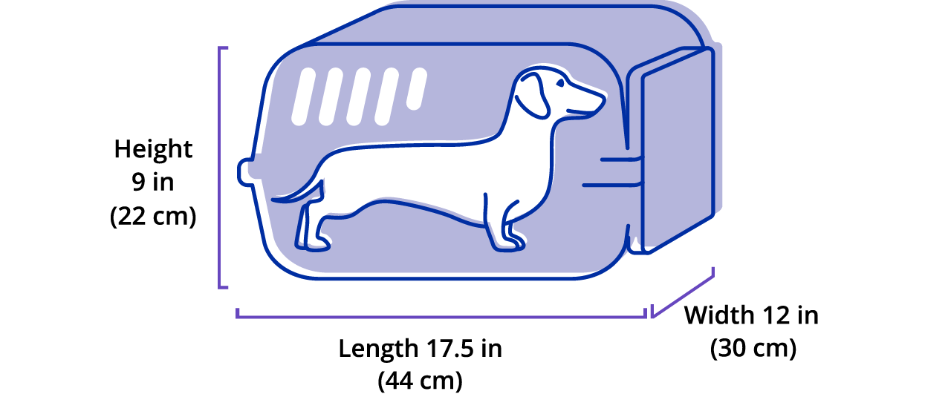

**Soft-sided carrier**

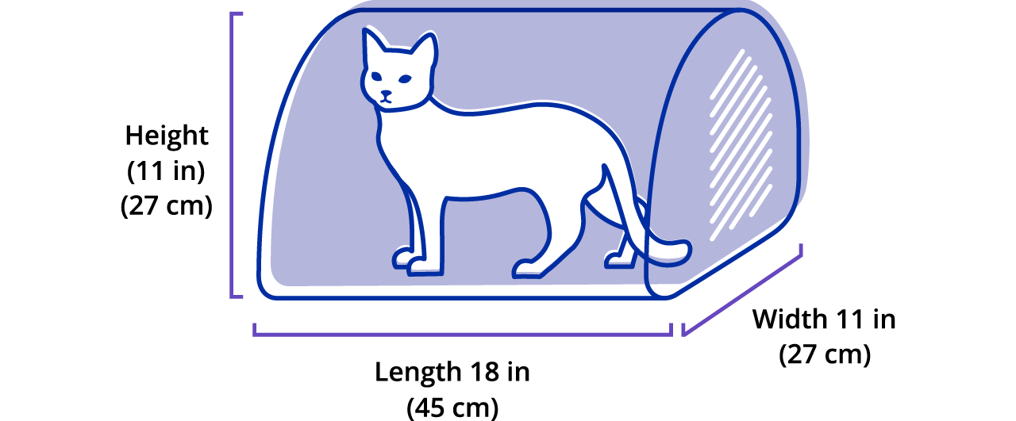

**Prepping to fly**

**Gather paperwork**

[Some countries don’t allow pets to travel](https://www.united.com/en/us/fly/travel/traveling-with-pets.html#some-countries) at all. Others have strict [rules for rabies vaccines](https://www.united.com/en/us/fly/travel/traveling-with-pets.html#rabies-rules). Make sure you have all your paperwork and proof of vaccination in order before you leave.

**Booking pet tickets**

All you have to do is select “Travel with a pet” as a traveler during booking on united.com. Or, you can go to [My Trips](https://www.united.com/en/us/manageres/mytrips) to add a pet to an existing trip. You cannot add a pet to your trip on the United app.

For tickets purchased before 4/26/24, there is a $125 fee each way for traveling with your pet. There is also a $125 fee for each layover of more than four hours for flights within the U.S. and more than 24 hours internationally. You cannot use travel credits to pay this fee.  
  
For tickets purchased on or after 4/26/24, the fee is $150 each way for traveling with your pet.

**Traveler pro tips**

We have a few recommendations to help you pack a pet-friendly travel kit:

* Remember to bring all the essentials to care for your pet while you’re still at the airport, including a collapsible water bowl, leash, treats and plastic bags.
* To keep them calm on the flight, it always helps to have a favorite toy, blanket or pillow that smells familiar.

**At the airport**

Here’s what you need to know once you get to the airport.

**Checking in**

Check in for your flight at the ticket counter. You’ll need both your own and your pet’s confirmation numbers, which you can find in your email or in [My Trips](https://www.united.com/en/us/fly/travel/traveling-with-pets.html). We’ll also give you a special bag tag for your pet’s carrier.

**Pet relief areas**

Many airports have places you can take your pet to use the bathroom while you’re there. Use the airport maps feature on the [United app](https://www.united.com/en/us/fly/travel-experience/united-app.html) to see where they’re located.

Please note, therapy and emotional support cats and dogs must fly as pets, not service animals. They must follow all rules outlined in this policy both at the airport and on the plane.

* **What are the rabies vaccination and travel restrictions?**

We require rabies and health certificates for dogs and cats traveling internationally on United. The rabies vaccinations must be completed at least 28 days before travel for both dogs and cats. This applies for all international travel, to and from the United States. Any additional rules for traveling to the U.S. depend on whether or not you’re traveling from a country the CDC considers to be high risk for rabies. We closely follow [CDC guidelines](https://www.cdc.gov/importation/dogs/foreign-vaccinated-high-risk-countries.html#cdc_generic_section_5-certification-of-foreign-rabies-vaccination-and-microchip-form) on these specific country requirements and recommend checking them to make sure you meet them at least two months before your trip.

If you’re traveling within the U.S. with your pet, we encourage you to get a certificate of health from your vet. Some destinations may request this certificate on arrival. It should include:

* + Your name, phone and address
  + Info about your pet, including breed, sex, age, color and markings
  + List of recent vaccines, including names, dates issued and expiration

**Where can I sit with my pet on the plane?**

Where you can sit with your pet depends on the type of plane you’re on. Keep in mind that while you can only bring one pet with you, each plane limits the total number of pets allowed on the same flight.

|  |  |
| --- | --- |
| **Pet max per cabin** | **Type of plane** |
| **Up to 2 pets allowed in premium cabins** | Airbus 319 Airbus 320 Boeing 7371 Boeing 757-300ER Bombardier CRJ EMB 175 EMB 145 |
| **Up to 4 pets allowed in Economy** | Airbus 319 Airbus 320 Boeing 7371 Boeing 757-2002 Boeing 757-300ER Bombardier CRJ EMB 175 EMB 145 |
| **Up to 6 pets allowed in Economy** | Boeing 767 Boeing 777 Boeing 787 |

1If you’re traveling on a Boeing 737 MAX 9, your pet carrier can be no more than 10 inches tall.  
2If you’re traveling with a pet in Economy on this type of plane, you must be in a window seat for a carrier to fit under the seat in front of you.

Please note, you cannot sit with a pet in an emergency exit row, a United Premium Plus seat, or in the front row of each cabin. Also, these guidelines are only for United flights. [Contact us](https://www.united.com/en/us/fly/customer-support/contact-directory.html) for information on United Express flights.

* **Do you have military or State Department pet exemptions?**

We do have [pet exemptions](https://www.united.com/en/us/fly/travel/trip-planning/military-pet-program.html) for members of the U.S. military on permanent change of station and their spouses, as well as State Department foreign service officers and their spouses.

* **How old do my pets have to be to fly?**

On domestic flights, puppies and kittens must be at least 2 months old. On international flights, dogs must be at least 6 months old to comply with CDC requirements. Kittens need to be 4 months old to comply with vaccination requirements.