**Formula 1 Data Analysis (United States Grand Prix)**

**Introduction:**

Formula 1 is one of the most exhilarating and technically challenging motorsport events globally, captivating millions of fans and enthusiasts worldwide. This report provides a comprehensive examination of the recent United States Grand Prix held at the Circuit of the Americas from October 20, 2023, to October 22, 2023. This analysis offers valuable insights into various aspects of the race weekend, including driver and team performance, qualifying sessions, and race dynamic.

**Qualifying Session Analysis:**

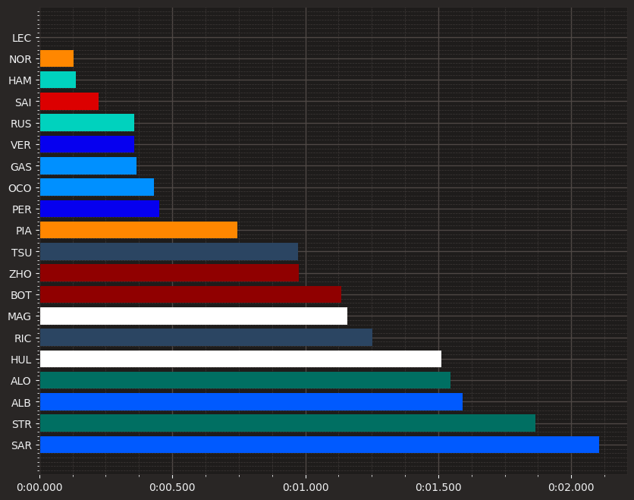

Ferrari's Charles Leclerc claimed the top spot in a nail-biting qualifying session. Initially, Max Verstappen looked set to grab pole, but a track limits violation cost him the position, handing it to Leclerc. Lando Norris also shone, earning a front-row spot.

The competition was fierce, with Lewis Hamilton narrowly behind the McLaren. However, some drivers, like Carlos Sainz, George Russell, and Oscar Piastri, struggled to keep up with their

teammates, especially Piastri, who fell behind significantly. This could be due to setup problems or challenges adapting to the Circuit of the Americas.

Alpine performed well, even beating one of the Red Bull cars. Yuki Tsunoda also impressed, leading the midfield pack.

The grid divided into two groups: the top nine were very close to pole position, with Piastri in the middle. The rest, from Tsunoda to Alex Albon, were also closely matched, except for Lance Stroll and Logan Sargeant who lagged behind.

**TOP 3 Drivers:**

1. **LEC VS VER (Deleted lap):**

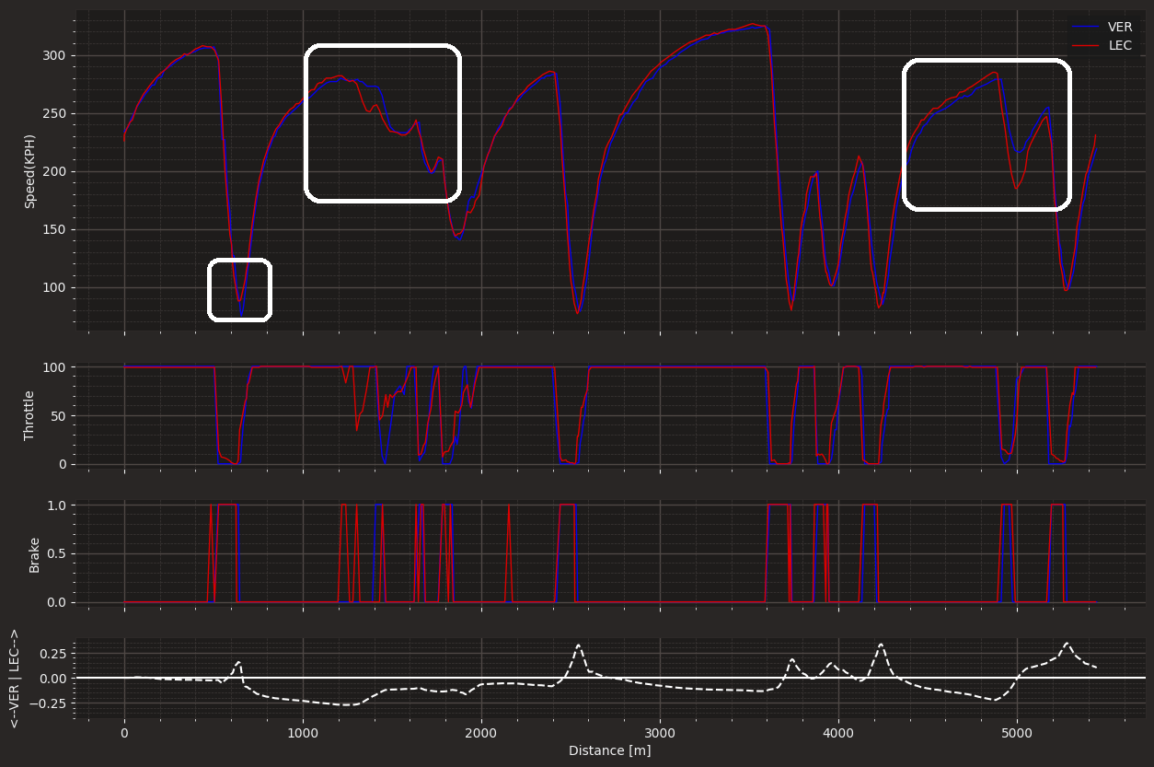

It looks like Verstappen has made a mistake into Turn 1, immediately putting him on the back foot. Nevertheless, he managed to recover some lost time in the high-speed section Turns 3, 4, 5, and 6. During this segment, the Red Bull showcased its strength in the mid to high speed corners, evident in the speed trace.

The Ferrari, on the other hand, demonstrated superior traction when exiting Turn 11. This difference in performance can be attributed to strategic differences between the drivers. Verstappen taking a later braking approach while maintaining higher apex speed, whereas Leclerc made a slight compromise in his entry to optimize his exit onto the back straight.

Notably, the Ferrari appear to be running lower downforce, reflected in their straight-line speed on the back straight and their struggles through the high speed bits. In the slow bits at the start of sector three, both drivers remained evenly matched. Leclerc managed to gain a slight advantage due to his superior traction out of Turn 15.

However, it became evident that Charles Leclerc made a significant mistake at Turn 19, nullifying the advantage he had built throughout the lap and leaving him trailing Max by 0.25 seconds. Yet, the Ferrari's strength shone through the final corner, where it excelled in traction, narrowing the gap to a mere 0.005 seconds.

Overall, it is apparent that the Ferrari's prowess lies in its ability to accelerate out of slower corners, while the Red Bull proves to be particularly adept in mid to high-speed sections of the circuit.

1. **LEC VS NOR:**

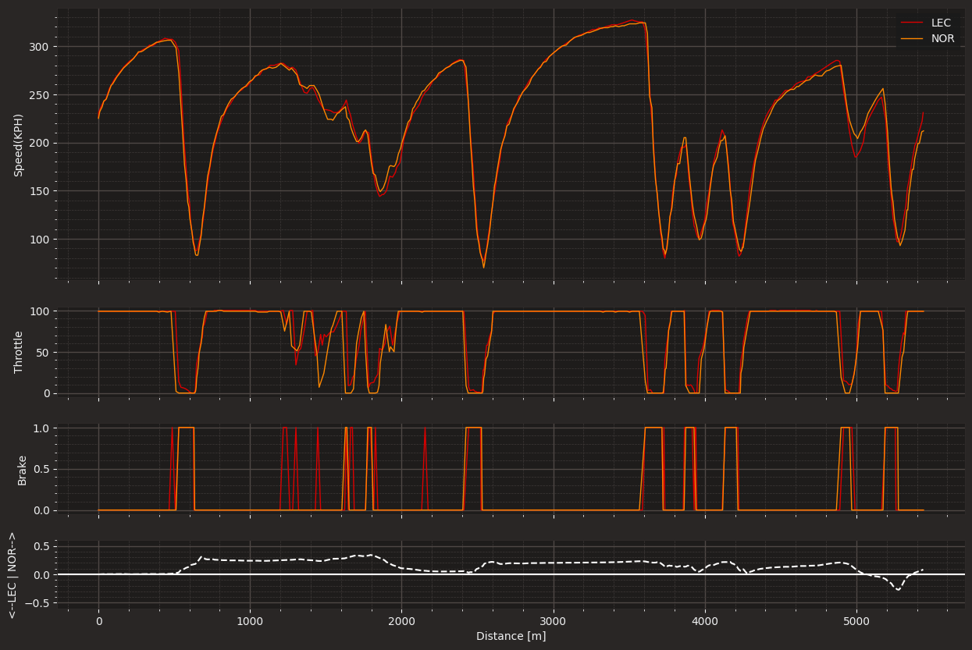

Once again, the Ferrari's exceptional traction is showcased, and this time it's surprising to see its prowess through the high-speed Turns 3, 4, 5, and 6. The Ferrari is proving to be a match for the McLaren, especially when considering McLaren's historical strength in high-speed corners.

Notably, Lando Norris exhibits remarkable performance through Turns 8 and 9, possibly due to differences in racing lines or more confidence in the car's rear end.

At Turn 11, the Ferrari's superior traction when entering the back straight becomes evident. However, McLaren manages to keep up admirably on the straights. In the slower sections at the start of sector 3, the two cars remain evenly matched, with Leclerc losing significant time at Turn 19 but subsequently recovering in the final corner.

Both cars are closely matched, with the Ferrari consistently demonstrating superior traction coming out of slower corners. An interesting observation is that McLaren appears to offer more stability which is evident through turns 8,9 and 19 where it’s all about stability, which could be advantageous in the race.

**The Sprint:**

Unfortunately I couldn’t extract the sprint shootout data. So, I’m gonna skip straight into the sprint race, where the top 5 were VER, HAM, LEC, NOR, PER.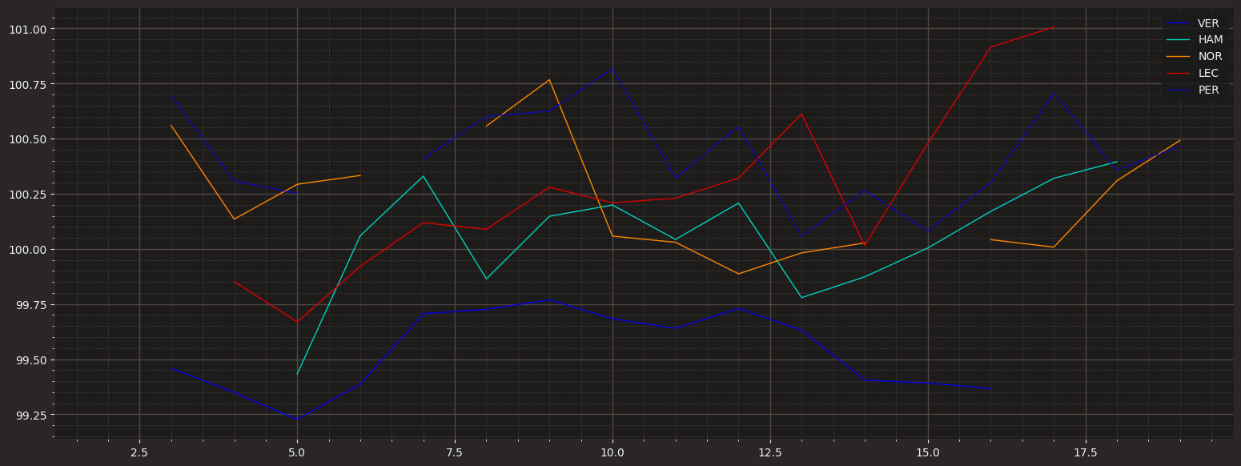

This chart compares lap times for different drivers. With a high fuel, Red Bull and Verstappen are notably faster than others. Mercedes, led by Hamilton, follows closely, and then comes Norris and Leclerc in their respective cars.

Interestingly, Ferrari can't maintain the same pace they showed in qualifying. They consistently lag behind, especially towards the end, suggesting tire issues.

McLaren and Mercedes seem evenly matched. Unfortunately, Perez is struggling with his pace compared to his teammate.

In short, this chart shows that Red Bull, with Verstappen, is leading in lap times, followed by Mercedes and then McLaren, while Ferrari is dealing with tire problems.

**The Race:**

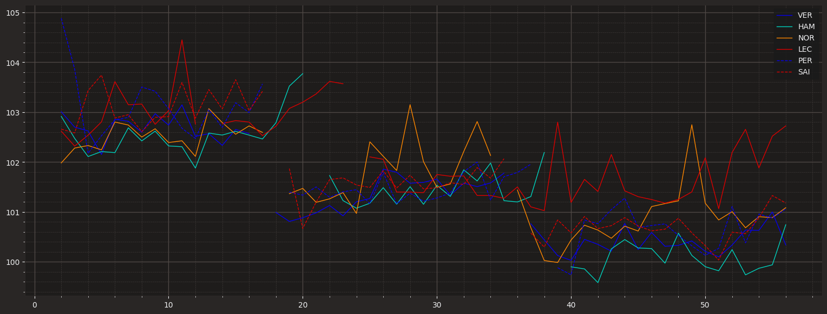

The race unfolded quite differently from expectations. During the initial stint on Medium tires, Norris got a better start, and instantly passed the pole-sitter Leclerc. Shortly after, Hamilton managed to overtake Leclerc without much difficulty. Verstappen also found his way past a few laps later. Surprisingly, this time it was Hamilton who appeared to have the fastest car on the track. Verstappen, on the other hand, couldn't match the same level of pace he displayed in the sprint race. His laps weren't consistently faster than those of Hamilton ahead.

Verstappen, Norris, Sainz, and Perez pitted for a two-stop strategy. In contrast, Hamilton and Leclerc chose to stay out a few laps longer, contemplating the possibility of extending their stints and aiming for a one-stop strategy. Leclerc decided to stick to this plan, which eventually resulted in him losing additional positions. It turned out not to be the most optimal strategy. However, Mercedes recognized this early and opted to return to a two-stop strategy. Unfortunately, this meant that they lost track position to Verstappen for no apparent reason, and they also lost ground due to the undercut.

The performance chart clearly shows that Hamilton had the quickest car in every stint. This begs the question: Could Hamilton have won the race if Mercedes had initially chosen a two-stop strategy and proactively countered Verstappen's undercut attempts?

**VER VS HAM Race:**

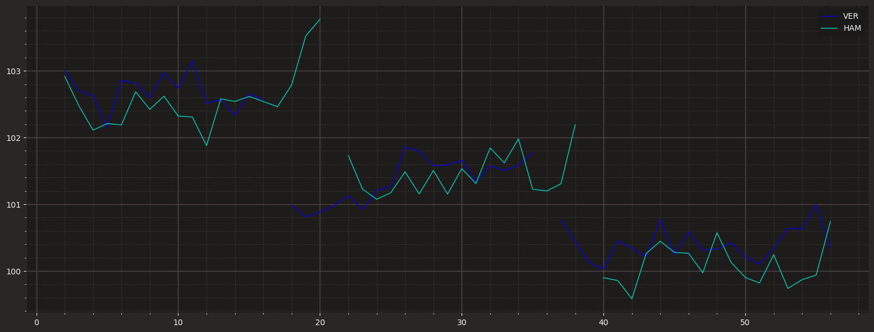

Unfortunately, the required data for conclusive proof isn't available. However, an analysis of lap times alone strongly suggests that there was a significant opportunity for Hamilton to secure victory had Mercedes committed to an early two-stop strategy, thereby avoiding the loss of track position and time due to Verstappen's undercut.