COURSE TITLE: **ADDITIVE MANUFACTURING AND PRODUCTION SYSTEMS**

GUIDED BY – Prof. ALBERTO BOSCHETTO

**EXERCISE A**

**CMM PROGRAMING**

**GROUP NUMBER: 10**

|  |  |
| --- | --- |
| VARUN YASHWANT RASALKAR | **1921452** |
|  |  |
|  |  |

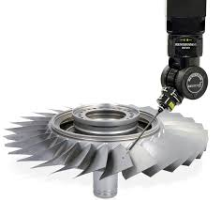

**Exercise Task to be performed:**

**GENERAL INTRODUCTION TO CMM:**

A **coordinate measuring machine** (CMM) is a device that measures the geometry of physical objects by sensing discrete points on the surface of the object with a probe. Various types of probes are used in CMMs, including mechanical, optical, laser, and white light. Depending on the machine, the probe position may be manually controlled by an operator, or it may be computer controlled. CMMs typically specify a probe's position in terms of its displacement from a reference position in a three-dimensional Cartesian coordinate system (i.e., with XYZ axes). In addition to moving the probe along the X, Y, and Z axes, many machines also allow the probe angle to be controlled to allow measurement of surfaces that would otherwise be unreachable. Coordinate-measuring machines include three main components:

* The main structure which includes three axes of motion. The material used to construct the moving frame has varied over the years. Granite and steel were used in the early CMM's. Today all the major CMM manufacturers build frames from aluminum alloy or some derivative and use ceramic to increase the stiffness of the Z axis for scanning applications. Few CMM builders today still manufacture granite frame CMM due to market requirement for improved metrology dynamics and increasing trend to install CMM outside of the quality lab. Typically, only low volume CMM builders and domestic manufacturers in China and India are still manufacturing granite CMM due to low technology approach and easy entry to become a CMM frame builder. The increasing trend towards scanning also requires the CMM Z axis to be stiffer and new materials have been introduced such as ceramic and silicon carbide.
* Probing system
* [Data collection](https://en.wikipedia.org/wiki/Data_collection_system) and reduction system — typically includes a machine controller, desktop computer and application software.

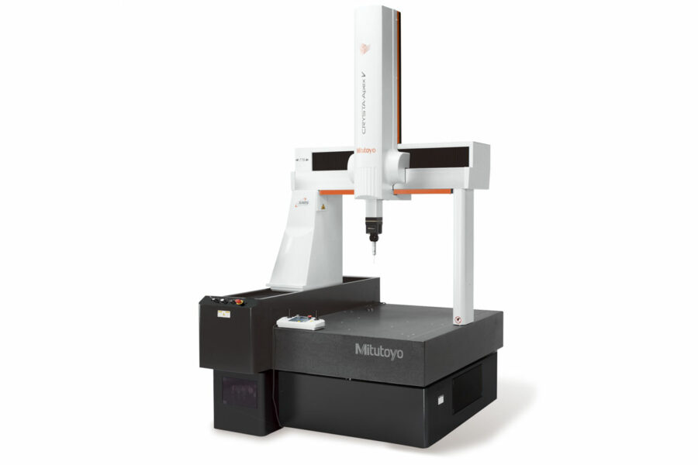

Figure: CMM machine by Mitutoyo.

Figure: Different types of probes used in CMM machine.

Here we consider using **ZEISS PRISMO Bridge Type CMM:**

The bridge arrangement over the table carries the quill (z-axis) along the x-axis and is sometimes referred to as a travelling bridge. It is claimed that the bridge construction provides better accuracy, although it may be offset by difficulty in making two members track in perfect alignment. This is by far the most popular CMM construction. Figure shows a bridge structure:

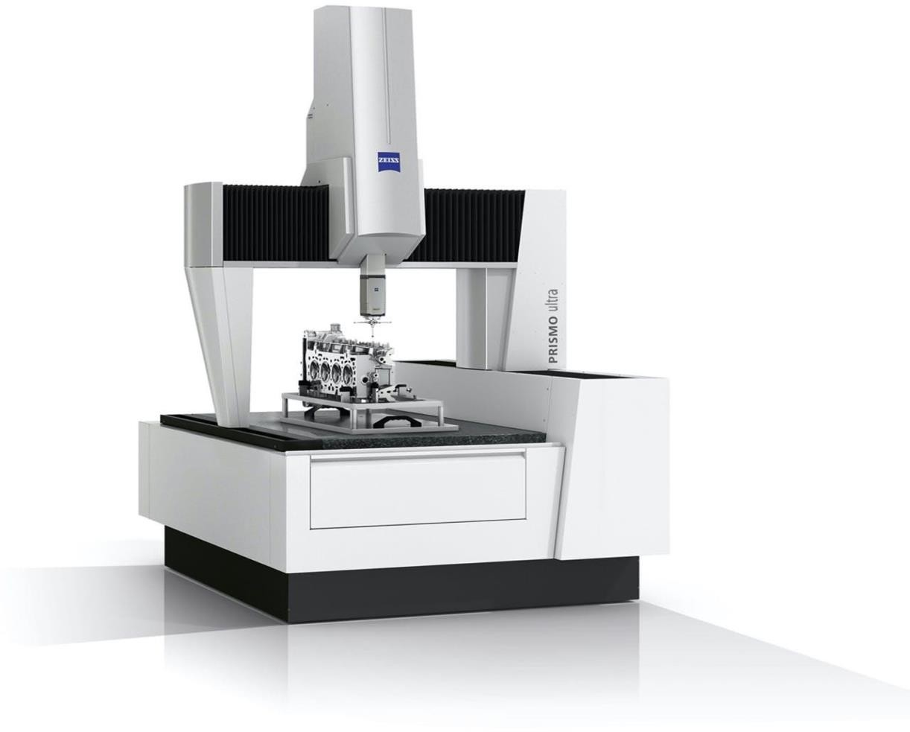

Picture: of ZEISS PRISMO Bridge Type CMMfrom the website.

Figure: Specification of the CMM machine.

**Probing System**

It is the part of a CMM that sense the different parameters required for the calculation. Appropriate probes must be selected and placed in the spindle of the CMM. Originally, the probes were solid or hard, such as tapered plugs for locating holes. These probes required manual manipulation to establish contact with the work piece, at which time the digital display was read. Nowadays, transmission trigger-probes, optical transmission probes, multiple or cluster probes, and motorized probes are available. They are discussed in brief below:

Inductive Transmission Probe:

Inductive transmission probe has been developed for automatic tool changing. Power is transmitted using inductive linking between modules fitted to the machine structure and attached to the probe. Figure shows a schematic of the inductive transmission probe. The hard-wired transmission probe shown is primarily for tool setting and is mounted in a fixed position on the machine structure.

Choose probing system:

**Zeiss Prismo comes** with **ZEISS CALYPSO VAST** probing the time of the single point measuring can be reduced significantly with adequate accuracy, resulting in measurement time reduction of up to 25%.

ZEISS Articulating Stylus:

The articulating stylus for ZEISS VAST gold is a brilliant complement for the ZEISS PRISMO family. With its continuous variable angle positions, it is ideal for measuring tasks where different stylus orientations are required by the application. ZEISS Articulating Stylus combines flexibility with the performance characteristics of ZEISS VAST gold.

ZEISS CALYPSO Pallet Optimizer:

By changing the measurement strategy with a pallet system, from the traditional “one probe at a time” method to the “feature by feature, complete pallet at once” method, a significantly reduced measuring time is achieved, resulting in greater efficiency and cost savings.

**Part Dimensions:**

**G-code programing:**

G-code program to manually find the radius of the curvature in red requires minimum two points on the curvature at the same height i.e same z-plane. Similarly, to find the slope of the surface in blue requires minimum two points on the surface at the same height.

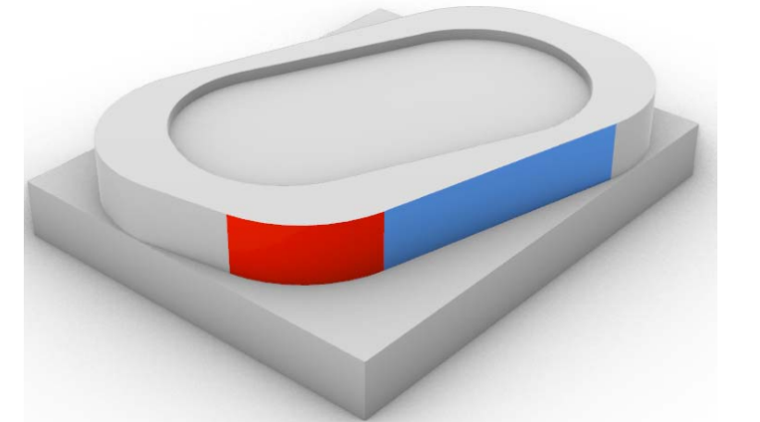

%

N010 G00 G21 Z30 F200 *(Point _1 on the curved surface in Red)*

N020 G00 G01 G54 X0.0 Y0.0

N030 G00 G01 X5 Z-5

N040 G38.2 Y27 F30 *(Point _2 on the curved surface in Red)*

N050 G00 G01 Y00 F200

N060 G00 G01 X10

N070 G38.2 Y25 F30 *(Point _3 on the curved surface in Red)*

N080 G00 G01 F200

N090 G00 G01 X15

N100 G38.2 Y23 F30 *(Point_4 on the linear surface in Blue)*

N110 G00 G01 Y0 F200

N120 G00 G01 X20

N130 G38.2 Y20 F30 *(Point_5 on the linear surface in Blue)*

N140 G00 G01 Y0 F200

N150 G00 G01 X35

N160 G38.2 Y15 F30 *(Point_6 on the linear surface in Blue)*

N170 G00 G01 Y0 F200

N180 G00 G01 X50

N190 G38.2 Y10 F30

N200 G00 G01 Y0 F200

N210 G00 G01 X0

N220 G00 G01 Z30

M30 *(End of the program)*

%