COURSE TITLE: **ADDITIVE MANUFACTURING AND PRODUCTION SYSTEMS**

GUIDED BY – Prof. ALBERTO BOSCHETTO

**EXERCISE-B**

**REVERSE ENGINEERING THROUGH STRUCTURED LIGHT**

**GROUP NUMBER: 10**

|  |  |
| --- | --- |
| VARUN YASHWANT RASALKAR | **1921452** |
|  |  |
|  |  |

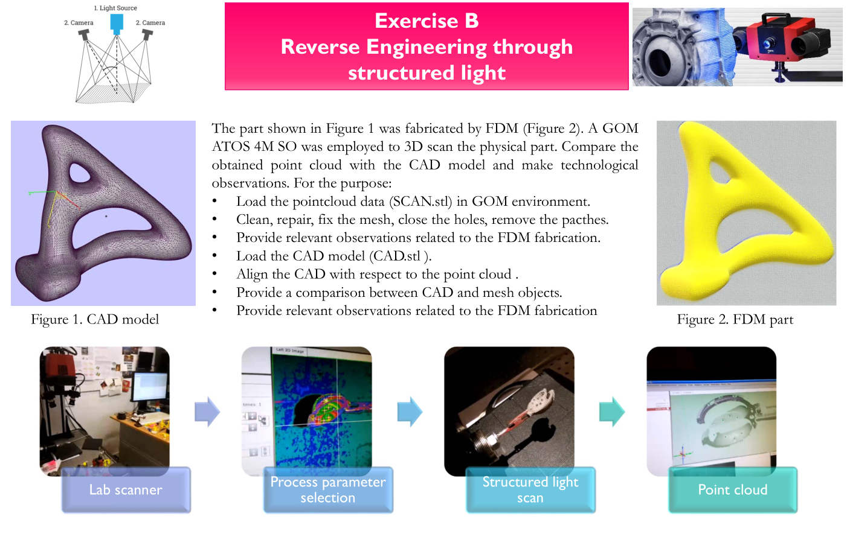

Objective of the exercise:

To provide relevant observations and extract design information from a part manufactured from FDM fabrication shown in figure 2 with the help of pointcloud data obtained from the 3D scan of the same part. This would include several steps from cleaning, repairing, closing the holes, removing patches from the scan file followed by comparing the same with the CAD file of the same part. For this purpose, we employ GOM INSPECT (Trial Version) software.

**Step_1** Loading the pointcloud data (SCAN.stl) in GOM environment.

As it is clear, the scan file is loaded on the GOM Inspect software and by double clicking the surface of the object, the information about Number of points and Number of holes in the scan file appear clearly on the right side.

The mesh contains cluster of points outside the surface and holes at number of locations. These point clusters and holes are important to be removed and closed.

Defects of mesh file are classified into two ways:

Firstly, STL file defects which were Gaps, Overlapping surfaces, and degenerated surfaces.

Secondly, FDM process defects similar to the actual object surface like staircase or step wise effect.

**Step_2** Cleaning, repairing, fixing the mesh, closing the holes, removing the patches

Figure: The scattered points are removed from the scan file and the holes are clearly visible.

Figure: The holes are closed but still some degenerated surfaces remain.

The functions used for this process are as follows:

For closing of holes:

*Operation_Mesh_ Close Hole_Close Hole Interactively*

Removing degenerated surfaces and creating smooth surface:

*Operation_Mesh_Smooth*

Figure: After closing all the holes and using smoothing the surface a good quality of mesh is created.

**Step_3** Loading the CAD model (CAD.stl):

Figure: CAD and MESH file before any alignment.

**Step_4** This step is for the alignment of the CAD and MESH files.

The 1st method used is **pre-alignment**, which provides the best fit between the CAD and the MESH that minimizes all deviations between both nominal and actual surfaces. This gives us a deviation of 0.04 mm.

The 2nd method used is **RPS (reference point system)** alignment, which is based on the fact that the RPS elements (points) on the nominal data creates the actual elements on the actual data. For this we selected 6 surface points randomly w.r.t 3-2-1 method on the surface of the MESH and perform the RPS alignment on those selected points. This gives us a deviation of 0.02 mm.

After this we use ‘CAD Comparison’ command from the Inspection toolbar and the following result as Surface Comparison 1 is generated. This result provides deviation of each point in each direction. To point out, for point 3 the deviation is 0 in X, Y, and Z direction.

Diagram

surface comparison 1

Figure: comparison between CAD and MESH object.