1 <https://developers.facebook.com/>

2. Click on MyApps

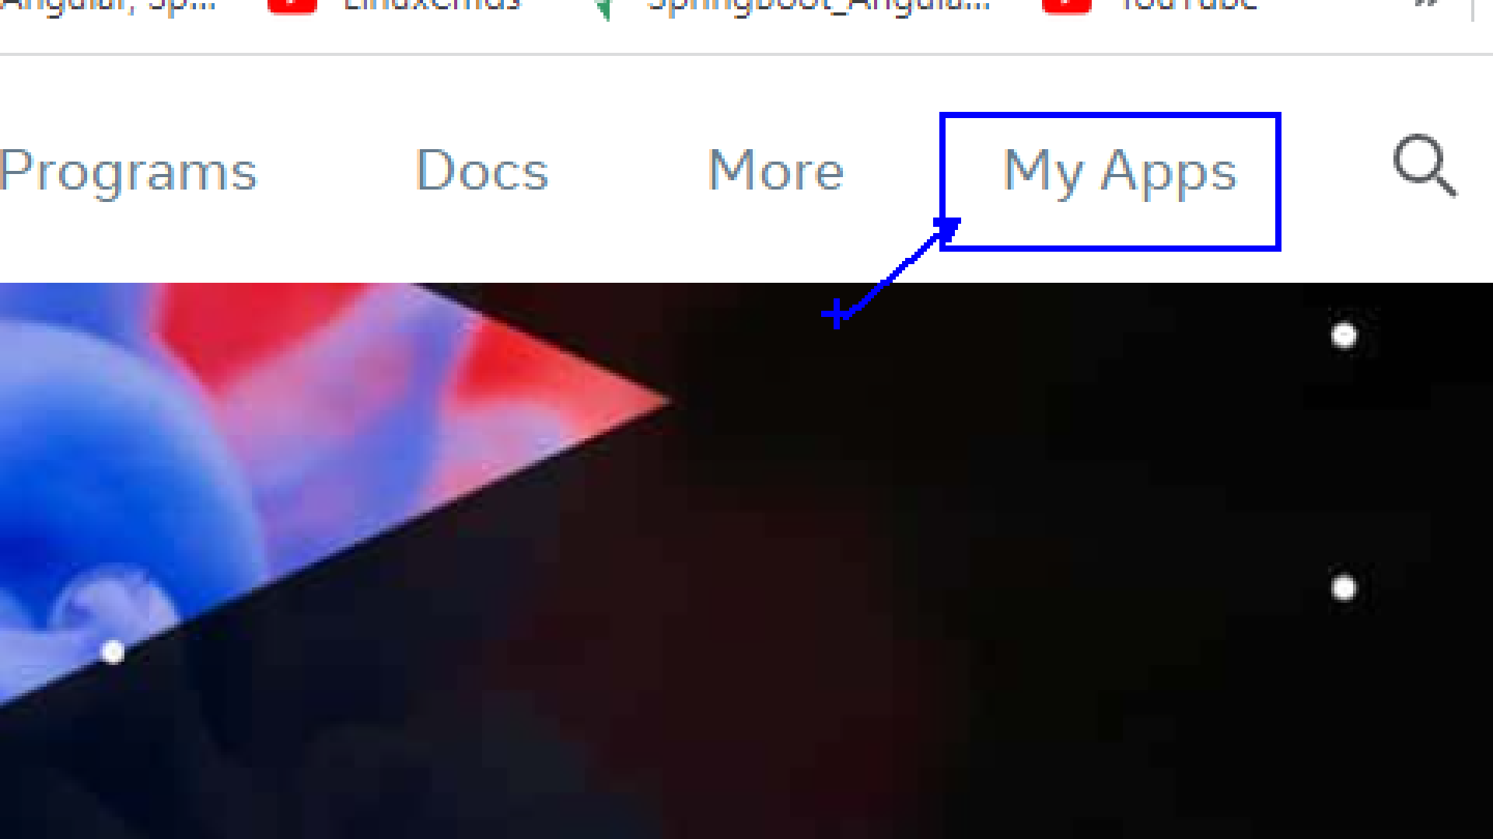

**3. Cerate App**

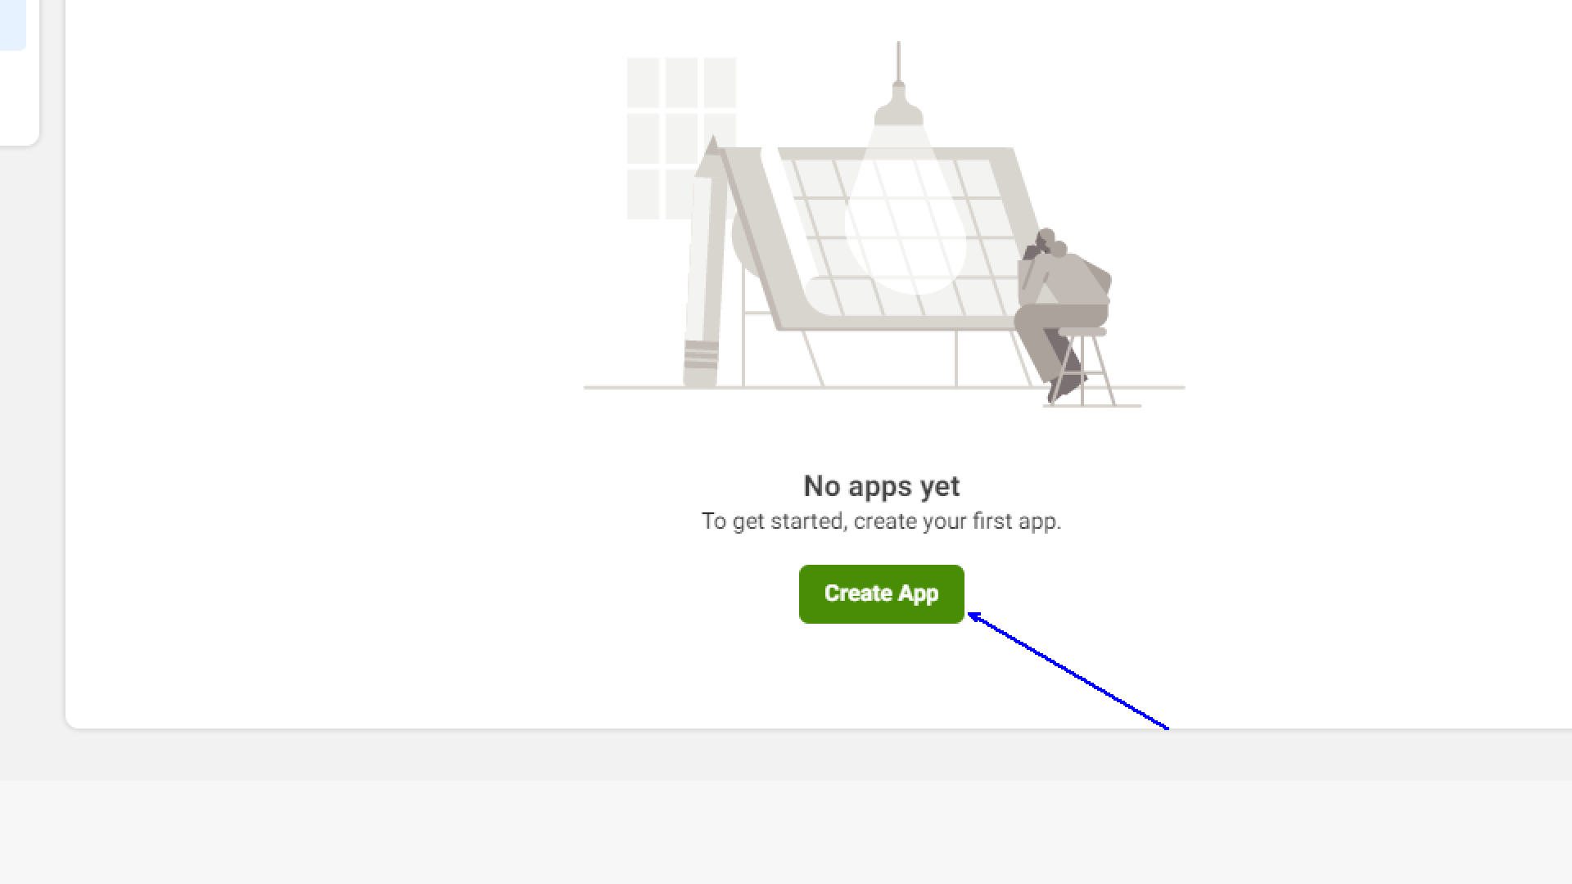

**4. Choose Consumer**

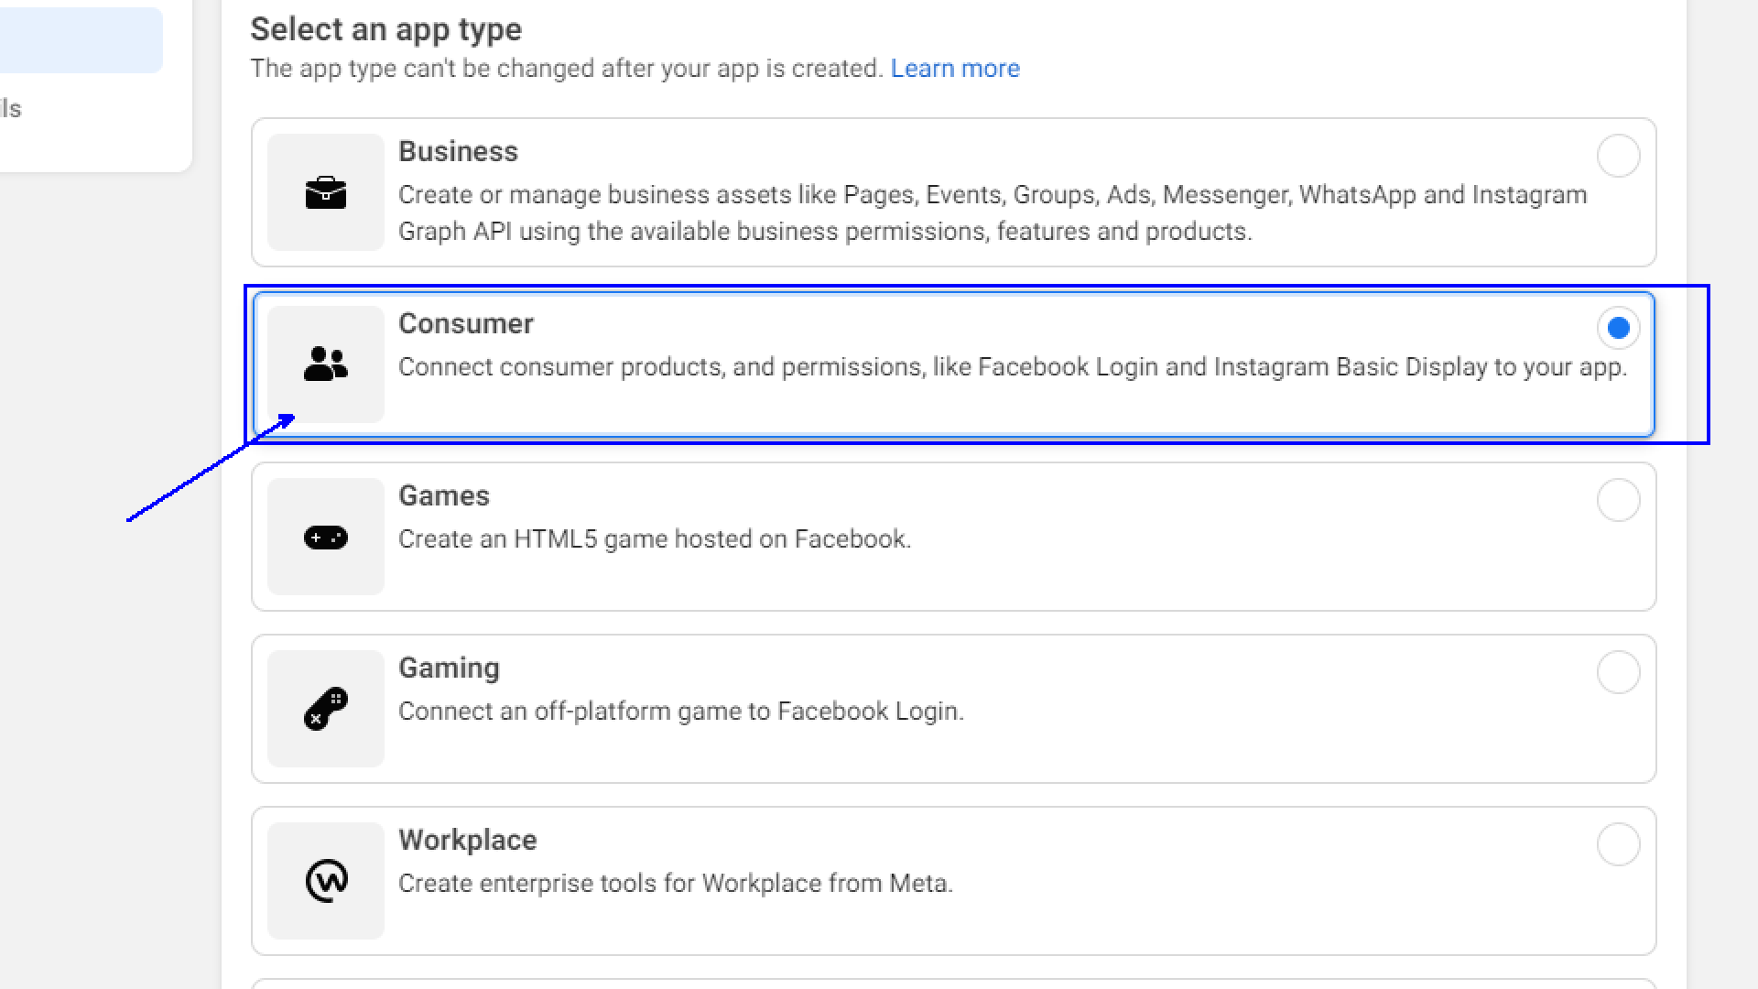

**5. Next and Enter Details and Create App**

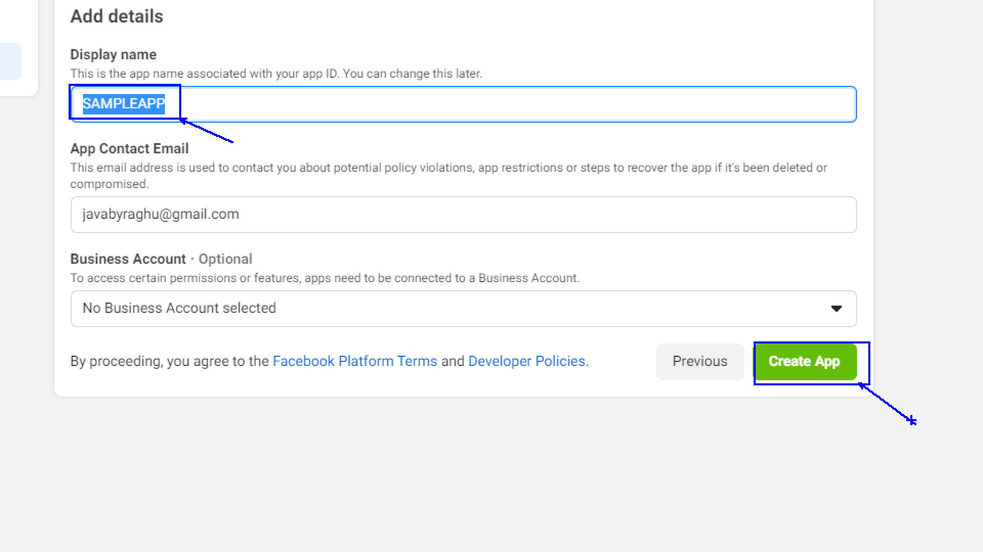

6. Click on Settings and choose basic

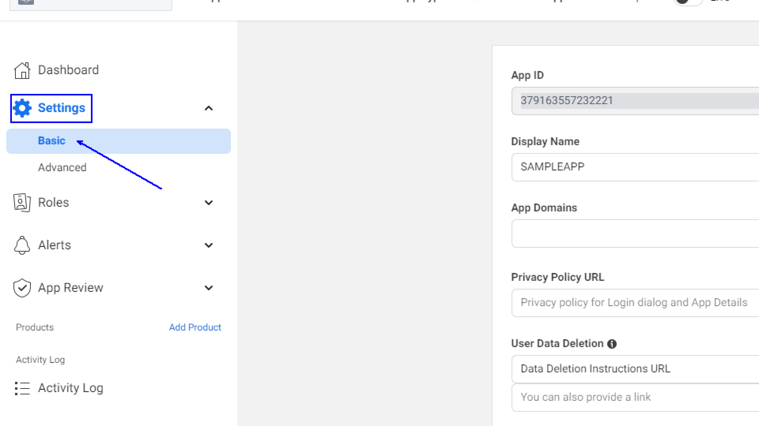

7. Copy Client Id and Secret

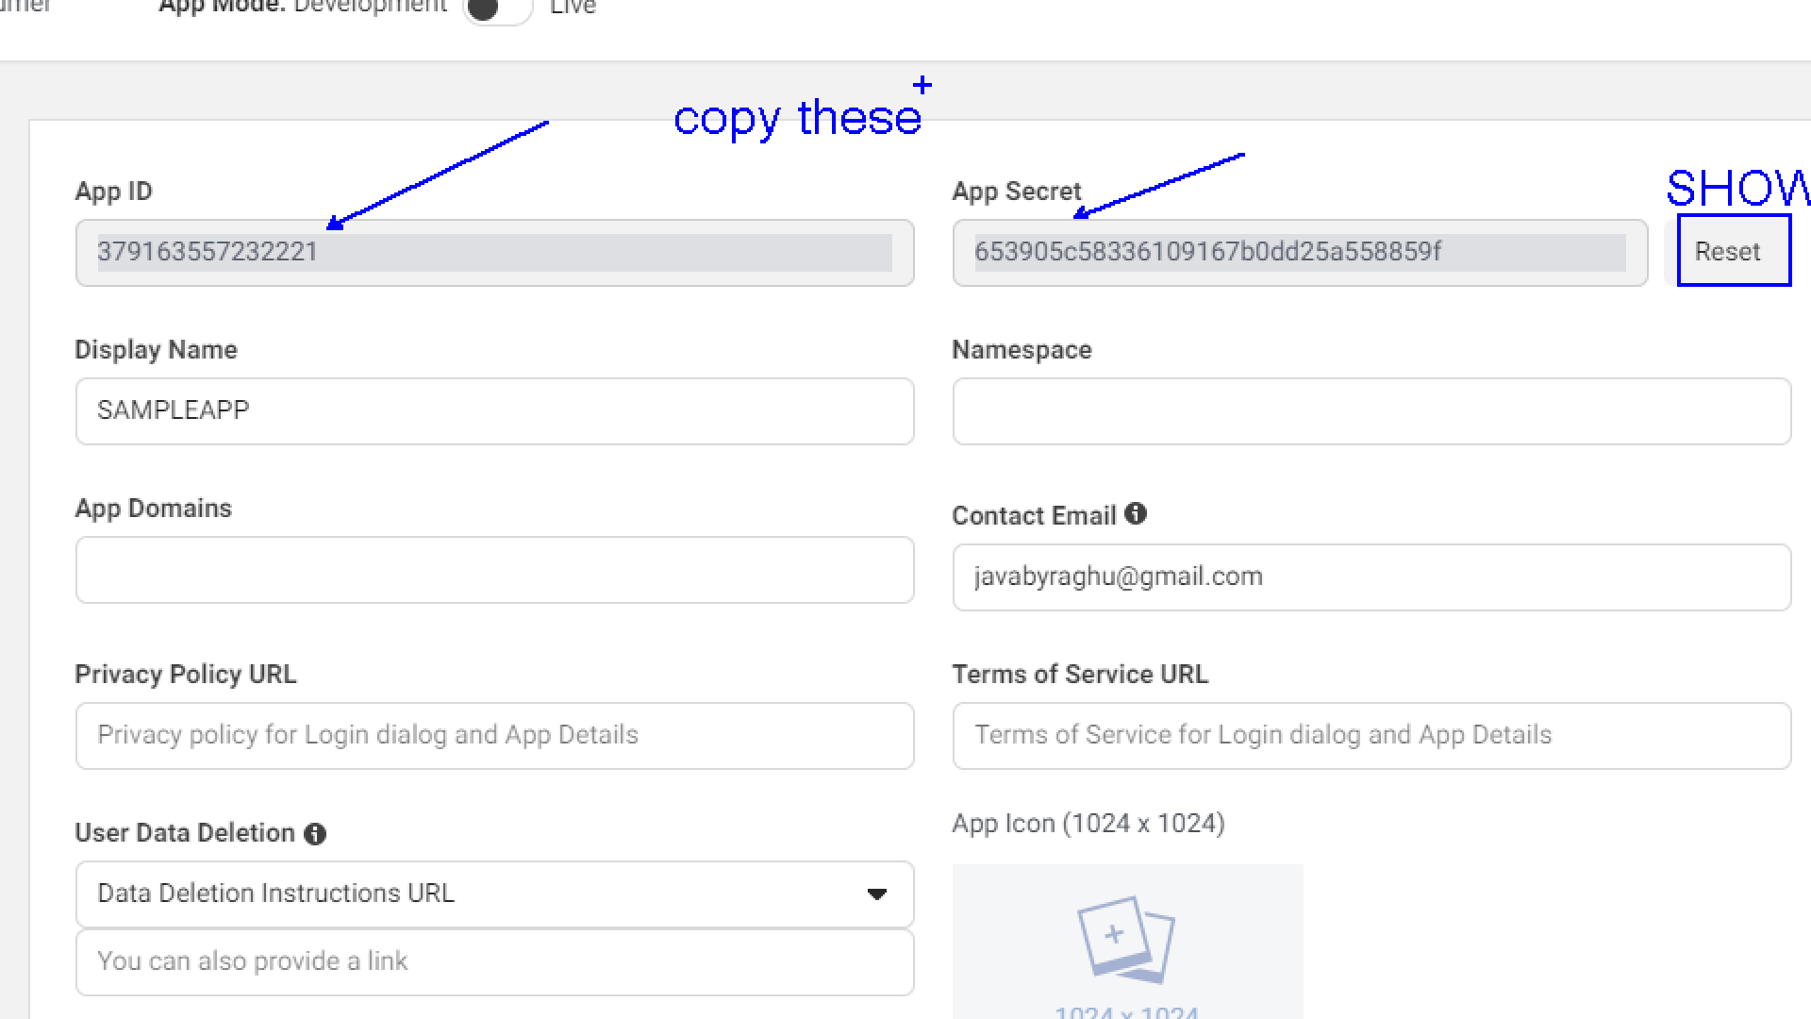

8. Click on Top left corner on project name > create test App > settings > Basic > Copy ClientId and Secret.

