KOPS

Rancher

Managed Clustercluster

* AWS Elastic Kubernetes Service(EKS)
* Asure Kubeernetes Service(AKS)
* Google Kubernetes Service(GKS)

Control plane is managed by vendors like AWS, Azure, Google.

Customer is responsible for Worker Nodes.

Managed K8S has good integration with Cloud Services.

Step 1 : Create an IAM user with AdmininstratorAccess(Attach existing policies directly).

Step 2 : Create an Ubuntu(20.04 instance) with t3.small 2GB Ram Instance Type.

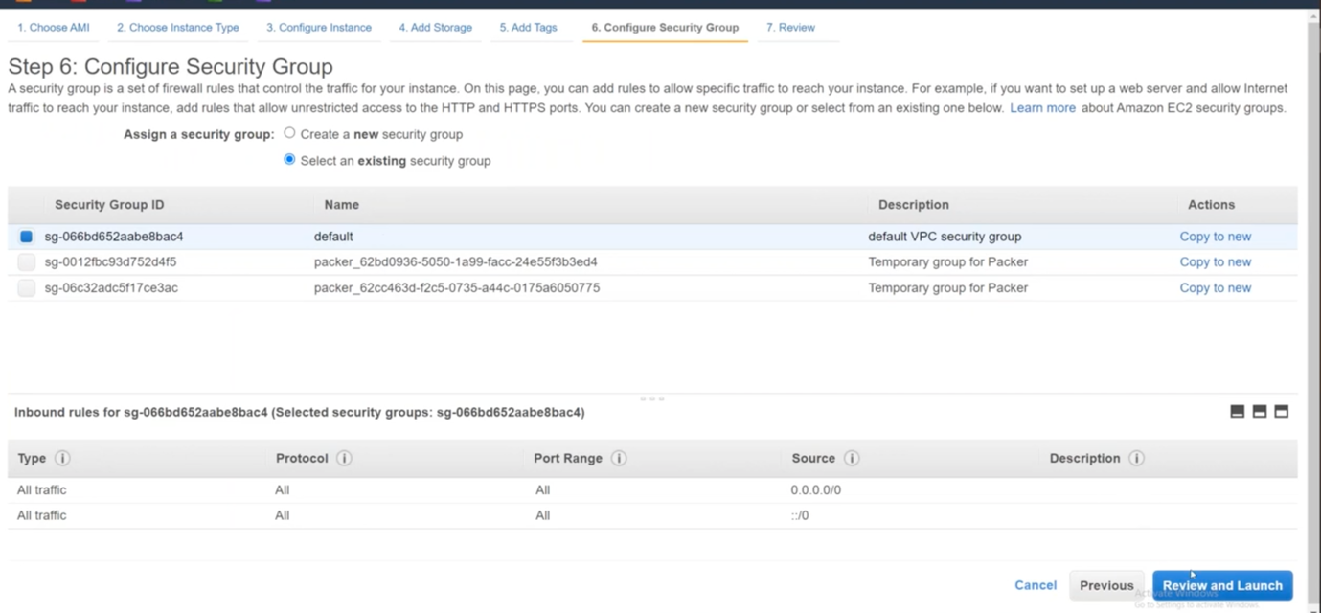

Step : 3

Login to EKS server.

sudo su –

apt update && apt install -y jq net-tools

install aws cli

ref: <https://docs.aws.amazon.com/cli/latest/userguide/getting-started-install.html>

$ **curl "https://awscli.amazonaws.com/awscli-exe-linux-x86_64.zip" -o "awscliv2.zip"**

**unzip awscliv2.zip**

**sudo ./aws/install**

**check version using ‘aws –version’**

Step : 4

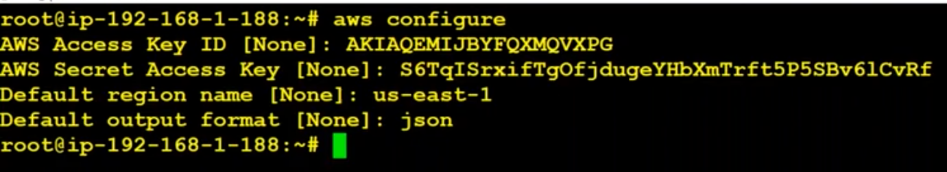

Step : 5:

Install kubectl

##Kubectl

curl -LO "https://storage.googleapis.com/kubernetes-release/release/$(curl -s https://storage.googleapis.com/kubernetes-release/release/stable.txt)/bin/linux/amd64/kubectl"

sudo mv ./kubectl /usr/local/bin/kubectl

chmod 777 /usr/local/bin/kubectl

kubectl version --short

Step : 6

Dowload eksctl

##Download eksctl

curl --silent --location "https://github.com/weaveworks/eksctl/releases/latest/download/eksctl_$(uname -s)_amd64.tar.gz" | tar xz -C /tmp

sudo mv /tmp/eksctl /usr/local/bin

sudo chmod 700 /usr/local/bin/eksctl

eksctl version

Step : 7

Create Cluster : the below command creates the control-plane

eksctl create cluster \

--name "k8sb14-cluster" \

--version 1.21 \

--zones=us-east-1a,us-east-1b,us-east-1c \

--without-nodegroup

Step : 8

To assign aws roles to pods. (Assign service accounts to pods)

eksctl utils associate-iam-oidc-provider \

--region us-east-1 \

--cluster k8sb02-cluster \

--approve

Step : 9

#For Node Group In Public Subnet

eksctl create nodegroup --cluster=k8sb02-cluster \

                    --region=us-east-1 \

                    --name=k8sb02-cluster-ng-1 \

                    --node-type=t3.medium \

                    --nodes=2 \

                    --nodes-min=2 \

                    --nodes-max=4 \

                    --node-volume-size=20 \

                    --ssh-access \

                    --ssh-public-key=LaptopKey \

                    --managed \

                    --asg-access \

                    --external-dns-access \

                    --full-ecr-access \

                    --appmesh-access \

                    --alb-ingress-access