Stacked Machine learning Model

Stacked Machine learning model is a combination of either classification or regression models which are generally known as ensemble learning algorithms.

It is uses a meta-learning algorithm, where combination of models are used to improve model predictions by combining the output of multiple models and running them through another machine models called as meta learner. It is a popular strategy to improve the model accuracy and prediction.

Essentially a stacked model works by running the output of multiple models through a “meta-learner” (usually a linear regressor/classifier, but can be other models like decision trees). The meta-learner attempts to minimize the weakness and maximize the strengths of every individual model. The result is usually a very robust model that generalizes well on unseen data.

The architecture for a stacked model can be illustrated by the image below:

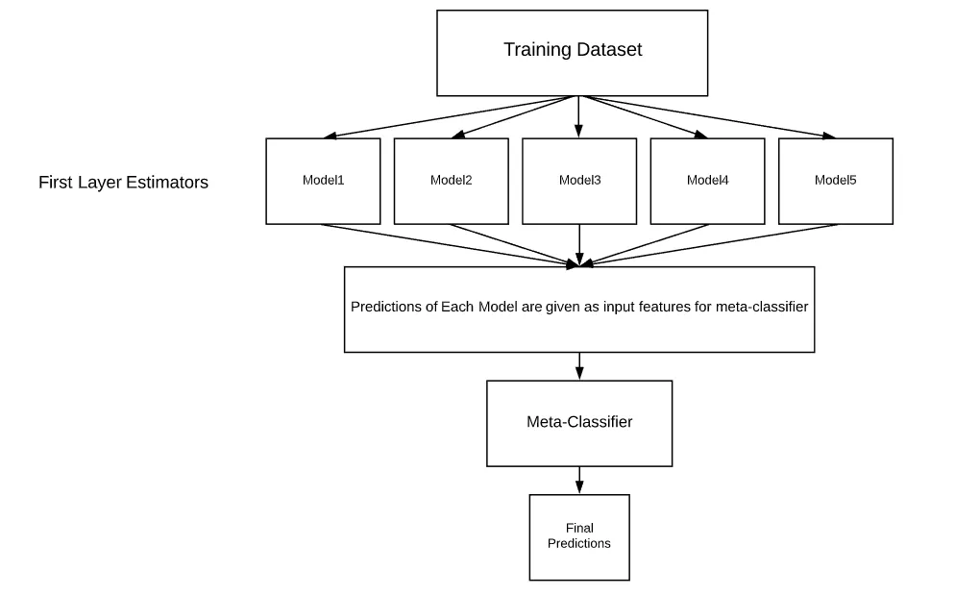

**Conclusion:**

Creating stacking models can make it trivial to “squeeze” out every little bit of performance out of your models. In some data science problems every little bit of performance matters substantially, so stacking models can be a quick and convenient solution to achieve this.

However, keep in mind, stacking models usually require substantially longer to train and also have much slower latencies than other models. So, if you need rapid predictions sent to your users then stacking models may not be ideal.