**DESIGN REPORT**

https://web.cs.kent.edu/~vpisati/

**Histogram**:

A diagram consisting of rectangles whose area is proportional to the frequency of a variable and whose width is equal to the class interval.

Output:

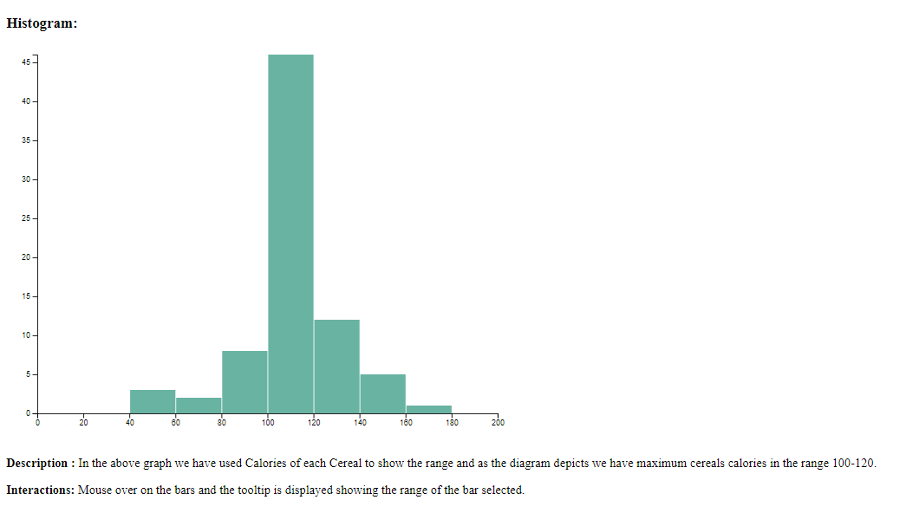

Interaction:

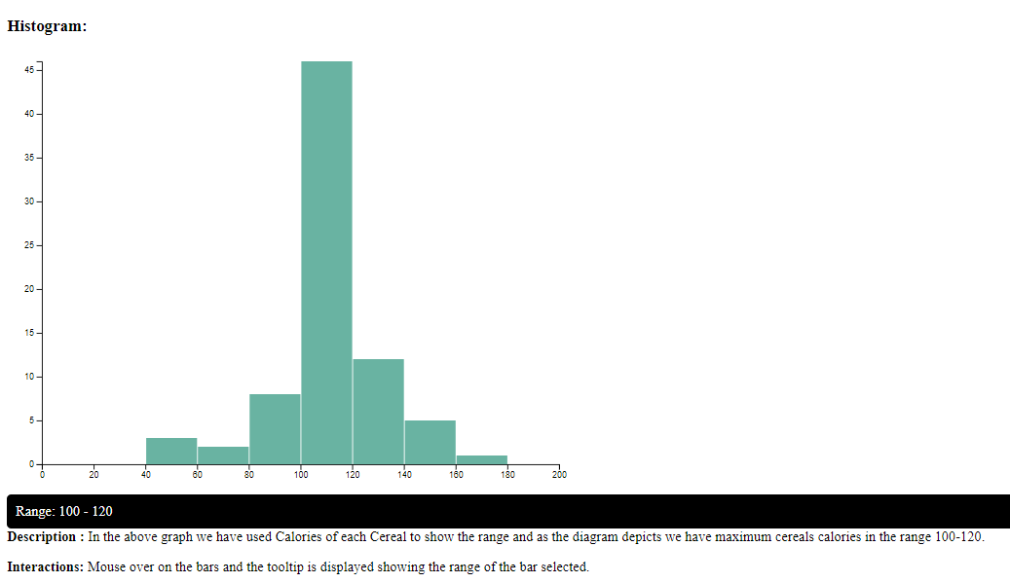

**Lollipop Graph:**

A lollipop plot is basically a [barplot](https://www.data-to-viz.com/graph/barplot.html), where the bar is transformed in a line and a dot. It shows the relationship between a numeric and a categoric variable.

Output:

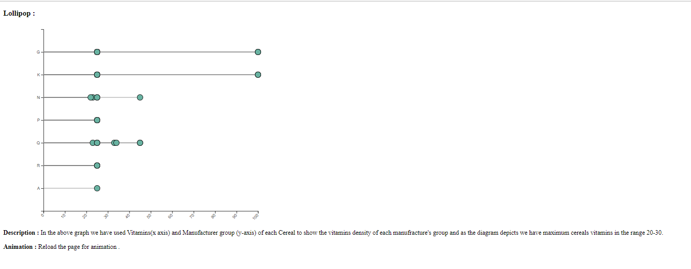

Animation : Points starts from left and move along the x axis.

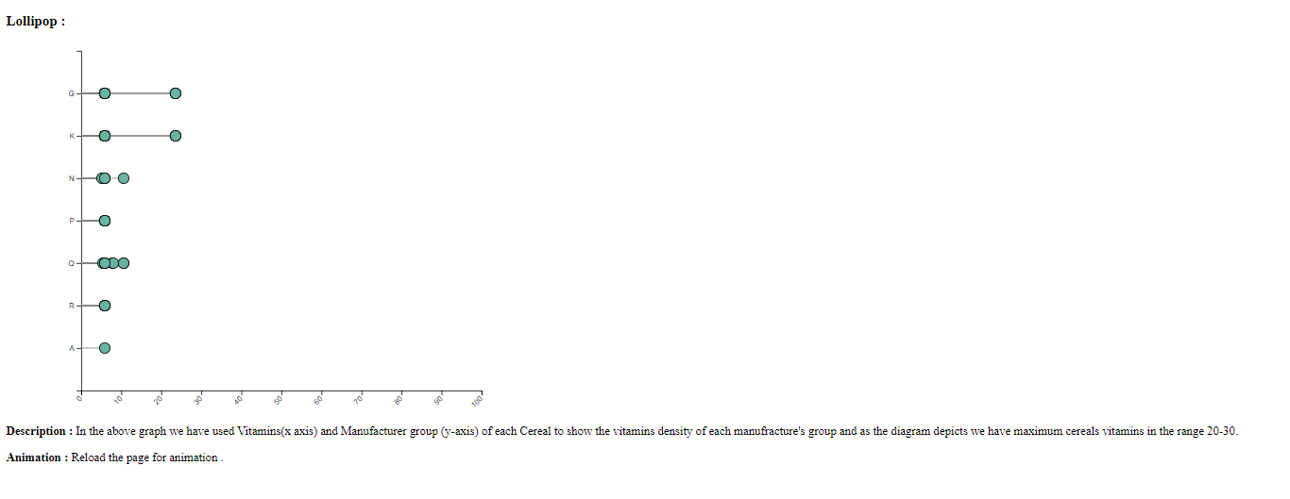

**Scatter Plot:**

A graph in which the values of two variables are plotted along two axes, the pattern of the resulting points revealing any correlation present.

Output:

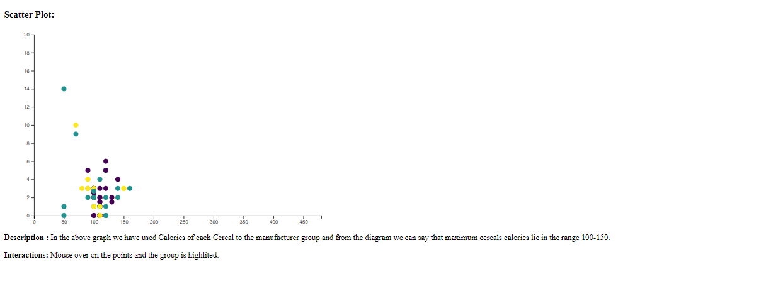

Interaction:

