MolCurator property prediction tool
  - Implementation and validation report for the MolCurator team
21 October 2026 | Code snapshot 5edaaf7 | Contributor aelm-nv
We developed an isolated property predictor for molecules supplied by MolCurator’s generator. It exposes xTB, ORCA and trained molecular ML backends through a Python interface and a command line. The agent remains responsible for choosing molecules and methods, managing calculation budgets, and curating accepted results.
The contribution is ready for explicit integration through the shared prediction contract. All 70 offline tests passed locally, and the supplied cluster installation transcript also shows 70 passing tests. Complete graph wiring and persistent CURATE remain team work.
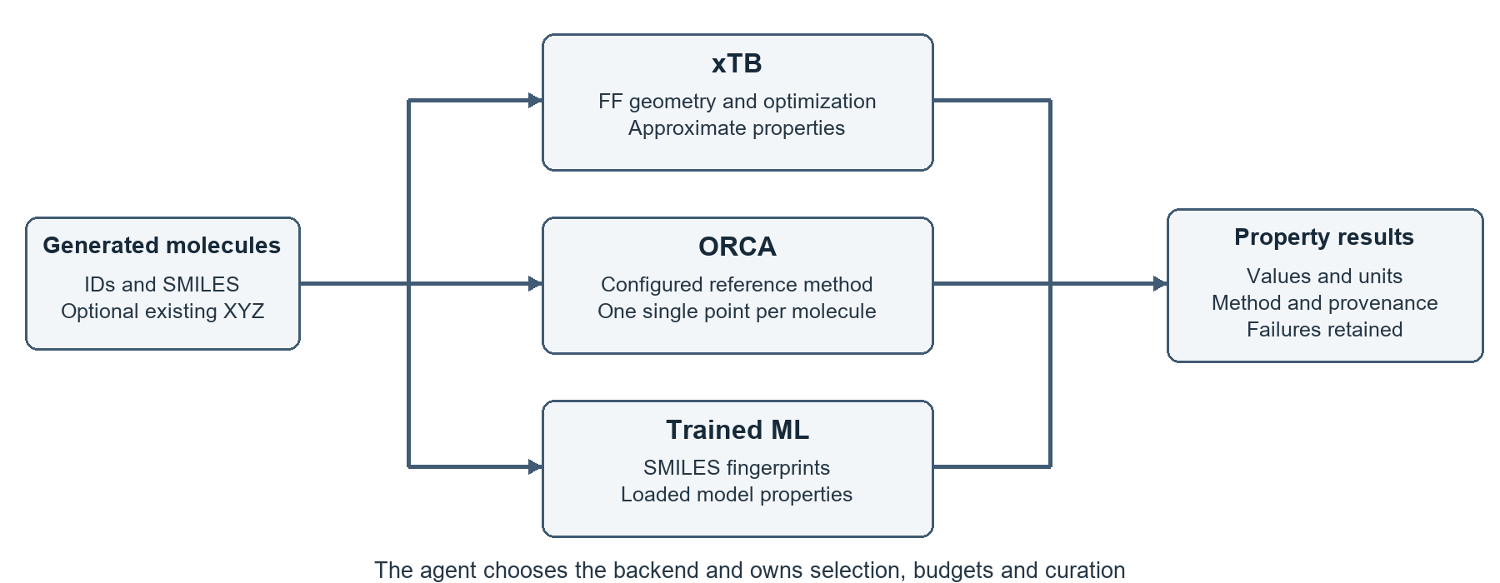
Figure 1. The predictor consumes generated molecules and returns properties. Backend choice and all agent decisions stay outside the tool.

Contribution boundary
Every contributed file is inside subprojects/property_validation_v1/. The package name is molcurator_property_validation. It imports the team’s existing molcurator.schemas and molcurator.config without modifying root code, agent files, dependencies or defaults. Shared main remained unchanged during publication.

Evidence at a glance
Earlier B3LYP calibration studies provide 24 initial calculations and 60 stratified reference validations. Recomputed CSV metrics show substantial reduction of xTB gap bias. Those findings apply to the stated orbital-gap protocol; they do not validate the new ML baseline or every newly exposed property.

Implemented prediction capabilities
Backend | Calculation path | Returned properties
xTB | Lowest FF minimum then GFN2-xTB optimization | HOMO, LUMO, gap in eV; dipole in D
ORCA | Supplied XYZ, xTB refinement by default, or explicit FF-only geometry; configured single point | HOMO, LUMO, gap in eV; dipole in D
Trained ML | SMILES to Morgan fingerprints and a loaded ridge model | Properties actually trained into the model

Geometry selection and reporting
The physics workflow samples 30 ETKDGv3 conformers with seed 42, optimizes them using MMFF94 or UFF when MMFF parameters are unavailable, and discards nonconverged or nonfinite results. It deduplicates minima using symmetry-aware heavy-atom RMSD at 0.25 Å and selects the lowest converged FF-energy representative.
The geometry report records the selected energy, force field, number of unique minima and FF-based Boltzmann weight at 298.15 K. The weight is normalized over the sampled unique FF minima without an energy-window cutoff. It is conditional on the sampling and FF energy model, rather than an experimental conformer population.

Results and failure handling
The rich interface preserves input IDs and order and returns values, units, backend, method, geometry path, errors and provenance. Missing requested properties are reported explicitly; available values survive a partial failure. Normal termination and convergence checks protect physics labels. Unsupported charged, radical and disconnected inputs fail explicitly.
The PropertyPredictor binding returns the unchanged shared Prediction model for one requested property. Rich metadata is retained separately because the shared model has no fields for several properties or method provenance. ML supplies no XYZ geometry, so subsequent QM requires preparation or a supplied structure.

ML scope
The optional training utility fits a Morgan-fingerprint ridge model from the user’s finite, canonically unique, same-method labels and saves a portable JSON artifact. No pretrained model, independently validated accuracy or calibrated predictive uncertainty is supplied. Fitting never occurs automatically during prediction.

Calibration evidence and error reduction
The earlier calibration protocol used GFN2-xTB optimized geometries and ORCA B3LYP/def2-SVP single-point orbital gaps. Coefficients were fitted on 16 molecules and frozen before subsequent evaluation. The separate eight-molecule holdout had MAEs of 2.600 eV raw, 0.695 eV with a constant correction and 0.772 eV with a linear correction.
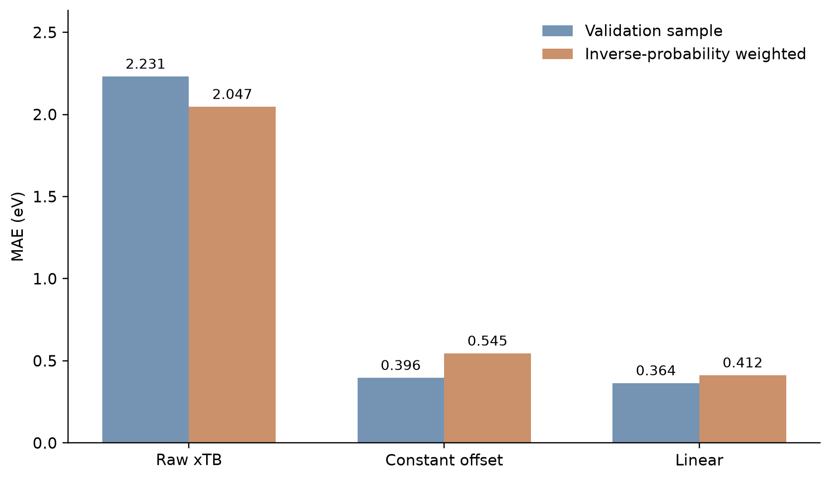
Figure 2. Errors on the 60 stratified reference validations. Blue bars describe the validation sample; orange bars use recorded inverse-probability weights to estimate errors across the 568 successful screens.
Estimate | Sample MAE eV | Weighted MAE eV
Raw xTB | 2.231 | 2.047
Constant correction | 0.396 | 0.545
Linear calibration | 0.364 | 0.412

The frozen constant correction adds 2.261744 eV to the raw gap. The linear model multiplies the raw gap by 0.827078 and adds 2.990190 eV. The linear correction performs best on this later cohort, while the constant correction performed better on the initial holdout. Neither result establishes universal superiority.
The figures and table were checked against consolidated_validation.csv. All 60 IDs are unique, and their inclusion weights sum to 568. No confidence intervals for these design-weighted errors were available in the saved study.

Prediction agreement and residual errors
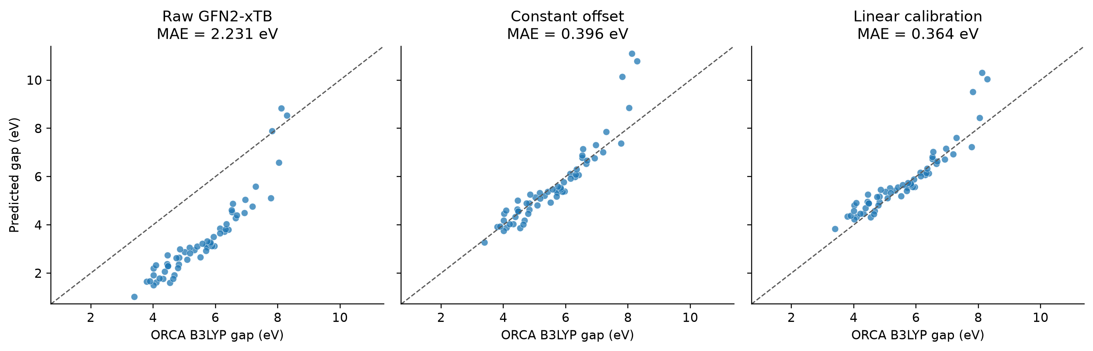
Figure 3. Raw and calibrated gaps against the same B3LYP reference values for 60 molecules. Dashed lines mark equal predicted and reference gaps.
Raw xTB generally underestimates the B3LYP orbital gap in this study. Frozen corrections bring most observations closer to the reference, while several higher predicted gaps retain substantial residual error. The panels describe the selected validation cohort, not unrestricted molecular space.
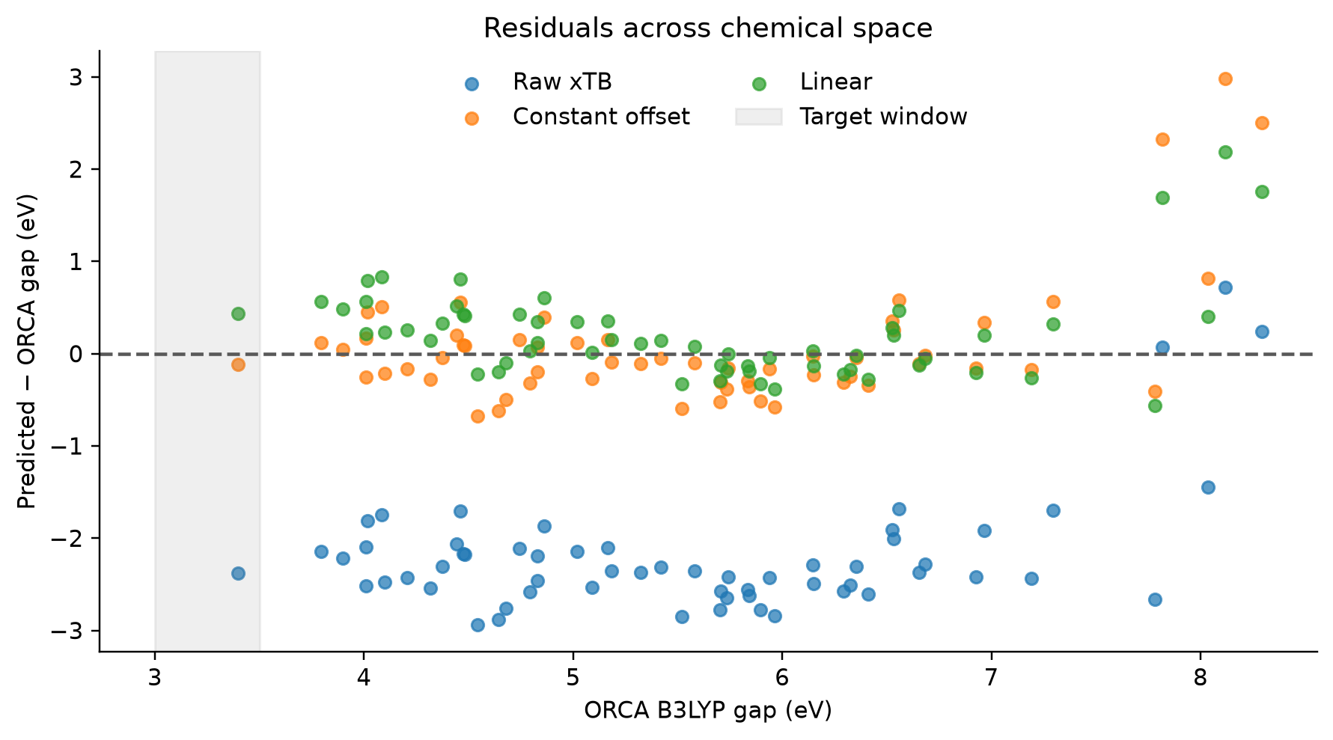
Figure 4. Saved residual analysis for the same validation cohort. Remaining structure and outliers motivate further independent evaluation rather than assuming a constant error bound.
Keep raw xTB values, calibrated estimates and actual ORCA values distinct in reports and datasets. The calibrated gap is a prioritization estimate; it is not a new reference calculation. These corrections must not be transferred unchanged to PBE0, vertical S1 excitations, emission energies or S1–T1 gaps.

Screening performance and scientific limits
The target-enriched campaign began with 600 candidate molecules. Of these, 568 completed xTB screening, and 60 were selected by randomized stratified sampling for ORCA. All 60 recorded validations succeeded. The 32 unsuccessful screens remain outside the weighted population claims and require failure analysis.
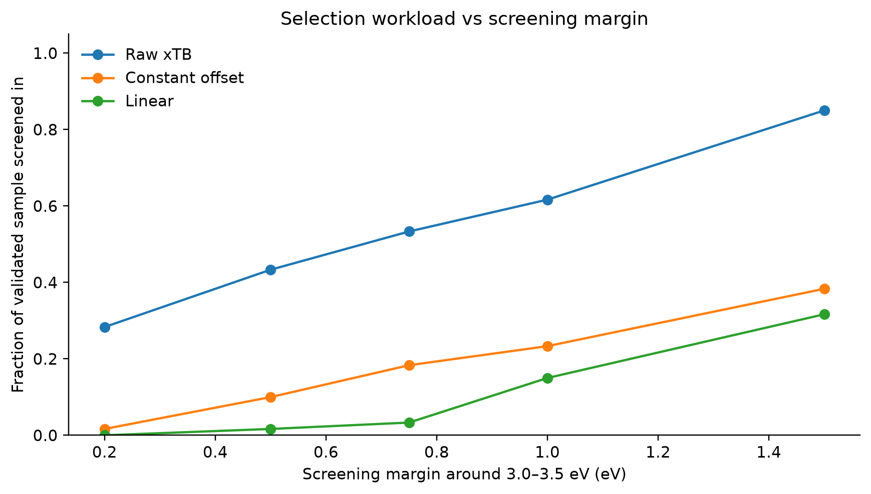
Figure 5. Fraction of the 60 validated molecules inside each provisional screening band. This is sample workload, not a population recall curve or a validated rejection rule.
Observed target hit | Raw xTB eV | Linear estimate eV | ORCA gap eV
pool_0359 | 1.0192 | 3.8332 | 3.3968

Only one observed reference value falls inside the 3.0–3.5 eV target window. Linear ranking recovered that observation at margins of at least 0.5 eV but missed it at 0.2 eV. One positive case cannot establish reliable screening recall. Keep nonzero exploration outside a prioritized band and estimate uncertainty before adopting a hard exclusion policy.
The earlier 276-molecule PBE0 dataset is retained separately. Its labels must not be pooled as interchangeable B3LYP targets. All campaign calculations are research evaluations, not one agent run within the standard 20-QM-call budget.

How to integrate the tool into MolCurator
An implementation guide is available in the subproject at docs/AGENT_CHEMISTRY_USAGE.md. The graph maintainer explicitly injects the callable; our contribution does not replace a root module. The following illustrates the tool boundary rather than claiming a complete graph exists.
from molcurator_property_validation import (
PredictorSettings, PropertyPredictor,
)
from molcurator_property_validation.tools.validate import validate

# PREDICT node receives Candidates from GENERATE.
tool = PropertyPredictor(PredictorSettings(backend="xtb"))
predictions = tool.predict(candidates, config.target, run_dir / "xyz")

# Agent chooses IDs and enforces remaining capacity.
good = {p.candidate_id: p for p in predictions
if p.status.value == "ok" and p.xyz_path is not None}
batch = [good[cid] for cid in chosen_ids[:remaining_qm_calls]]

# Reuse the optimized geometry for gap reference calculations.
qm_results = validate(batch, config.target, config.qm)
# Accept reference-target hits and pass them to persistent CURATE.

The agent must validate chosen IDs for membership and duplicates, retain all failures, charge failed QM attempts, and persist cumulative budgets. The legacy validate function above is the HOMO–LUMO gap adapter. Use the rich predict_properties interface for several properties or supplied geometries. Avoid repeating xTB geometry preparation when an existing compatible XYZ can be reused.

Backend choice and command line
Use xTB for an inexpensive first estimate, ORCA for selected reference values, and ML only after supplying a compatible trained model. ML estimates have no geometry or validated uncertainty. The new property CLI accepts generated-molecule JSON and writes a new request directory:
molcurator-properties predict --backend xtb \
--input examples/generated_molecules.json \
--output runs/check-001 --properties homo_lumo_gap dipole

For ORCA, configure functional and basis and document the geometry policy. Default rich ORCA requests refine geometry with xTB; explicit force_field mode skips xTB. Calibration remains a separate ranking utility and must match the reference method. The existing all-in-one chemistry-stage helper is optional supporting code, not a required agent policy.

Operational status and remaining work
Area | Established status | Next action
Tool and tests | Installed CLI and 70 offline checks passed locally and in supplied cluster transcript | Integrate into the graph through explicit injection
Latest ethanol job | xTB succeeded at 12.55670887355 eV; supplied snapshot showed no final QM result | Inspect job 9209380 and the final ORCA result
Physics evidence | Reported benzene smoke plus saved 24 and 60 molecule studies | Audit versions, convergence, raw artifacts and failed screens
New ML baseline | Training, loading and inference tested in software | Evaluate on independent molecules before deployment
Full MolCurator | Shared contracts/config are available; graph and persistent CURATE remain incomplete | Connect generation, selection, budgets, traces and dataset storage

The immediate handoff is to wire one small HOMO–LUMO run from generated Candidates through xTB, agent selection, ORCA and persistent curation. Record method/geometry provenance and sampled FF weights in the final summary. Then compare rule-based and LLM decisions under the same calculation budget. TADF and wider chemistry require separate protocols and validation.

Sources and reproducibility
Code snapshot: 5edaaf7 on codex/calibrated-screening-v1. All source paths below are relative to subprojects/property_validation_v1/. Scientific plots are embedded from the committed research report; the software review did not rerun those QC campaigns.
Predictor installation and backend instructions
Agent implementation guide
Tool source and shared contract bridge
Calibration summary and fixed split results
Validation observations and sampling weights
Scientific report and embedded figures
Additional operational evidence: cluster installation and running-job output supplied in this conversation. The latest ethanol record was intermediate; this report does not infer an ORCA success from that snapshot.

