**Name: Varun Salgarkar**

**Reg No: 19BCE1435**

**Information Security Management**

**Lab I**

**Text Encryption and Decryption**

Tested String: “SUSANTH”

First Encryption

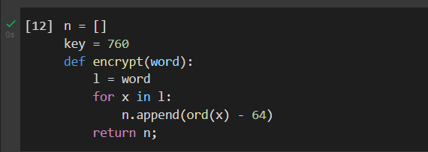

First Encryption Validation

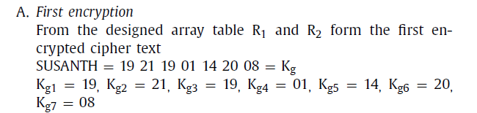

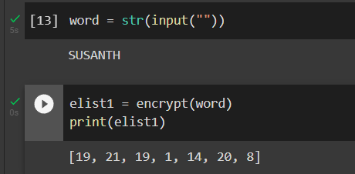

Second Encryption

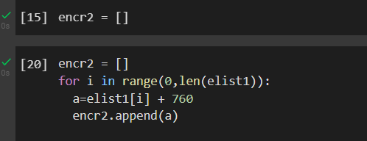

Our Result

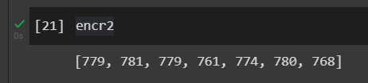

Validation Doc

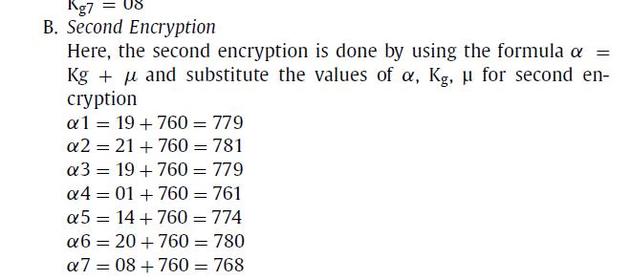

Decryption

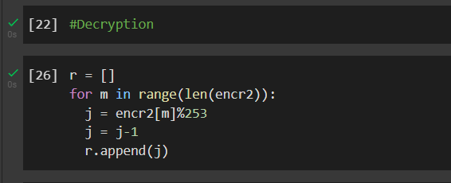

Our Result

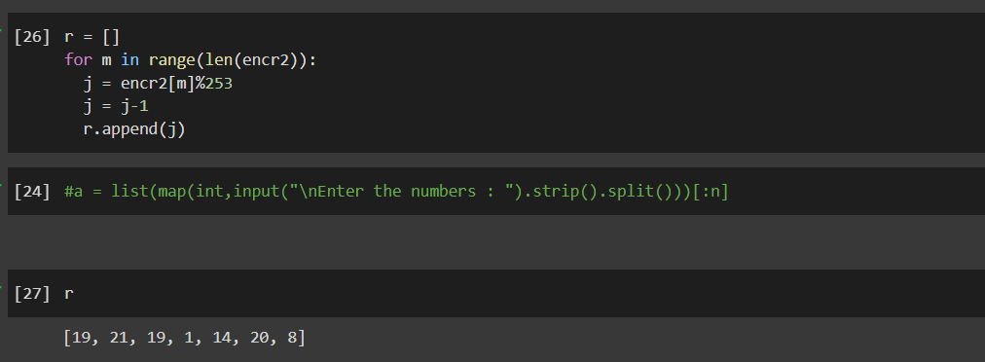

Validation doc

