**Name: Varun Salgarkar**

**Reg No: 19BCE1435**

**BURP SUITE SQL INJECTION ATTACK**

1. Open Metasploit and find its Ip address:

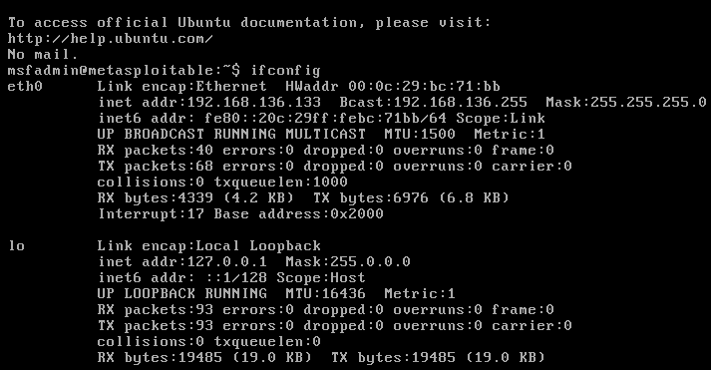

1. Go to the Metasploitable2 IP in browser

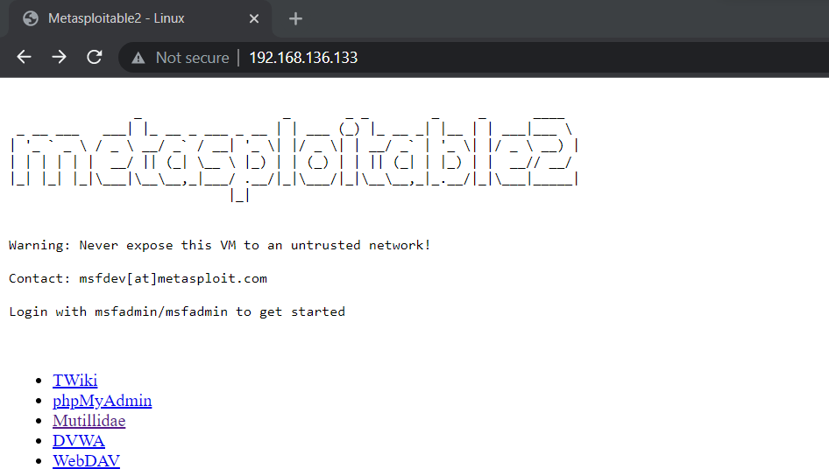

1. Open Mutillidae and select SQL injection as shown below

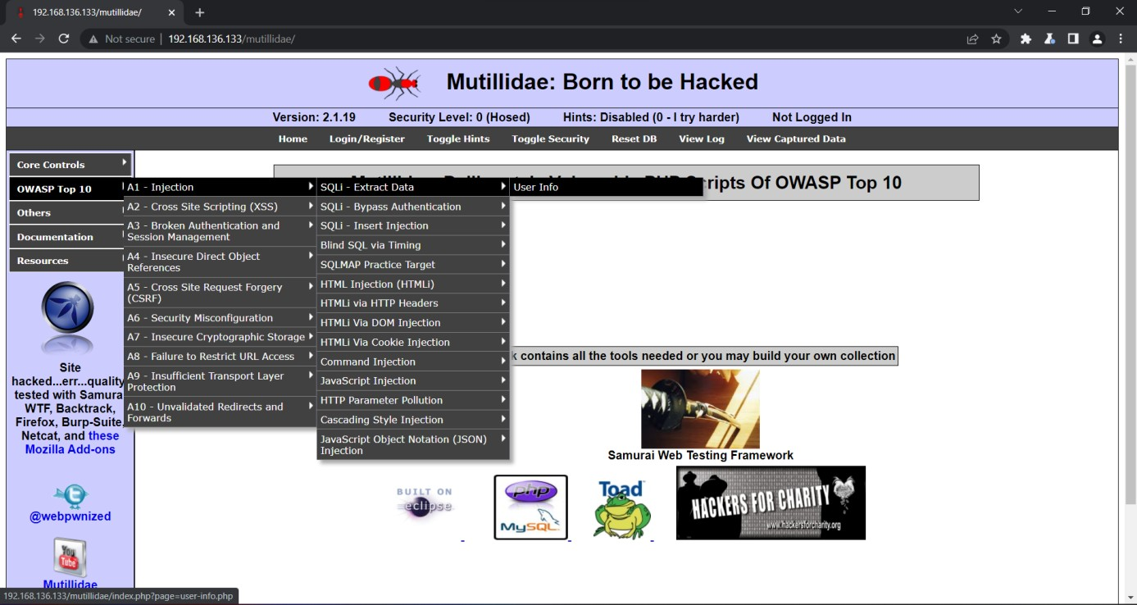

1. Open Burp ssuite and turn on Intercept:

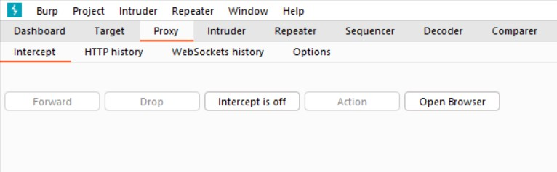

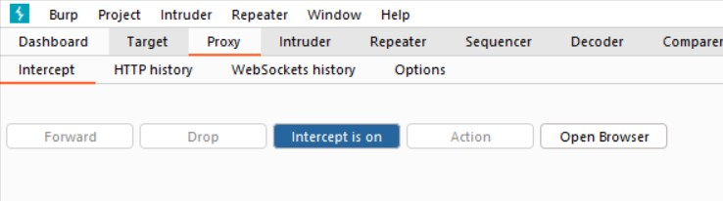

1. Login Once:

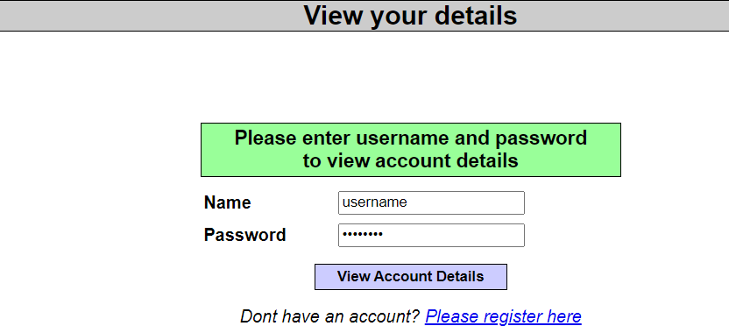

1. Under proxy we can see the captured data

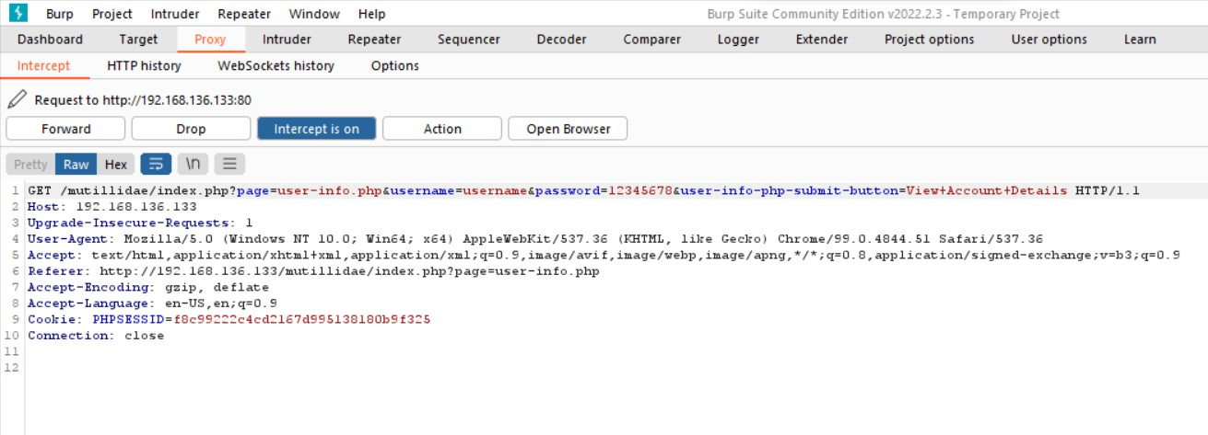

1. Send it to Intruder

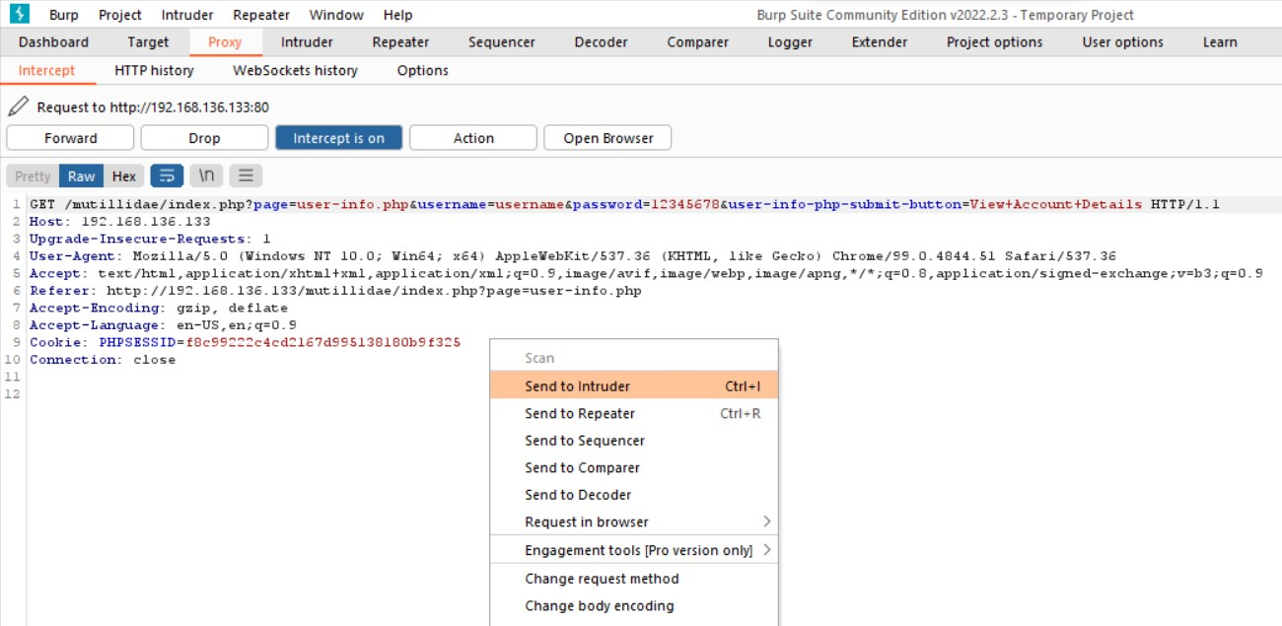

1. Select Username field for attack under intruders

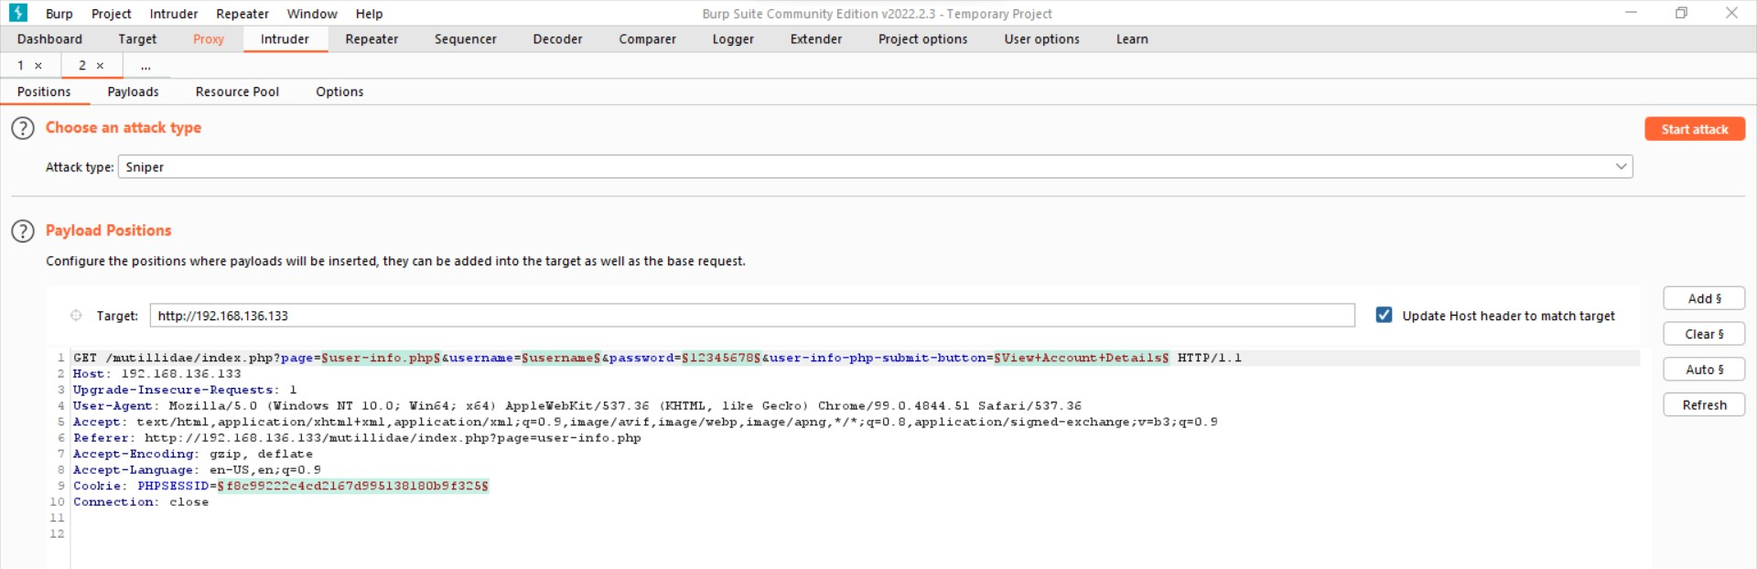

1. Download SQL file for payloads

[https://github.com/xmendez/wfuzz/blob/master/wordlist/Inje](https://github.com/xmendez/wfuzz/blob/master/wordlist/Injections/SQL.txt) [ctions/SQL.txt](https://github.com/xmendez/wfuzz/blob/master/wordlist/Injections/SQL.txt)

1. Go to Payload section in downloads file:

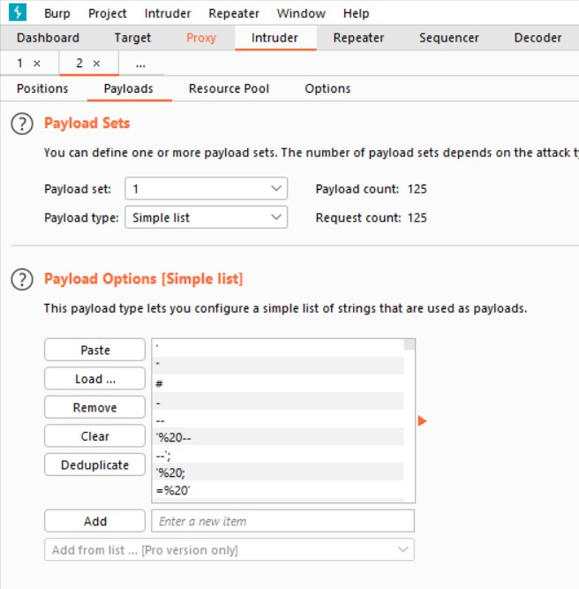

1. Start the attack:

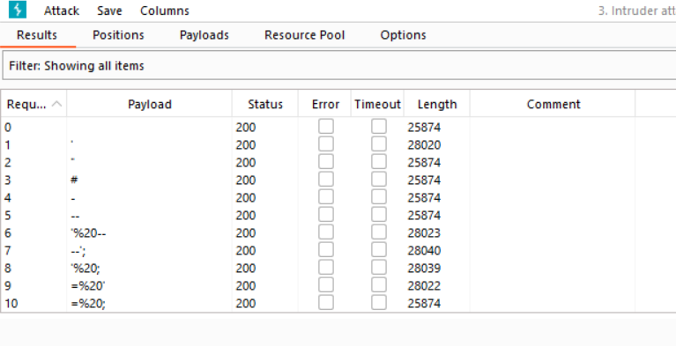

1. Use filter 3XX:

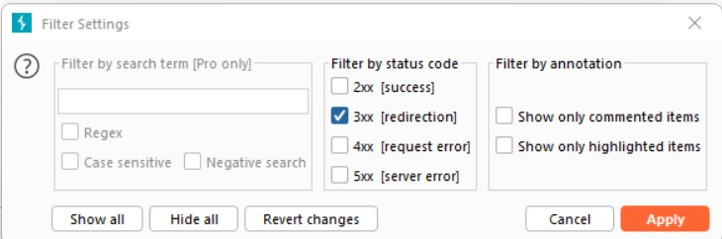

1. We can observe all payloads

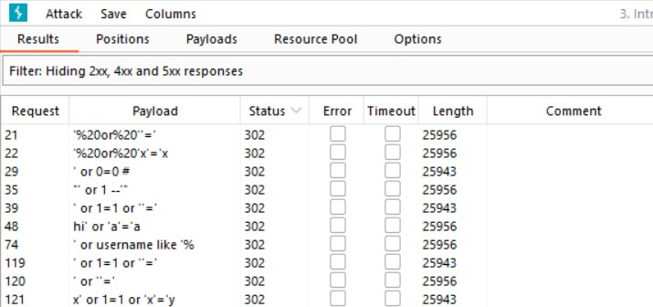

1. We can observe that we have successfully implemented SQL injection.

