**Name: Varun Salgarkar**

**Reg No: 19BCE1435**

**Standard ACL**

**Topology:** 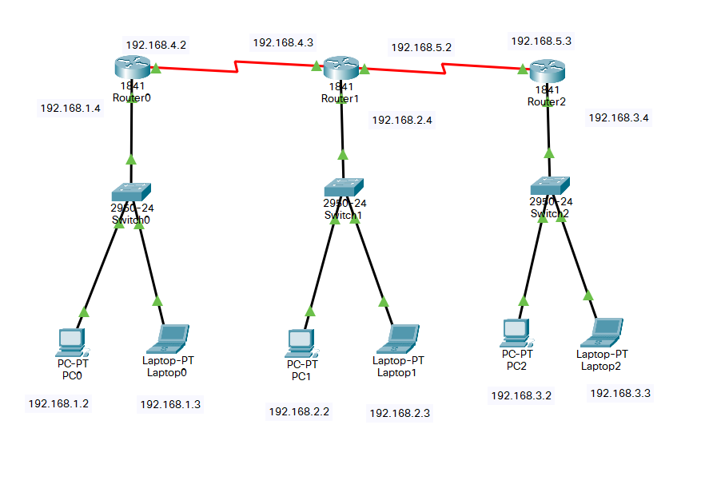

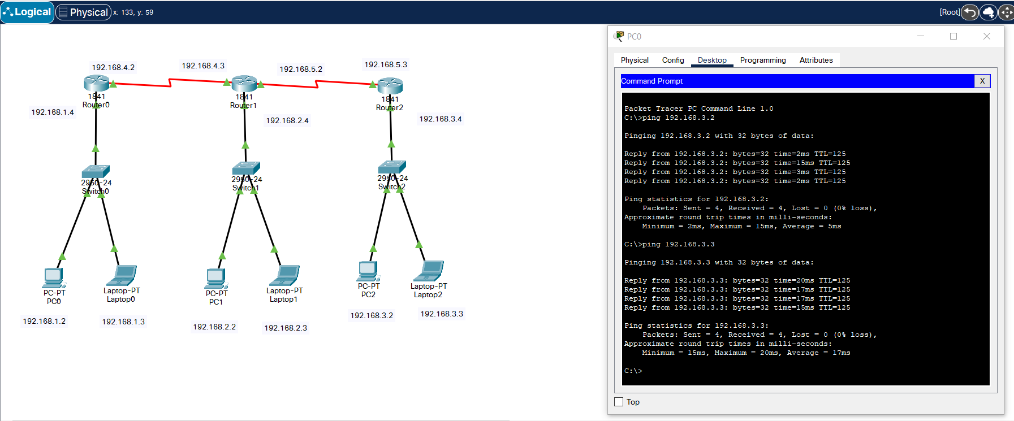

**CMD at “*PC0”* scanning all nodes under “*Router2”*:**

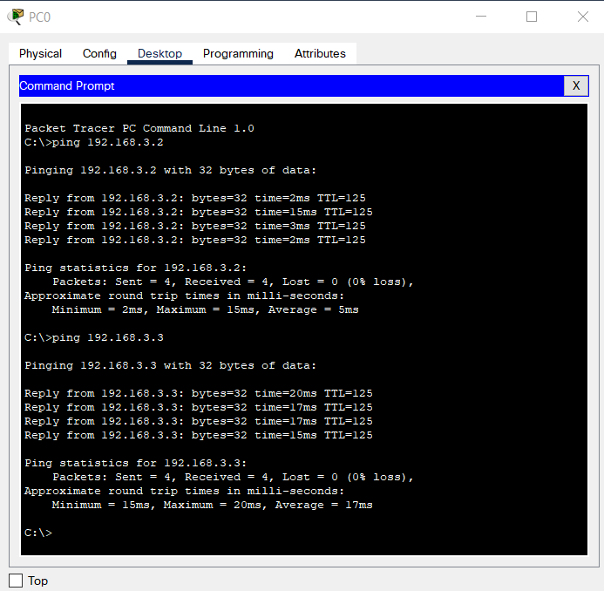

**CLI of *“Router2”:***

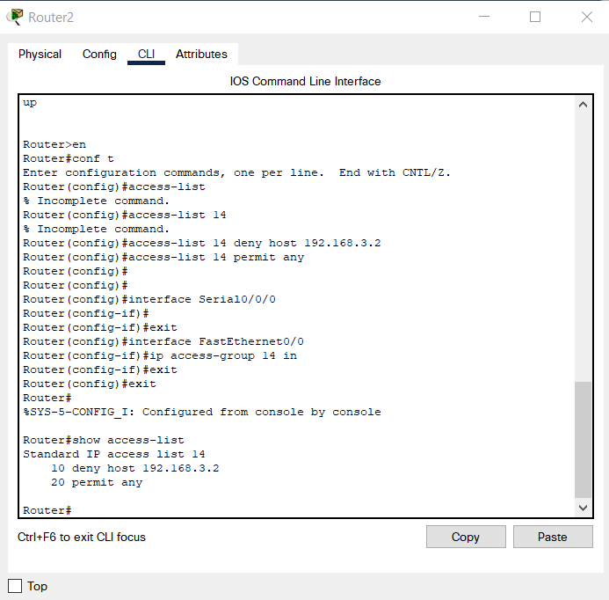

**CMD at “*PC0”* after changes:**

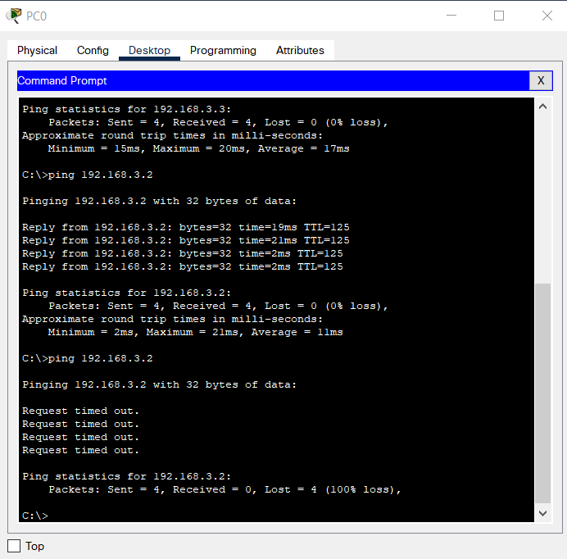

**Packet Transmission**

