**Name: Varun Salgarkar**

**Reg No: 19BCE1435**

**Lab 4 - Extended ACL**

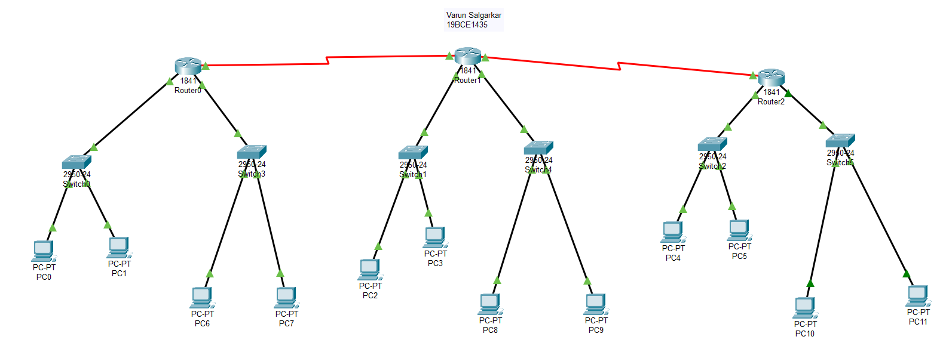

**Steps**

1) Open CLI section in router2

2) Enter following commands

en

conf t

access-list 100 deny ip 192.168.3.2 0.0.0.0 192.168.1.2 0.0.0.255

access-list 100 permit ip any any

int fa0/0

ip access-group 100 in

show run

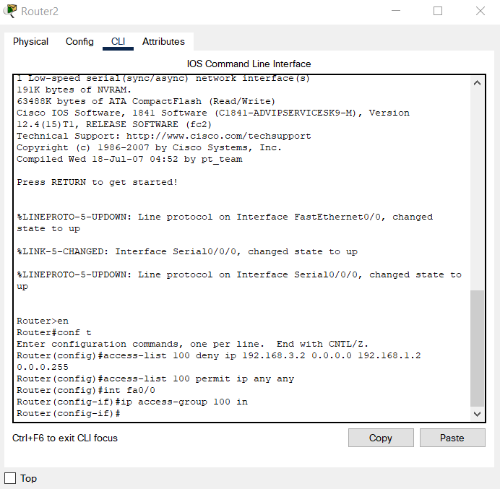

Access list 100 when “show run” command is used.

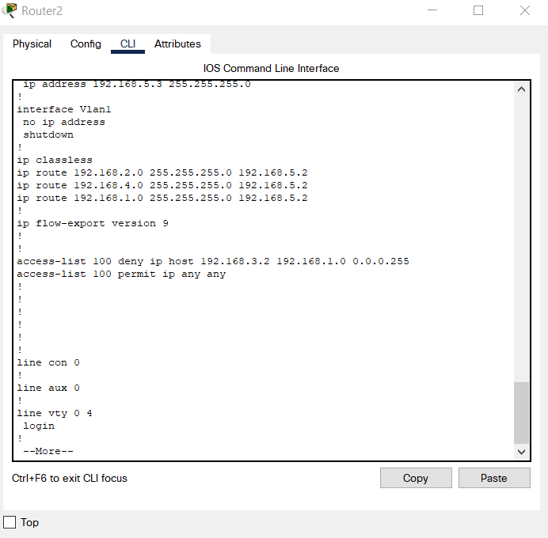

3) Check CLI of “PC2”

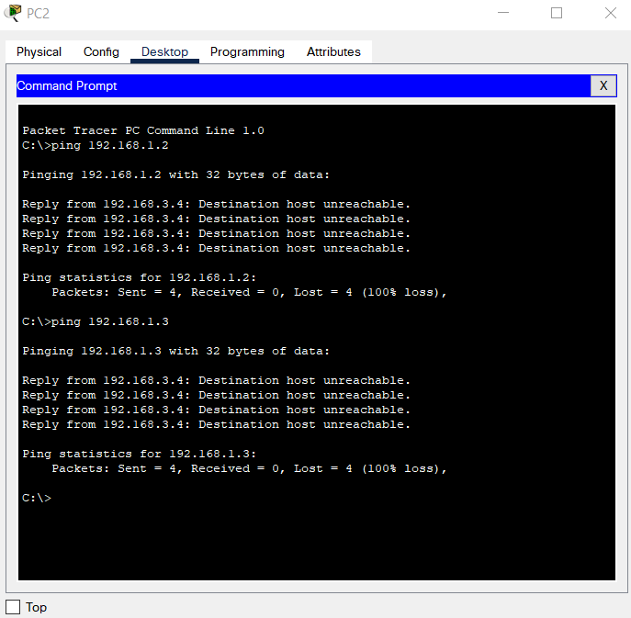

Host PC2(192.168.3.2) is denied to ping any host under router0(192.168.1.2 & 192.168.1.3). Router2 is the one which has shared the message of “destination host unreachable”, this being evident as the reply IP is 192.168.3.4, which belongs to router2.

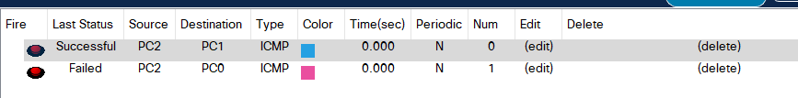

However, since we used extended ACL, Host PC2(192.168.3.2) can ping any host under router1(192.168.2.2 & 192.168.2.3).

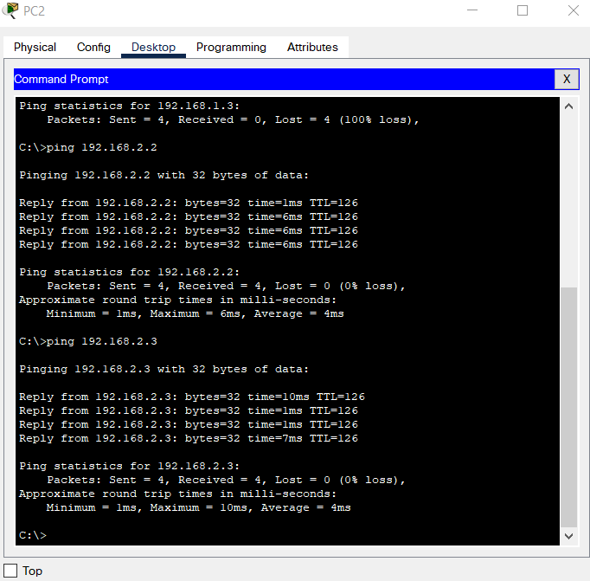

4) Commands in CLI of Router0 to remove Extended ACL

en

conf t

no access-list 100

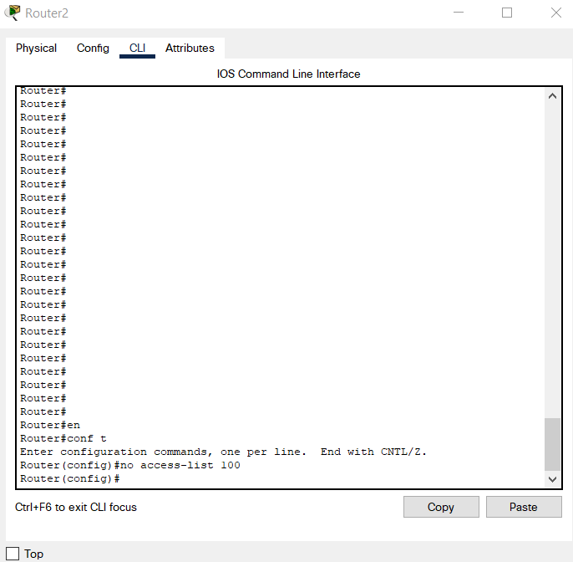

5)All hosts of router0 can be accessed by PC2 ffter clearing extended ACL

