**STOCK PRICE ANALYSIS**

Analysis of stocks using data mining will be useful for new investors to invest in stock market based on the various factors considered by the software.  
Stock market includes daily activities like sensex calculation, exchange of shares. The exchange provides an efficient and transparent market for trading in equity, debt instruments and derivatives.

* Stock analysis is a process followed by traders to evaluate and understand the value of a security or the stock market.
* Stock analysis follows the idea that analysts can create methodologies to select stocks by studying past and present data.

Types of Stock Analysis :-

#### Fundamental Analysis

#### Technical Analysis

**Prototype Development :-**

[**https://github.com/varunsalunkhe/Stock_Price_Analysis.git**](https://github.com/varunsalunkhe/Stock_Price_Analysis.git)

**Business Modelling :-**

1> *Demand and Supply:*  
Demand and Supply of shares of a company is a major reason price change in stocks. When Demand Increase and Supply is less, price rises. and vice versa.  
2> *Corporate results:* This will be regarding to the profits or progress of the company over a span of time say 3 months.  
3> *Popularity:* Main Strength in hands of share buyer. Popularity of a company can effect on buyers. Like if any good news of a company, may result in rise of stock price. And a bad news may break dreams.  
The stock value depends on other factors as well, but we are taking into consideration only these main factors.

**Financial Equation :-**

The most common way to value a stock is to compute the company's **price-to-earnings (P/E) ratio**. The P/E ratio equals the company's stock price divided by its most recently reported earnings per share (EPS). A low P/E ratio implies that an investor buying the stock is receiving an attractive amount of value.

We can calculate the stock price by simply **dividing the market cap by the number of shares outstanding**.

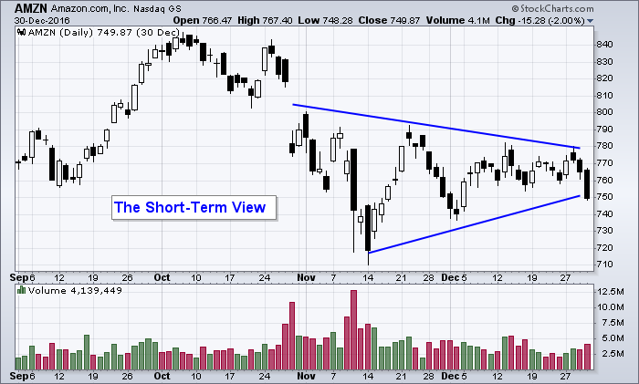

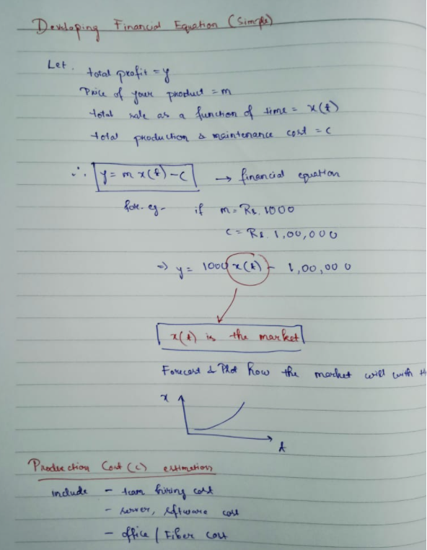

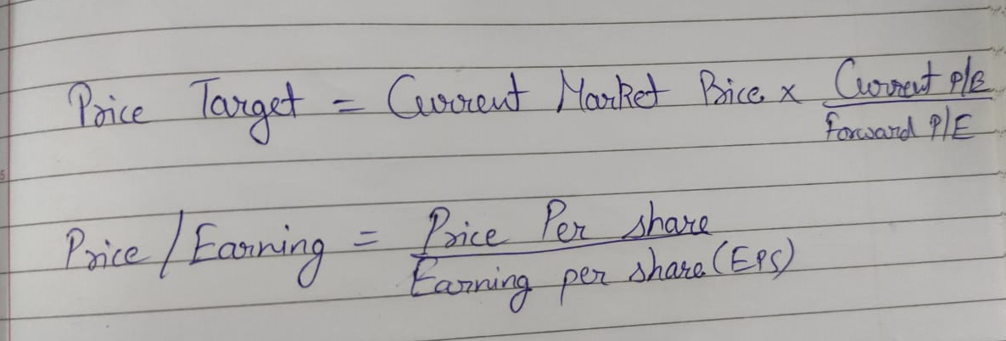

**Team Members :-**

**Aryan Kalra**

**Varun Salunkhe**

**Atharva Nagare**

**Yugandhar**