FINAL PROJECT

POSITION KINEMATICS FOR DELTA ROBOT

**TEAM MEMBERS:** Nivedha Sivakumar, Varun Sanghvi

**TEAM NUMBER:** FINAL PROJECT-4

**GOAL**: The goal of this final project is to design, build and analyze the position kinematics of a delta robot.

**DELTA ROBOT- DESIGN AND QUALITATIVE ANALYSIS:**

A delta robot is a type of [parallel robot](https://en.wikipedia.org/wiki/Parallel_robot) that consists of three arms connected to [universal joints](https://en.wikipedia.org/wiki/Universal_joints) at the base. The key design feature is the use of [parallelograms](https://en.wikipedia.org/wiki/Parallelogram) in the arms, which maintains the orientation of the [end effector](https://en.wikipedia.org/wiki/Industrial_robot_end_effector). Industries that take advantage of the high speed of delta robots are the packaging industry, medical and pharmaceutical industry. For its stiffness, it is also used for surgery. Other applications include high precision assembly operations in a [clean room](https://en.wikipedia.org/wiki/Clean_room) for electronic components. The structure of a delta robot can also be used to create [haptic](https://en.wikipedia.org/wiki/Haptic_technology#Games) controllers. More recently, the technology has been adapted to [3D printers](https://en.wikipedia.org/wiki/3D_printers). These printers can be built for about a thousand dollars and compete well with traditional Cartesian printers.

We have designed and built a delta robot with 3 DOF, i.e., the robot can exhibit motion in X, Y and Z directions as detailed in figures below. The mechanical design, circuit design for motor movement, and the 3-D symbolic representation of the delta robot are as illustrated below.

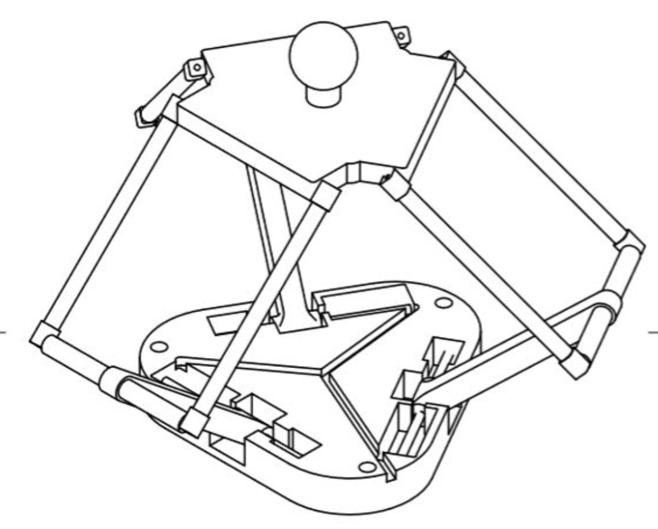

FIG 1. Mechanical design of the delta robot

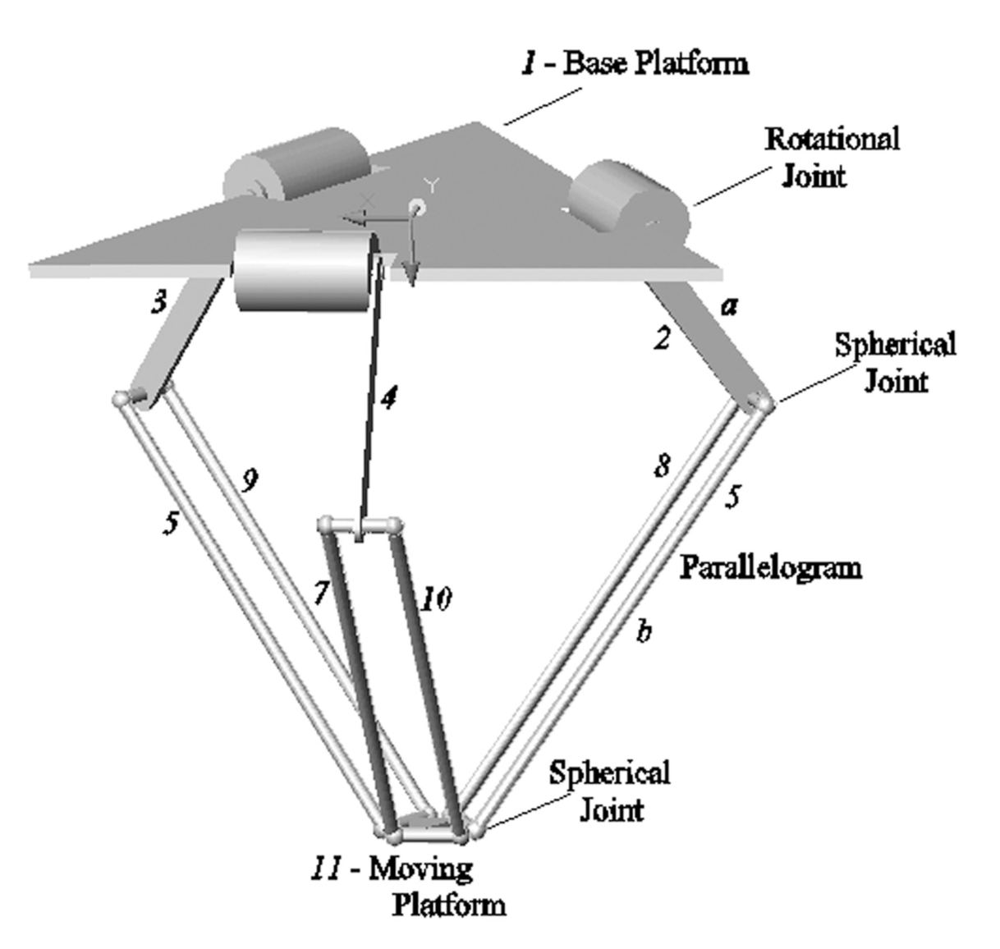

FIG 2. 3-D representation of delta robot

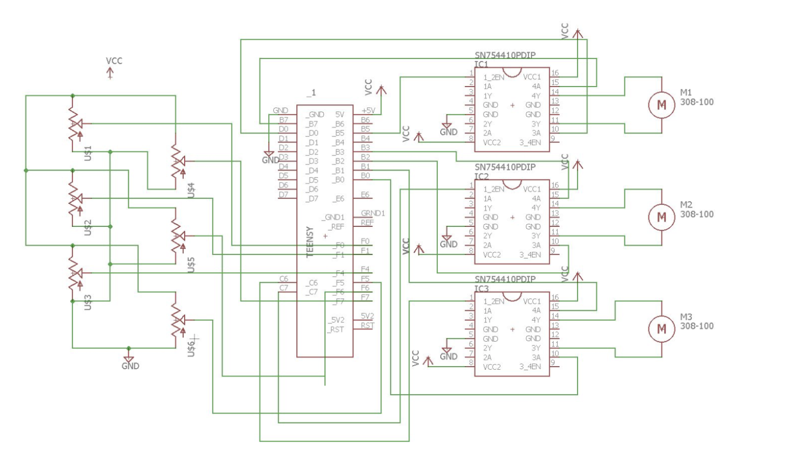

FIG 3. Circuit design for motor movement:

The designed robot has only revolute and spherical joints (illustrated in figure below), its kinematic arrangement is found to be RUU (U represents the universal joints used in the delta robot, which are implemented using 3 non-collocated revolute joints).

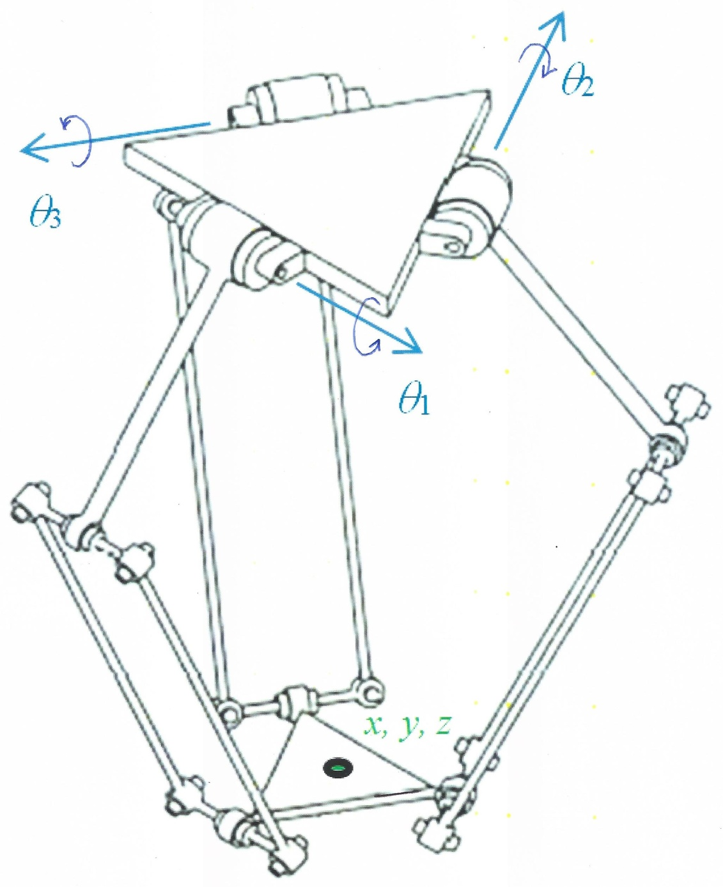

FIG 4. DOF estimation for delta robot

This qualitative analysis of DOF estimation is backed up by the Kutzbach mobility equation given below:

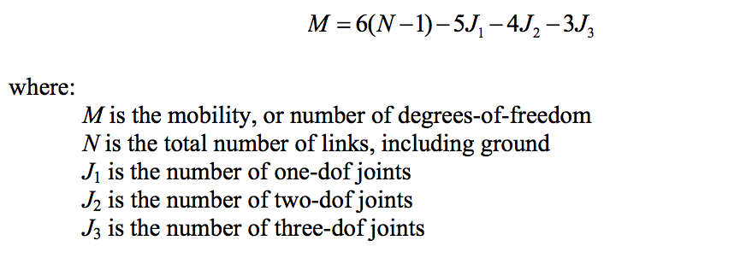

Substituting for N, J1 , J2 and J3 as 14, 15, 0 and 0 (as per design of the delta robot) in the Kutzbach equation, we obtain a DOF of 3.

**METHOD:**

1. Homogeneous Transformation - ?
2. Forward Kinematics derivation:
3. Inverse Kinematics derivation: Approach- Geometric? When does no IK solution exist?

**PSEUDO-CODE:**

**EVALUATION:**

1. Forward Kinematics: 3 TEST CASES WITH FIGURES
2. Inverse Kinematics: 3 TEST CASES WITH FIGURES

**ANALYSIS:**

* Comparison with expected results: Simulation?
* When does it work well? And when does it not?
* Any differences from expected result?
* Workspace

**RELATION TO COURSE:**

**FUTURE SCOPE OF PROJECT:**

* **Velocity analysis to find which works better- position or velocity kinematics**
* **Haptics applications**

**REFERENCES:**