Total size of data to be transferred

The size comes up if the size of individual points is stored in the memory. Prevents stack overflow but total data size is huge.

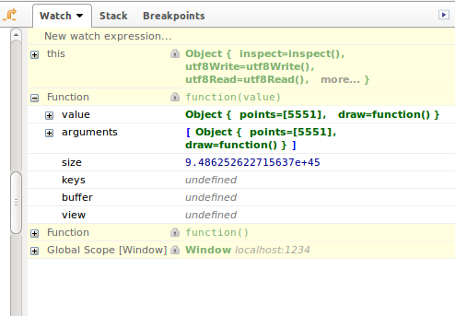

A 5x5 square cloth would have 816 bytes of size considering each point to be of 1 byte

