CREATE A GITHUB ACCOUNT TO FOLLOW THESE STEPS :

.OPEN BROWERS .

.WRITE A **GitHub**

.**Configuring your GitHub account**

**.create a Github account**

**.To sign up for an account on GitHub.com, navigate to *https://github.com/* and follow the prompts.**

**.To keep your GitHub account secure you should use a strong and unique password. For more information, see "**[**Creating a strong password**](https://docs.github.com/en/authentication/keeping-your-account-and-data-secure/creating-a-strong-password)**."**

**2. Choou can choose GitHub Free or GitHub Pro to get access to different features for your personal account. You can upgrade at any time if you are unsure at first which product you want.**

**For more information on all of GitHub's plans, see "[GitHub’s products](https://docs.github.com/en/get-started/learning-about-github/githubs-products) chosing your GitHub product**

**3. Verifying your email address**

**To ensure you can use all the features in your GitHub plan, verify your email address after signing up for a new account. For more information, see "**[Verifying your email address](https://docs.github.com/en/get-started/signing-up-for-github/verifying-your-email-address)."

**4. Configuring two-factor authentication**

Two-factor authentication, or 2FA, is an extra layer of security used when logging into websites or apps. We strongly urge you to configure 2FA for the safety of your account. For more information, see "[About two-factor authentication](https://docs.github.com/en/authentication/securing-your-account-with-two-factor-authentication-2fa/about-two-factor-authentication)."

**5. Viewing your GitHub profile and contribution graph**

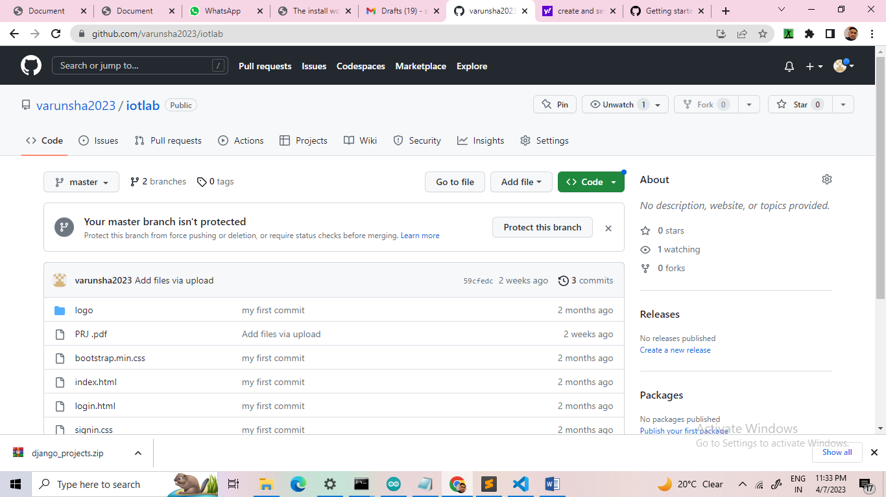

**Contribution graph**

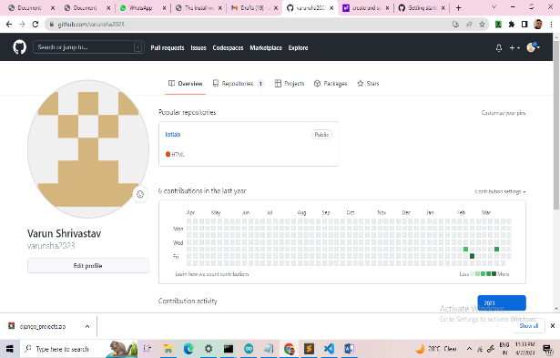

**Part 2: Using GitHub's tools and processes**

**1. Learning Git**

**GitHub's collaborative approach to development depends on publishing commits from your local repository to GitHub for other people to view, fetch, and update using Git.**

**2. Setting up Git**

**If you plan to use Git locally on your computer, whether through the command line, an IDE or text editor, you will need to install and set up Git. For more information, see "**[**Set up Git**](https://docs.github.com/en/get-started/quickstart/set-up-git)**."**

**Part 3: Collaborating on GitHub**

1. Working with repositories

**Creating a repository**

**A repository is like a folder for your project. You can have any number of public and private repositories in your personal account. Repositories can contain folders and files, images, videos, spreadsheets, and data sets.**

**ADD A REPOSITORY BY CMD**

**NAME OF REPOSITORY : IOTLAB**

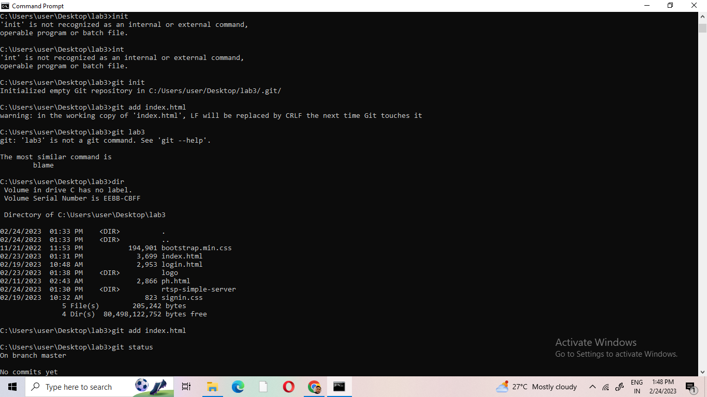

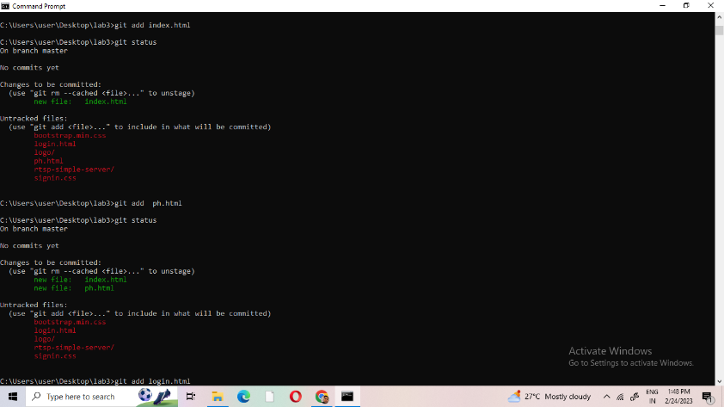

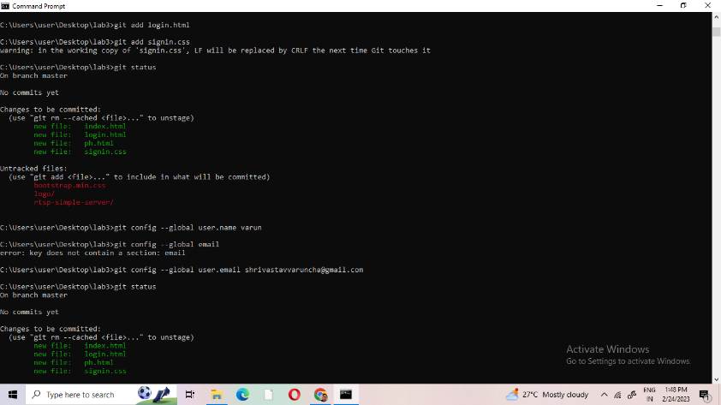

**Cloning a repository**

**You can clone an existing repository from GitHub to your local computer, making it easier to add or remove files, fix merge conflicts, or make complex commits. Cloning a repository pulls down a full copy of all the repository data that GitHub has at that point in time, including all versions of every file and folder for the project. For more information, see "**[**Cloning a repository**](https://docs.github.com/en/repositories/creating-and-managing-repositories/cloning-a-repository)**."**

**ADD A PRJOJECT WITHOUT CMD**

**.ADD A README**

**.CREATE A FILE 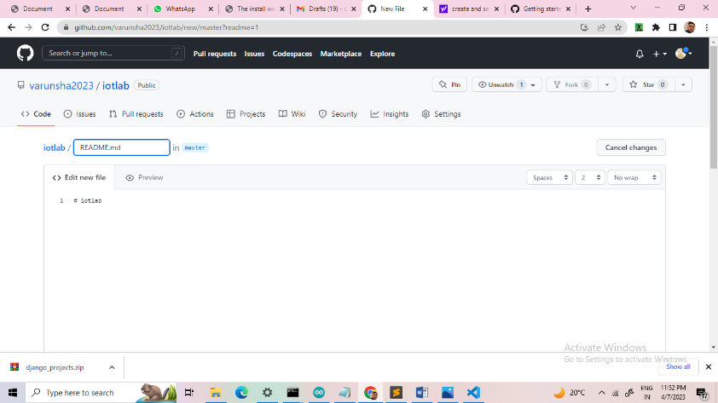NAME AND ADD THESE FILE**

**ADD THE VARIOUS PRJ TO GITHUB ACCOUNT**

**LOGO**

**BOOTSTRAP.CSS**

**INDEX.HTML**

**WEBPAGE.HTML**

**SIGNIN.HTML**

**LOGIN.HTML**

**CREATE A PROJECT USING HTML CSS JS BOOTSTRAP AND TO DEVELOP A NEW WEBSITE**

**LINK OF MY GIT HUB ACCOUNT --https://github.com/varunsha2023**

**LINK OF MY PROJECTS --** [**https://github.com/varunsha2023/iotlab.git**](https://github.com/varunsha2023/iotlab.git)

.