SETUP DJANGO PROJECT ON YOUR LAPTOP TO FOLLOWED BY SOME STEPS.

OPEN CMD ()

* Set up a **virtual environment**
* **Install** Django
* Pin your project **dependencies**
* Set up a Django **project**
* Start a Django **app**

**Prepare Your Environment**

**< python3 -m venv env**

**< source env/bin/activate**

***Install Django and Pin Your Dependencies***

**(env) $ python -m pip install django**

**(env) $ python -m pip freeze > requirements.txt**

**(env) $ python -m pip freeze > requirements.txt**

**Set Up a Django Project ::**

* A Django project is a high-level unit of organization that contains logic that governs your whole web application. Each project can contain multiple apps.
* **A Django app is a lower-level unit of your web application. You can have zero to many apps in a project, and you’ll usually have at least one app. You’ll learn more about apps in the next section.**

**(env) $ django-admin startproject <test_django>**

**(env) $ django-admin startproject setup**

**setup/**

**│**

**├── setup/**

**│ ├── __init__.py**

**│ ├── asgi.py**

**│ ├── settings.py**

**│ ├── urls.py**

**│ └── wsgi.py**

**│**

**└── manage.py**

**Start a Django App ::**

**env) $ pytho(env) $ python manage.py startapp**

**n manage.py startapp <ip_scan>**

**setup/**

**│**

**├── example/**

**│ │**

**│ ├── migrations/**

**│ │ └── __init__.py**

**│ │**

**│ ├── __init__.py**

**│ ├── admin.py**

**│ ├── apps.py**

**│ ├── models.py**

**│ ├── tests.py**

**│ └── views.py**

**│**

**├── setup/**

**│ ├── __init__.py**

**│ ├── asgi.py**

**│ ├── settings.py**

**│ ├── urls.py**

**│ └── wsgi.py**

**│**

**└── ma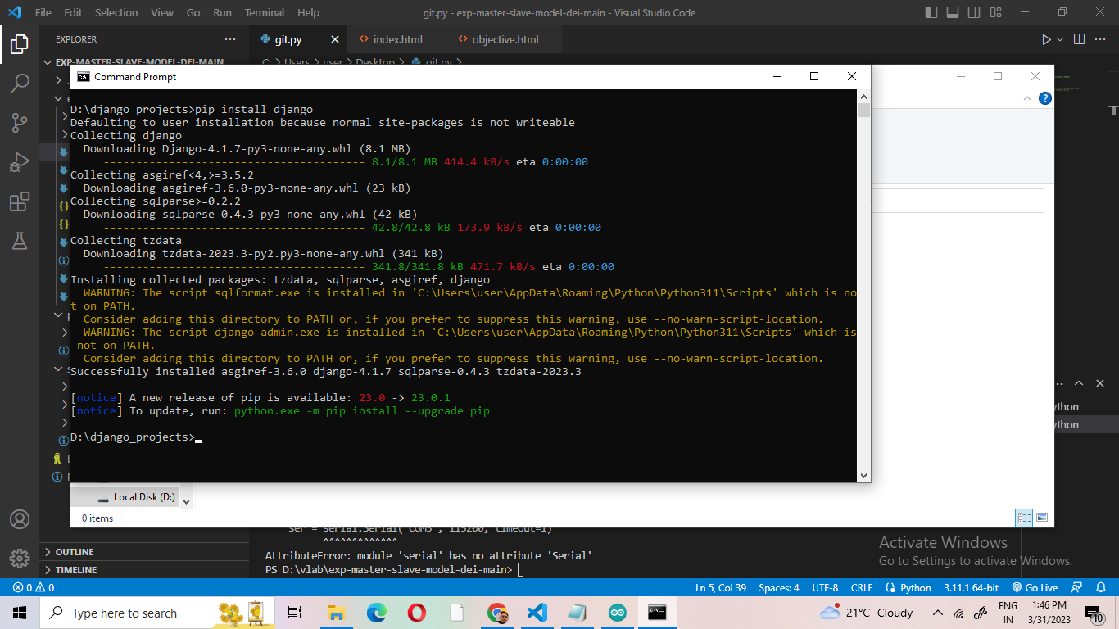nage.py**