NAME:SAKSHI PATIL

UID:2018130039

CEL 51, DCCN, Monsoon 2020

Lab 7: RIPv2 Router Configuration



**Topology Diagram**

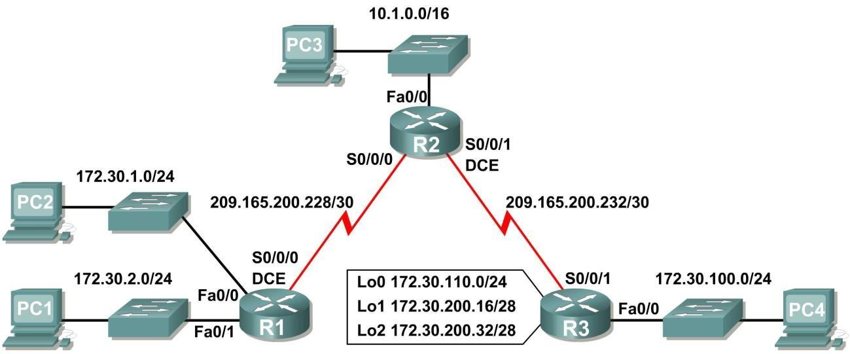

**Addressing Table**

|  |  |  |  |  |
| --- | --- | --- | --- | --- |
| **Device** | **Interface** | **IP Address** | **Subnet Mask** | **Default Gateway** |
| **R1** | **Fa0/0** | 172.30.1.1 | 255.255.255.0 | N/A |
| **Fa0/1** | 172.30.2.1 | 255.255.255.0 | N/A |
| **S0/0/0** | 209.165.200.230 | 255.255.255.252 | N/A |
| **R2** | **Fa0/0** | 10.1.0.1 | 255.255.0.0 | N/A |
| **S0/0/0** | 209.165.200.229 | 255.255.255.252 | N/A |
| **S0/0/1** | 209.165.200.233 | 255.255.255.252 | N/A |
| **R3** | **Fa0/0** | 172.30.100.1 | 255.255.255.0 | N/A |
| **S0/0/1** | 209.165.200.234 | 255.255.255.252 | N/A |
| **Lo0** | 172.30.110.1 | 255.255.255.0 | N/A |
| **Lo1** | 172.30.200.17 | 255.255.255.240 | N/A |
| **Lo2** | 172.30.200.33 | 255.255.255.240 | N/A |
| **PC1** | **NIC** | 172.30.1.10 | 255.255.255.0 | 172.30.2.1 |
| **PC2** | **NIC** | 172.30.2.10 | 255.255.255.0 | 172.30.1.1 |
| **PC3** | **NIC** | 10.1.0.10 | 255.255.0.0 | 10.1.0.1 |
| **PC4** | **NIC** | 172.30.100.10 | 255.255.255.0 | 172.30.100.1 |

1 of 49

**Learning Objectives**

Upon completion of this lab, you will be able to:

* Cable a network according to the Topology Diagram.
* Load provided scripts onto the routers.
* Examine the current status of the network.
* Configure RIPv2 on all routers.
* Examine the automatic summarization of routes.
* Examine routing updates with **debug ip rip**.
* Disable automatic summarization.
* Examine the routing tables. • Verify network connectivity.
* Document the RIPv2 configuration.

**Scenario**

The network shown in the Topology Diagram contains a discontiguous network, 172.30.0.0. This network has been subnetted using VLSM. The 172.30.0.0 subnets are physically and logically divided by at least one other classful or major network, in this case the two serial networks 209.165.200.228/30 and 209.165.200.232/30. This can be an issue when the routing protocol used does not include enough information to distinguish the individual subnets. RIPv2 is a classless routing protocol that can be used to provide subnet mask information in the routing updates. This will allow VLSM subnet information to be propagated throughout the network.

**Task 1: Cable, Erase, and Reload the Routers.**

**Step 1: Cable a network.**

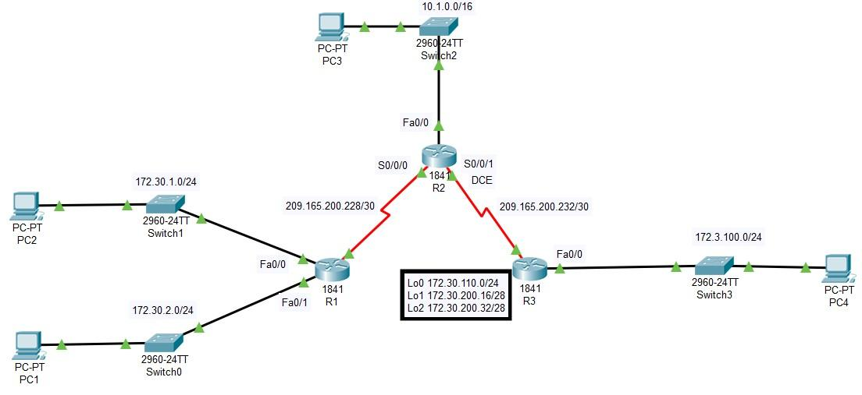

**PC1 config**

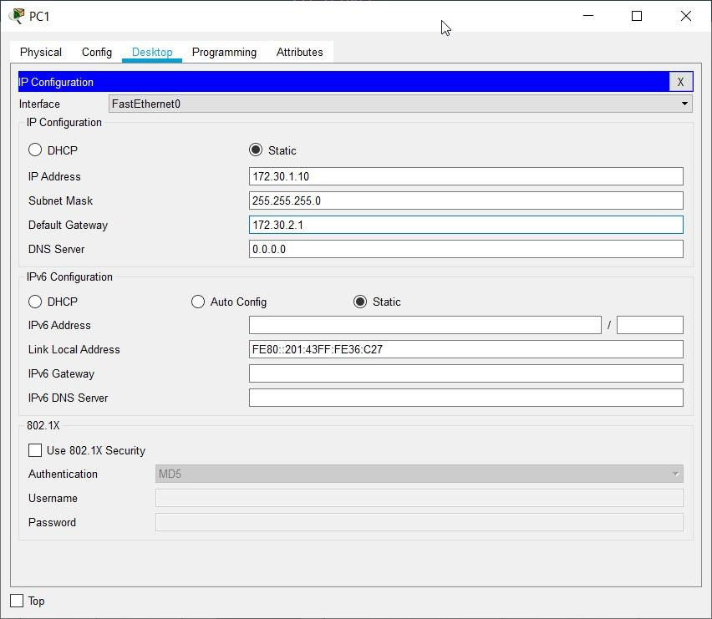

**PC2 config**

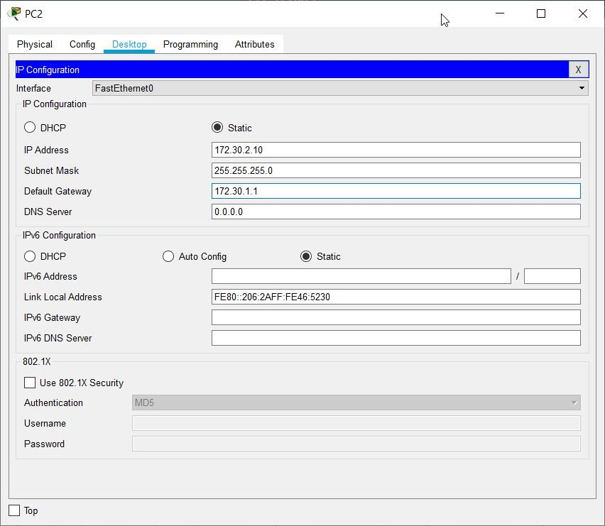

**PC3 config**

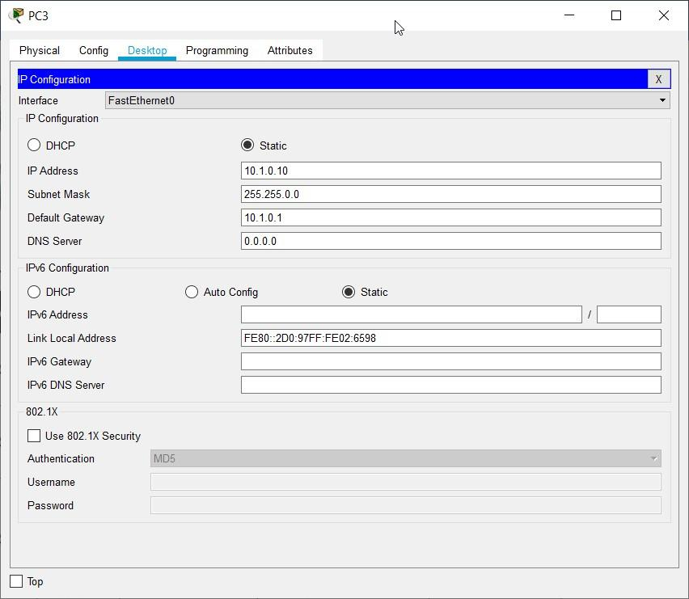

**PC4 config**

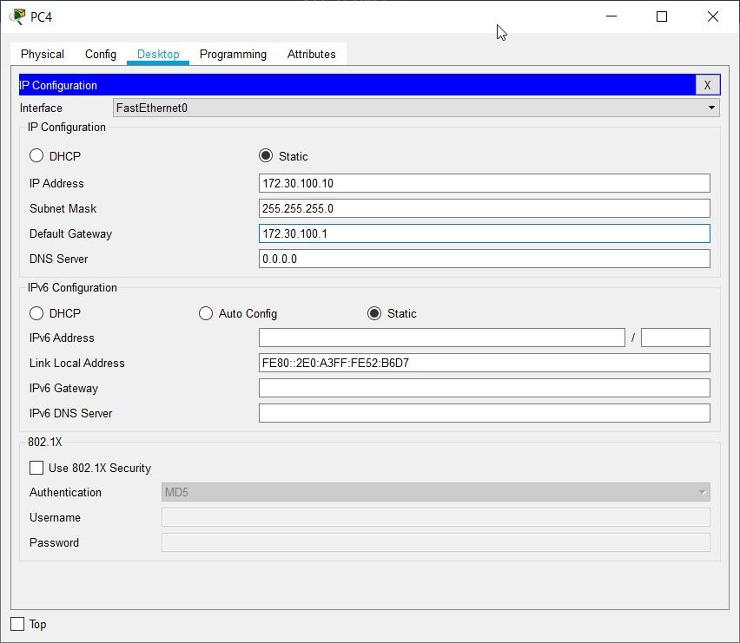

**Step 2: Clear the configuration on each router.**

Clear the configuration on each of routers using the **erase startup-config** command and then **reload** the routers. Answer **no** if asked to save changes.

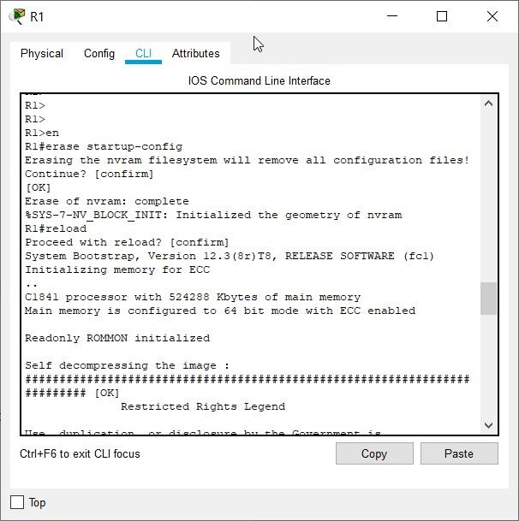

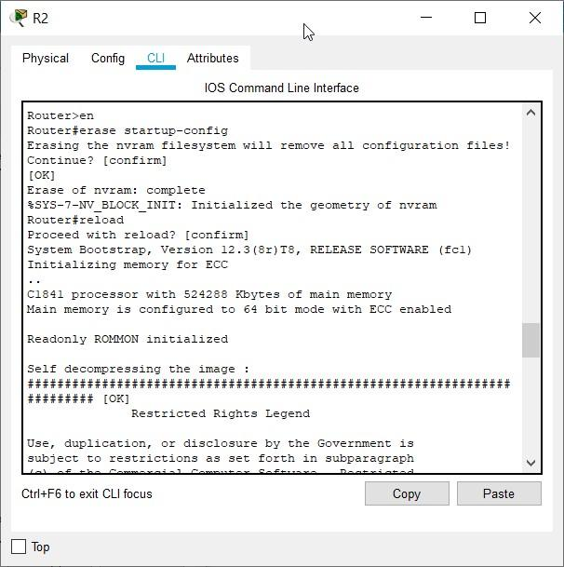

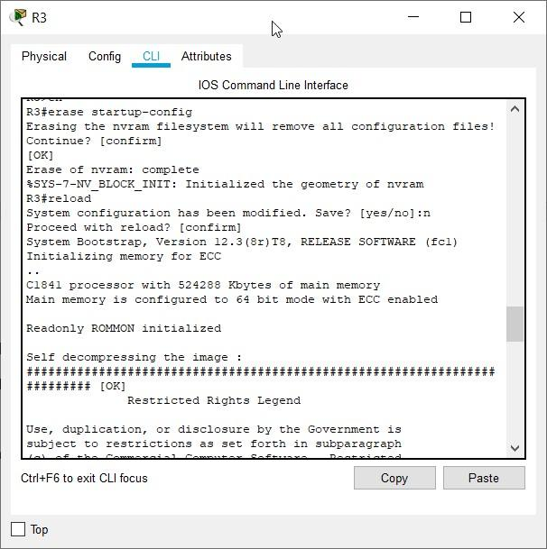

**Task 2: Load Routers with the Supplied Scripts.**

**Step 1: Load the following script onto R1.**

!

hostname R1

!

! ! interface FastEthernet0/0 ip address 172.30.1.1 255.255.255.0 duplex auto speed auto no shutdown ! interface FastEthernet0/1 ip address 172.30.2.1 255.255.255.0 duplex auto speed auto no shutdown !

interface Serial0/0/0

ip address 209.165.200.230 255.255.255.252 clock rate 64000 no shutdown

!

router rip

passive-interface FastEthernet0/0 passive-interface FastEthernet0/1 network 172.30.0.0 network 209.165.200.0 !

line con 0 line vty 0 4 login

! end

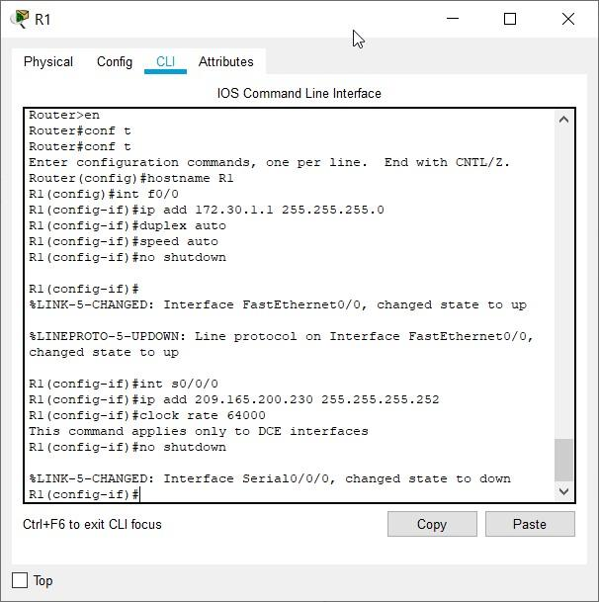

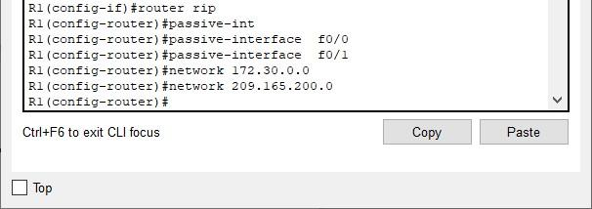

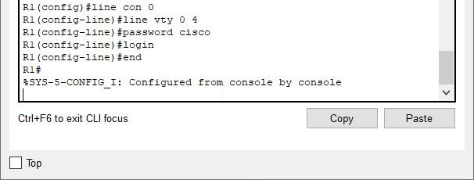

**Step 2: Load the following script onto R2.**

hostname R2

!

! ! interface FastEthernet0/0 ip address 10.1.0.1 255.255.0.0 duplex auto

speed auto no shutdown !

interface Serial0/0/0 ip address 209.165.200.229 255.255.255.252 no shutdown !

interface Serial0/0/1 ip address 209.165.200.233 255.255.255.252 clock rate 64000 no shutdown

!

router rip passive-interface FastEthernet0/0 network 10.0.0.0 network 209.165.200.0 !

line con 0 line vty 0 4 login

! end

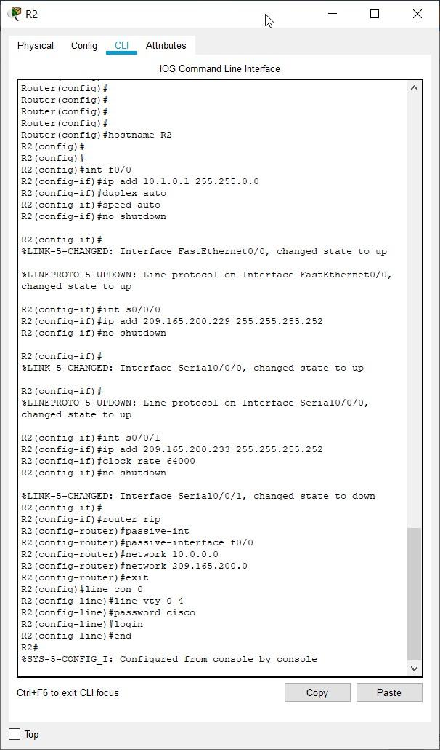

**Step 3: Load the following script onto R3.**

hostname R3 !

! ! interface FastEthernet0/0 ip address 172.30.100.1 255.255.255.0 duplex auto speed auto no shutdown !

interface Serial0/0/1 ip address 209.165.200.234 255.255.255.252 no shutdown !

interface Loopback0 ip address 172.30.110.1 255.255.255.0 !

interface Loopback1 ip address 172.30.200.17 255.255.255.240 !

interface Loopback2 ip address 172.30.200.33 255.255.255.240 !

router rip passive-interface FastEthernet0/0 network 172.30.0.0 network 209.165.200.0 !

line con 0 line vty 0 4 login

! end

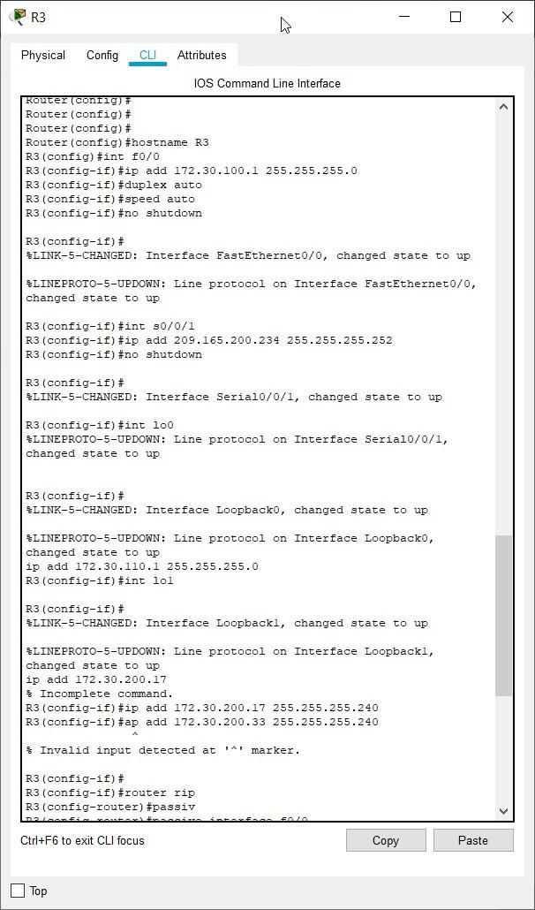

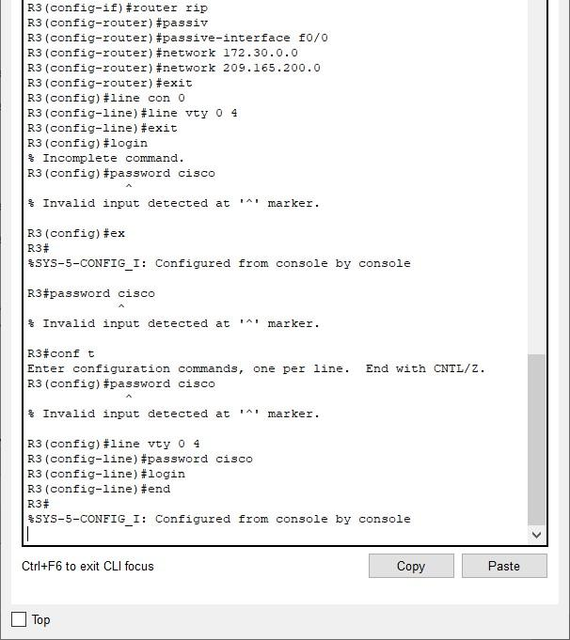 **Task 3: Examine the Current Status of the Network.**

**Step 1: Verify that both serial links are up.**

The two serial links can quickly be verified using the **show ip interface brief** command on R2.

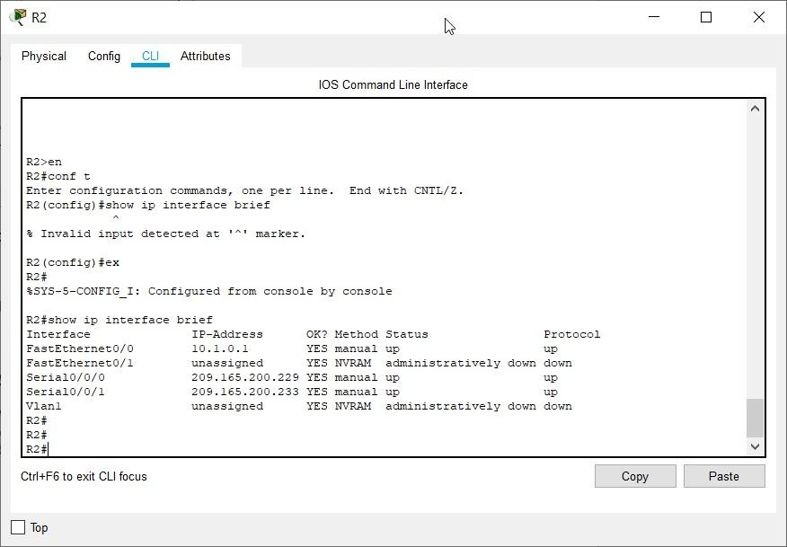

**Step 2: Check the connectivity from R2 to the hosts on the R1 and R3 LANs.**

Note: For the 1841 router, you will need to disable IP CEF to obtain the correct output from the **ping** command. Although a discussion of IP CEF is beyond the scope of this course, you may disable IP CEF by using the following command in global configuration mode:

R2(config)#**no ip cef**

From the R2 router, how many ICMP messages are successful when pinging PC1?

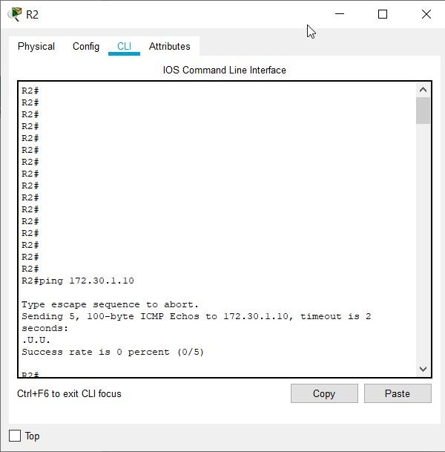

Here we encountered a problem, ping 172.30.1.10 gave 0% success rate, we note that initially 172.30.1.10 doesn’t belong to the 172.30.2.10/24 subnet,

So to rectify this, we exchange the IP addresses of PC1 and PC2

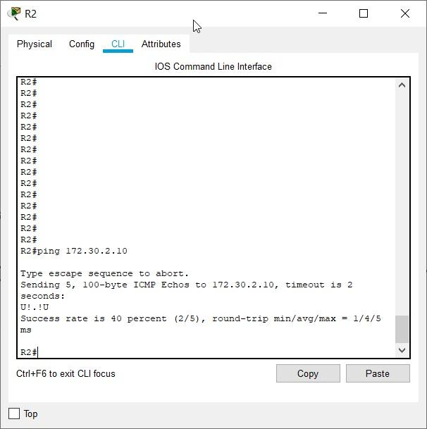

2/5 messages are successful when pinging PC1

From the R2 router, how many ICMP messages are successful when pinging PC4?

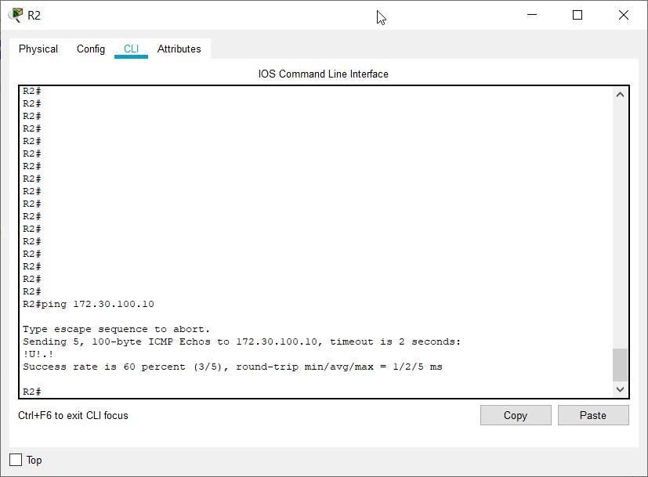

3/5 messages are successful when pinging PC4

**Step 3: Check the connectivity between the PCs.**

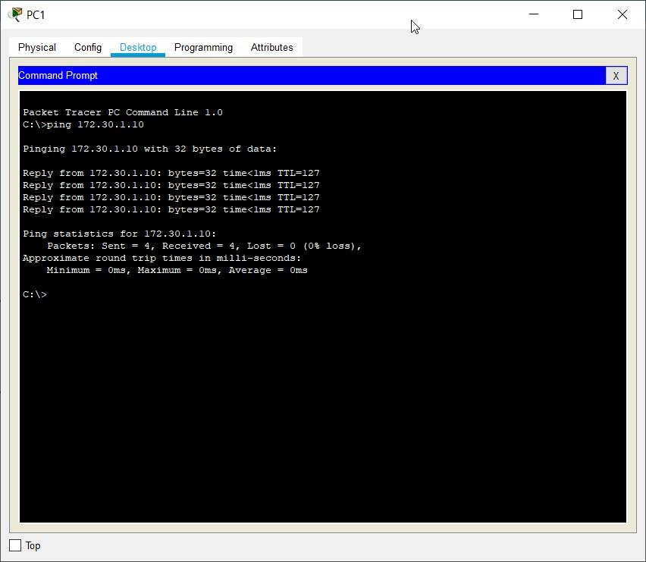

From the PC1, is it possible to ping PC2? yes

What is the success rate? 100%

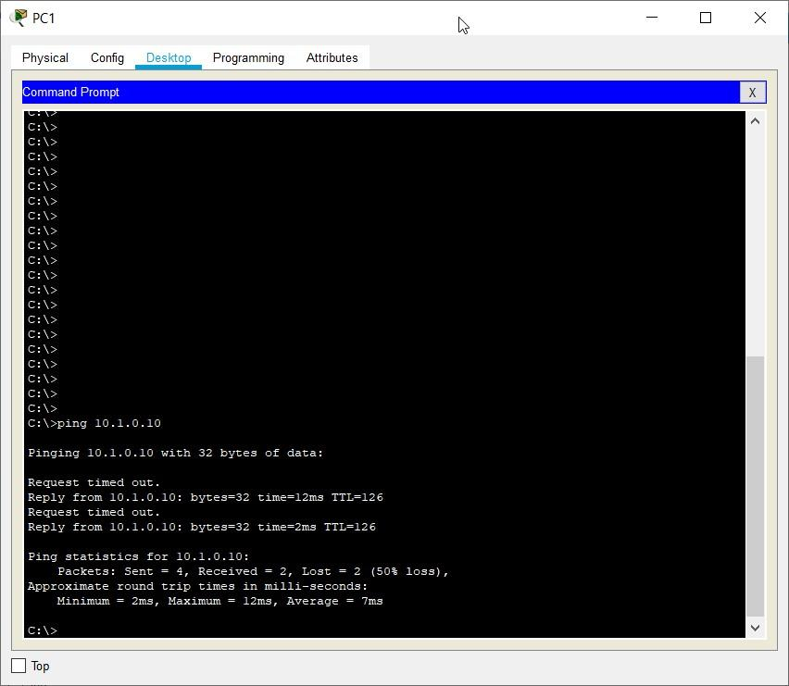

From the PC1, is it possible to ping PC3? yes

What is the success rate? 50%

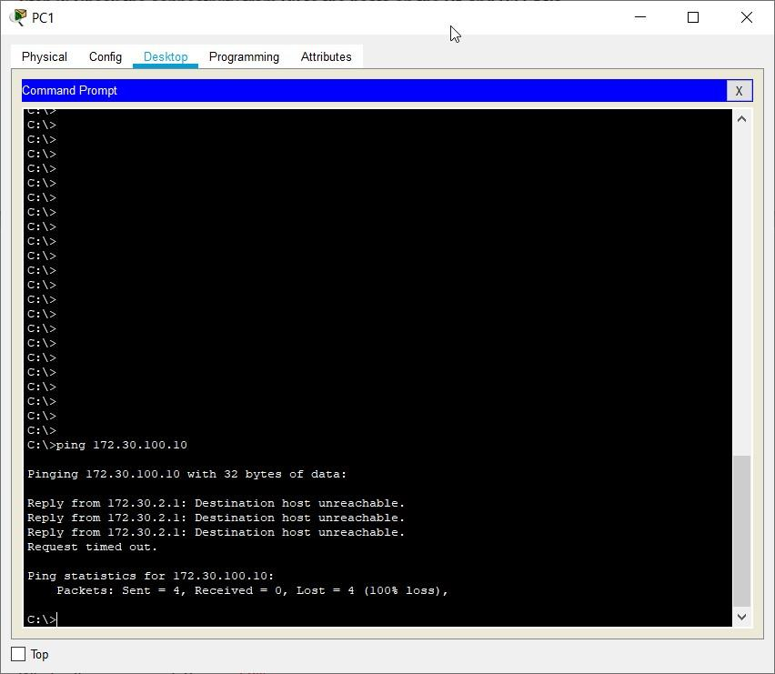

From the PC1, is it possible to ping PC4? no

What is the success rate? 0%

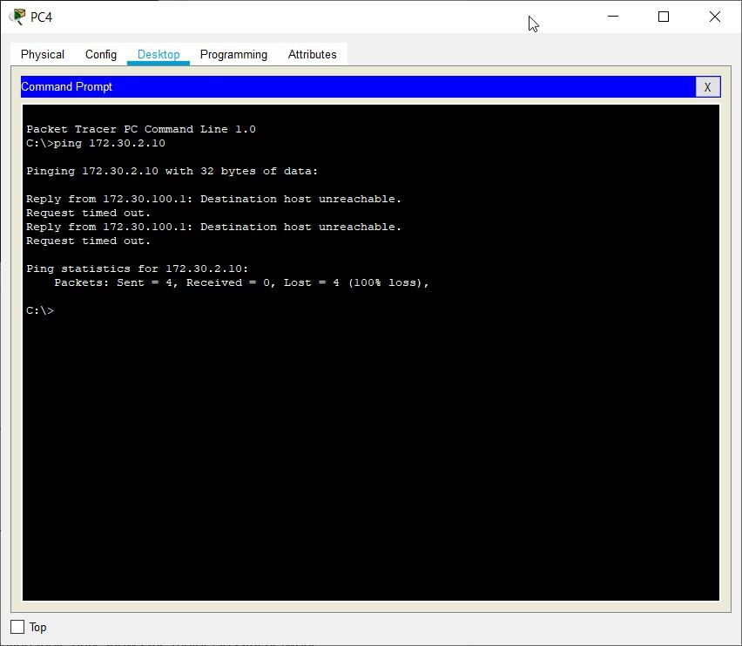

From the PC4, is it possible to ping PC2? no

What is the success rate? 0%

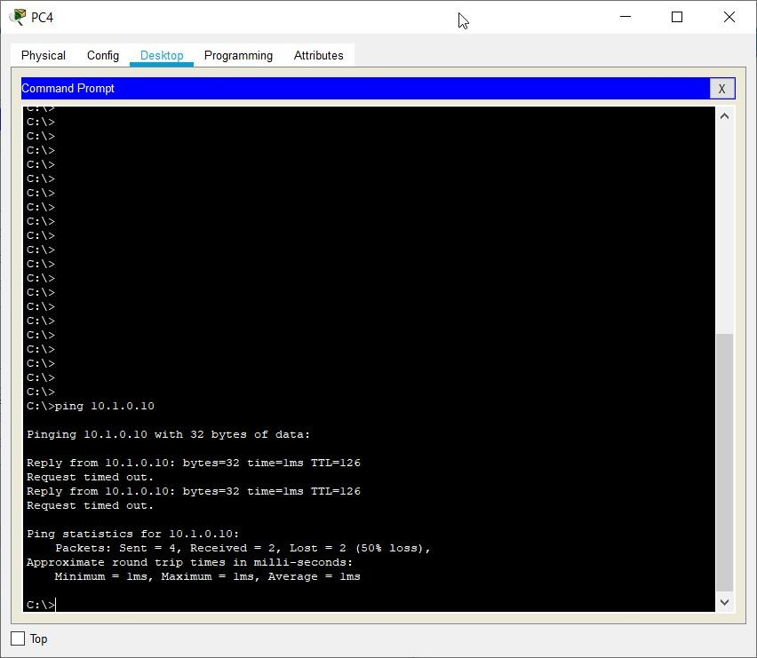

From the PC4, is it possible to ping PC3? yes

What is the success rate? 50%

**Step 4: View the routing table on R2.**

Both the R1 and R3 are advertising routes to the 172.30.0.0/16 network; therefore, there are two entries for this network in the R2 routing table. The R2 routing table only shows the major classful network address of 172.30.0.0—it does not show any of the subnets for this network that are used on the LANs attached to R1 and R3. Because the routing metric is the same for both entries, the router alternates the routes that are used when forwarding packets that are destined for the 172.30.0.0/16 network.

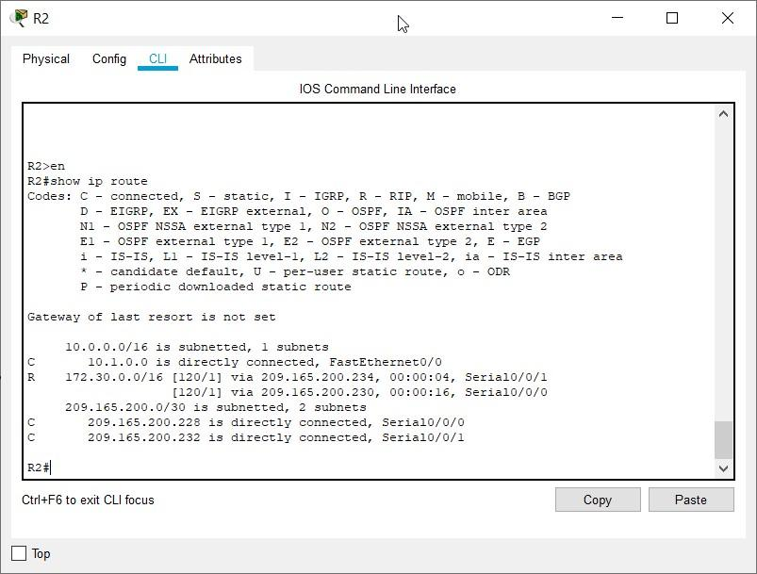

**Step 5: Examine the routing table on the R1 router.**

Both R1 and R3 are configured with interfaces on a discontiguous network, 172.30.0.0. The 172.30.0.0 subnets are physically and logically divided by at least one other classful or major network—in this case, the two serial networks 209.165.200.228/30 and 209.165.200.232/30. Classful routing protocols like RIPv1 summarize networks at major network boundaries. Both R1 and R3 will be summarizing 172.30.0.0/24 subnets to 172.30.0.0/16. Because the route to 172.30.0.0/16 is directly connected, and because R1 does not have any specific routes for the 172.30.0.0 subnets on R3, packets destined for the R3 LANs will not be forwarded properly.

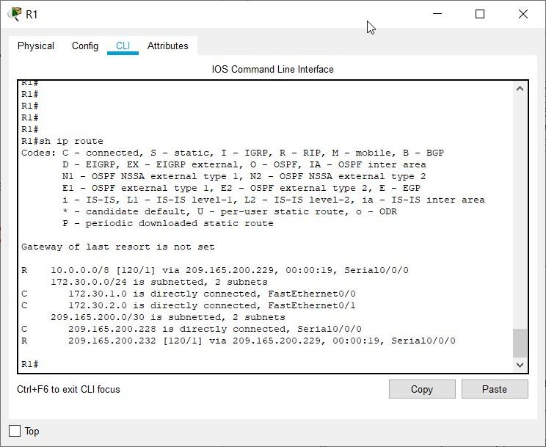

**Step 6: Examine the routing table on the R3 router.**

R3 only shows its own subnets for 172.30.0.0 network: 172.30.100/24, 172.30.110/24, 172.30.200.16/28, and 172.30.200.32/28. R3 does not have any routes for the 172.30.0.0 subnets on R1.

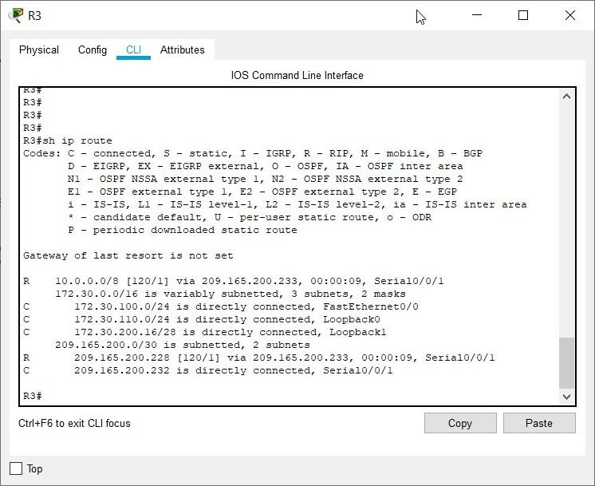

**Step 7: Examine the RIPv1 packets that are being received by R2.**

Use the **debug ip rip** command to display RIP routing updates.

R2 is receiving the route 172.30.0.0, with 1 hop, from both R1 and R3. Because these are equal cost metrics, both routes are added to the R2 routing table. Because RIPv1 is a classful routing protocol, no subnet mask information is sent in the update.

# R2#debug ip rip

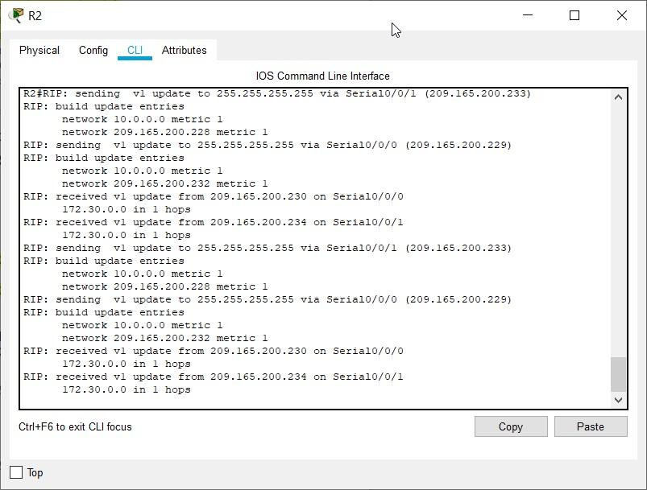

R2 is sending only the routes for the 10.0.0.0 LAN and the two serial connections to R1 and R3. R1 and R3 are not receiving any information about the 172.30.0.0 subnet routes.

When you are finished, turn off the debugging.

# R2#undebug all

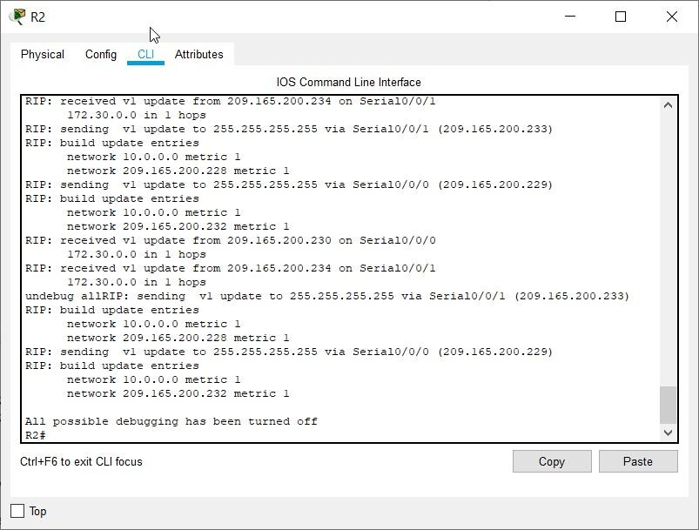

**Task 4: Configure RIP Version 2.**

**Step 1: Use the version 2 command to enable RIP version 2 on each of the routers.**

R2(config)#**router rip**

R2(config-router)#**version 2**

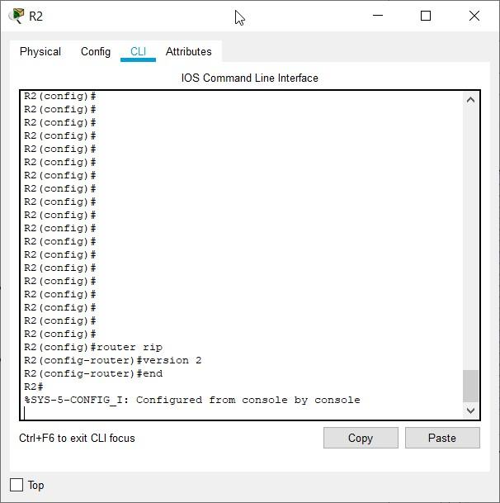

R1(config)#**router rip**

R1(config-router)#**version 2**

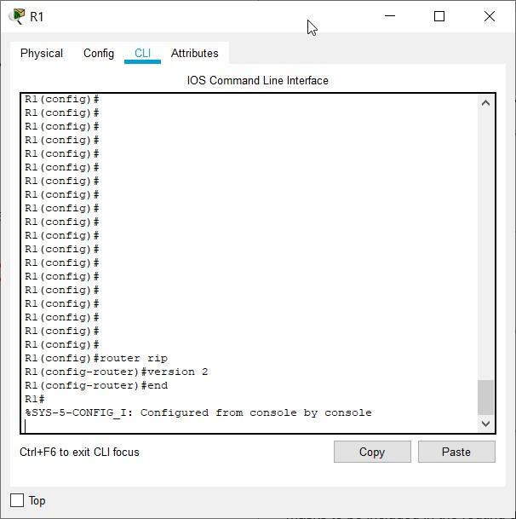

R3(config)#**router rip**

R3(config-router)#**version 2**

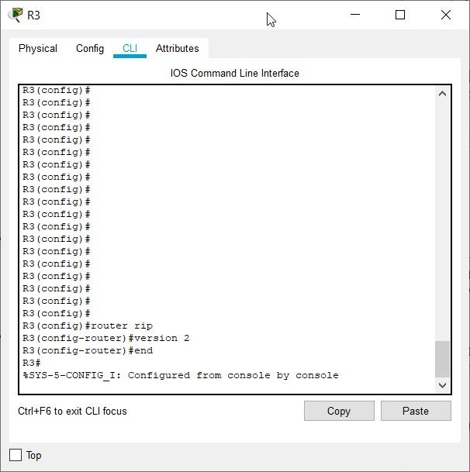

RIPv2 messages include the subnet mask in a field in the routing updates. This allows subnets and their masks to be included in the routing updates. However, by default RIPv2 summarizes networks at major network boundaries, just like RIPv1, except that the subnet mask is included in the update.

**Step 2: Verify that RIPv2 is running on the routers.**

The **debug** **ip rip**, **show ip protocols**, and **show run** commands can all be used to confirm that RIPv2 is running. The output of the **show ip protocols** command for R1 is shown below.

# R1# show ip protocols

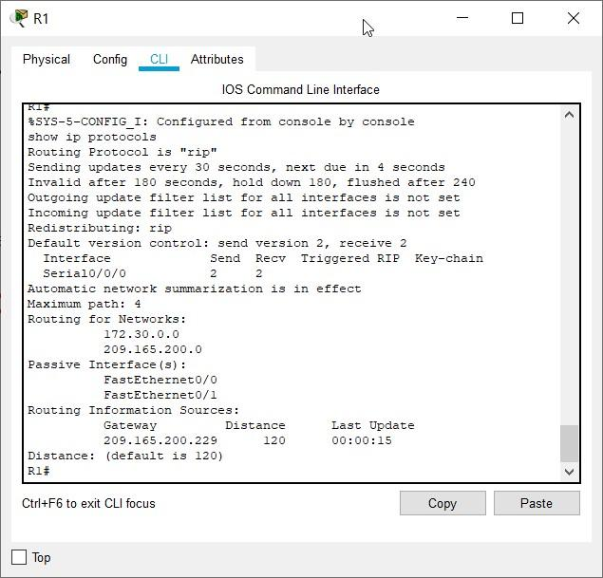



**Task 5: Examine the Automatic Summarization of Routes.**

The LANs connected to R1 and R3 are still composed of discontiguous networks. R2 still shows two equal cost paths to the 172.30.0.0/16 network in the routing table. R2 still shows only the major classful network address of 172.30.0.0 and does not show any of the subnets for this network.

# R2#show ip route

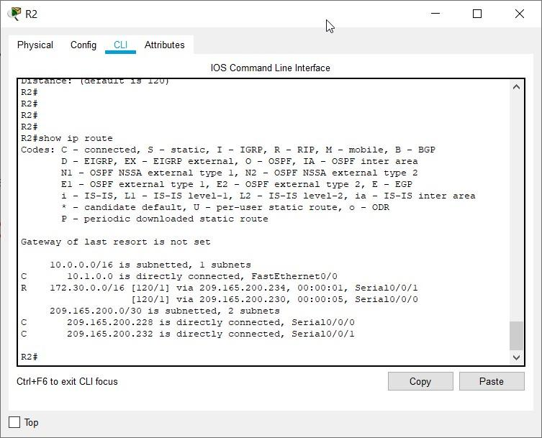

R1 still shows only its own subnets for the 172.30.0.0 network. R1 still does not have any routes for the 172.30.0.0 subnets on R3.

# R1#show ip route

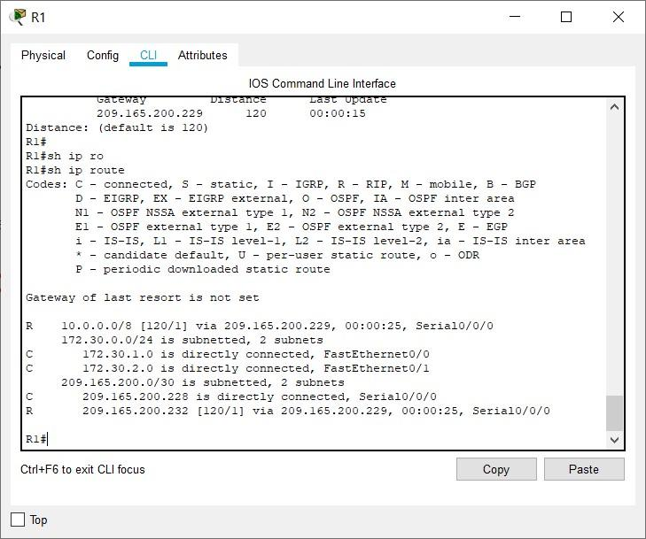

R3 still only shows its own subnets for the 172.30.0.0 network. R3 still does not have any routes for the 172.30.0.0 subnets on R1.

# R3#show ip route

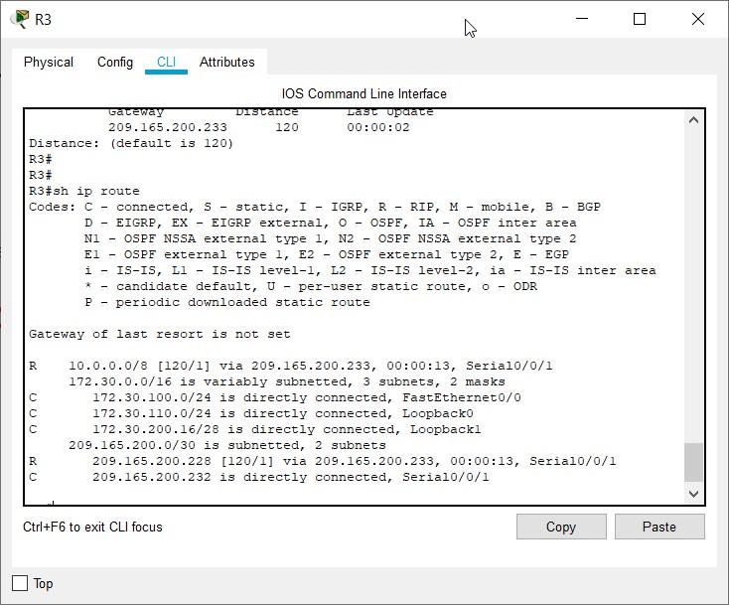

Use the output of the **debug ip rip** command to answer the following questions:

What entries are included in the RIP updates sent out from R3?

RIP protocol debugging is on

R3#RIP: received v2 update from 209.165.200.233 on Serial0/0/1

10.0.0.0/8 via 0.0.0.0 in 1 hops

209.165.200.228/30 via 0.0.0.0 in 1 hops

RIP: sending v2 update to 224.0.0.9 via Loopback0 (172.30.110.1)

RIP: build update entries

10.0.0.0/8 via 0.0.0.0, metric 2, tag 0

172.30.100.0/24 via 0.0.0.0, metric 1, tag 0

172.30.200.16/28 via 0.0.0.0, metric 1, tag 0

172.30.200.32/28 via 0.0.0.0, metric 1, tag 0

209.165.200.0/24 via 0.0.0.0, metric 1, tag 0

RIP: sending v2 update to 224.0.0.9 via Loopback1 (172.30.200.17)

RIP: build update entries

10.0.0.0/8 via 0.0.0.0, metric 2, tag 0

172.30.100.0/24 via 0.0.0.0, metric 1, tag 0

172.30.110.0/24 via 0.0.0.0, metric 1, tag 0

172.30.200.32/28 via 0.0.0.0, metric 1, tag 0

209.165.200.0/24 via 0.0.0.0, metric 1, tag 0

RIP: sending v2 update to 224.0.0.9 via Serial0/0/1 (209.165.200.234)

RIP: build update entries

172.30.0.0/16 via 0.0.0.0, metric 1, tag 0

RIP: sending v2 update to 224.0.0.9 via Loopback2 (172.30.200.33)

RIP: build update entries

10.0.0.0/8 via 0.0.0.0, metric 2, tag 0

172.30.100.0/24 via 0.0.0.0, metric 1, tag 0

172.30.110.0/24 via 0.0.0.0, metric 1, tag 0

172.30.200.16/28 via 0.0.0.0, metric 1, tag 0

209.165.200.0/24 via 0.0.0.0, metric 1, tag 0

10.0.0.0/8

172.30.100.0/24 172.30.110.0/24

172.30.200.16/28

209.165.200.0/24

On R2, what routes are in the RIP updates that are received from R3?

RIP protocol debugging is on

R2#RIP: sending v2 update to 224.0.0.9 via Serial0/0/1 (209.165.200.233)

RIP: build update entries

10.0.0.0/8 via 0.0.0.0, metric 1, tag 0

209.165.200.228/30 via 0.0.0.0, metric 1, tag 0

RIP: sending v2 update to 224.0.0.9 via Serial0/0/0 (209.165.200.229)

RIP: build update entries

10.0.0.0/8 via 0.0.0.0, metric 1, tag 0

209.165.200.232/30 via 0.0.0.0, metric 1, tag 0

RIP: received v2 update from 209.165.200.230 on Serial0/0/0 172.30.0.0/16 via 0.0.0.0 in 1 hops

RIP: received v2 update from 209.165.200.234 on Serial0/0/1

172.30.0.0/16 via 0.0.0.0 in 1 hops

10.0.0.0/8

209.165.200.228/30

172.30.0.0/16

R3 is not sending any of the 172.30.0.0 subnets—only the summarized route of 172.30.0.0/16, including the subnet mask. This is why R2 and R1 are not seeing the 172.30.0.0 subnets on R3.

**Task 6: Disable Automatic Summarization.**

The **no auto-summary** command is used to turn off automatic summarization in RIPv2. Disable auto summarization on all routers. The routers will no longer summarize routes at major network boundaries.

R2(config)#**router rip**

R2(config-router)#**no auto-summary**

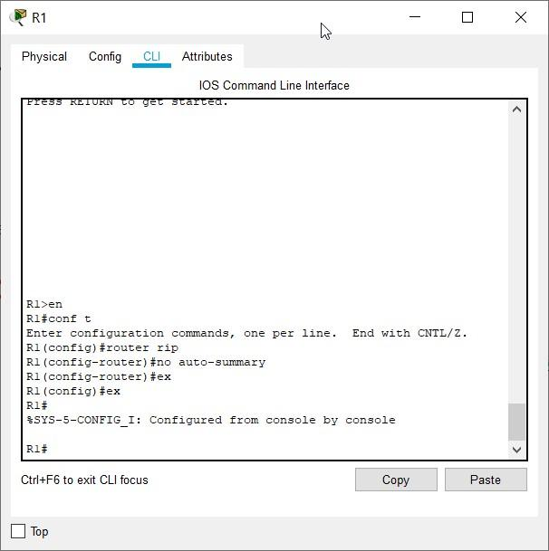

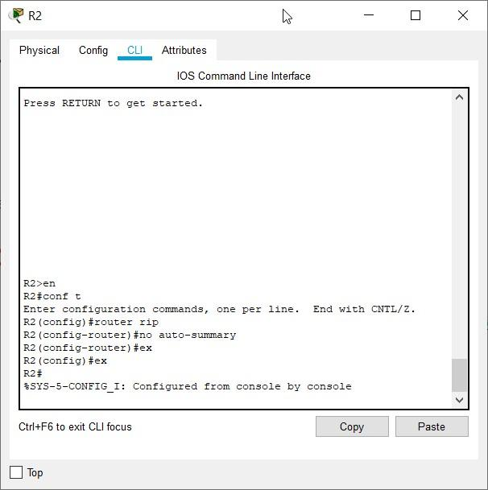

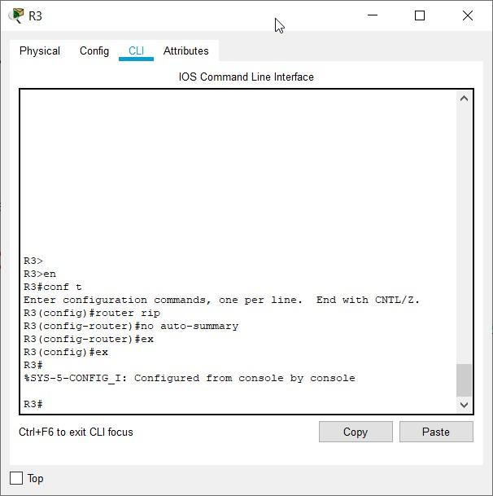

The **show ip route** and **ping** commands can be used to verify that automatic summarization is off.

**Task 7: Examine the Routing Tables.**

The LANs connected to R1 and R3 should now be included in all three routing tables.

# R2#show ip route

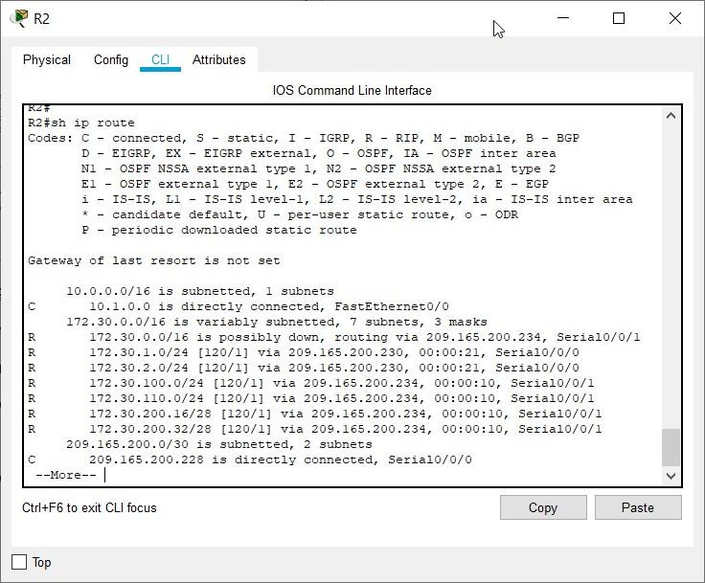

# R1#show ip route

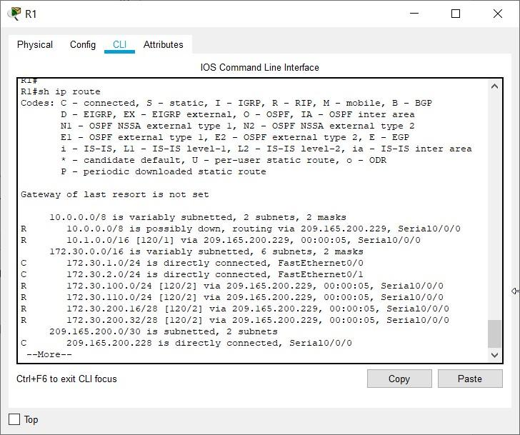 R3#**show ip route**

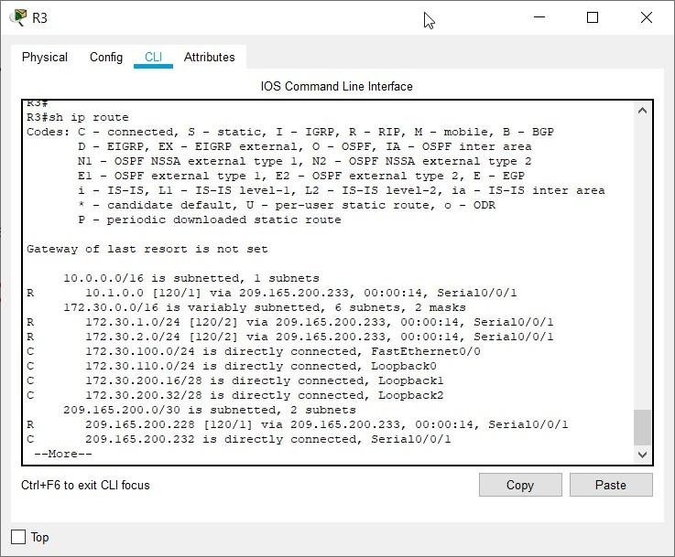

Use the output of the **debug ip rip** command to answer the following questions:

What entries are included in the RIP updates sent out from R1?

172.30.1.0/24

172.30.2.0/24

On R2, what routes are in the RIP updates that are received from R1?

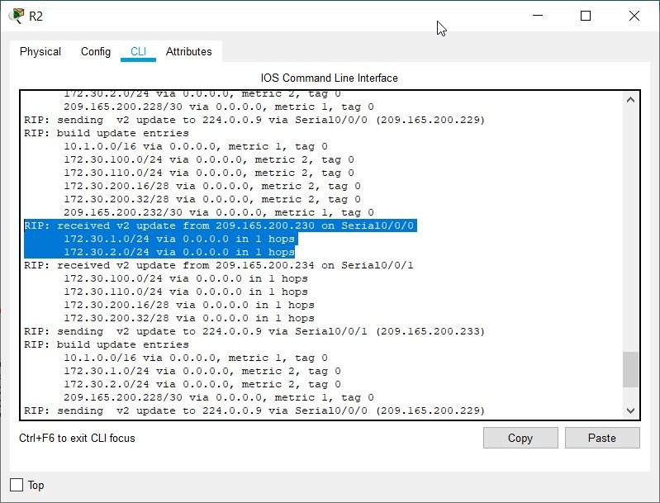

172.30.1.0/24

172.30.2.0/24

Are the subnet masks now included in the routing updates? yes **Task 8: Verify Network Connectivity.**

**Step 1: Check connectivity between R2 router and PCs.**

From R2, how many ICMP messages are successful when pinging PC1? 5/5 messages

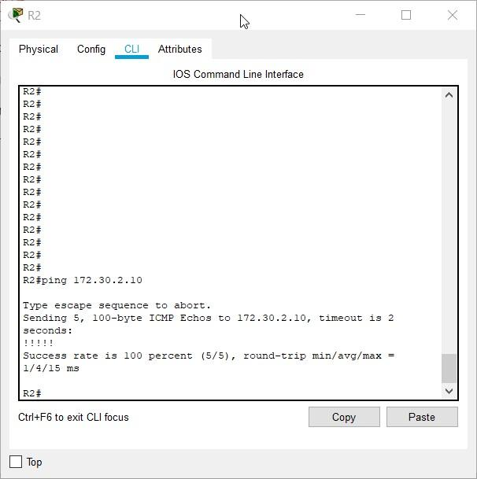

From R2, how many ICMP messages are successful when pinging PC4? 5/5 messages

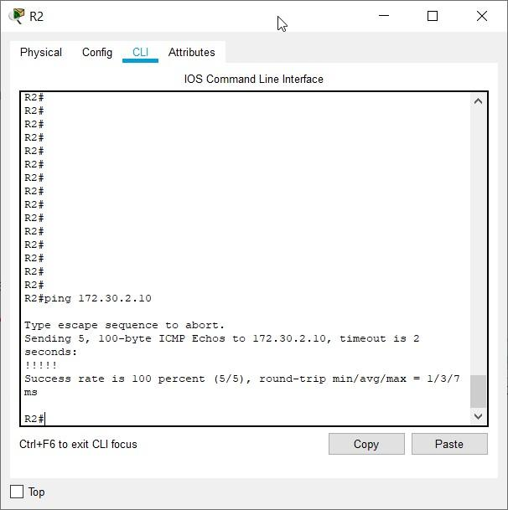

**Step 2: Check the connectivity between the PCs.**

From PC1, is it possible to ping PC2? yes

What is the success rate? 4/4

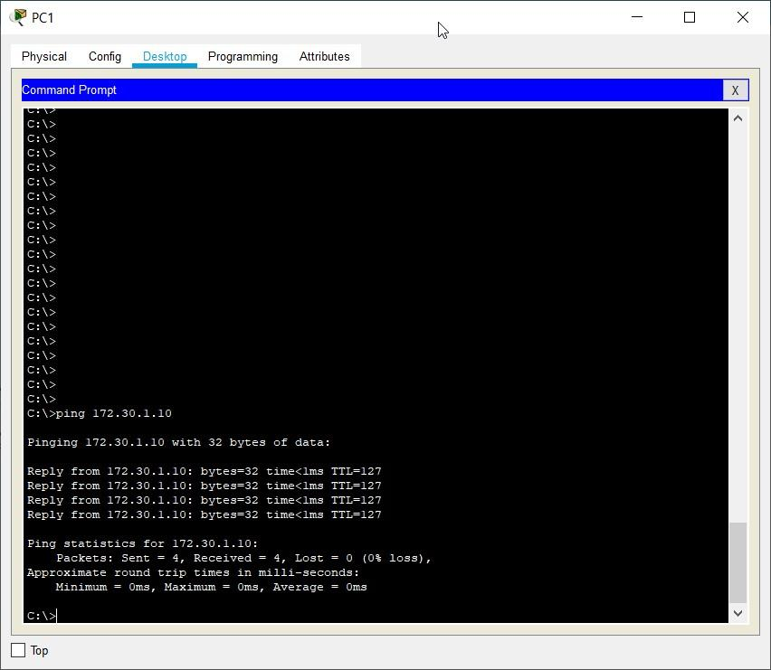

From PC1, is it possible to ping PC3? yes

What is the success rate? 4/4

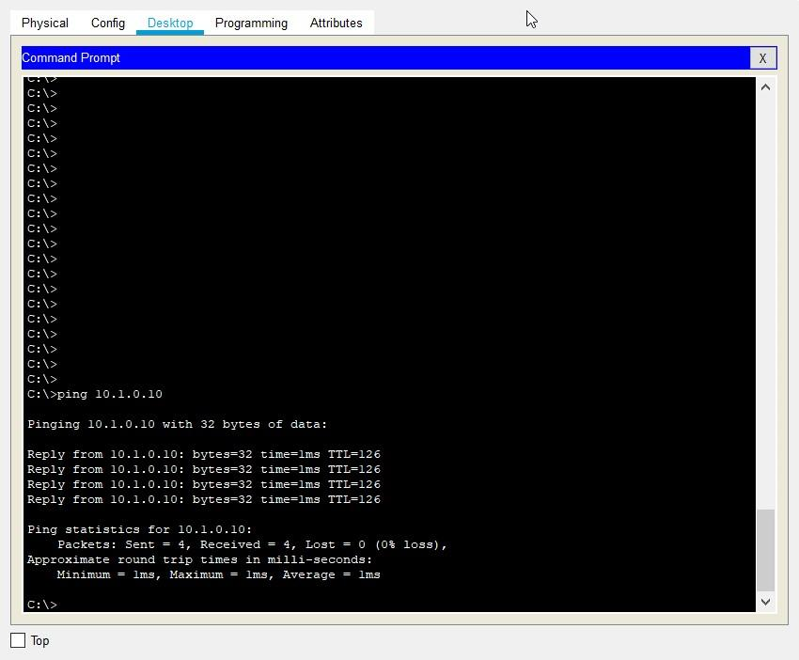

From PC1, is it possible to ping PC4? yes

What is the success rate? 4/4

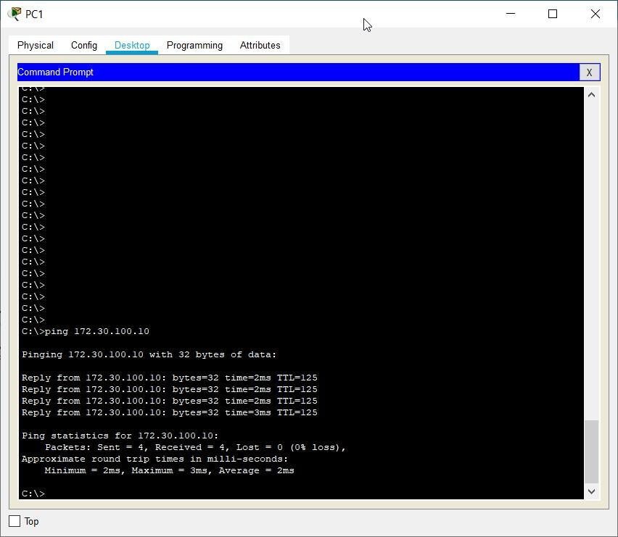

From PC4, is it possible to ping PC2? yes

What is the success rate? 4/4

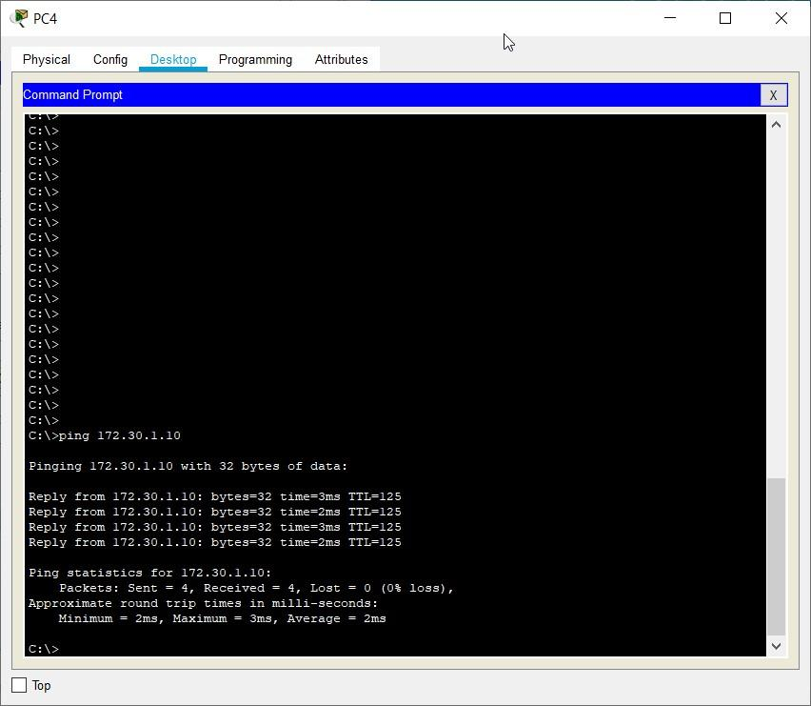

From PC4, is it possible to ping PC3? yes

What is the success rate? 4/4

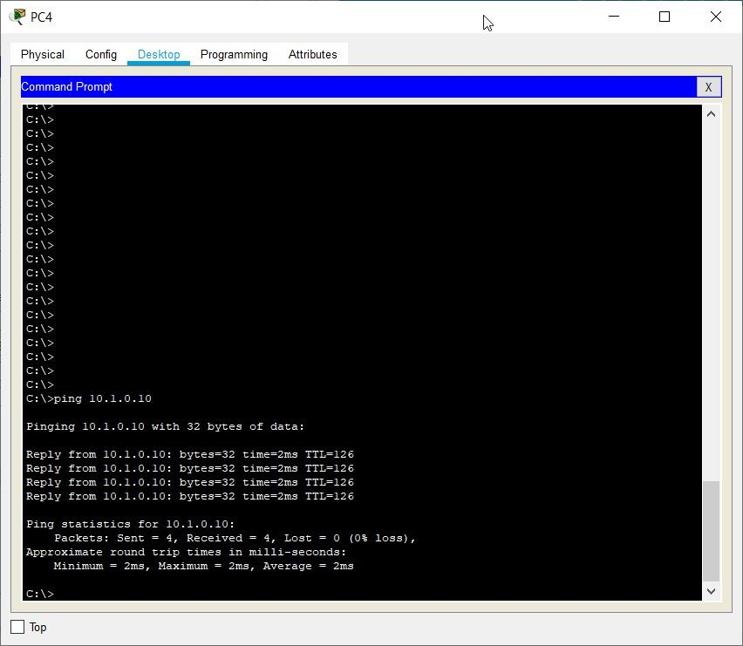

**Task 9: Documentation**

On each router, capture the following command output to a text (.txt) file and save for future reference.

**Router – R1**

# • show running-config

**R1#**sh running-config Building configuration...

Current configuration : 883 bytes !

version 12.4

no service timestamps log datetime msec no service timestamps debug datetime msec no service password-encryption !

hostname R1 !

!

!

!

!

!

! !

no ip cef no ipv6 cef !

!

!

!

!

!

!

!

!

!

! !

spanning-tree mode pvst !

!

!

!

! ! interface FastEthernet0/0 ip address 172.30.1.1 255.255.255.0 duplex auto speed auto ! interface FastEthernet0/1 ip address 172.30.2.1 255.255.255.0 duplex auto speed auto ! interface Serial0/0/0

ip address 209.165.200.230 255.255.255.252 ! interface Serial0/0/1 no ip address clock rate 2000000 shutdown ! interface Vlan1 no ip address shutdown !

router rip version 2

passive-interface FastEthernet0/0 passive-interface FastEthernet0/1 network 172.30.0.0 network 209.165.200.0 no auto-summary !

ip classless !

ip flow-export version 9 !

!

!

!

!

!

! !

line con 0 !

line aux 0 ! line vty 0 4 password cisco login

!

!

! end

# • show ip route

**R1**#sh ip route

Codes: C - connected, S - static, I - IGRP, R - RIP, M - mobile, B - BGP

D - EIGRP, EX - EIGRP external, O - OSPF, IA - OSPF inter area

N1 - OSPF NSSA external type 1, N2 - OSPF NSSA external type 2

E1 - OSPF external type 1, E2 - OSPF external type 2, E - EGP i - IS-IS, L1 - IS-IS level-1, L2 - IS-IS level-2, ia - IS-IS inter area

* - candidate default, U - per-user static route, o - ODR

P - periodic downloaded static route

Gateway of last resort is not set

10.0.0.0/16 is subnetted, 1 subnets

R 10.1.0.0 [120/1] via 209.165.200.229, 00:00:18, Serial0/0/0

172.30.0.0/16 is variably subnetted, 6 subnets, 2 masks

C 172.30.1.0/24 is directly connected, FastEthernet0/0

C 172.30.2.0/24 is directly connected, FastEthernet0/1

R 172.30.100.0/24 [120/2] via 209.165.200.229, 00:00:18, Serial0/0/0

R 172.30.110.0/24 [120/2] via 209.165.200.229, 00:00:18, Serial0/0/0

R 172.30.200.16/28 [120/2] via 209.165.200.229, 00:00:18, Serial0/0/0

R 172.30.200.32/28 [120/2] via 209.165.200.229, 00:00:18, Serial0/0/0

209.165.200.0/30 is subnetted, 2 subnets

C 209.165.200.228 is directly connected, Serial0/0/0

R 209.165.200.232 [120/1] via 209.165.200.229, 00:00:18, Serial0/0/0

# • show ip interface brief

**R1**#sh ip interface brief

Interface IP-Address OK? Method Status Protocol

FastEthernet0/0 172.30.1.1 YES manual up up

FastEthernet0/1 172.30.2.1 YES manual up up

Serial0/0/0 209.165.200.230YES manual up up

Serial0/0/1 unassigned YES NVRAM administratively down down Vlan1 unassigned YES unset administratively down down

# • show ip protocols

**R1**#sh ip protocols

Routing Protocol is "rip"

Sending updates every 30 seconds, next due in 24 seconds

Invalid after 180 seconds, hold down 180, flushed after 240

Outgoing update filter list for all interfaces is not set

Incoming update filter list for all interfaces is not set

Redistributing: rip

Default version control: send version 2, receive 2

Interface Send Recv Triggered RIP Key-chain

Serial0/0/0 2 2

Automatic network summarization is not in effect

Maximum path: 4 Routing for Networks:

172.30.0.0

209.165.200.0

Passive Interface(s):

FastEthernet0/0

FastEthernet0/1

Routing Information Sources:

Gateway Distance Last Update

209.165.200.229 120 00:00:03

Distance: (default is 120)

**Router – R2**

# • show running-config

**R2**#sh running-config Building configuration...

Current configuration : 867 bytes !

version 12.4 no service timestamps log datetime msec no service timestamps debug datetime msec no service password-encryption !

hostname R2 !

!

!

!

!

!

! ! no ip cef no ipv6 cef !

!

!

!

!

!

!

!

!

!

! !

spanning-tree mode pvst !

!

!

!

! !

interface FastEthernet0/0 ip address 10.1.0.1 255.255.0.0 duplex auto speed auto !

interface FastEthernet0/1 no ip address duplex auto speed auto shutdown !

interface Serial0/0/0 ip address 209.165.200.229 255.255.255.252 clock rate 2000000 !

interface Serial0/0/1 ip address 209.165.200.233 255.255.255.252 clock rate 64000 !

interface Vlan1 no ip address shutdown ! router rip version 2 passive-interface FastEthernet0/0 network 10.0.0.0 network 209.165.200.0 no auto-summary !

ip classless

!

ip flow-export version 9 !

!

!

!

!

!

! !

line con 0 !

line aux 0 !

line vty 0 4 password cisco login

!

!

!

end

# • show ip route

**R2**#sh ip route

Codes: C - connected, S - static, I - IGRP, R - RIP, M - mobile, B - BGP

D - EIGRP, EX - EIGRP external, O - OSPF, IA - OSPF inter area

N1 - OSPF NSSA external type 1, N2 - OSPF NSSA external type 2 E1 - OSPF external type 1, E2 - OSPF external type 2, E - EGP i - IS-IS, L1 - IS-IS level-1, L2 - IS-IS level-2, ia - IS-IS inter area

* - candidate default, U - per-user static route, o - ODR

P - periodic downloaded static route

Gateway of last resort is not set

10.0.0.0/16 is subnetted, 1 subnets

C 10.1.0.0 is directly connected, FastEthernet0/0

172.30.0.0/16 is variably subnetted, 6 subnets, 2 masks

R 172.30.1.0/24 [120/1] via 209.165.200.230, 00:00:10, Serial0/0/0

R 172.30.2.0/24 [120/1] via 209.165.200.230, 00:00:10, Serial0/0/0

R 172.30.100.0/24 [120/1] via 209.165.200.234, 00:00:19, Serial0/0/1

R 172.30.110.0/24 [120/1] via 209.165.200.234, 00:00:19, Serial0/0/1

R 172.30.200.16/28 [120/1] via 209.165.200.234, 00:00:19, Serial0/0/1

R 172.30.200.32/28 [120/1] via 209.165.200.234, 00:00:19, Serial0/0/1

209.165.200.0/30 is subnetted, 2 subnets

C 209.165.200.228 is directly connected, Serial0/0/0 C 209.165.200.232 is directly connected, Serial0/0/1

# • show ip interface brief

|  |  |
| --- | --- |
| **R2**#sh ip int brief |  |
| Interface | IP-Address OK? Method Status Protocol |
| FastEthernet0/0 | 10.1.0.1 YES manual up up |
| FastEthernet0/1 | unassigned YES NVRAM administratively down down |
| Serial0/0/0 | 209.165.200.229 YES manual up up |
| Serial0/0/1 | 209.165.200.233 YES manual up up |
| Vlan1 | unassigned YES unset administratively down down |

# • show ip protocols

**R2**#sh ip protocols

Routing Protocol is "rip"

Sending updates every 30 seconds, next due in 18 seconds

Invalid after 180 seconds, hold down 180, flushed after 240

Outgoing update filter list for all interfaces is not set

Incoming update filter list for all interfaces is not set

Redistributing: rip

Default version control: send version 2, receive 2

Interface Send Recv Triggered RIP Key-chain

Serial0/0/0 2 2

Serial0/0/1 2 2

Automatic network summarization is not in effect

Maximum path: 4 Routing for Networks:

10.0.0.0 209.165.200.0 Passive Interface(s):

FastEthernet0/0

Routing Information Sources:

Gateway Distance Last Update

209.165.200.230 120 00:00:09

209.165.200.234 120 00:00:13

Distance: (default is 120)

**Router – R3**

# • show running-config

**R3**#sh running-config Building configuration...

Current configuration : 1027 bytes !

version 12.4 no service timestamps log datetime msec no service timestamps debug datetime msec no service password-encryption !

hostname R3 !

!

!

!

!

!

! ! no ip cef no ipv6 cef !

!

!

!

!

!

!

!

!

!

! !

spanning-tree mode pvst !

!

!

!

! !

interface Loopback0 ip address 172.30.110.1 255.255.255.0 !

interface Loopback1 ip address 172.30.200.17 255.255.255.240 !

interface Loopback2 ip address 172.30.200.33 255.255.255.240 !

interface FastEthernet0/0 ip address 172.30.100.1 255.255.255.0 duplex auto speed auto !

interface FastEthernet0/1 no ip address duplex auto speed auto shutdown ! interface Serial0/0/0 no ip address clock rate 2000000 shutdown !

interface Serial0/0/1 ip address 209.165.200.234 255.255.255.252 !

interface Vlan1 no ip address shutdown

!

router rip version 2

passive-interface FastEthernet0/0 network 172.30.0.0 network 209.165.200.0 no auto-summary !

ip classless !

ip flow-export version 9 !

!

!

!

!

!

! !

line con 0 !

line aux 0 !

line vty 0 4 password cisco login

!

! ! end

# • show ip route

**R3**#sh ip route

Codes: C - connected, S - static, I - IGRP, R - RIP, M - mobile, B - BGP

D - EIGRP, EX - EIGRP external, O - OSPF, IA - OSPF inter area

N1 - OSPF NSSA external type 1, N2 - OSPF NSSA external type 2 E1 - OSPF external type 1, E2 - OSPF external type 2, E - EGP i - IS-IS, L1 - IS-IS level-1, L2 - IS-IS level-2, ia - IS-IS inter area

* - candidate default, U - per-user static route, o - ODR

P - periodic downloaded static route

Gateway of last resort is not set

10.0.0.0/16 is subnetted, 1 subnets

R 10.1.0.0 [120/1] via 209.165.200.233, 00:00:04, Serial0/0/1

172.30.0.0/16 is variably subnetted, 6 subnets, 2 masks

R 172.30.1.0/24 [120/2] via 209.165.200.233, 00:00:04, Serial0/0/1

R 172.30.2.0/24 [120/2] via 209.165.200.233, 00:00:04, Serial0/0/1

C 172.30.100.0/24 is directly connected, FastEthernet0/0

C 172.30.110.0/24 is directly connected, Loopback0

C 172.30.200.16/28 is directly connected, Loopback1

C 172.30.200.32/28 is directly connected, Loopback2

209.165.200.0/30 is subnetted, 2 subnets

R 209.165.200.228 [120/1] via 209.165.200.233, 00:00:04, Serial0/0/1

C 209.165.200.232 is directly connected, Serial0/0/1

# • show ip interface brief

|  |  |  |
| --- | --- | --- |
| **R3**#sh ip interface brief | |  |
| Interface | IP-Address OK? Method Status | Protocol |
| FastEthernet0/0 | 172.30.100.1 YES manual up | up |
| FastEthernet0/1 | unassigned YES NVRAM administratively down | down |
| Serial0/0/0 | unassigned YES NVRAM administratively down | down |
| Serial0/0/1 | 209.165.200.234 YES manual up | up |
| Loopback0 | 172.30.110.1 YES manual up | up |
| Loopback1 | 172.30.200.17 YES manual up | up |
| Loopback2 | 172.30.200.33 YES manual up | up |
| Vlan1 | unassigned YES unset administratively down | down |

# • show ip protocols

**R3**#sh ip protocols

Routing Protocol is "rip"

Sending updates every 30 seconds, next due in 13 seconds

Invalid after 180 seconds, hold down 180, flushed after 240

Outgoing update filter list for all interfaces is not set

Incoming update filter list for all interfaces is not set

Redistributing: rip

Default version control: send version 2, receive 2

Interface Send Recv Triggered RIP Key-chain

Loopback0 2 2

Loopback1 2 2

Loopback2 2 2

Serial0/0/1 2 2

Automatic network summarization is not in effect

Maximum path: 4 Routing for Networks:

172.30.0.0

209.165.200.0

Passive Interface(s):

FastEthernet0/0

Routing Information Sources:

Gateway Distance Last Update

209.165.200.233 120 00:00:19 Distance: (default is 120) **Task 10: Clean Up**

Erase the configurations and reload the routers. Disconnect and store the cabling. For PC hosts that are normally connected to other networks (such as the school LAN or to the Internet), reconnect the appropriate cabling and restore the TCP/IP settings.

Since there is no PC host which are connected to other networks, we disconnect cabling and reload the routers after erasing the configurations







Hence, we have Erased all configurations and disconnected and stored the cables.