**AI ASSISTED CODING (3):**

TASK-1:

● Ask AI to write a function to calculate compound interest, starting with only the  
function name. Then add a docstring, then input-output example  
Expected Output#1  
● Comparison of AI-generated code styles

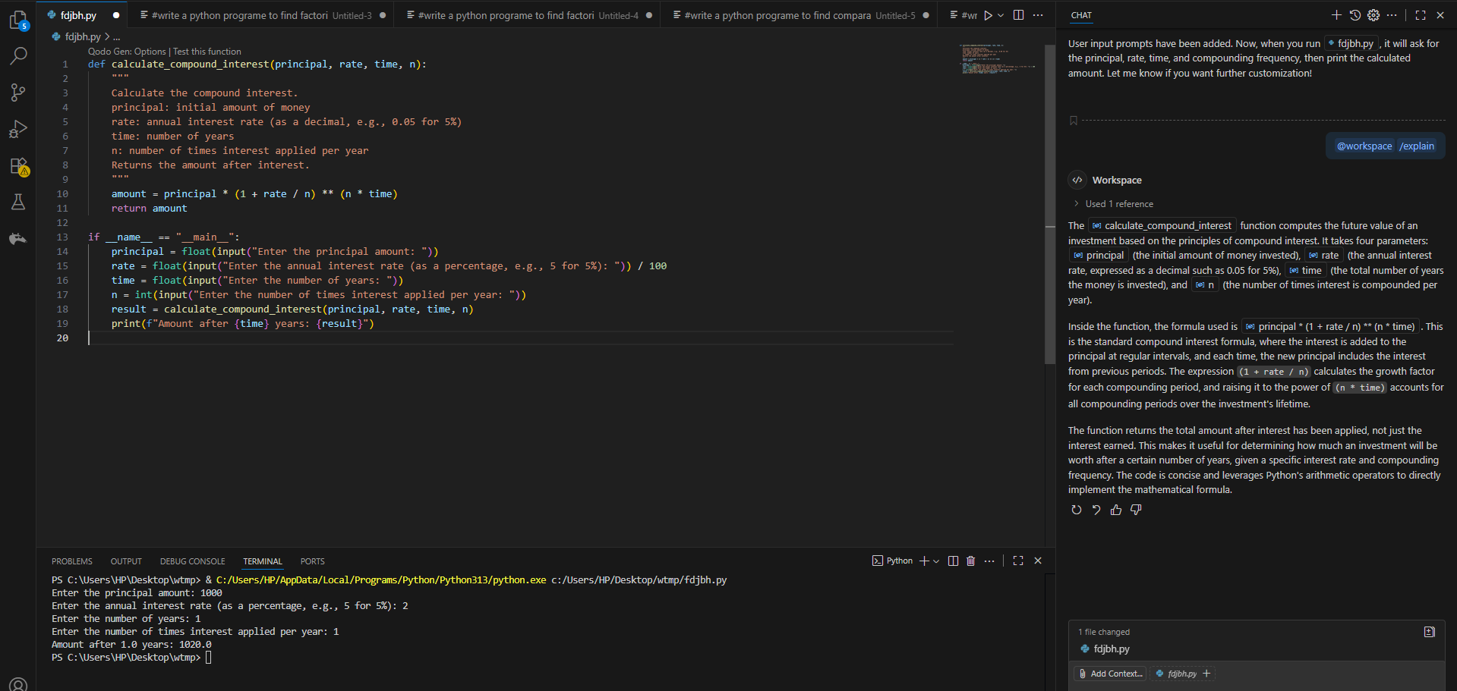

TASK-2:

● Do math stuff, then refine it to: # Write a function to calculate average, median, and  
mode of a list of numbers.

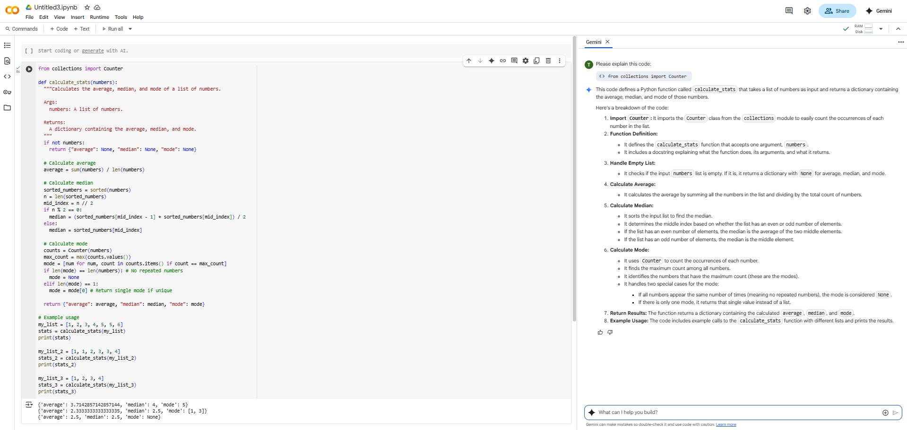

TASK-3:

● Provide multiple examples of input-output to the AI for convert_to_binary(num)  
function. Observe how AI uses few-shot prompting to generalize.

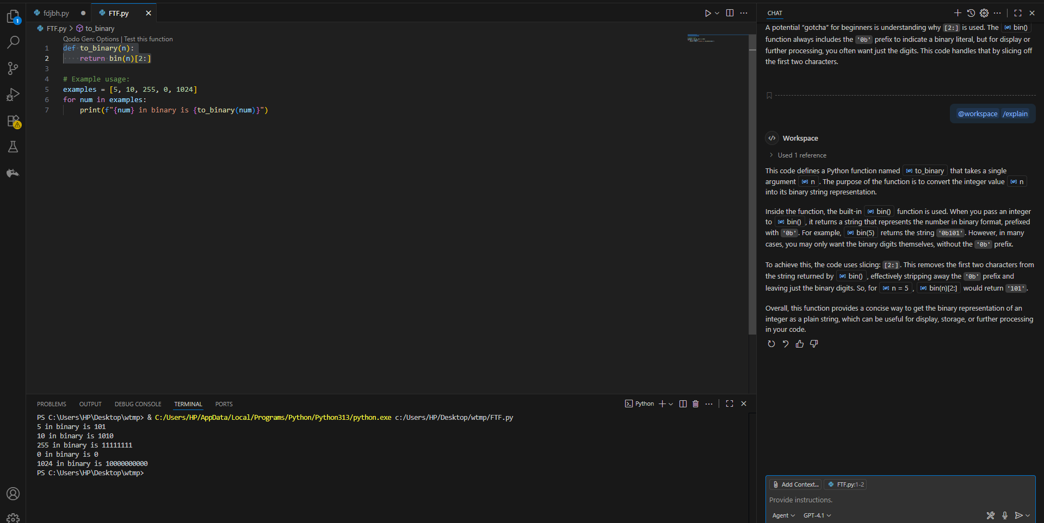

TASK-4:

● Create an user interface for an hotel to generate bill based on customer requirements

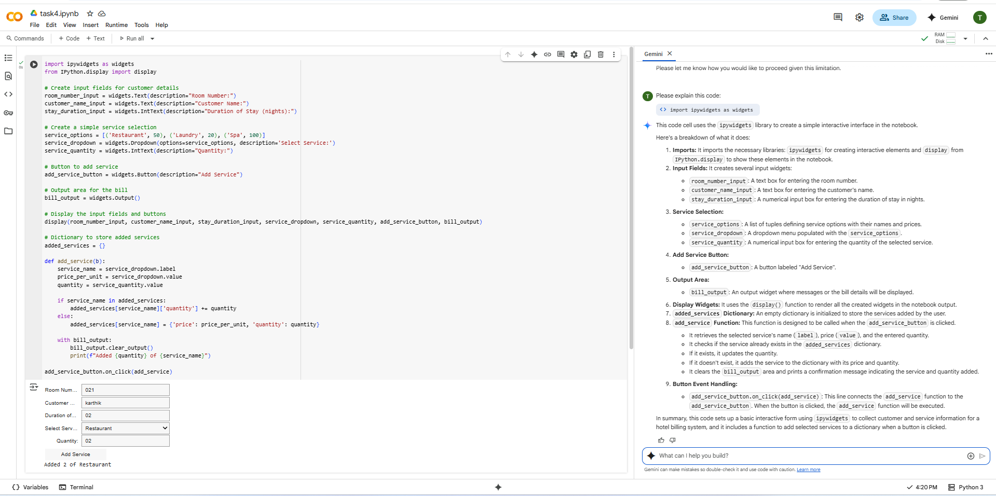

TASK-5:

● Analyzing Prompt Specificity: Improving Temperature Conversion Function with  
Clear Instructions

