Task:1

Zero-shot: Prompt AI to write a function that checks whether a given year is a leap  
year

Code:

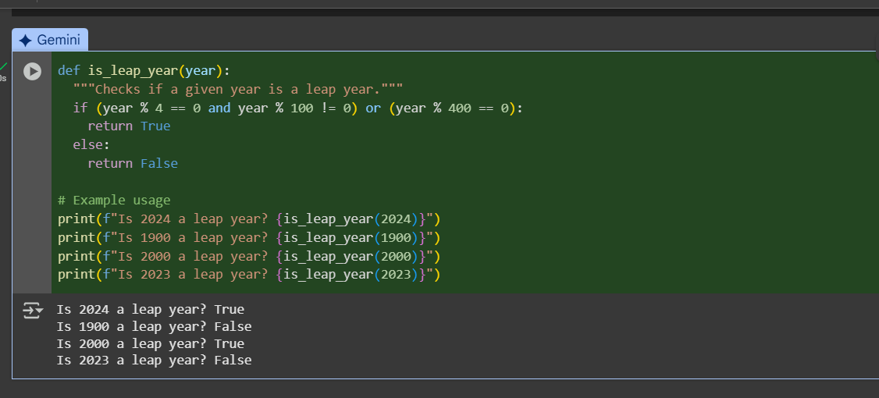

EXPLANATION:

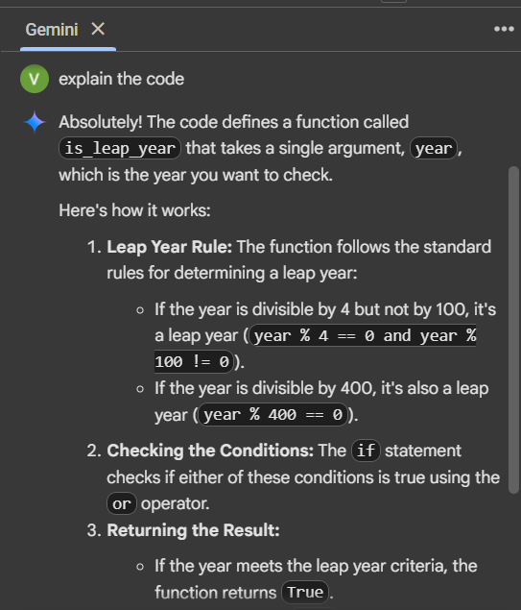

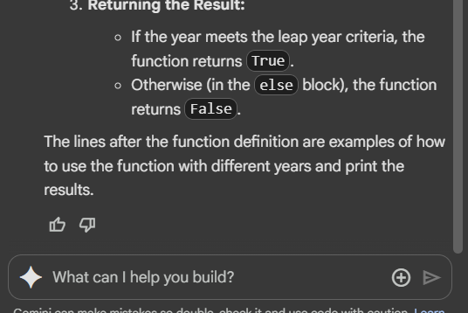

TASK:2

One-shot: Give one input-output example to guide AI in writing a function that  
converts centimeters to inches.

CODE: 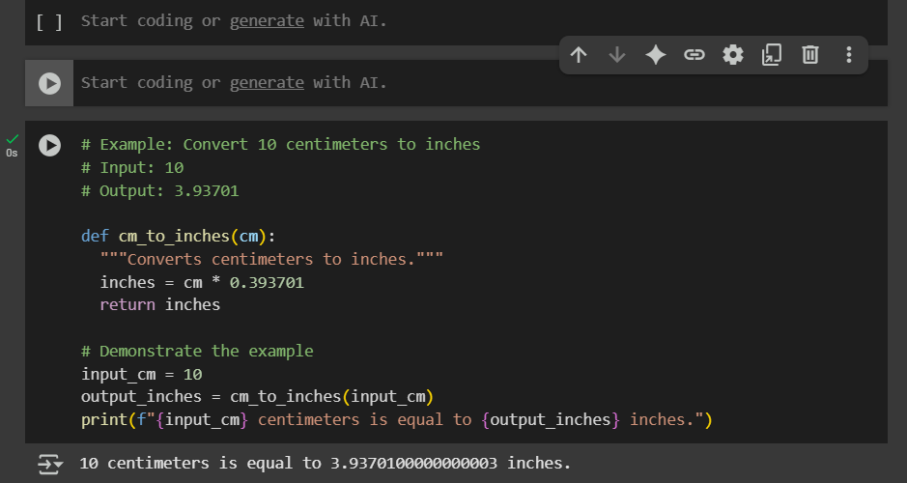

EXPLANATION:

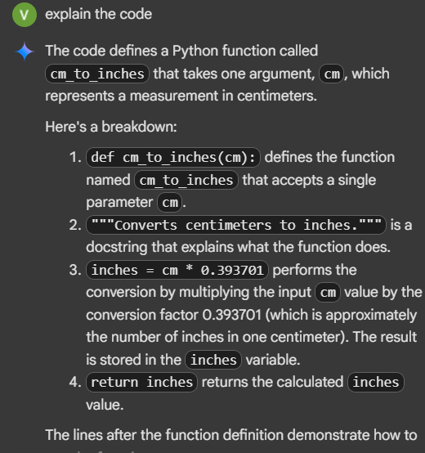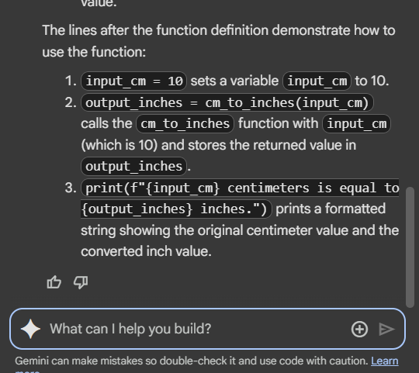

TASK:3

Few-shot: Provide 2–3 examples to generate a function that formats full names as  
“Last, First”

CODE:

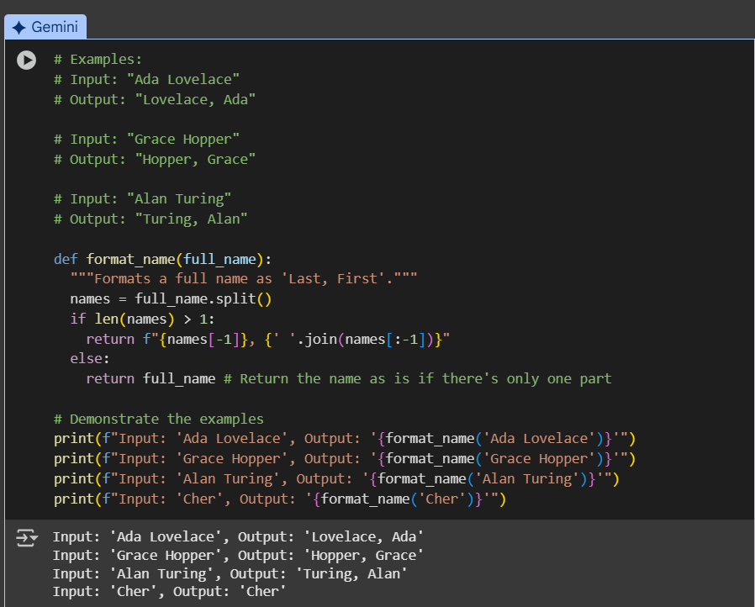

EXPLANATION:

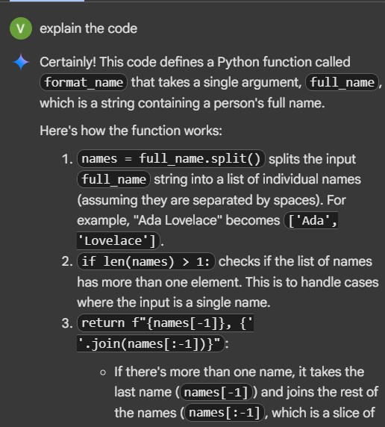

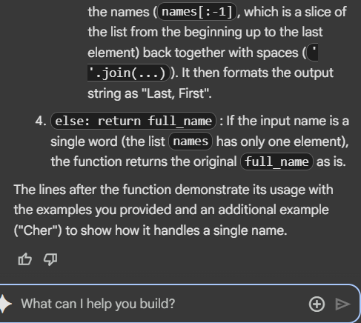

TASK:#4

Compare zero-shot and few-shot prompts for writing a function that counts the  
number of vowels in a string

CODE:

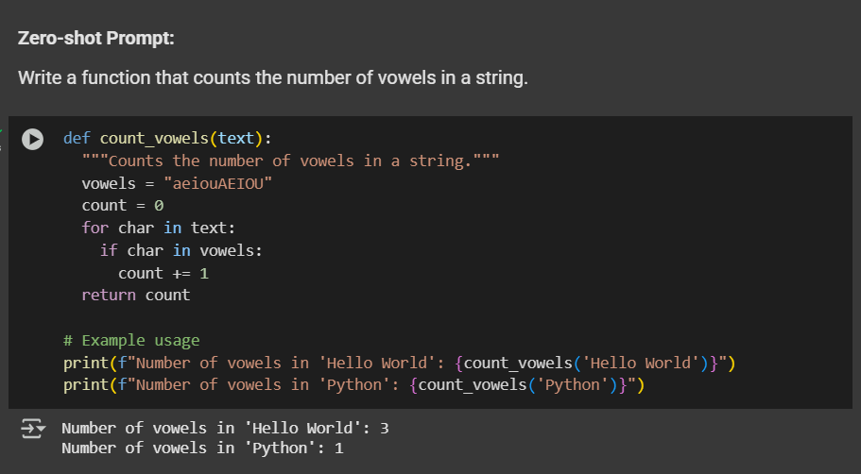

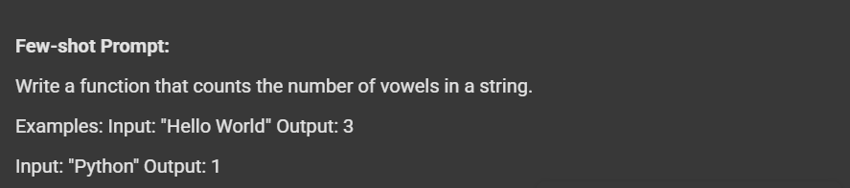

EXPLANATION:

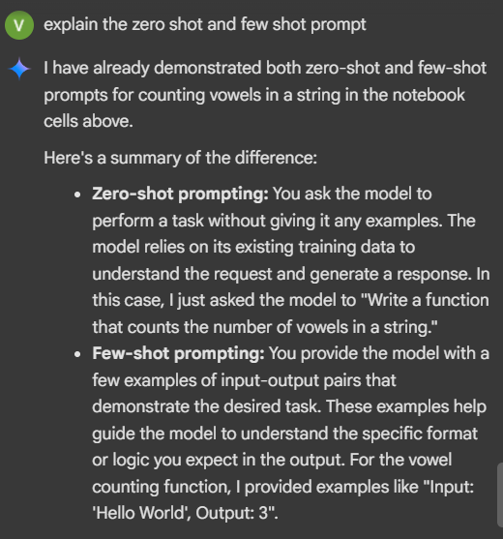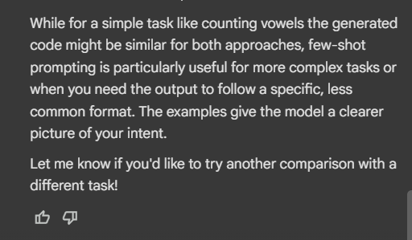

Task:#5

Use few-shot prompting to generate a function that reads a .txt file and returns the  
number of lines

Code:

