**Problem name**

[HTML, CSS] GridScape Interiors

**Problem statement**

You are provided with a project in which you are expected to **complete the *CSS* in styles.css** file in the *Website* folder.

**Tasks**

1. Add **grid row** and **grid column** properties in classes such that the elements having these classes **occupy the number of grid columns and grid rows given in the below table**:

|  |  |  |
| --- | --- | --- |
| **Class** | **Grid Columns** | **Grid Rows** |
| .grid1 | 9 | 3 |
| .grid2 | 3 | 2 |
| .grid3 | 6 | 2 |
| .grid4 | 6 | 2 |
| .grid5 | 3 | 4 |
| .grid6 | 3 | 2 |
| .grid7 | 3 | 2 |
| .grid8 | 5 | 2 |
| .grid9 | 4 | 2 |
|  |  |  |
|  |  |  |

.grid1 {

grid-column: span 9;

grid-row: span 3;

}

So on for other .grid2 to .grid 8 classes

1. Use **flex row layout**to align read more button by modifying styles in **.read-more** class. Use **flex properties** to **center align** read more text and icon **vertically**. **Add a column gap of 4 px.**

.read-more {

display: flex;

align-items: center;

column-gap: 4px;

}

1. In **.grid-container**class, Use **flex column layout** and **flex properties** to make the content inside the container as per this image:

.grid-container {

display: flex;

flex-direction: column;

justify-content: space-between;

align-items: flex-start;

}

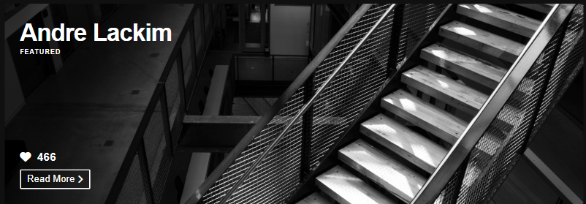

1. In **.grid4 .grid-container**class:
   * Add css property to **right align the text**.
   * Add css property to **align the flex items to the right side of the container**.

.grid4 .grid-container {

text-align: right;

align-items: flex-end;

}

1. In **.grid7 .grid-container**class:
   1. Add css property to **centrally align the text**.
   2. Add css property to **centrally** **align the flex items**.

.grid7 .grid-container {

text-align: center;

align-items: center;

}

