TASK 2:BASIC WIRESHARK TRAFFIC CAPTURE AND ANALYSIS

Submitted by
Name: VARUN.S
Reg No: RA2511003020700
Year: 2ND YEAR
College: SRM INSTITUTE OF SCIENCE AND TECHNOLOGY
Date: 24/9/2026

1.OBJECTIVE
The objective of this task is to capture and analyze network traffic using Wireshark. The captured packets were examined to identify common networking protocols, understand how devices communicate over a network, and study the flow of data between a client and server. This exercise helped in understanding real-world network communication and basic traffic analysis techniques used in cybersecurity.

2.INTRODUCTION TO WIRESHARK
Wireshark is a free and open-source network protocol analyzer used to monitor and inspect network traffic in real time. It captures packets travelling across a network and allows users to analyze communication between devices. Wireshark is widely used by network administrators, security analysts, and cybersecurity professionals for troubleshooting, protocol analysis, and security investigations.
Key Features of Wireshark
- Captures live network traffic
- Supports thousands of protocols
- Displays packet details in a readable format
- Provides filtering and search capabilities
- Helps identify network issues and security threats

3. SYSTEM REQUIREMENTS
Hardware Requirements
- Computer/Laptop
- Internet Connection
Software Requirements
- Windows 10/11
- Wireshark
- Web Browser

4. INSTALLATION OF WIRESHARK
Step 1
Downloaded Wireshark from the official website.
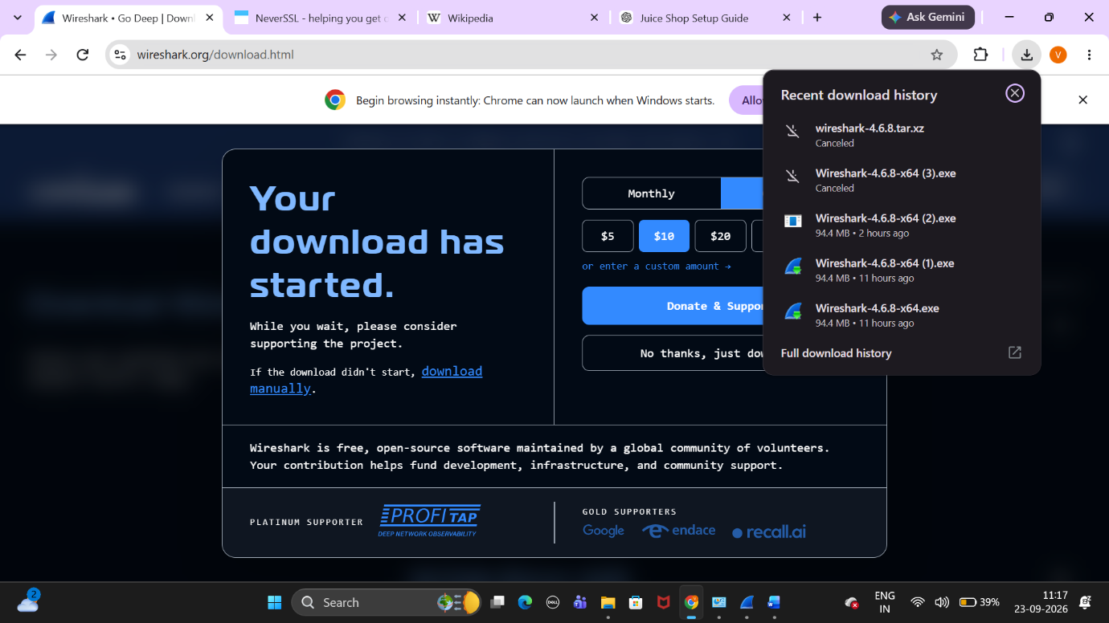

Step 2
Installed Wireshark and selected the default installation options.
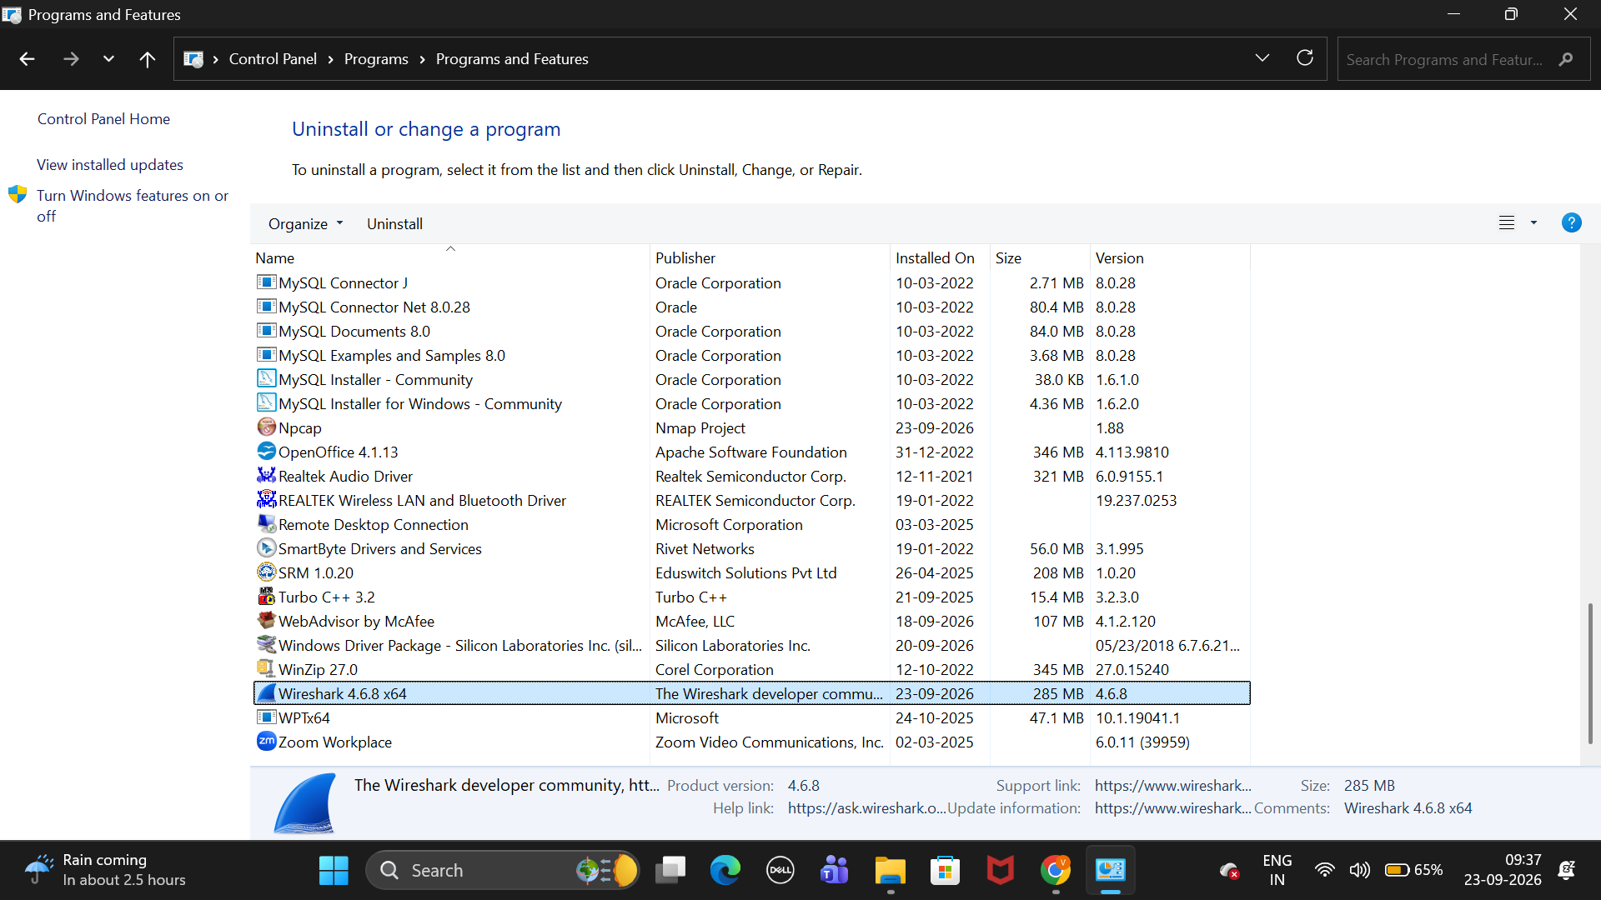

Step 3
Launched Wireshark successfully and selected the active network interface
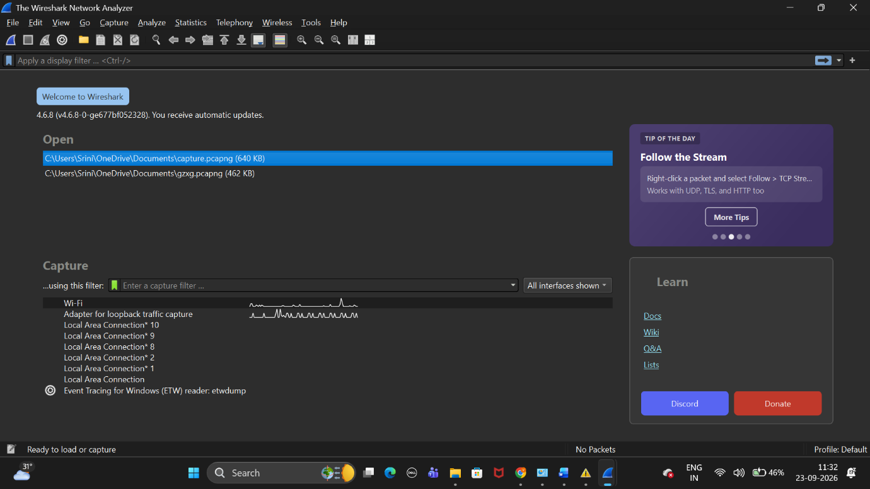

5. TRAFFIC CAPTURE PROCEDURE
Step 1: Starting Packet Capture
After launching Wireshark, the active Wi-Fi network interface was selected from the list of available interfaces. Packet capture was started by double-clicking the selected interface. Once the capture began, Wireshark started recording all incoming and outgoing network packets in real time.

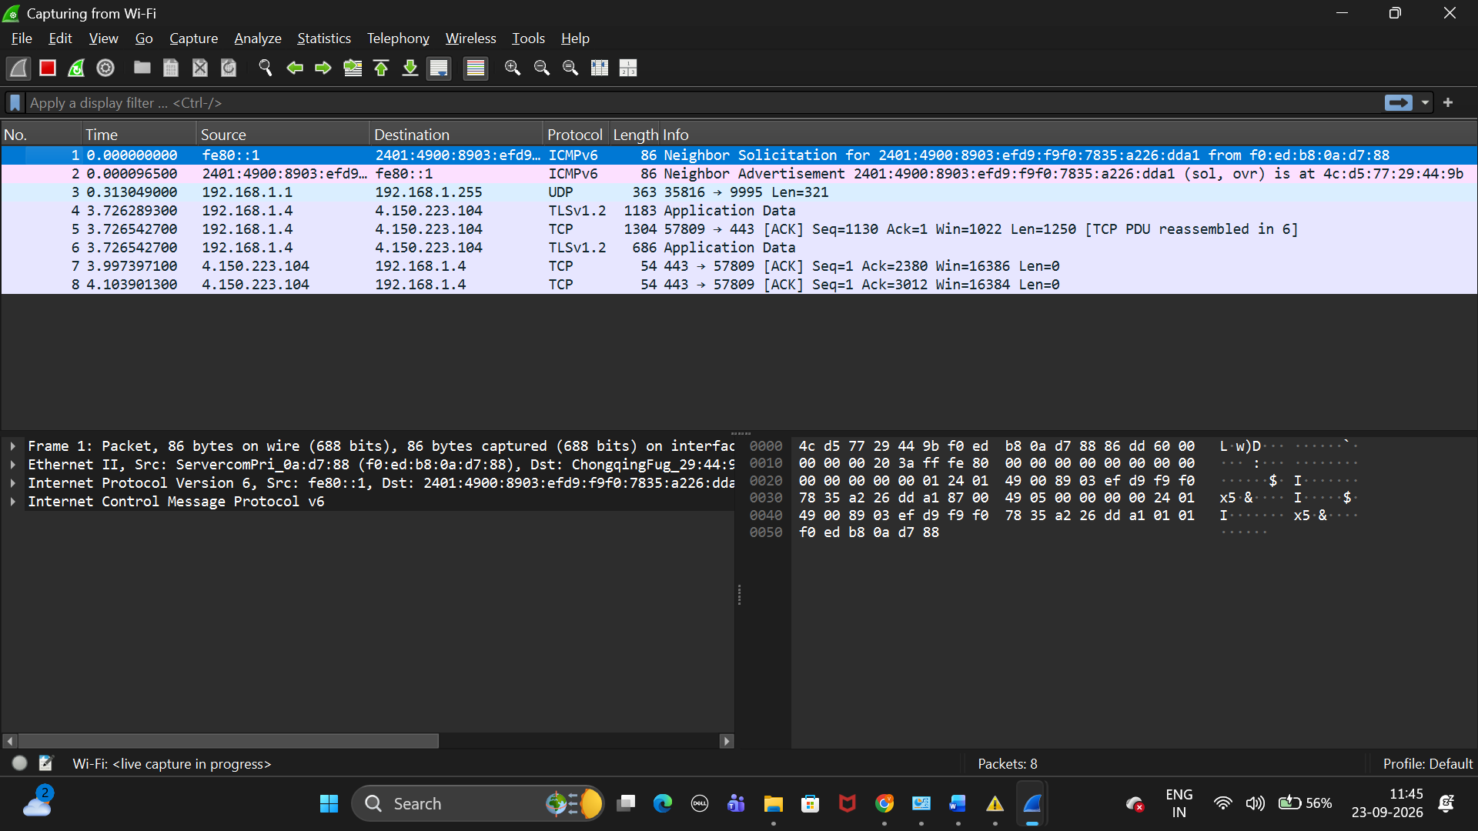
Figure 4: Starting packet capture on the active Wi-Fi interface.

Step 2: Generating Network Traffic
To generate network traffic for analysis, several websites were opened in a web browser. Activities such as browsing webpages, refreshing tabs, and performing online searches created network packets that could be captured by Wireshark. This provided a variety of protocols for analysis.

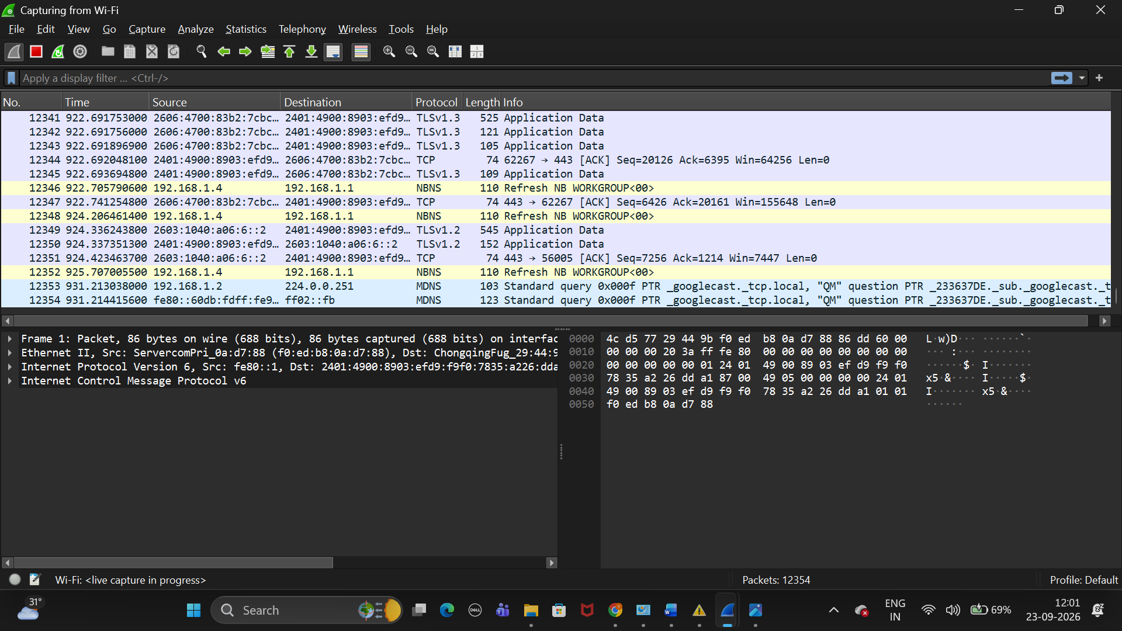
Figure 5: Live network traffic captured by Wireshark.

Step 3: Stopping Packet Capture
After sufficient traffic was collected, the packet capture process was stopped using the Stop Capture button. The captured data was then saved as a packet capture file (.pcapng) for further analysis.
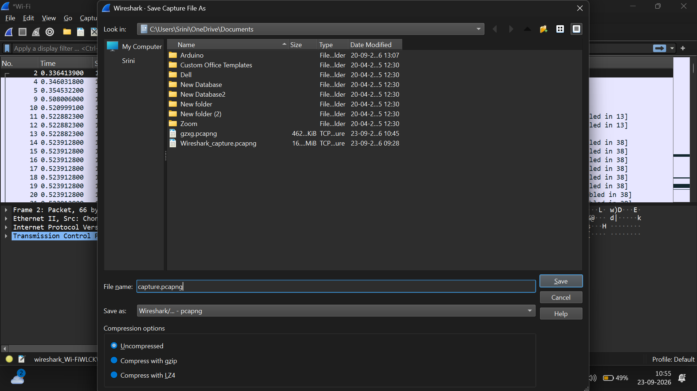

Figure 6: Captured traffic saved for analysis.

6. PROTOCOL IDENTIFICATION AND ANALYSIS
Overview
During the traffic capture process, several network protocols were observed. These protocols play different roles in network communication. The captured packets were analyzed to understand how devices communicate and exchange information across the network.

6.1 DNS (Domain Name System)
Purpose
DNS is responsible for converting domain names such as www.google.com into IP addresses that computers can understand.
Observation
DNS packets were observed whenever a website was accessed. Before connecting to a website, the system first sent a DNS request to obtain the corresponding IP address.
Importance
DNS makes internet usage easier because users can access websites using names instead of numerical IP addresses.
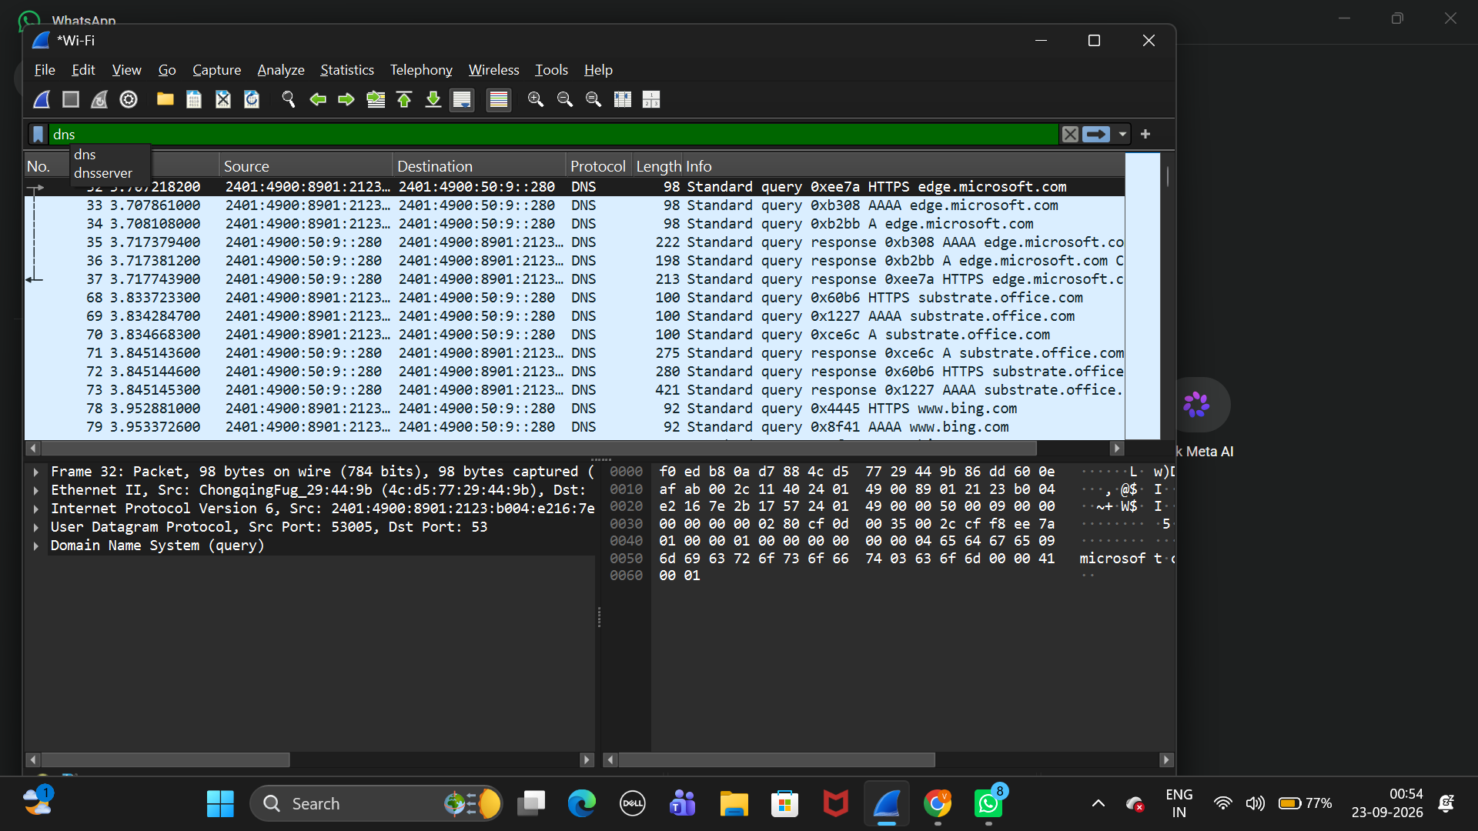
Figure 7: DNS request and response packets.

6.2 TCP (Transmission Control Protocol)

Purpose
TCP provides reliable communication between devices. It ensures that packets are delivered correctly and in the proper sequence.
Observation
Multiple TCP packets were captured during web browsing activities. TCP connections were established before data transfer occurred.
Importance
TCP is widely used because it guarantees reliable and error-checked data transmission.
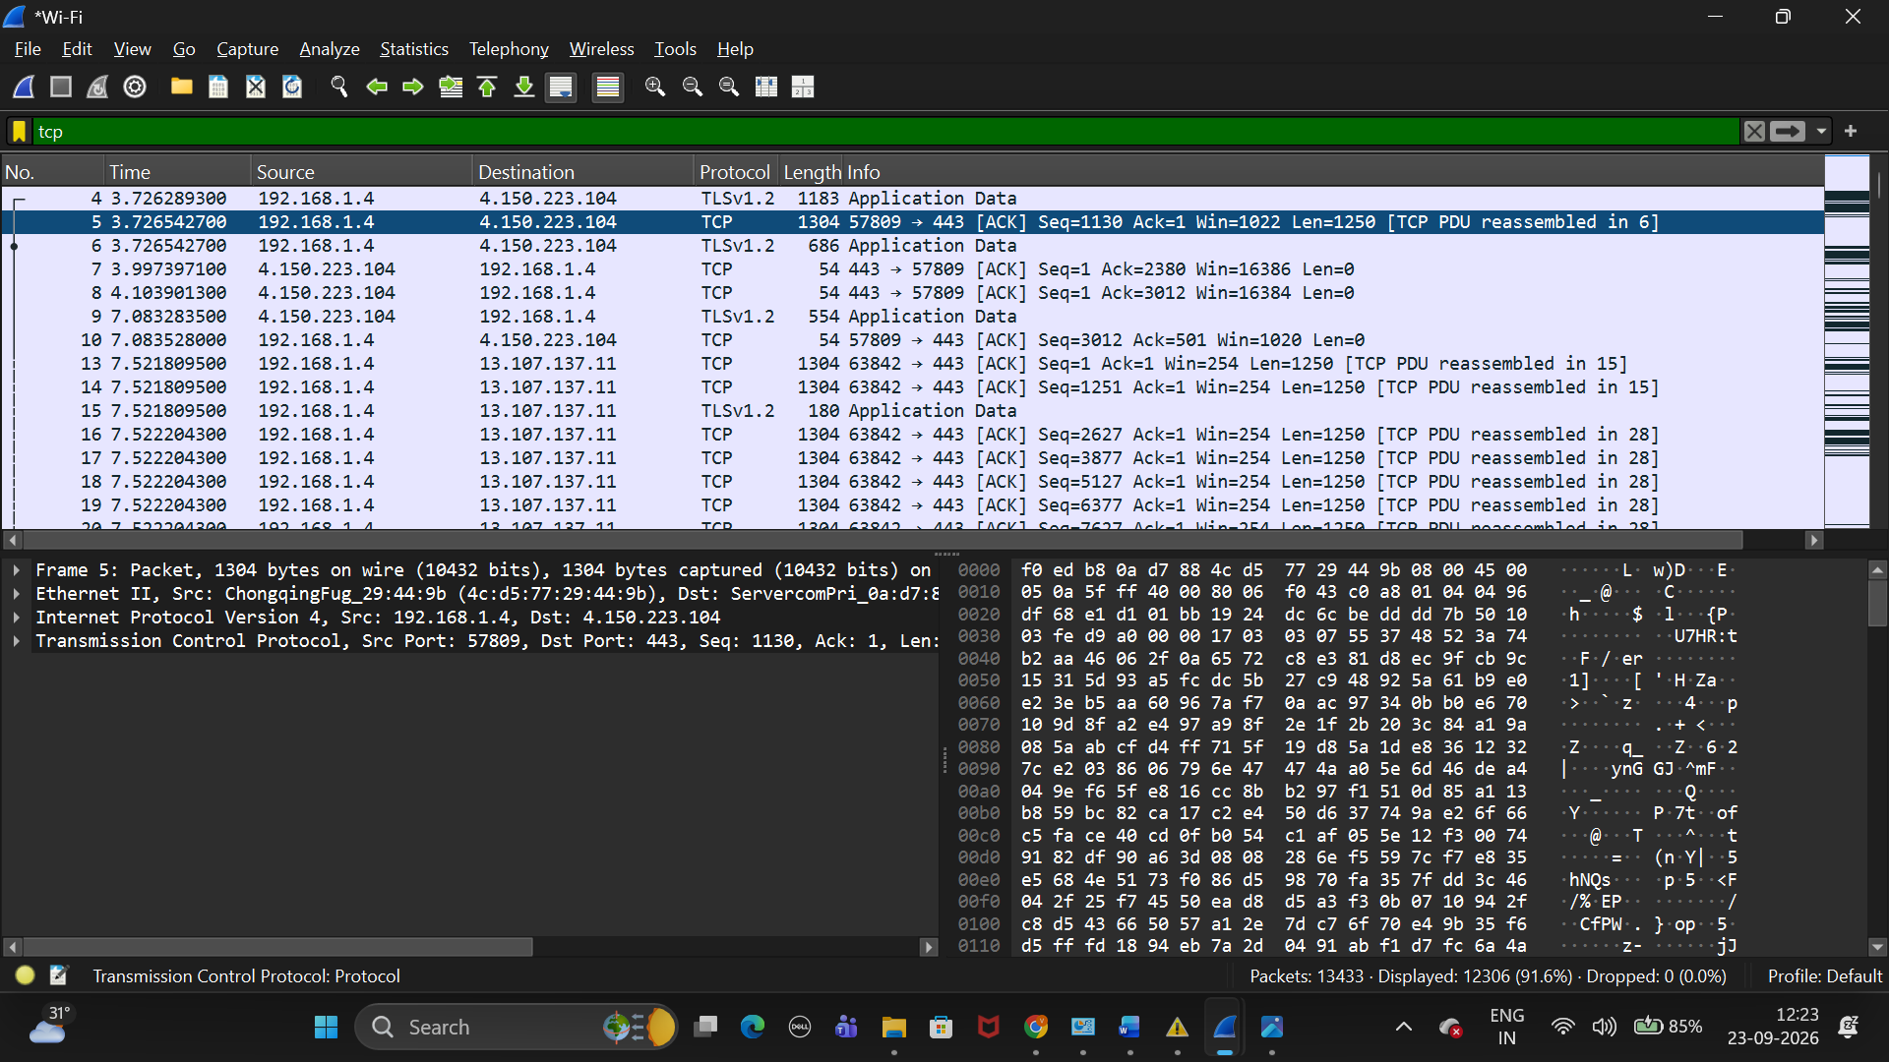

Figure 8: TCP communication observed during packet capture.

6.3 HTTPS / TLS
Write:
Purpose
HTTPS uses TLS encryption to secure communication between a web browser and a web server.
Observation
Encrypted HTTPS traffic was observed while accessing websites. The packet contents could not be directly read because the data was encrypted.
Importance
HTTPS protects user privacy by preventing attackers from viewing sensitive information transmitted across the network.
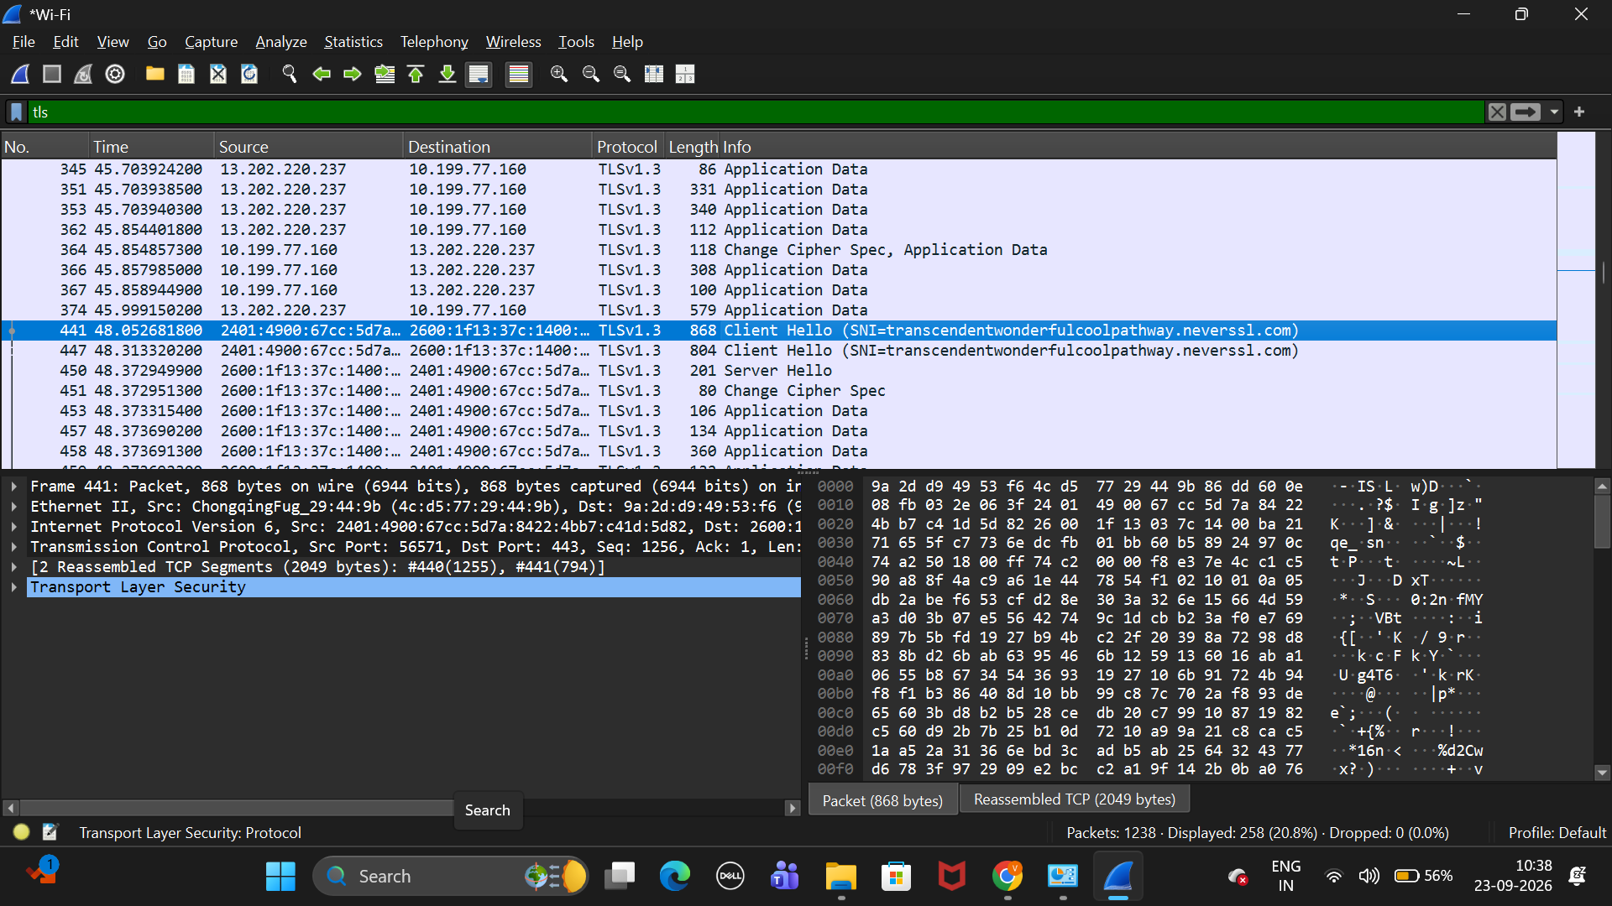
Figure 9: Encrypted HTTPS/TLS communication.

6.4 ARP (Address Resolution Protocol)
Purpose
ARP is used to map IP addresses to MAC addresses within a local network.
Observation
ARP requests and responses were observed during network communication.
Importance
ARP enables devices on a local network to locate and communicate with each other.
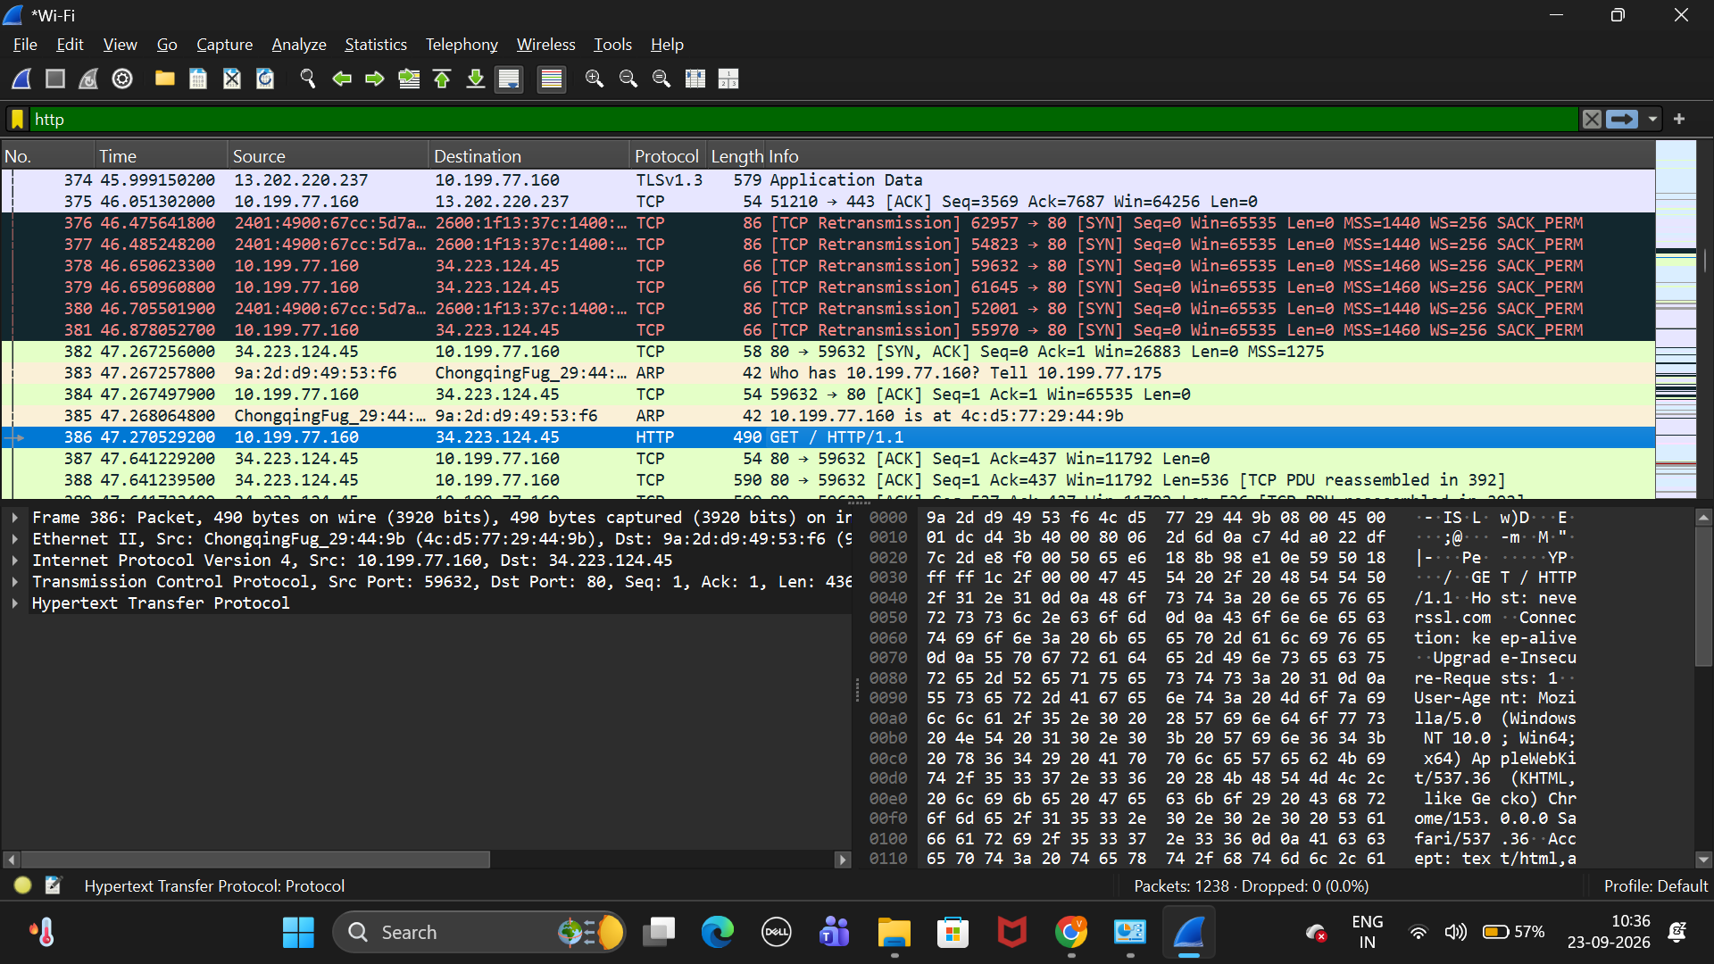
Figure 10: ARP request and response packets.

6.5 Packet-by-Packet Walkthrough (TCP 3-Way Handshake)
Place it after Figure 10 and the ARP section.
Structure it like this:
6.5 Packet-by-Packet Walkthrough (TCP 3-Way Handshake)
Packet 1: SYN
The client sends a SYN packet to initiate a connection with the server.
Packet 2: SYN-ACK
The server responds with a SYN-ACK packet, acknowledging the client's request and initiating its own synchronization.
Packet 3: ACK
The client sends an ACK packet to acknowledge the server's response, completing the connection establishment process.
Observation
The TCP three-way handshake was successfully observed before data transmission began.
Importance
The handshake ensures reliable communication and confirms that both devices are ready to exchange data.
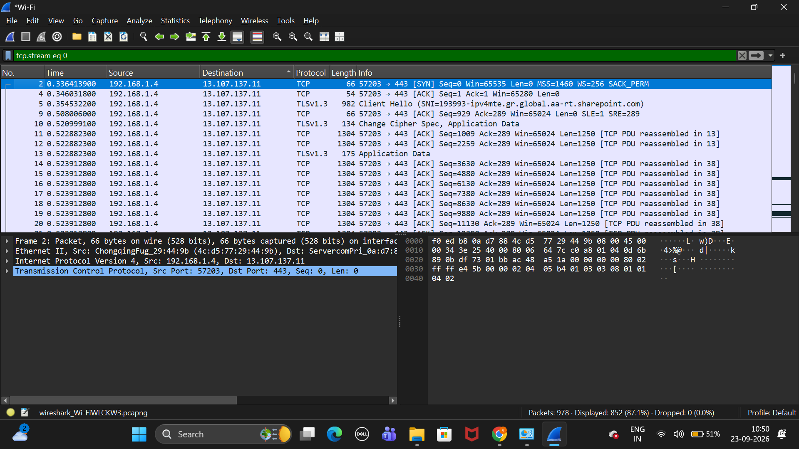

Figure 11: TCP 3-Way Handshake observed in Wireshark.

7. Summary of Findings
- DNS was used for domain name resolution.
- TCP provided reliable communication.
- TLS encrypted HTTPS traffic.
- ARP resolved IP addresses to MAC addresses.
- HTTP traffic was visible in plain text, while HTTPS traffic was encrypted.
8. Conclusion
Wireshark successfully captured and analyzed different network protocols. The experiment demonstrated how network communication occurs and highlighted the importance of encryption in securing data transmission.

