Abstract
The House Owners Insurance Management System is a web-based application designed to streamline the process of managing homeowners insurance policies, property information, premium calculations, and insurance claims. The system enables house owners to register and maintain property details, assess property risk factors, purchase suitable insurance coverage, renew policies, and submit claims for damages caused by events such as fire, theft, storms, and other covered risks.
The application follows industry-standard insurance workflows similar to those used by leading insurance providers, where property information is evaluated to determine risk levels and premium amounts before policy issuance. It also provides claim management capabilities, allowing policyholders to track claim status and submit supporting documents for review. Administrative users can manage policies, customers, claims, and reports through a centralized dashboard.
Developed using Angular, ASP.NET Core Web API, and SQL Server, the system adopts a microservices-based architecture with separate Authentication and Insurance services to ensure scalability, security, and maintainability. The proposed solution offers an efficient and user-friendly platform for homeowners to manage their insurance needs while supporting insurers in policy administration and claims processing.

Project Flow :
Frontend : Angular
Backend : ASP.NET Core Web API
Architecture : Microservices
Database : SQL Server
API Gateway : Ocelot
Authentication: JWT
ORM : Entity Framework Core

Angular UI
|
|
Ocelot Gateway
|
--------------------------------------------------
| | | | |
Auth Customer Property Policy Claim
Service Service Service Service Service
When the application starts:
Landing Page
The user sees:
Employee Benefits
Disaster Insurance
Auto Insurance
Business Insurance
Home Insurance

Only this option is active:
Home Insurance
↓
House Owner Insurance
User clicks:
House Owner Insurance
Navigate to:
Login Page

6. User Management
Login
Single Login Page
Email
Password
Login
Roles:
Customer
Surveyor

Registration
Customer Registration
Customer Id (Auto Generated)
First Name
Last Name
Email
Phone Number
Date of Birth
Address
City
State
Pincode
Password
Confirm Password
Role = Customer
API:
HTTP
POST /api/auth/register-customer

Surveyor Registration
Surveyor Id (Auto Generated)
First Name
Last Name
Email
Phone Number
License Number
Experience (Years)
Address
City
State
Pincode
Password
Confirm Password
Role = Surveyor
Show more lines
API:
HTTP
POST /api/auth/register-surveyor
Status = Pending
Surveyor Registration
↓
Pending Approval
↓
Admin Reviews Application
↓
Approve / Reject
Status = Approved
If Status = Rejected -- login denied

After Customer Login:
Welcome Customer
About House Owner Insurance
Profile
Buy Insurance
My Claims
Logout
Buy Insurance
Customer registers property and purchases insurance.
Property Registration
I want to use step form for this :
Address Line 1
Address Line 2
City
State
Pincode
Ownership Type
Primary Use
Property Type
Year Built
Area In Square Feet
Number Of Floors
Number Of Bedrooms
Number Of Bathrooms
Market Value
Construction Type
Roof Type
Safety & Security Details
Fire Alarm Installed
CCTV Installed
Security System Installed

Risk Score Generated
Risk Categories
0 - 30
Low Risk
31 - 60
Medium Risk
61 - 100
High Risk
↓
Recommended Insurance Plan
Low Risk
• Basic Plan
Medium Risk
• Standard Plan
High Risk
• Premium Plan

Available Plans
Basic Plan
• Fire Damage
• Theft Protection
• Property Damage
Premium amount
Coverage amount
Standard Plan
• Fire Damage
• Theft Protection
• Flood Coverage
• Natural Disaster Coverage
Premium amount
Coverage amount
Premium Plan
• Fire Damage
• Theft Protection
• Flood Coverage
• Natural Disaster Coverage
• Personal Liability Coverage
Premium amount
Coverage amount
↓
Policy Created Successfully
MY CLAIMS
=========================================================
Customer can
• Create Claim
• View Claims
• Track Claim Status
Claim Fields
• Policy Number
• Claim Type
• Incident Date
• Claim Amount
• Description
• Damage Details
• Upload Images
↓
Claim Submitted
Status = Pending
Surveyor Views Pending Claims
• Claim Details
• Customer Details
• Property Details
• Uploaded Images
↓
Survey Report Creation
Fields

• Damage Assessment
• Estimated Loss
• Surveyor Remarks
• Decision
Decision
• Approve
• Reject
↓
Survey Report Submitted

Risk Assessment Logic:
Risk Score = 0
STEP 2 : PROPERTY AGE RISK
Property Age = Current Year - Year Built
Property Age <= 10 Years
Risk Score += 5
Property Age Between 11 And 25 Years
Risk Score += 15
Property Age Greater Than 25 Years
Risk Score += 30
STEP 3 : MARKET VALUE RISK
Market Value < 50,00,000
Risk Score += 10
Market Value Between 50,00,000 And 1,00,00,000
Risk Score += 20
Market Value > 1,00,00,000
Risk Score += 30
STEP 4 : AREA IN SQUARE FEET
Area < 1000 Sq Ft
Risk Score += 5
Area Between 1000 And 3000 Sq Ft
Risk Score += 10
Area > 3000 Sq Ft
Risk Score += 20
STEP 5 : NUMBER OF FLOORS
1 Floor
Risk Score += 5
2 Floors
Risk Score += 10
3 Or More Floors
Risk Score += 15
STEP 6 : OWNERSHIP TYPE
Owned
Risk Score += 5
Rented
Risk Score += 15
Leased
Risk Score += 20
STEP 7 : CONSTRUCTION TYPE

Concrete
Risk Score += 5
Brick
Risk Score += 10
Mixed
Risk Score += 15
Wood
Risk Score += 25

STEP 8 : ROOF TYPE

Concrete Roof
Risk Score += 5
Metal Roof
Risk Score += 10
Wooden Roof
Risk Score += 20
STEP 9 : SECURITY FEATURES
Fire Alarm Installed = Yes
Risk Score -= 10
Fire Alarm Installed = No
Risk Score += 10
CCTV Installed = Yes
Risk Score -= 5
CCTV Installed = No
Risk Score += 5
Security System Installed = Yes
Risk Score -= 10
Security System Installed = No
Risk Score += 10
STEP 10 : PREVIOUS CLAIMS
Previous Claims = No
Risk Score += 0
Previous Claims = Yes
Risk Score += 25

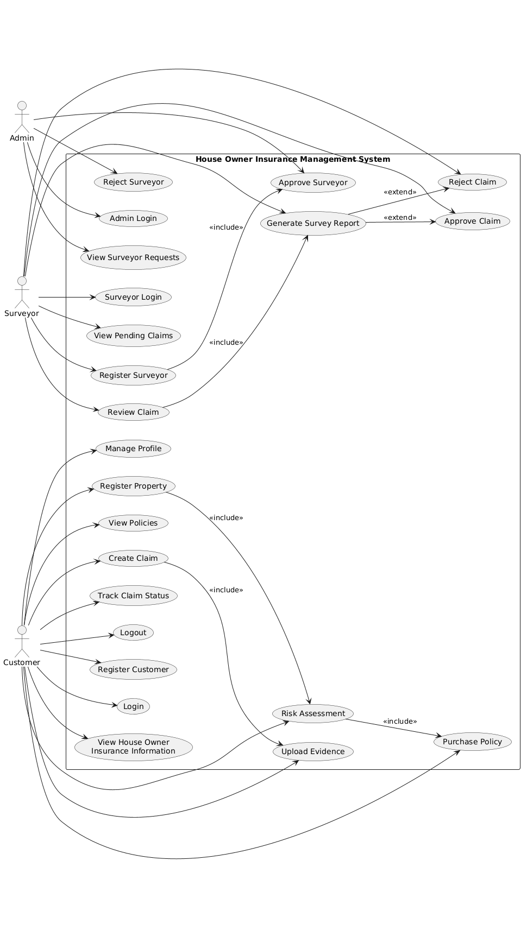
Class Daigram:
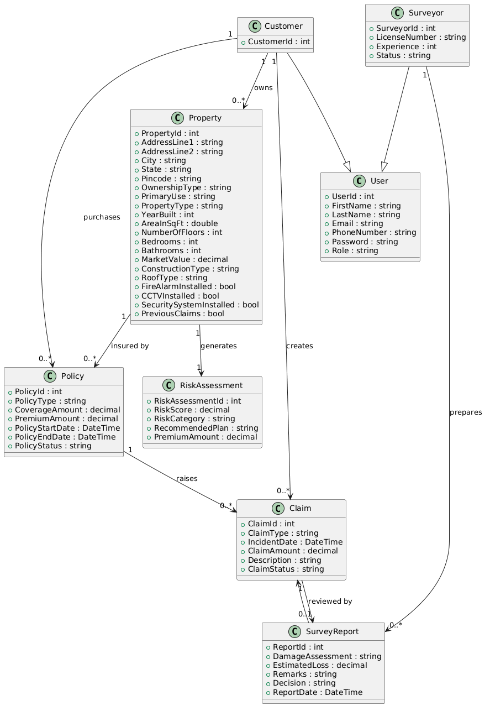
8 Functional Requirements:
1. Authentication Module
1.1 Login Component
- Login
- JWT Token Storage
1.2 Register Component
Customer Registration
2. Dashboard Module
2.1 Customer Dashboard
Display:
- Total Properties
- Active Policies
- Claims Count.
2.2 Admin Dashboard
Display:
- Total Customers
- Total Properties
- Total Policies
- Total Claims
3. Customer Module
3.1 Profile Component
- View Profile
- Edit Profile
4. Property Module
4.1 Property List Component
- View Properties
4.2 Add Property Component
Fields:
Property Type
- Address
- Year Built
- Construction Type
- Property Value
- Square Feet
4.3 Edit Property Component
- Update Property
5. Risk Assessment Module
5.1 Risk Assessment Dashboard
Display:
- Risk Score
- Risk Level
6. Policy Module
6.1 Available Policies Component
Display:
- Basic Policy
- Standard Policy
- Premium Policy
6.2 Policy Detail Component
Display:
- Coverage Details
- Policy Information
6.3 Purchase Policy Component
- Select Property
- Select Policy
- Submit Policy Request
6.4 My Policies Component
Display:
- Policy Number
- Coverage Amount
- Start Date
- End Date
- Status
6.5 Renew Policy Component
- Renew Policy
6.6 Cancel Policy Component
- Cancel Policy
7. Claims Module
7.1 Claims Dashboard Component
Display:
- Total Claims
Pending Claims
- Approved Claims
- Rejected Claims
7.2 Submit Claim Component
Fields:
- Policy
- Claim Type
- Claim Amount
- Incident Date
- Description
7.3 Claim List Component
- View Claims
7.4 Claim Detail Component
- View Claim Information
7.5 Claim Status Component
- Rejected
- Approved
8. Document Module
8.1 Upload Document Component
Upload:
- Property Documents
- Damage Photos
- Claim Evidence

9. Admin Module
9.1 Customer Management Component
- View Customers
9.2 Property Management Component
- View Properties
- View Risk Assessments
9.3 Policy Management Component
- Manage Policies
- Approve Policy Requests
9.4 Claims Management Component
- Review Claims
- Approve Claims
- Reject Claims

