DETAILED PROJECT REPORT
Google Ads Campaign for an
Imaginary Website

A complete search advertising campaign built for SparkleNest, a fictional residential deep-cleaning service operating in Bengaluru, Karnataka.

Project | Google Ads Campaign for an Imaginary Website
Programme | Unified Mentor — Digital Marketing Internship
Business modelled | SparkleNest Home Cleaning (fictional)
Primary campaign type | Search, with Display remarketing support
Monthly budget modelled | ₹30,000
Reporting track | For Students Practising Google Ads
Submitted by | [Your name]
Date | [Submission date]

SparkleNest is a fictional business created for this capstone. The campaign was constructed and reviewed but never served live traffic, so no billed spend, impressions, clicks or conversions exist. Every performance figure in this report is a forecast derived from Google Keyword Planner bid ranges and published India home-services benchmarks, and is identified as such wherever it appears.

Contents
1. Executive summary
2. Project overview
3. Campaign objectives
4. Target audience
5. Campaign type and structure
6. Keyword research and strategy
7. Budget and bid strategy
8. Ad content creation
9. Landing page and conversion tracking
10. Performance forecast
11. Challenges faced
12. What I learned
13. Conclusion
Appendix A — Deliverables

1. Executive summary
This project builds a complete Google Ads campaign for SparkleNest, an invented residential deep-cleaning service in Bengaluru. The brief permits an imaginary website; this project builds the website for real and deploys it, because message match and conversion tracking — which are most of what running Google Ads actually consists of — cannot be demonstrated against a mockup.
The campaign is a Search campaign carrying 80% of a ₹30,000 monthly budget, supported by a Display remarketing campaign on the remaining 20%. It contains 26 keywords across four tightly themed ad groups, 36 negative keywords loaded before launch, four Responsive Search Ads totalling 60 headlines and 16 descriptions, seven ad extension types, and seven display banner sizes.
The forecast model projects roughly 129 leads per month at a blended cost per lead of ₹233, converting to 45 booked jobs and ₹1,57,500 in revenue — a 5.25x return on ad spend. These are planning targets built on Keyword Planner benchmarks, not measured results.

Headline figures
Metric | Forecast | Basis
Monthly budget | ₹30,000 | Realistic for a small local service business
Search clicks | 1,091 | ₹24,000 at a ₹22 average CPC
Leads per month | 129 | 10% landing page conversion on search, 2% on display
Blended cost per lead | ₹233 | Total budget divided by total leads
Jobs booked | 45 | 35% lead-to-job close rate
Cost per booked job | ₹667 | Against a ₹3,500 average order value
Return on ad spend | 5.25x | Revenue divided by ad spend

2. Project overview

2.1 The business
SparkleNest is a fixed-price residential deep-cleaning service covering south and east Bengaluru. Customers are quoted before the job and pay after inspecting the work. Average order value is ₹3,500, and approximately 35% of qualified leads convert into a booked job.
Four service lines were defined, and these become the campaign's ad group structure:
Service line | Price | Role in the campaign
Full home deep cleaning | From ₹2,499 (1BHK) | Highest volume and highest ticket
Bathroom and kitchen | ₹999 / ₹1,499 | Strong intent, lower ticket, good entry point
Sofa and carpet shampooing | ₹399/seat, ₹18/sq ft | Strong intent, upsells into full home
Move-in / move-out cleaning | From ₹4,499 (2BHK) | Low volume, urgent, highest value per lead

2.2 Why this business was chosen
A generic e-commerce store would have been easier to invent. A local service business was chosen instead for three reasons that materially change the quality of the exercise:
- The demand already exists as search queries. Nobody discovers they need their bathroom descaled from a display banner — they type it into Google. That makes Search the honest primary channel rather than a default choice.
- The conversion is a lead, not a purchase. A form submission or phone call is fully measurable without a payment gateway, so a working conversion setup can be demonstrated on a static site.
- Geography constrains the campaign usefully. A business whose teams travel roughly 30 km forces genuine decisions about location targeting, radius bidding and out-of-area negative keywords, rather than a blanket "target India".

2.3 Why the website was actually built
The brief allows the website to remain imaginary. Building it cost one HTML file and made three things possible that a mockup cannot support:
- The ads have a genuine final URL, so message match between keyword, ad and landing page can be verified rather than asserted.
- UTM and GCLID capture can be demonstrated end to end, from ad click through to the confirmation screen.
- The submission requirement for a deployed project link has something real to point at.

3. Campaign objectives
Objectives are stated as targets, since no live spend exists to report against. Each is tied to a number that can be defended rather than a vague aspiration such as "increase brand awareness".
Objective | Target | Why this number
Generate qualified leads | 120–135 per month | What ₹30,000 buys at a ₹22 CPC and a 10% landing page conversion rate
Cost per lead | Under ₹250 | At 35% close and ₹3,500 AOV this implies roughly a 4.8x return
Return on ad spend | 4x or better | Below this the campaign does not clear the cost of delivering the service
Search click-through rate | Above 5% | Benchmark for high-intent local service search
Search impression share | 45–55% | Meaningful presence without over-bidding a small budget
Landing page conversion rate | 10% | Achievable for a short lead form with a fixed-price offer above the fold
A secondary objective is data collection: building a keyword and search-term dataset that reveals which service lines actually carry commercial intent, so budget can be reallocated with evidence in month two rather than by assumption.

4. Target audience

4.1 Primary — the time-poor dual-income household
Ages 28 to 45, working professionals in HSR Layout, Koramangala, Whitefield, Indiranagar, Bellandur and Electronic City. They own or rent a 2–3BHK. They do not lack money; they lack a free Saturday.
Their objection is not price. It is trust: who is this stranger I am letting into my house, and will the final bill match the quote? Both objections are answered in the ad copy before the click, and again above the fold on the landing page.

4.2 Secondary — the tenant at handover
Moving out and facing a deposit deduction, or moving in and unwilling to sleep on a previous tenant's dust. A small segment, but urgent, high-ticket and almost entirely price-insensitive, because the deposit at stake exceeds the cost of the cleaning.

4.3 Tertiary — the specific-problem searcher
Hard-water scale on bathroom tiles, a greasy chimney, a stained sofa. This group searches the symptom rather than the service, and converts well when the ad names their exact problem back to them.

4.4 Who is deliberately excluded
Job seekers, DIY researchers, people looking for cleaning products, and commercial or office enquiries. All are blocked through the negative keyword list rather than left to consume budget.

5. Campaign type and structure

5.1 Campaign type selection
Search is the primary campaign type. The entire strategy rests on capturing intent that already exists, and appearing at the moment someone has the problem.
Display remarketing runs on 20% of budget as support. Home cleaning has a genuine consideration gap — customers typically compare two or three providers before booking — so remarketing exists to stay in front of people who visited and left, not to generate new demand.
Other campaign types were considered and rejected:
Type | Why it was rejected
Performance Max | Needs conversion volume to learn from. At roughly 130 leads a month it would starve, and it hides the search-term data this project exists to teach.
Video | Strong for brand building, wrong for a business that needs bookings within 30 days on a ₹30,000 budget.
Shopping | Requires a product feed. Not applicable to a service business.
Demand Gen | Same objection as Performance Max — too little conversion signal to optimise against.

5.2 Account structure
Four tightly themed ad groups, so that every ad can match its keywords closely. A broad, mixed ad group is the most common cause of a low Quality Score, because no single ad can be relevant to everything inside it.
Campaign | Ad group | Keywords | Daily budget
BLR | Search | Home Cleaning | AG1 — Full Home Deep Cleaning | 9 | ₹380
BLR | Search | Home Cleaning | AG2 — Bathroom & Kitchen | 6 | ₹180
BLR | Search | Home Cleaning | AG3 — Sofa & Carpet | 6 | ₹180
BLR | Search | Home Cleaning | AG4 — Move-in / Move-out | 5 | ₹60
BLR | Display | Remarketing | Site visitors, 30 days, no lead | — | ₹200
Budget is weighted by intent and value rather than by search volume. AG4 has the smallest search volume of the four but the highest value per lead, so it is funded despite the low traffic.

6. Keyword research and strategy

6.1 Method
Research began with the four service lines and expanded outward using Google Keyword Planner, seeded with the terms a customer would actually type. Terms were then filtered by intent rather than by volume alone: a keyword with 3,600 monthly searches and informational intent is worth less than one with 390 searches and transactional intent.
The final list contains 26 keywords. Full data, including volume, competition, top-of-page bid ranges and assigned starting bids, is in the accompanying workbook.
Theme | Keywords | Monthly volume | Dominant intent
Full home deep cleaning | 9 | ~16,400 | Transactional
Bathroom and kitchen | 6 | ~3,960 | Transactional, some informational
Sofa and carpet | 6 | ~6,480 | Transactional
Move-in / move-out | 5 | ~1,500 | Transactional, urgent
Total | 26 | ~28,330 | —

6.2 Match type strategy
Phrase match is the default, with Exact match applied to the two highest-value head terms. Broad match is deliberately avoided at launch.
The reasoning is budget protection. On a ₹1,000 daily budget, a single poor broad-match interpretation can consume a meaningful share of the day's spend before anyone reviews the account. Broad match becomes viable later, once Smart Bidding has accumulated conversion data capable of steering it.

6.3 Negative keywords
36 negative keywords are loaded before launch rather than added reactively afterwards. They are grouped by the kind of waste each one blocks:
Category | Examples | What it prevents
Job seekers | jobs, vacancy, salary, hiring, part time | Clicks from people wanting employment
DIY researchers | diy, how to, tips | Clicks from people who will never hire anyone
Product buyers | buy, machine, products, liquid | Clicks from people shopping for supplies
Adjacent services | maid, cook, nanny, pest control, car | Enquiries for services not offered
Out of area | mumbai, delhi, hyderabad, chennai | Clicks from outside the service radius
Commercial | office, commercial, factory | Enquiries outside the residential scope
Loading negatives before launch rather than after is the single highest-return decision in the setup. Every term on this list would otherwise have to be paid for at least once, and often several times, before it appeared in the search terms report and could be excluded.

7. Budget and bid strategy

7.1 Allocation
Campaign | Share | Monthly | Daily | Bid strategy
Search — Home Cleaning | 80% | ₹24,000 | ₹800 | Manual CPC, then Maximise Conversions
Display — Remarketing | 20% | ₹6,000 | ₹200 | Maximise Clicks, ₹8 CPC cap
Total | 100% | ₹30,000 | ₹1,000 | —

7.2 Why the campaign starts on Manual CPC
Automated bidding needs roughly 30 conversions in a 30-day window before it optimises rather than guesses. At launch there is no conversion history whatsoever, so Smart Bidding would be spending real money to learn what a tight keyword list and sensible manual bids already encode.
The plan is to switch to Maximise Conversions once approximately 30 conversions have accumulated, which the forecast places at around week three. Choosing the manual option first is the less impressive-sounding answer and the correct one.

7.3 Scheduling, devices and location
- Ads run 07:00 to 22:00 IST. Bids are raised 20% during 18:00–22:00 on weekdays and 09:00–13:00 at weekends — the windows in which households actually book services.
- Ads are paused overnight, because the call extension would otherwise drive calls to an unstaffed line, spending budget to create a bad first impression.
- Mobile bid adjustment of +15%. Local service searches skew heavily mobile, and the click-to-call extension only functions there.
- Location targeting covers Bengaluru Urban plus a 12 km radius around Anekal and Attibele, set to Presence only rather than Presence or interest.

8. Ad content creation

8.1 Responsive Search Ads
Four Responsive Search Ads, one per ad group, each carrying 15 headlines and 4 descriptions — 60 headlines and 16 descriptions in total. Google assembles up to three headlines and two descriptions per impression, so every headline must read sensibly in any position and in any combination.
Each asset in the ad copy bank is annotated with the job it performs — price signal, trust signal, objection handling, urgency, call to action. A bank of fifteen interchangeable slogans teaches nothing when the asset performance report is later reviewed; a bank where each asset has a stated purpose can actually be diagnosed.
Character limits were validated by script rather than counted by hand. The validator enforces 30 characters for headlines, 90 for descriptions and 15 for display paths, and it caught a display path at 16 characters that would have been rejected at upload.

8.2 Pinning
Only two positions are pinned, because pinning reduces the number of combinations Google can test and usually costs Ad Strength:
- Headline 1 is pinned in every ad group so the ad always opens with the service the searcher typed. Message match to the query is worth more than combination variety.
- The price headline is pinned to position 2 in AG1 and AG4, where the ticket is large enough that an unqualified click is expensive.
- Everything else is left unpinned so the system can learn.

8.3 Ad extensions
Extension | Content
Sitelinks | Deep cleaning prices · Bathroom & kitchen · Sofa & carpet · Areas we cover
Callouts | Fixed price upfront · Pay after inspection · Police-verified staff · 7-day re-clean
Structured snippets | Services: deep, bathroom, kitchen, sofa, carpet, move-out cleaning
Call extension | Scheduled 08:00–21:00 IST only, so no ad drives a call nobody answers
Location extension | Linked Business Profile, Bengaluru
Lead form extension | Name, mobile, service type — a fallback for users who will not leave the SERP
Price extension | Deep clean from ₹2,499 · Bathroom from ₹999 · Sofa from ₹399/seat

8.4 Display creative
Seven banner sizes were produced, covering the placements that carry most Display Network inventory. All seven share a single message, so remarketing reinforces the landing page rather than introducing a competing offer.
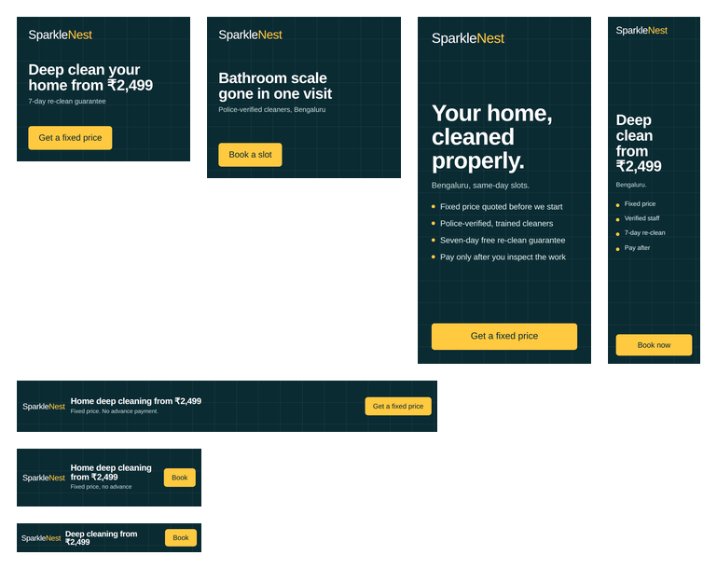
Figure 1 — Display creative set: 300×250, 336×280, 300×600, 160×600, 728×90, 320×100 and 320×50.

9. Landing page and conversion tracking

9.1 The landing page
The page was designed around a single job: convert a paid click into a lead. The quote form sits above the fold on desktop and one short scroll away on mobile, and the fixed-price offer, the guarantee and the trust signals all appear before any scrolling is required.
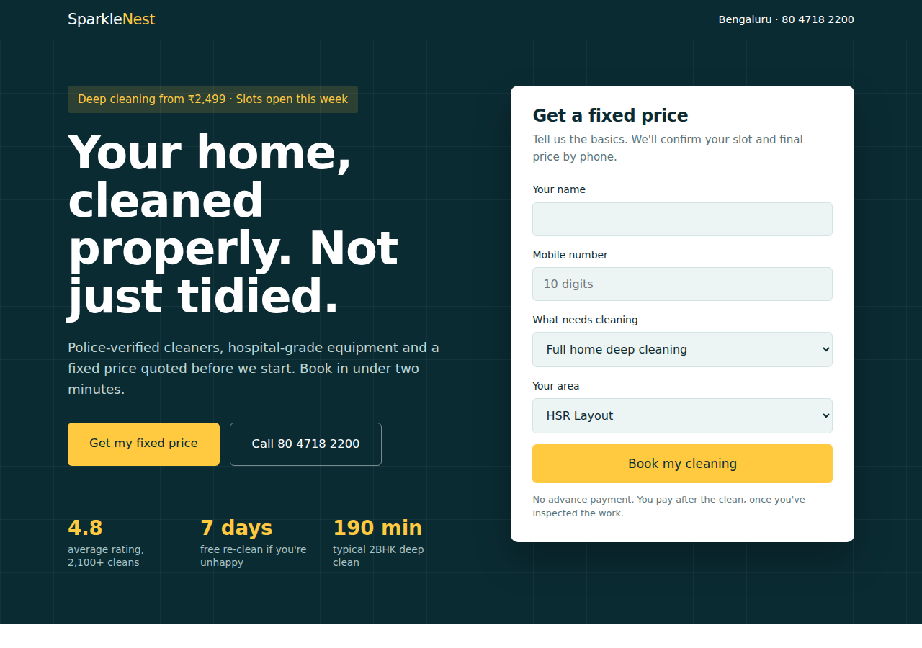
Figure 2 — The deployed landing page. The lead form is the hero, because converting the click is the page's only job.
Structural decisions that follow from it being an ad destination rather than a general website:
- No site navigation. Every exit route other than converting has been removed.
- Four form fields only. Each additional field measurably reduces completion.
- Click-to-call in the header and hero, since a large share of local service traffic prefers to phone.
- Pricing stated openly, which pre-qualifies the click and reduces wasted lead volume.
- An FAQ block that answers the objections raised in the ad copy, supporting landing page relevance within Quality Score.

9.2 Conversion actions
Conversion action | Category | Value | Counting
Lead form submitted | Submit lead form | ₹1,225 | One
Phone call tapped | Phone call lead | ₹1,225 | One
The ₹1,225 value is deliberate. A lead is not worth the ₹3,500 order value, because only about 35% of leads become jobs; 35% of ₹3,500 is ₹1,225. Feeding the true expected value rather than the headline order value is what prevents a value-based bid strategy from overbidding by nearly a factor of three.
Counting is set to One rather than Every, because a single household submitting the form twice is one customer, not two.

9.3 Attribution capture
An account-level tracking template appends campaign metadata to every ad click. The landing page reads those parameters on load, stores them in session storage so they survive on-page navigation, writes them into hidden form fields, and carries them through to the confirmation page.
The result is that any lead can be traced back to the exact campaign, ad group, search term and creative that produced it. On the deployed page this attribution is displayed on the confirmation screen so that a reviewer can verify the tracking functions; in a production build these values would be posted to a CRM and never shown to the customer.

9.4 What could not be verified
Being explicit about the limits of the build:
- No live conversions were recorded. The campaign was constructed and reviewed but never served traffic.
- The conversion IDs are placeholders, so the tags fire into nothing. The event logic is verifiable in the browser console; the delivery to Google Ads is not.
- The form has no backend. It validates input and hands off to the confirmation page. A production version requires a server or form service to store the lead.
- Call tracking is click-based rather than call-based. A tap on the number is counted, not a connected call of minimum duration, which would require a Google forwarding number and an active account.

10. Performance forecast
The model is assumption-driven: every input is an editable cell and every output is a formula, so the whole forecast recalculates when an assumption changes. This matters more than the specific numbers, because the assumptions are the part most likely to be wrong.

10.1 Assumptions
Assumption | Value | Source
Monthly budget | ₹30,000 | Set by the project
Search average CPC | ₹22 | Weighted average of Keyword Planner top-of-page bid ranges
Search CTR | 6.0% | Benchmark for high-intent local service search
Landing page conversion rate | 10% | Benchmark for a short lead form with pricing shown
Display CPC / CTR / CVR | ₹6 / 0.5% / 2% | Display network benchmarks for remarketing
Lead-to-job close rate | 35% | Business assumption
Average order value | ₹3,500 | Business assumption

10.2 Projected outcome
Metric | Search | Display | Blended
Budget | ₹24,000 | ₹6,000 | ₹30,000
Clicks | 1,091 | 1,000 | 2,091
Impressions | 18,183 | 200,000 | 218,183
Leads | 109 | 20 | 129
Cost per lead | ₹220 | ₹300 | ₹233
Jobs booked | — | — | 45
Cost per booked job | — | — | ₹667
Revenue | — | — | ₹1,57,500
Return on ad spend | — | — | 5.25x
This is a planning target, not a result. Actual cost per click in a live auction moves with competitor bidding, Quality Score and seasonality, and the close rate is a business assumption rather than a measured figure.

11. Challenges faced

11.1 Character limits reshaped the copy, not just trimmed it
Ad copy was written first and then cut to fit, which was the wrong order. Thirty characters is roughly four words, and several strong headlines simply could not survive the ceiling. The fix was to write a validation script that checks every asset against Google's limits at build time. It caught a display path at 16 characters against a 15-character maximum — an error that would have been rejected at upload and, in a live account, would have blocked the ad from serving.
The broader lesson was to treat the constraint as a design input rather than an editing step.

11.2 Two default settings that quietly waste budget
Two Google Ads defaults were nearly shipped unchanged:
- Display Network expansion is enabled by default within a Search campaign. Left on, a budget intended for high-intent search leaks into banner placements at a fraction of the intent, and the blended cost per lead looks fine while the quality of leads collapses.
- Location targeting defaults to Presence or interest, which serves ads to anyone anywhere in the world showing interest in Bengaluru. For a business whose teams travel 30 km, that is spend directed at people who can never buy.
Neither is obvious from the interface. Both were found by reading the settings line by line rather than accepting the recommended configuration.

11.3 Setting the conversion value incorrectly
The lead conversion value was initially set to ₹3,500, the average order value. This is wrong: only about 35% of leads become jobs, so the expected value of a lead is ₹1,225. Had a value-based bidding strategy been enabled on the original figure, it would have bid as though every lead were worth nearly three times its actual value.
This was the most instructive error in the project, because the campaign would have appeared to be working while systematically overspending.

11.4 Choosing the less impressive bid strategy
Smart Bidding was the tempting choice, and manual bidding felt like the unsophisticated answer. But automated strategies require conversion history to optimise against, and on day one there is none. Committing to Manual CPC for the first three weeks, with a defined trigger for switching, required accepting that the correct answer and the impressive answer were not the same.

11.5 Forecasting without live data
The largest constraint was building a credible performance model with no campaign history. The approach taken was to derive every figure from a stated, checkable source — Keyword Planner bid ranges and published benchmarks — put each assumption in its own editable cell, and label the output as a forecast everywhere it appears. Presenting modelled numbers as though they were results would have been the easier and less honest route.

12. What I learned

12.1 Most of Google Ads is subtraction
The negative keyword list and the settings that were switched off shaped this campaign more than the keyword list did. Deciding who not to show ads to — job seekers, DIY researchers, other cities, commercial enquiries — protected more budget than any bidding decision. Before this project the instinctive question was "what else can we target"; the more useful question turned out to be "what are we currently paying for that can never buy".

12.2 The landing page is part of the ad
Quality Score, cost per click and conversion rate all move with the destination page. Treating "the campaign" and "the website" as separate pieces of work is a false split — a campaign pointed at a weak page pays more per click for worse results, and no amount of bid management corrects it. Building the page as part of the campaign, rather than inheriting one, changed how the ad copy was written.

12.3 Cost per lead is a vanity metric on its own
A campaign can meet its cost-per-lead target and still lose money if the leads do not close. Cost per booked job — ₹667 against a ₹3,500 order value in this model — is the figure the business actually pays its bills with. Tracking the lead-to-job close rate as a campaign metric rather than a sales metric is what connects the advertising to the outcome.

12.4 Automation needs data before it needs trust
Smart Bidding, broad match and Performance Max are all genuinely powerful, and all three are actively harmful when applied to an account with no conversion history. The sequencing matters: build structure and collect signal manually first, then hand control to the machine once there is something for it to learn from.

12.5 Constraints are best encoded, not remembered
The character-limit validator caught an error that manual checking had missed twice. Anywhere a platform imposes a hard rule — asset lengths, budget caps, geographic limits — writing the rule into a script or a checklist is more reliable than intending to remember it.

13. Conclusion
This project produced a complete, launch-ready Google Ads campaign for a fictional local service business: a documented strategy, 26 researched keywords with 36 pre-loaded negatives, four Responsive Search Ads with validated assets, seven display creatives, a deployed landing page, and a working attribution and conversion-tracking layer.
The campaign was never served live traffic, so the value of the exercise lies in the reasoning rather than in performance data. The decisions that mattered most were the restrictive ones — narrower match types, more negatives, manual bidding, a smaller conversion value, fewer form fields — and each of those was chosen against an easier and more impressive-sounding alternative.
The most transferable outcome is the habit of asking what a number is actually measuring. A ₹233 cost per lead means nothing until it is set against a ₹667 cost per booked job and a ₹3,500 order value. Everything upstream of that — keywords, ads, bids, the landing page — exists to move that final relationship.

Appendix A — Deliverables
File | Contents
index.html | Deployed landing page with UTM capture and conversion tags
thank-you.html | Conversion confirmation page displaying captured attribution
docs/01-campaign-proposal.md | Week 1 proposal: objectives, audience, budget, keyword themes
docs/02-keyword-research-and-forecast.xlsx | 26 keywords, 36 negatives, account structure, forecast model
docs/03-ad-copy-bank.md | 60 headlines and 16 descriptions, character-validated
docs/04-launch-and-optimisation-plan.md | Pre-launch checklist and four-week optimisation plan
docs/05-tracking-and-measurement.md | Conversion setup, attribution, verification limits
docs/06-feedback-video-script.md | Script for the submission video
assets/banners/ | Seven display creatives at IAB standard sizes
README.md | Repository overview and deployment instructions

SparkleNest is a fictional business created for this Unified Mentor capstone project. It is not a real company, the contact details are not live, and no bookings are accepted or processed.

