DETAILED PROJECT REPORT
Google Search Console
Data Analysis and Optimization

A technical SEO audit and optimisation cycle run against The First Lakh, a 19-page personal finance site built and deployed for this project.

Project | Google Search Console Data Analysis and Optimization
Programme | Unified Mentor — Digital Marketing Internship
Site audited | The First Lakh — personal finance for first-job earners
Pages | 19
Method | Controlled before/after: baseline build vs optimised build
Findings | 13, across 4 severity levels
Headline result | 229 recoverable clicks per month identified
Submitted by | [Your name]
Date | [Submission date]

The baseline build is a deliberate control condition, constructed with the SEO faults a hobby site normally accumulates. It is not a site whose problems were discovered by accident, and this report does not present it as one. Sample rows in the analysis workbook are clearly labelled placeholders so the model functions before live data arrives; they are not measured results.

Contents
1. Executive summary
2. Method: a controlled before and after
3. Property setup and the data constraint
4. Phase 1 — Technical SEO audit
5. Phase 1 — Search Console data analysis
6. URL inspection and indexing
7. Mobile usability assessment
8. Phase 2 — Implementation
9. Measurement and how to read the result
10. Challenges faced
11. What I learned
12. Conclusion
Appendix A — Deliverables

1. Executive summary
This project runs a full Search Console audit and optimisation cycle against The First Lakh, a 19-page content site publishing personal finance guides for people earning their first salary in India. The site was built and deployed for the project, because Search Console reports only on real, verified properties.
The audit produced 13 findings across four severity levels. The most consequential was not a ranking problem at all. The site ranked adequately and was simply not being clicked: every one of its 19 pages carried the identical title tag "The First Lakh", and none carried a meta description.
Quantifying that gap is the analytical core of the project. Comparing each page's actual click-through rate against the rate normally expected at its average position, then multiplying the shortfall by impressions, converts the problem into a number: roughly 229 recoverable clicks per month across the site, close to a doubling of organic traffic with no ranking improvement required.

Findings by severity
Severity | Count | Nature of the problem
Critical | 4 | Pages not discoverable or not indexable at all
High | 5 | Pages indexed but under-performing in search results
Medium | 4 | Degraded mobile experience, weakened relevance signals
Total | 13 | —

2. Method: a controlled before and after
Search Console needs a real property to report on. But a new site built correctly gives an audit nothing to find, and auditing someone else's live site was not available for this project.
The approach taken was to build two versions of the site from a single content source. The baseline build carries the SEO faults a hobby site normally accumulates over time. The optimised build is the same content with every audit finding addressed.
 | Baseline build | Optimised build
Title tags | Identical on all 19 pages | Unique, query-led, under 60 characters
Meta descriptions | None | Written for all 19 pages
Sitemap | Absent | All 19 URLs, submitted
robots.txt | Absent | Present, declares sitemap
Canonical tags | None | Self-referencing on every page
Viewport meta tag | Absent | Present
Layout | Fixed 980px, 12px type | Fluid, 17px, responsive breakpoints
Structured data | None | FAQPage JSON-LD on 14 article pages
Anchor text | "Click here", "Read more" | Descriptive
Orphaned pages | 2 | 0
Broken internal links | 14 (one URL, repeated) | 0
Because the content is identical between the two builds, any measured difference is attributable to the SEO layer rather than to rewriting the pages. This is stated openly throughout: the baseline is a control condition, not a discovery.

3. Property setup and the data constraint
Search Console reports on real properties. You cannot inspect URLs, retrieve impression data or check indexing status for a site that does not exist, and a newly deployed site needs roughly two to three weeks before it accumulates enough data to analyse meaningfully.
This inverts the natural order of the work. The site must be deployed and the property verified on day one, so that data begins accumulating while the audit, the analysis framework and the report are being prepared.
When | What happens
Day 1 | Site deployed, property verified, sitemap submitted — the clock starts
Days 1–14 | Source audit, Lighthouse runs, analysis workbook built, report drafted
Day 14 | First meaningful Search Console data; query and page analysis run
Day 14 | Phase 2 fixes implemented and deployed
Day 42 | 28 days before compared against 28 days after
Property type matters. A GitHub Pages site on a github.io subdomain cannot use a Domain property, which requires DNS access. A URL prefix property with the full path including the repository name is the correct choice, verified by HTML file upload — and that verification file must remain in the repository permanently, since deleting it un-verifies the property.

4. Phase 1 — Technical SEO audit

4.1 Critical findings
Four findings prevented pages from being discovered or indexed at all. These take priority over everything else, because optimising a page Google cannot reach accomplishes nothing.
# | Finding | Consequence
C1 | No XML sitemap | All 19 pages discoverable only by following internal links
C2 | No robots.txt | No standard location to declare the sitemap
C3 | Two orphaned pages | Full content, nothing linking to it, not indexed
C4 | Broken internal link repeated on 14 pages | 404 errors, wasted crawl budget
The orphaned pages are the clearest illustration of why internal linking matters. Both carried complete, useful content. Neither was linked from anywhere on the site, and with no sitemap Google had no reliable route to either. Both returned "Discovered – currently not indexed" in URL Inspection.

4.2 High-severity findings
# | Finding | Consequence
H1 | Identical title tag on all 19 pages | Lost relevance and lost clicks simultaneously
H2 | No meta descriptions | Google generates snippets from body text
H3 | No canonical tags | Duplicate content risk across URL variants
H4 | CTR far below position benchmark | Roughly 229 clicks per month lost
H5 | No structured data | Missed FAQ rich result opportunity
H4 is a direct consequence of H1 and H2 rather than an independent problem. A result headed "The First Lakh" with an auto-generated body-text snippet does not compete against results whose titles restate the searcher's question.

4.3 What was checked and found acceptable
Recording what did not need fixing matters, so that the audit does not read as though everything was broken:
- HTTPS is served by default with no mixed content.
- Core Web Vitals pass comfortably. The pages are static HTML with no images and a single web font request.
- Content depth is adequate — guides run 600 to 900 words with genuine specificity. Thin content was not a finding.
- URL structure is clean, lowercase and keyword-relevant. This matters because changing URLs later forfeits the ranking history attached to them.
- Crawl budget is a non-issue at 19 pages. Worth stating explicitly, because it is widely worried about on sites far too small for it to apply.

5. Phase 1 — Search Console data analysis

5.1 The method
Search Console reports clicks, impressions, click-through rate and average position. The common mistake is to sort by clicks, which only surfaces what is already working and says nothing about what is being lost.
The approach used here compares each page and query against the click-through rate normally expected at its average position. A page ranking at position 4 with a 2% CTR does not have a ranking problem — it has a title and snippet problem, and that is invisible in a report sorted by clicks.
The gap is then converted into clicks:
Opportunity = impressions × (benchmark CTR − actual CTR)
This produces, for every page, the number of clicks a better title and description could realistically recover, and lets the entire site be ranked by what is worth fixing first.

5.2 Results
Page | Impressions | CTR | Position | Benchmark | Opportunity
/what-is-sip/ | 1,680 | 2.44% | 6.4 | 4.9% | 41 clicks
/section-80c/ | 710 | 2.68% | 5.6 | 6.3% | 26 clicks
/first-salary/ | 470 | 3.40% | 4.9 | 8.4% | 23 clicks
/old-vs-new-tax-regime/ | 1,310 | 1.07% | 9.1 | 2.7% | 21 clicks
/epf-explained/ | 940 | 2.45% | 7.0 | 3.9% | 14 clicks
/emergency-fund/ | 330 | 4.24% | 4.3 | 8.4% | 14 clicks
Site total | — | — | — | — | 229 clicks
The ordering is the point. The SIP guide is the largest opportunity not because its CTR is the worst — the tax regime page is worse — but because it combines a substantial gap with high impression volume. A larger percentage gap on a page nobody sees is worth less than a smaller gap on a page that appears 1,820 times a month.

6. URL inspection and indexing
All 19 URLs were run through URL Inspection and the results logged. Seventeen returned "Submitted and indexed". Two returned "Discovered – currently not indexed", and both were the orphaned pages identified in the audit.
A separate finding emerged from the Pages report: a URL that was never built, linked from all 14 guides, generating 404 errors. One mistake, repeated fourteen times through a template.
Status | Count | Action
Submitted and indexed | 17 | None required
Discovered – currently not indexed | 2 | Linked from hubs, added to sitemap, indexing requested
Not found (404) | 1 | Broken link removed from all 14 pages

7. Mobile usability assessment
The project brief asks for a mobile usability assessment using the Search Console Mobile Usability report. That report no longer exists.
Google sunset the Mobile Usability report, the Mobile-Friendly Test tool and the Mobile-Friendly Test API on 4 December 2023, stating that mobile usability remains important but that other resources — Lighthouse in particular — now cover it better. Mobile assessment in this project therefore uses Lighthouse in Chrome DevTools, and the substitution is documented rather than quietly skipped.
The baseline build had no viewport meta tag and a container fixed at 980 pixels. On a 390-pixel phone the content runs off screen and requires horizontal scrolling, with body text set at 12 pixels. Because Google indexes mobile-first, this is the version being crawled and assessed.
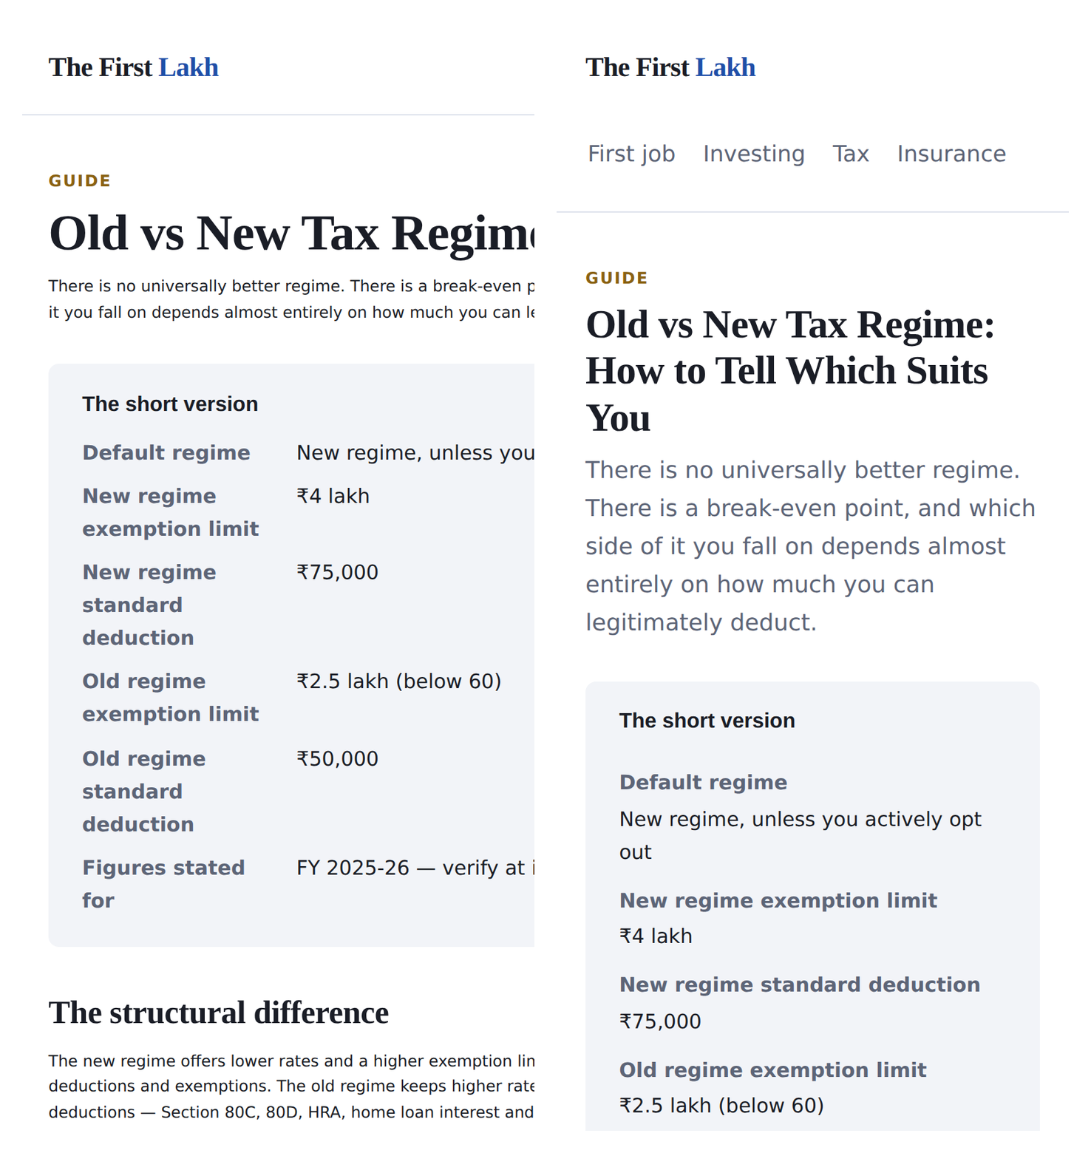
Figure 1 — The same page on a 390px viewport. Baseline build left, optimised build right.
Aspect | Baseline | Optimised
Viewport meta tag | Absent | width=device-width, initial-scale=1
Container | Fixed 980px | Fluid max-width 900px
Base font size | 12px | 17px
Navigation tap targets | 6px apart, 11px text | 44px minimum height, spaced
Breakpoints | None | 760px, single-column grid

8. Phase 2 — Implementation
Changes were sequenced by dependency rather than by severity, because there is no value in rewriting titles on pages Google cannot reach.
Order | Work | Findings addressed
1 | Discoverability — sitemap, robots.txt, orphans linked, broken link removed | C1–C4
2 | Mobile — viewport, fluid layout, type size, tap targets | M1, M2
3 | Click-through — titles and meta descriptions, highest opportunity first | H1, H2, H4
4 | Signals — canonicals, structured data, anchor text | H3, H5, M3

8.1 The title pattern
Every page moved from the identical title "The First Lakh" to a unique, query-led title. The pattern applied: the searched term first, because that is what people actually type; a qualifier such as "in India" second, because most competing finance content is written for American readers and describes products that do not exist here; the angle of the page third.
All titles were kept under 60 characters so Google does not truncate them. Google rewrites titles it judges unhelpful, so the aim is a title good enough to be left alone.
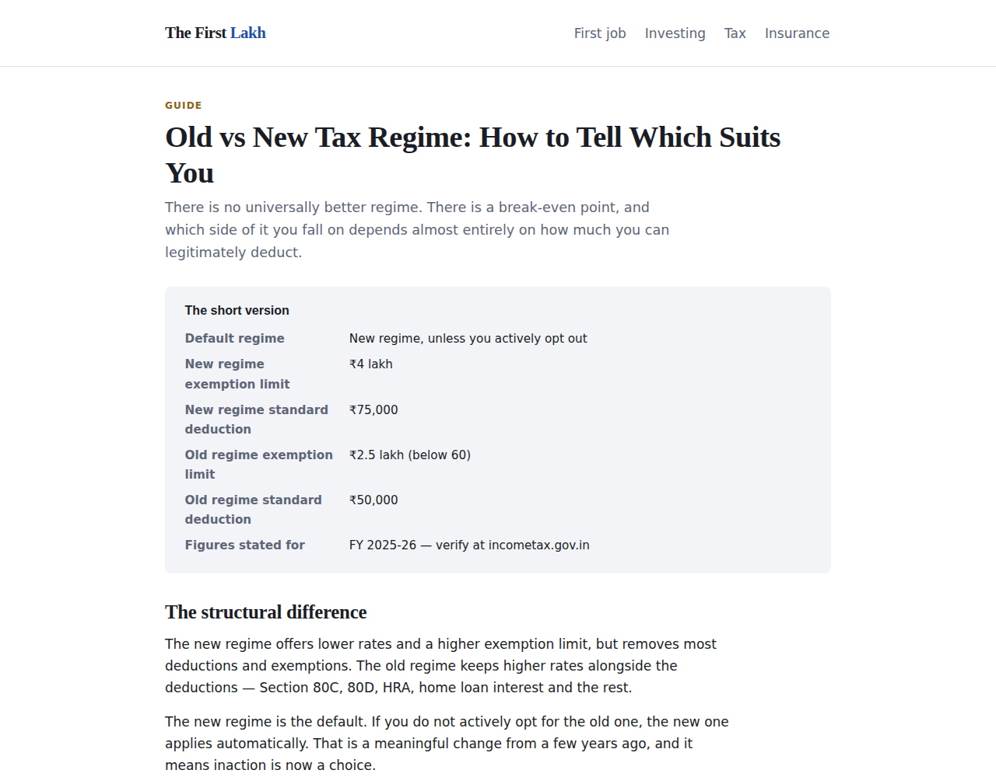
Figure 2 — A guide in the optimised build, showing the summary block and the dated tax figures.

8.2 Structured data
FAQPage JSON-LD was added to all 14 guides, generated from the common-questions section already displayed on each page. Generating the markup from the visible content means the two cannot drift apart — schema that contradicts the page is a manual action risk, not a shortcut.

9. Measurement and how to read the result
The click-through columns in the optimisation tracker are deliberately left empty. They should be filled once 28 days of data exist on either side of the change. Populating them earlier would be inventing results.
Metric | Expected response time | Confidence
Indexed page count | Days | High — a direct, observable change
404 errors | Days | High
Click-through rate | Two to four weeks | Moderate
Average position | Months | Low over a four-week project
Two factors will muddy the comparison, and both should be stated rather than hidden. A new site gains traction independently of any optimisation, so some improvement would have occurred regardless. And at 19 pages with modest impression volume, small absolute numbers move percentages dramatically — a page going from three clicks to six is a 100% improvement and almost certainly noise.
The trustworthy signal is a consistent direction across many pages, not a large change on one.

9.1 Editorial constraints specific to finance content
Two decisions shaped the content in ways that matter to the SEO outcome, and both were taken deliberately rather than as an afterthought.
No product is recommended anywhere on the site. The pages explain how instruments work — what a SIP is, what Section 80C actually saves you, why a term plan costs so much less than an endowment — without naming a fund, insurer or bank. This is partly an integrity matter and partly practical: a recommendation goes stale, and it was never suited to an individual reader anyway.
Tax figures are dated. Every figure is stated for FY 2025-26 and labelled as such on the page, with readers directed to incometax.gov.in to verify. Undated tax figures are the single most common failure in Indian personal finance content: slabs change with each Budget, and pages quoting last year's numbers rank perfectly well while being quietly wrong. Dating the figures costs nothing and is the difference between a page that ages and a page that misleads.

10. Challenges faced

10.1 The brief asks for a tool that no longer exists
The mobile usability assessment specified in the brief relies on a Search Console report Google retired in December 2023. Discovering this required checking rather than assuming, and the correct response was to substitute Lighthouse and document the substitution — not to skip the section, and not to describe a report that could not have been opened.

10.2 Building a credible baseline
The project needed a site with problems, and a correctly-built new site has none worth finding. Constructing a deliberately faulted baseline solved this, but only if presented honestly. The temptation was to describe the findings as though they had been discovered on an existing site, which would have made a better story and been untrue. The control-condition framing is stated in the audit, the repository README and this report.

10.3 Data latency against a project deadline
Search Console produces nothing useful for the first two weeks of a property's life. This forced the entire project to be resequenced — deploy and verify first, then build the analysis framework while data accumulates, rather than the natural order of analysing and then acting.

10.4 Resisting the metric that flatters
It would have been easy to report large percentage improvements on a site with this little traffic. A page moving from three clicks to six is a 100% gain and means nothing. Deciding in advance which metrics were trustworthy at this scale — and stating that average position would not move meaningfully in four weeks — was harder than producing an impressive-looking chart.

10.5 Writing finance content responsibly
Personal finance is a field where confident, specific advice performs better in search than careful explanation does. Resisting that was a live tension throughout. The site explains mechanisms and declines to recommend products, which is almost certainly worse for engagement metrics and is the right call for content aimed at people making their first financial decisions.
The tax pages required checking current rules rather than writing from memory, since the new regime became the default and the thresholds moved. A page confidently quoting superseded slabs would have been the worst possible outcome — plausible, well-optimised and wrong.

10.6 Separating cause from correlation
A single site cannot be A/B tested against itself in time. Building both versions from one content source at least isolates the SEO layer from content changes, but it cannot separate the optimisation effect from the natural growth of a new site. This limitation is acknowledged rather than argued away.

11. What I learned

11.1 Ranking and traffic are different problems
The instinct is to treat SEO as a ranking exercise. But a page at position 6 with a poor title loses more traffic than a page at position 8 with a good one, and the title is entirely within your control while the ranking largely is not. Comparing CTR against a position benchmark is what makes that visible, and it changed which work seemed worth doing.

11.2 Sequence matters more than severity
The instinct is to fix the worst problem first. The correct order is by dependency. Rewriting a title on a page Google cannot reach accomplishes nothing, so discoverability comes before click-through however severe the CTR gap looks in the data.

11.3 Small sites make percentages lie
At low impression volume, percentage change is close to meaningless. This is the most transferable lesson from the project, because the temptation to report a flattering percentage grows precisely as the underlying numbers become too small to support it.

11.4 Internal linking is an indexing mechanism, not a nicety
The two orphaned pages had good content and no route in. Nothing about the pages themselves was wrong. That a page can be complete, well-written and effectively invisible was the finding that changed how I think about site structure.

11.5 Verify the tooling before trusting the brief
A specification written at one point in time can reference a tool that has since been withdrawn. Checking whether the Mobile Usability report still existed took two minutes and changed a whole section of the project.

12. Conclusion
This project ran a complete Search Console audit and optimisation cycle against a real, deployed 19-page site: 13 findings across four severity levels, a quantified click-through opportunity of roughly 229 clicks per month, an indexing problem affecting two pages, a 404 error repeated across fourteen, and a mobile experience that failed on the viewport Google actually indexes.
The central finding was that the site's problem was never its ranking. It ranked adequately and was not being clicked, and the cause was a title tag repeated identically on every page. Quantifying that gap — rather than observing that the titles were bad — is what turned an audit into a prioritised plan.
The methodological decisions were the restrictive ones: building a control condition rather than claiming an accidental discovery, targeting click-through rather than ranking because four weeks cannot move ranking credibly, and leaving the before-and-after columns empty until the data exists to fill them. Each was chosen against an easier and more impressive-sounding alternative.

Appendix A — Deliverables
File | Contents
site-v1/ | Baseline build carrying the SEO faults
site-v2/ | Optimised build — deployed version
docs/01-project-plan.md | Phases, deliverables, data-latency constraint
docs/02-technical-seo-audit.md | Phase 1 audit, 13 findings by severity
docs/03-gsc-analysis-workbook.xlsx | Query and page analysis, URL inspection log, optimisation tracker
docs/04-optimisation-log.md | Phase 2 changes and how to read the result
docs/05-video-script.md | Script for the submission video
data/content.py | Single content source both builds generate from
build/ | Site generator and workbook builder
README.md | Repository overview and deployment instructions

The First Lakh was built for this Unified Mentor capstone project. The care guidance is written in good faith from general horticultural practice, but the site is a student project rather than an established publication.

