Probleam Statement:
- To harness Data Science to refine credit underwriting process.
- Focus on Personnel Loan Segement : Borrow Behaviour and Creditworthiness
- Financial Behaviour
- Spending Habits
- Potentials Risks for each borrower
- Objective is to :
- Optimize loan Disbursal
- Balancing Customer outreach with risk management.

Questionnaire

1. What percentage of customers have fully paid their Loan Amount?

Percentage would be ( Fully Paid / Charged Off ) = 318357 / 396030 = ~ 80.4%

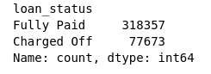

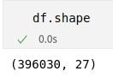

2. Comment about the correlation between Loan Amount and Installment features ?

The correlation coefficients we’ve obtained indicate a strong positive relationship between the two variables, both according to Pearson and Spearman correlation methods

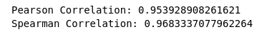

3. The majority of people have home ownership as ?

Looks like MORTAGE is majority in terms of home ownership.
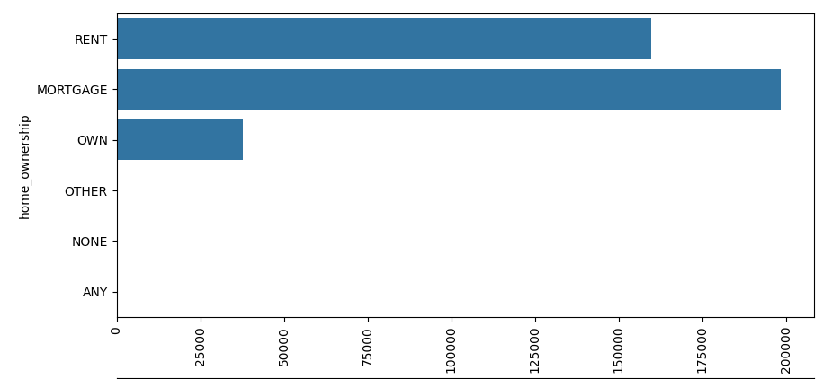

4. People with grades ‘A’ are more likely to fully pay their loan. (T/F) ?

A is represented by 1 in below graph, by below analysis YES ‘A’ is most likely to fully pay the loan when we calculate the probability.

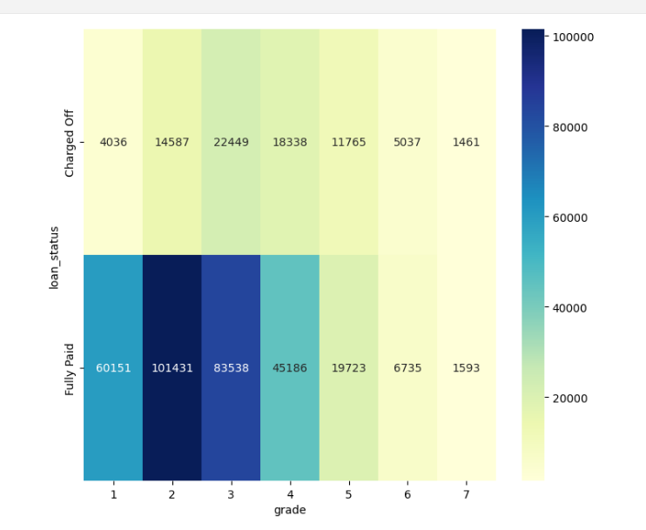

5. Name the top 2 afforded job titles.

Teacher and Manager have are the maximum count in terms of Fully Paid loan status

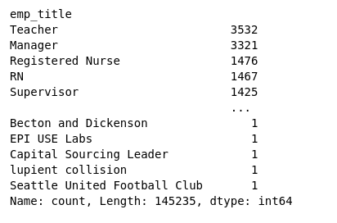

6. Thinking from a bank's perspective, which metric should our primary focus be on..

- ROC AUC : ROC AUC measures the ability of the model to discriminate between repaid and defaulted loans across various thresholds. But as we’ve significant class imbalance (e.g., more repaid loans than defaulted ones), precision, recall, and F1 score might be more informative than ROC AUC.

- Precision : Precision is the proportion of approved loans that are genuinely repaid. It is relevant when the cost of approving a loan that might not be repaid (false positive) is high. Hence it is important

- Recall : Recall is the proportion of actual repaid loans that are correctly identified. It is relevant when the cost of missing a genuinely repaid loan (false negative) is high. Hence it is important.

- F1 Score : F1 Score provides a balance between precision and recall. It is suitable when there is a need to balance the trade-off between false positives and false negatives. So yes it is important matrics as well.

7. How does the gap in precision and recall affect the bank?

- High Precision, Low Recall: The bank is conservative in approving loans. The loans approved are likely to be repaid, but there's a risk of rejecting genuinely creditworthy applicants (false negatives). This approach minimizes the risk of approving risky loans but may lead to missed opportunities.

- Low Precision, high Recall: The bank is more lenient in approving loans. While capturing a larger portion of genuinely creditworthy applicants, there's a risk of approving loans that may not be repaid (false positives). This approach increases the chances of approving loans but may lead to higher default rates.

- Balanced Precision and Recall : The bank strikes a balance between minimizing the risk of approving risky loans and maximizing the approval of genuinely creditworthy applicants. The trade-off is optimized to meet the bank's risk tolerance and business objectives.

- Financial Impact :
Low Precision : May lead to financial losses due to defaulted loans that were incorrectly approved.
Low Recall : May result in missed opportunities and reduced revenue from potentially creditworthy applicants.

8. Which were the features that heavily affected the outcome?

Top 5 features include:
- Pincode
- Grade
- Term
- Annual Income
- Debt-to-Income ratio (DTI)

9. Will the results be affected by geographical location? (Yes/No)

Yes, it seems that Geographical location impacts the outcome of the model.

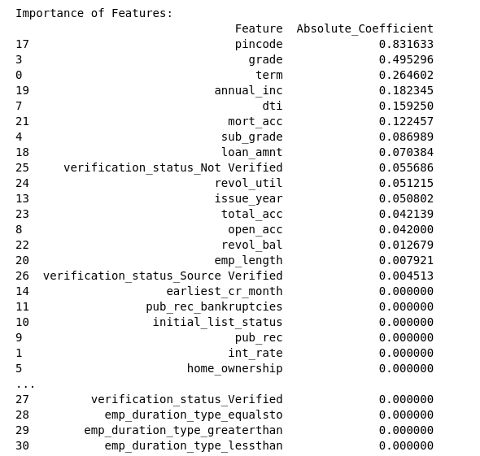

END

