Define Problem Statement and perform Exploratory Data Analysis :

Analyze Jamboree in understanding what factors are important in graduate admissions and how these factors are interrelated among themselves. It will also help predict one's chances of admission given the rest of the variables.

Insights on EDA:

1. Below is the density ditribution of different features, from which we can understand where our most of the students belongs

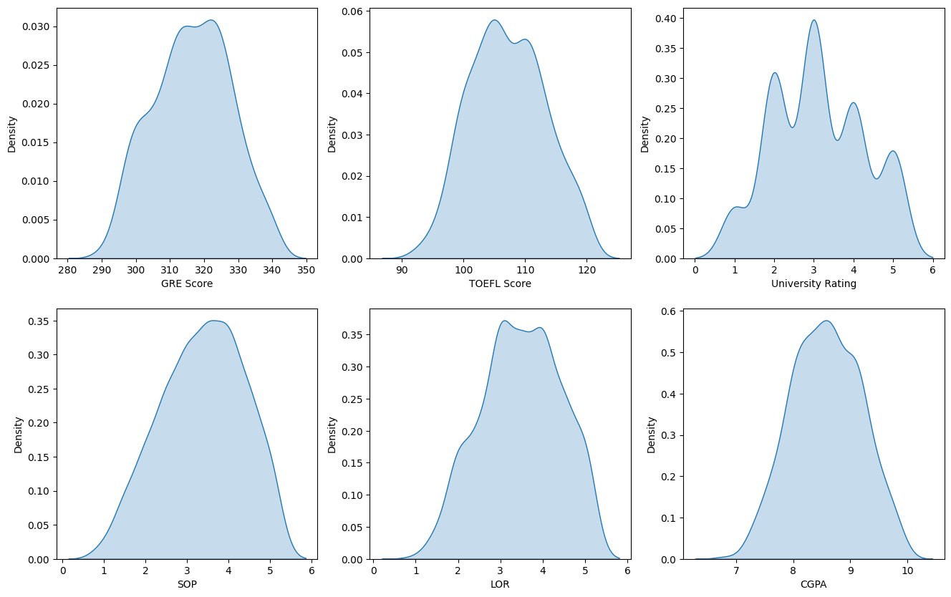

2. Research experience impacts on GRE and TOEFL score

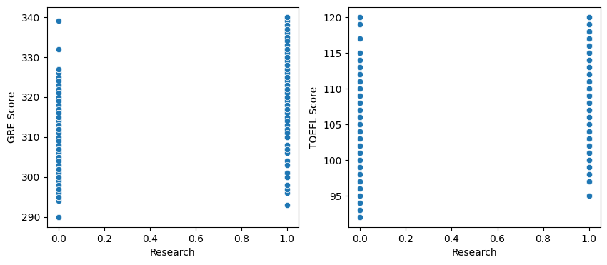

3. - Higher TOEFL score indicates higher GRE score
- With increate in CGPA,SOP,LOP,University Rating your chances of getting in Admission increases.

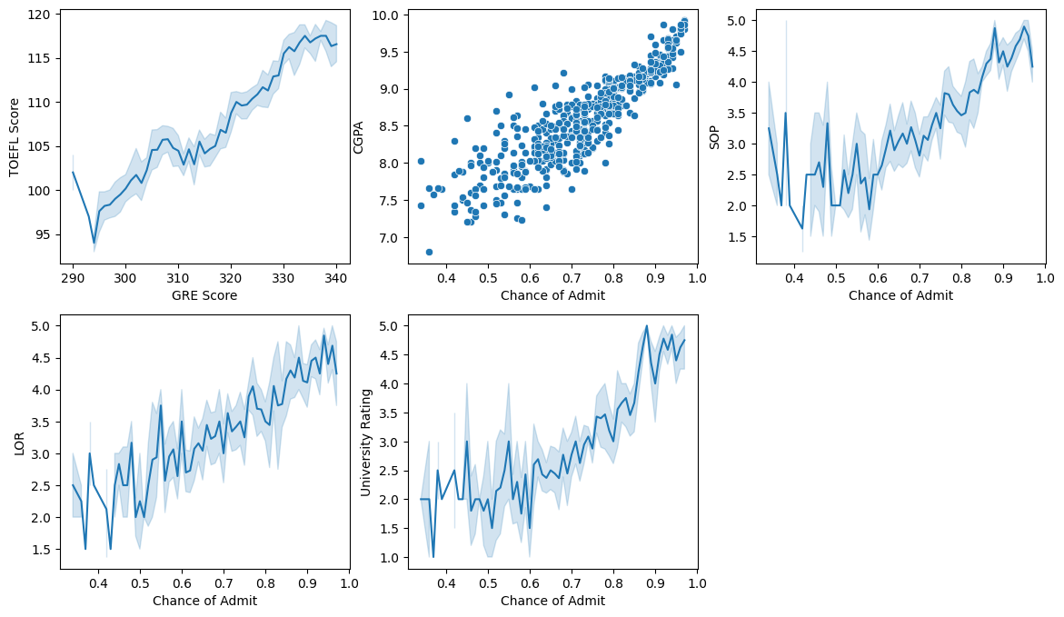

4. Correlation Heatmap for different features in our dataset :

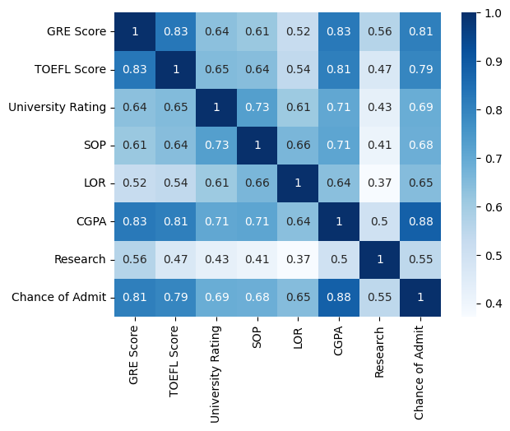

5. Attached visualization does seems to have any outliers in dataset :

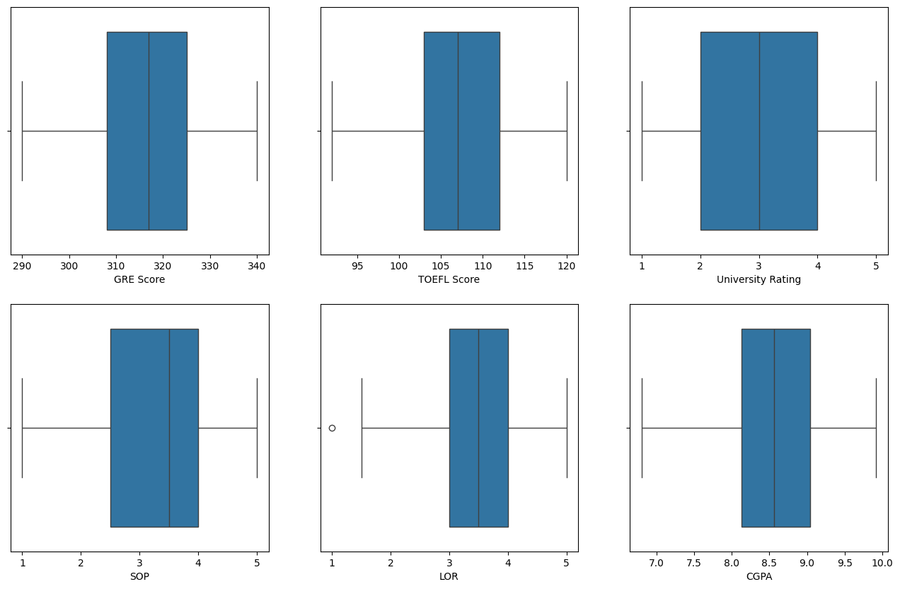

Actionable Insights & Recommendations

- Model performances on Test Data:
MAE : 0.03966
RMSE : 0.05877
R2 : 0.8439
Ajusted R2 : 0.81 79

- People with higher GRE Scores also have higher TOEFL Scores.
- A student with a higher CGPA has a good LOR.
- Top 3 correlated features with the Chance of Admit
- CGPA
- GRE Score
- Letter of Recommendation

- Research experience for sure increases a student’s
- Chance of Admit
- LOR
- University Rating

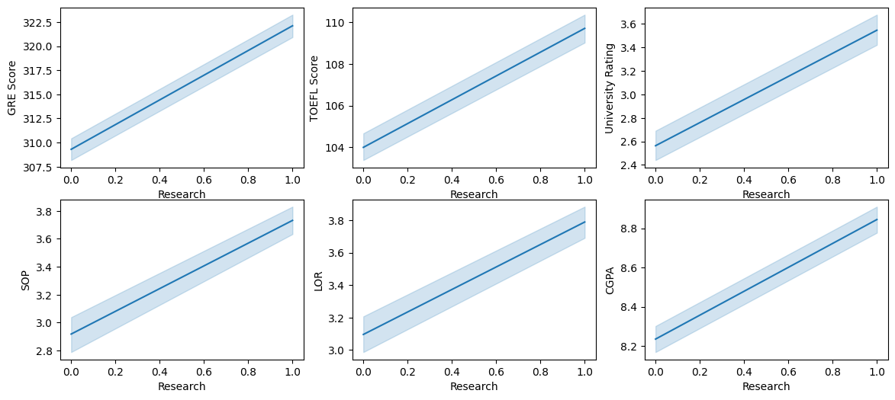

- Comments on additional data sources for model improvement, model implementation in real world and potential business benefits from improving the model :

- We need more data points to get more in-depth understanding on how well each individual features effecting the Chances of Admit.

- Additinal features that may help in improving model performance includes:
>> Past Attempts : how many times the candidate attempted in past.
>> Age : Candidate’s age may play a significant role.

- Potential business benefits :
- Getting an understanding on how well the feature impacts the Chances of Admit, business can accordingly build the infrastructure to enhance the individuals capabilities and gain more profit by advertising the positive results it generates.
- If features like Age are impacting the results, the bussiness can focus on that specific segment to generate more positive results and gain more profit.

<END>

