Experiment 1 with alpha=0.01, epochs=100, reg_const=0.01

------------------------------------

Training Accuracy: 24.259183673469387

Validation Accuracy: 23.599999999999998

Test Accuracy:23.3

------------------------------------

Experiment 2 with alpha=0.01, epochs=100, reg_const=0.05

------------------------------------

Training Accuracy: 23.981632653061226

Validation Accuracy: 26.0

Test Accuracy:23.7

------------------------------------

Experiment 3 with alpha=0.01, epochs=200, reg_const=0.01

------------------------------------

Training Accuracy: 24.10408163265306

Validation Accuracy: 24.099999999999998

Test Accuracy:22.48

------------------------------------

Experiment 4 with alpha=0.01, epochs=200, reg_const=0.05

------------------------------------

Training Accuracy: 23.72448979591837

Validation Accuracy: 21.3

Test Accuracy:22.54

------------------------------------

Experiment 5 with alpha=0.1, epochs=100, reg_const=0.01

------------------------------------

Training Accuracy: 22.6

Validation Accuracy: 23.599999999999998

Test Accuracy:23.02

------------------------------------

Experiment 6 with alpha=0.1, epochs=100, reg_const=0.05

------------------------------------

Training Accuracy: 22.0734693877551

Validation Accuracy: 24.8

Test Accuracy:21.6

------------------------------------

Experiment 7 with alpha=0.1, epochs=200, reg_const=0.01

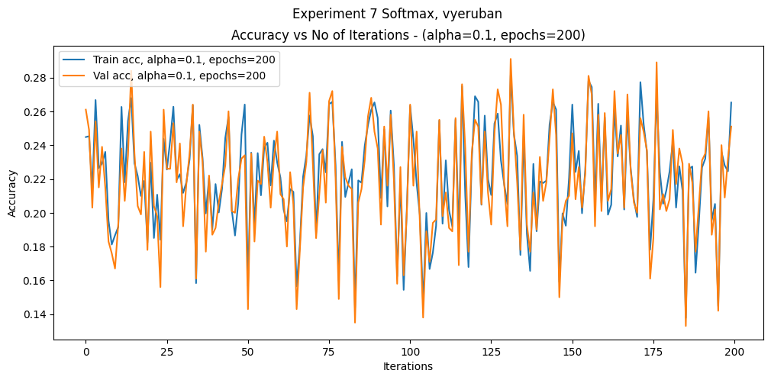

------------------------------------

Training Accuracy: 26.518367346938774

Validation Accuracy: 25.1

Test Accuracy:25.319999999999997

------------------------------------

Experiment 8 with alpha=0.1, epochs=200, reg_const=0.05

------------------------------------

Training Accuracy: 25.875510204081632

Validation Accuracy: 25.5

Test Accuracy:26.279999999999998

------------------------------------

Best alpha: 0.1, Best epochs: 200, Best accuracy: 26.279999999999998, Best Regularization Constant: 0.05