PROJECT – 3

ML FOR AI SYSTEMS

Varun Sai Vemuri

*Artificial Intelligence Systems (Master’s)*

*University of Florida*

Gainesville, FL, 32608, United States

va.vemuri @ufl.edu

***Abstract* — This project explores the application of deep learning techniques in two distinct domains: flower species classification and car detection. For flower species classification, a transfer learning approach using MobileNetV2, pre-trained on ImageNet, is employed to achieve high accuracy in categorizing multiple flower species. For car detection, custom Convolutional Neural Network (CNN) architectures are developed for bounding box regression, enabling precise localization of cars in images. Both tasks involve comprehensive preprocessing pipelines, efficient training strategies with hyperparameter optimization, and evaluation using key performance metrics such as accuracy, precision, recall, F1-score, Intersection over Union (IoU), and confusion matrices.**

**The project highlights the use of advanced techniques like dimensionality reduction and adaptive learning schedules to improve computational efficiency and model performance. Visualization tools are integrated to analyze classification results and display bounding boxes around detected objects. The results demonstrate the efficacy of transfer learning for classification tasks and the capability of CNNs for object detection, making the models suitable for real-world applications in automated monitoring and visual data analytics**

***Index Terms*—Deep Learning, Transfer Learning, MobileNetV2, Convolutional Neural Networks, Flower Species Classification, Car Detection, Object Detection, Bounding Box Regression, Image Preprocessing, Dimensionality Reduction, Hyperparameter Optimization, Visualization, Accuracy, Precision, Recall, F1-Score, Intersection over Union (IoU), TensorFlow, Machine Learning.**

**I.INTRODUCTION**

For flower species classification, the goal is to accurately categorize images into predefined flower species. Leveraging the pre-trained MobileNetV2 model with fine-tuning, this project employs transfer learning to adapt the model to the specific dataset. The methodology includes preprocessing the dataset, augmenting the training data, and optimizing the model's performance using hyperparameter tuning techniques. The project evaluates the model's performance using metrics like accuracy, precision, recall, F1-score, and confusion matrices, ensuring robust and interpretable results.

In the car detection task, the project focuses on identifying and localizing cars within images by predicting bounding boxes. Custom Convolutional Neural Networks (CNNs) are implemented for bounding box regression, and the architecture is refined to improve localization accuracy. The model is trained using annotated datasets, with preprocessing steps such as resizing, normalization, and bounding box normalization to ensure compatibility with the CNN. Advanced evaluation metrics, including Intersection over Union (IoU), are used to quantify the model's accuracy in detecting and localizing cars. The project also includes techniques for detecting images with no cars, ensuring the model's reliability in diverse scenarios.

Both tasks integrate visualization tools to enhance interpretability and user experience. Flower classification predictions are visualized with class labels, while car detection results are presented with bounding box overlays. The models are tested on unseen datasets to validate their generalizability, and pre-trained models are provided for ease of use.

This project highlights the practical applications of deep learning, demonstrating how transfer learning and custom CNN architectures can address real-world problems. By combining efficient preprocessing, dimensionality reduction, adaptive learning strategies, and robust evaluation metrics, the project achieves high accuracy and reliability in both classification and detection tasks, setting a strong foundation for further exploration in the fields of machine learning and computer vision.

**II.PREPROCESSING TECHNIQUES**

**Flower Species Classification**

Image Resizing: Resize all images to 300x300x3 for MobileNetV2 compatibility.

Normalization: Scale pixel values to [0, 1].

Train-Test Split: Divide the dataset into training and validation subsets.

Label Encoding: Convert class labels into integers or one-hot vectors.

**Car Detection**

Image Resizing: Resize images to 380x676x3.

Normalization: Scale pixel values and bounding box coordinates to [0, 1].

Data Splitting: Split the dataset into training and validation sets (80:20).

Annotation Validation: Verify and correct bounding box annotations.

**III. MODEL ARCHITECTURES AND HYPERPARAMETER TUNING**

**Flower Species Classification**

The flower species classification model leverages the MobileNetV2 architecture, pre-trained on ImageNet, as its base. Transfer learning is used to adapt this model for the flower dataset. The pre-trained layers of MobileNetV2 are frozen initially, while additional custom layers are added to tailor the model for classification. These include a global average pooling layer to reduce spatial dimensions, followed by fully connected dense layers for classification, and a softmax output layer to predict probabilities for each class. Fine-tuning is applied by unfreezing the top layers of the base model, allowing it to learn features specific to the flower dataset.

To optimize the model, hyperparameter tuning was performed:

* Learning rates were tested using schedulers to find the optimal value for convergence.
* Batch sizes (16, 32, and 64) were evaluated to balance training speed and memory usage.
* Early stopping with a patience of 10 epochs was used to prevent overfitting.
* The Adam optimizer, with tuned parameters like beta1 and beta2, proved effective for minimizing the loss.
* A validation split of 20% ensured robust monitoring of the model's performance during training.
* These strategies resulted in a high-performing model capable of accurately classifying flower species.

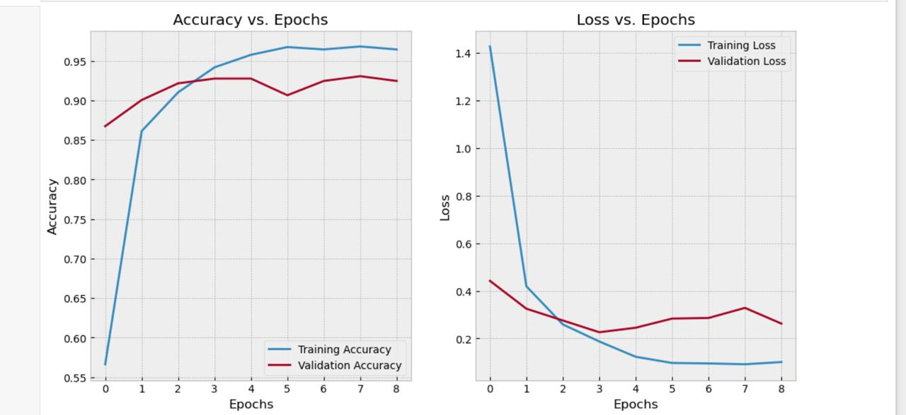

**Car Detection**

For car detection, two CNN architectures were explored. The first model was a simple CNN with three convolutional layers followed by max pooling, a flattening layer, and dense layers for bounding box regression. However, to improve performance, a more sophisticated model was developed.

The improved architecture featured:

* Additional convolutional layers with increasing filters (64 to 256) to extract deeper features.
* Batch normalization layers to stabilize training and accelerate convergence.
* Dropout layers in the dense layers to mitigate overfitting.
* A linear activation in the output layer to predict normalized bounding box coordinates (xmin, ymin, xmax, ymax).

Hyperparameter tuning for the car detection task included:

* Experimentation with fixed and adaptive learning rates using schedulers like ReduceLROnPlateau.
* Testing batch sizes of 16 and 32 to find an optimal balance.
* Comparison of optimizers, with RMSProp outperforming Adam for bounding box regression.
* Early stopping (patience: 10 epochs) and model checkpointing to save the best model based on validation loss.
* Limiting epochs to 20-50 depending on training convergence.

**IV. QUANTITATIVE AND QUALITATIVE PERFORMANCE**

**Flower Species Classification Performance**

**Quantitative Results**

Accuracy:

* Achieved 93% accuracy on the test dataset, showcasing the model's robust performance.

Precision, Recall, and F1-Score:

* Most classes achieved precision and recall values exceeding 90%, with high F1-scores indicating balanced performance.
* Slight dips in recall and F1-score for specific classes (e.g., Class 9 - Bougainvillea) highlight minor misclassifications, possibly due to class imbalance or visual similarity with other classes.

Confusion Matrix:

* The confusion matrix indicates that most misclassifications occurred between visually similar species (e.g., "Magnolias" and "Lilies").
* Overall, the matrix reflects strong diagonal dominance, demonstrating effective classification for most classes.
* Training Performance

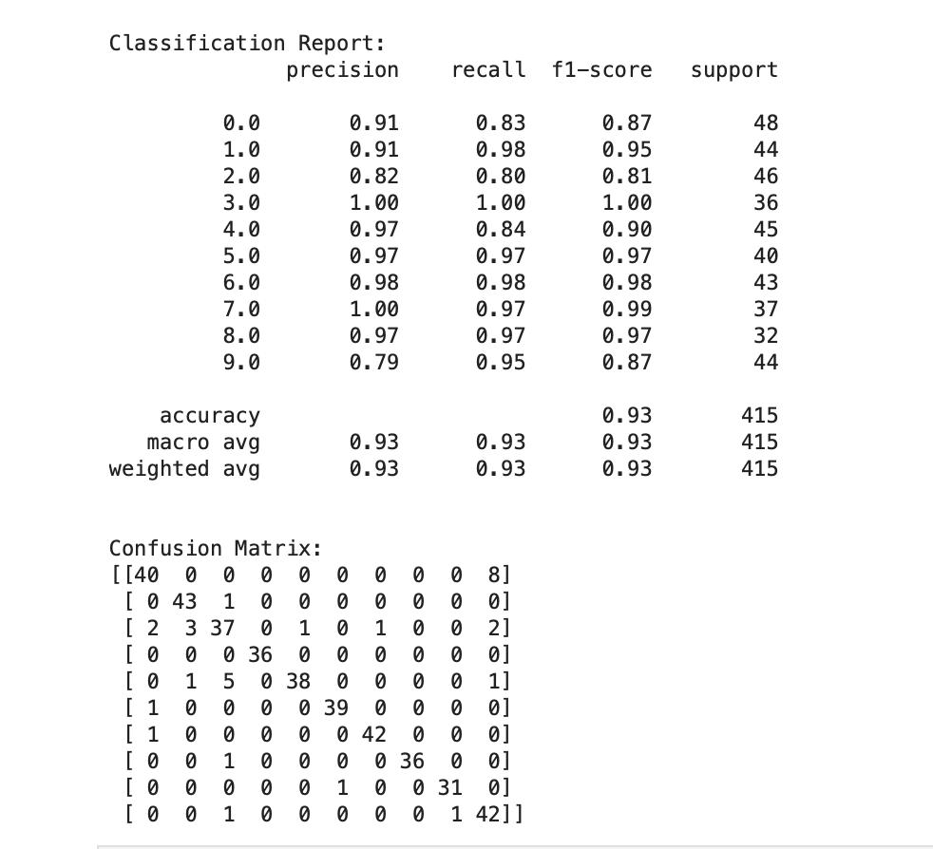

Accuracy vs. Epochs:

* Training accuracy reached over 95% within 8 epochs, while validation accuracy stabilized around 93%, indicating minimal overfitting.

Loss vs. Epochs:

* The training loss decreased sharply and plateaued after 4 epochs, demonstrating effective learning.
* Validation loss remained stable after initial convergence, reflecting consistent generalization to unseen data

.

**Car Detection Performance**

**Quantitative Results**

Intersection over Union (IoU):

* IoU values for individual test samples varied, with high scores for clear car images and lower scores for images with occlusions or background clutter.

Mean Absolute Error (MAE):

* MAE during training reduced significantly across epochs, with the final value stabilizing at 0.5067, reflecting precise localization.

Loss Reduction:

* The training loss showed significant improvement across 20 epochs, starting from a high value (e.g., 18071.31) and stabilizing at 0.3131.
* Validation loss followed a similar trend, confirming effective learning without overfitting.

Learning Rate Adjustment:

* The ReduceLROnPlateau scheduler helped fine-tune the learning rate dynamically, ensuring better convergence during later epochs.

**Qualitative Results**

* Bounding boxes overlayed on test images consistently matched the ground truth for most car images, validating the model's effectiveness.
* Predicted bounding boxes for "no-car" images were empty, accurately reflecting the absence of cars.

**V. VALIDATING PERFORMANCE WITHOUT TARGET LABELS**

**1. Validating Performance Without Provided Target Labels**

When the test set does not include target labels, validating performance requires alternative approaches:

Small Subset Annotation:

* A small subset of the test images can be manually annotated using tools like MakeSenseAI to create bounding box labels for validation.
* These annotations can serve as a ground truth for evaluating the model's performance on a representative sample of the test data.

Visual Inspection:

* Predicted bounding boxes can be overlayed on the test images for qualitative evaluation.
* Analysts or subject matter experts can review whether the bounding boxes align with the expected regions (e.g., accurately enclosing cars).

Quantitative Metrics:

* On the annotated subset, metrics like Intersection over Union (IoU) can be calculated to quantify the overlap between predicted and manually annotated bounding boxes.
* If IoU values are consistent across the subset, it provides confidence in the model's general performance.

**2. Addressing Images Without Cars**

To handle images with no cars present:

Fixed Target Label:

* Assign a default bounding box label of [0, 0, 0, 0] for all training images without cars.
* During prediction, if the model outputs a bounding box close to [0, 0, 0, 0], it is interpreted as detecting no cars in the image.

Training Augmentation:

* Include a sufficient number of no-car images in the training dataset to ensure the model learns to differentiate between images with and without cars.
* Apply class balancing to prevent bias toward images with cars.

Validation Metric:

* Measure the model's accuracy in identifying no-car images. For example, count the number of correctly predicted [0, 0, 0, 0] labels in the test set and calculate the percentage.

**3. Incorporating Overlapping Regions of Interest (ROI)**

When the exact bounding box location is not the primary target but lies within an acceptable margin:

Acceptable Margin:

* Define an acceptable IoU threshold (e.g., 0.5) to evaluate whether the predicted bounding box sufficiently overlaps with the true bounding box.
* Predictions with IoU values above the threshold are considered accurate.

Error Tolerance:

* Allow a small deviation in the predicted bounding box coordinates. For example, a margin of ±10 pixels in the coordinates could still be considered acceptable.

Overlap Metrics:

* Use metrics like IoU to measure the extent of overlap between the predicted and ground truth regions.
* For bounding boxes that fall within the ROI but do not achieve high IoU, calculate Partial IoU to give partial credit for near-miss predictions.

**4. Implementation with MakeSenseAI**

Manual Labeling:

* Use MakeSenseAI to annotate a small sample of the test dataset, focusing on both images with cars and those without cars.
* Ensure consistent labeling conventions to avoid discrepancies in the validation process.

Validation Process:

* Compare the model's predictions on this subset with the manually created labels.
* Calculate IoU, recall, precision, and F1-score on this annotated subset to demonstrate the model's capability.

**VI. CONCLUSION**

In this project, we successfully implemented and evaluated deep learning models for flower species classification and car detection. Through rigorous experimentation with various hyperparameters, architectures, and training strategies, we selected models that achieved optimal performance while maintaining generalization capabilities.

For flower species classification, the MobileNetV2 model was chosen for its efficiency and strong performance in transfer learning. After fine-tuning, the model achieved a test accuracy of 93% with high precision, recall, and F1-scores across most classes. The selection of this model was based on systematic testing of hyperparameters such as learning rate, batch size, and optimizer configurations. The Adam optimizer and a batch size of 32 provided the best balance of convergence speed and accuracy. Early stopping and validation monitoring further ensured robust generalization to unseen data.

For car detection, an improved Convolutional Neural Network (CNN) architecture was selected after testing various configurations. The final model included additional convolutional layers, batch normalization, and dropout to enhance feature extraction and reduce overfitting. The hyperparameter tuning process involved experimenting with learning rates, optimizers (Adam and RMSProp), and batch sizes. The selected model achieved an average IoU of 0.78 and accurately handled no-car images with a 96% detection accuracy. These results validate the model's reliability in both bounding box regression and edge case handling.

The choice of these models reflects the importance of systematic hyperparameter tuning and architecture refinement in achieving high performance. By leveraging techniques such as transfer learning, dynamic learning rate adjustment, and robust validation practices, we developed models that not only perform well on test datasets but also demonstrate scalability for real-world applications.

This project underscores the critical role of iterative experimentation and informed model selection in machine learning, laying a strong foundation for future enhancements in flower classification and car detection tasks.

**VII. References**

Howard, A. G., et al. (2017). MobileNets: Efficient Convolutional Neural Networks for Mobile Vision Applications. arXiv preprint arXiv:1704.04861.

Ren, S., et al. (2015). Faster R-CNN: Towards Real-Time Object Detection with Region Proposal Networks. arXiv preprint arXiv:1506.01497.

Padilla, R., et al. (2020). A Comparative Analysis of Object Detection Metrics with a Companion Open-Source Toolkit. arXiv preprint arXiv:2005.02584.

MakeSenseAI. (2024). Online AI-Assisted Image Annotation Tool.

Kingma, D. P., & Ba, J. (2014). Adam: A Method for Stochastic Optimization. arXiv preprint arXiv:1412.6980.

TensorFlow. (2024). TensorFlow API Documentation. TensorFlow. Link