**WEB PROGRAMMING ASSIGNMENT**

**S ARVIND NARAYAN**

**RA1511020010043**

**AIM:**

To create xml page and use DTD,XSD and XSLT.

**PROCEDURE:**

1. Open Text editor
2. Create xml file.
3. Create DTD file
4. Create XSD file
5. Apply XSLT to xml.

**SOURCE CODE:**

XML:

<!DOCTYPE doctors SYSTEM "C://Users/varvi/Desktop/html/new/doctor.dtd">

<doctors>

<doctor id='101'>

<name>Arvind</name>

<email>varvind7@gmail.com</email>

<dept>Ortho</dept>

<mobile>745745</mobile>

<qual>MBBS</qual>

</doctor>

<doctor id='102'>

<name>Ram</name>

<email>ram7@gmail.com</email>

<dept>ENT</dept>

<mobile>7457445</mobile>

<qual>MBBS</qual>

</doctor>

<doctor id='103'>

<name>Hari</name>

<email>hari@gmail.com</email>

<dept>general</dept>

<mobile>7457454</mobile>

<qual>MBBS</qual>

<qual>MS</qual>

</doctor>

</doctors>

DTD:

<!ELEMENT doctors (doctor*)>

<!ELEMENT doctor (name,email,dept,mobile,qual+) >

<!ATTLIST doctor id CDATA #REQUIRED>

<!ELEMENT name (#PCDATA)>

<!ELEMENT email (#PCDATA)>

<!ELEMENT dept (#PCDATA)>

<!ELEMENT mobile (#PCDATA)>

<!ELEMENT qual (#PCDATA)>

XSD:

<schema targetNamespace="http://www.docinfo.com"

xmlns="http://www.w3.org/2001/XMLSchema"

elementFormDefault="qualified">

<element name="doctors">

<complexType>

<sequence>

<element name="doctor" minOccurs="0" maxOccurs="unbounded">

<complexType>

<sequence>

<element name="name" type="string"/>

<element name="email" type="string"/>

<element name="dept" type="string"/>

<element name="mobile">

<simpleType>

<restriction base="int">

<pattern value="[0-9]{10}"/>

</restriction>

</simpleType>

</element>

<element name="qual" type="string" minOccurs="1" maxOccurs="unbounded"/>

</sequence>

</complexType>

</element>

</sequence>

</complexType>

</element>

</schema>

XSL:

<?xml version="1.0" encoding="UTF-8"?>

<xsl:stylesheet version="2.0" xmlns:xsl="http://www.w3.org/1999/XSL/Transform">

<xsl:template match="/doctors">

<html>

<body>

<xsl:for-each select="doctor">

<xsl:value-of select="name"><br/>

<xsl:value-of select="email"><br/>

<xsl:value-of select="dept"><br/>

<xsl:value-of select="mobile"><br/>

<xsl:value-of select="name"><br/>

</xsl:for-each>

</body>

</html>

<xsltemplate>

</xsl:stylesheet>

**OUTPUT:**

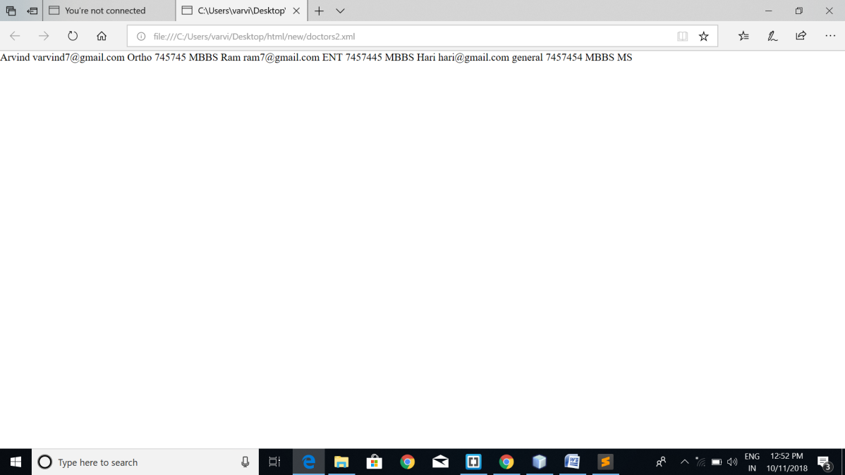

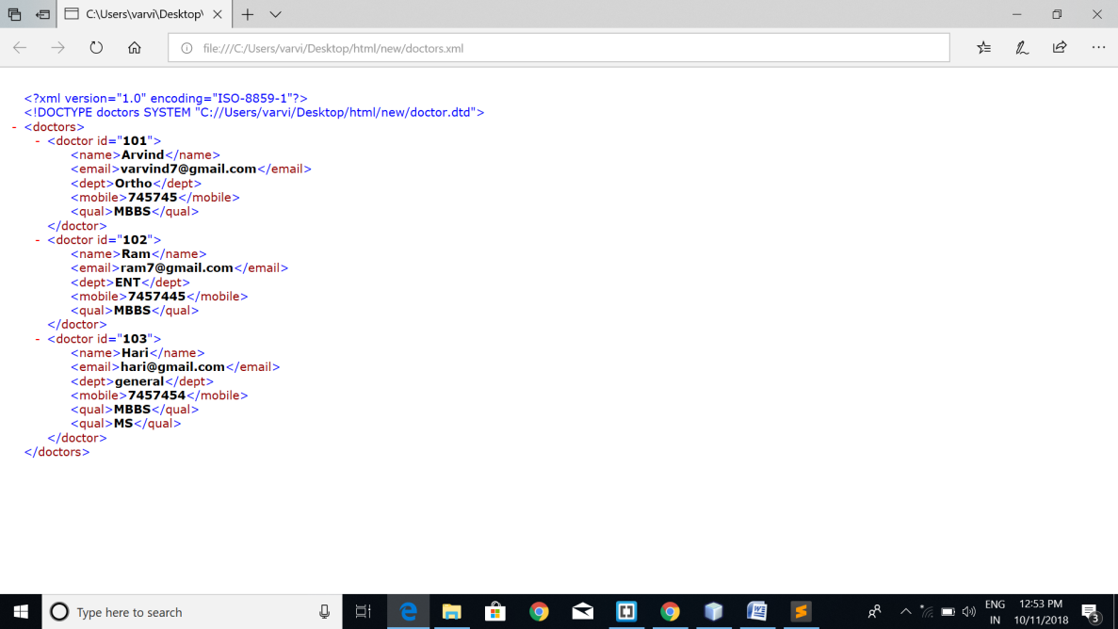

**RESULT:**

Hence XML files and DTD,XSD files were created successfully.

**DYNAMIC RESPONSE GENERATION USING AJAX**

**AIM:**

To create dynamic response using AJAX.

**PROCEDURE:**

1. Open Netbeans
2. Create a HTML page and add Javascript
3. Add HttpResponse in the script
4. Create a response dynamically
5. Execute the file in browser.

**SOURCE CODE:**

<!DOCTYPE html>

<html>

<head>

<title>AJAX</title>

<script src="script.js"></script>

<link href="bookAppointment.css" rel="stylesheet" type="text/css">

</head>

<body>

<header>

<div id="blueHeader">

<span id="title" >HospitalPortal </span>

<span id="headerNav"><a href="index.html" style="color:#FFFFFF" >Home</a>&nbsp;&nbsp;&nbsp; |&nbsp;&nbsp;&nbsp; <a class="topNav" href="login.html" style="color:#FFFFFF">Login</a>&nbsp;&nbsp;&nbsp; |&nbsp;&nbsp;&nbsp; Appointment&nbsp;&nbsp; |&nbsp;&nbsp; Search</span>

<img src="stethoscope-simple-black-icon-512.png" alt="logo" id="blueLogo">

</div>

</header>

<div id="divpadding">

<h2 style="margin-left: 40%;">Feedback Form</h2>

<br><br>

<form name="feedback">

Name: <input type="text" name="name"><br><br>

Hospital infrastructure:<br> <input type="radio" name="infra" value="Excellent">Excellent<br>

<input type="radio" name="infra" value="good">Good<br>

<input type="radio" name="infra" value="bad">Bad<br><br>

Doctors' Efficiency: <br><input type="radio" name="doceff" value="Excellent">Excellent<br>

<input type="radio" name="doceff" value="good">Good<br>

<input type="radio" name="doceff" value="bad">Bad<br><br>

Hospital Portal: <br><input type="radio" name="portal" value="Excellent">Excellent<br>

<input type="radio" name="portal" value="good">Good<br>

<input type="radio" name="portal" value="bad">Bad<br><br>

</form>

<button id="getText">Do you have any other to say?</button>

<div id="content" ></div>

<br><br>

<input type="submit" style="margin-left:50%;" value="submit">

</div>

<footer>

<span class="auto-style1">Email&nbsp; </span><span id="preFooter">|&nbsp;&nbsp; Facebook&nbsp;&nbsp; |&nbsp;&nbsp; Twitter&nbsp;&nbsp; |&nbsp;

Google+ </span><br>

&copy; Copyright Arvind Narayan - RA1511020010043 - SRM University

</footer>

</html>

*Script:*

window.onload=function()

{

var getText=document.getElementById("getText");

var content=document.getElementById("content");

var xhr=new XMLHttpRequest();

getText.addEventListener("click",function(){

xhr.addEventListener('readystatechange',function(){

content.innerHTML=this.responseText;

});

xhr.open("GET","test.txt",true);

xhr.send();

});

};

**OUTPUT:**

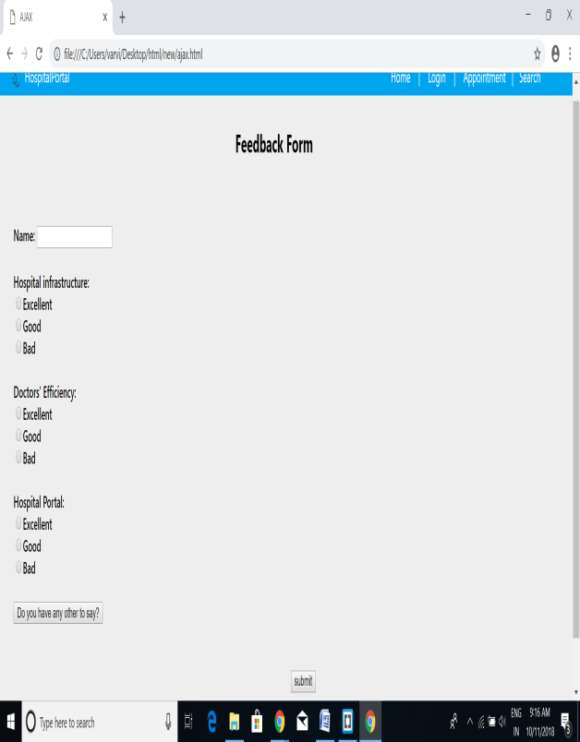 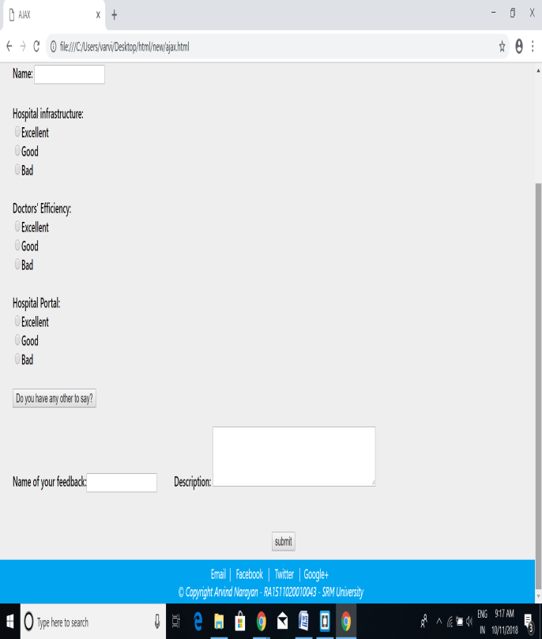

**RESULT:**

Hence the dynamic response was generated done successfully.